Solid Waste Management Improvement Project
ADB Loan No.: 3067-UZB

PROJECT MANAGEMENT, IMPLEMENTATION AND SUPERVISION CONSULTANCY SERVICES

Contract No.: SUE/Maxsustrans/QCBS-Cons_1-2016-01

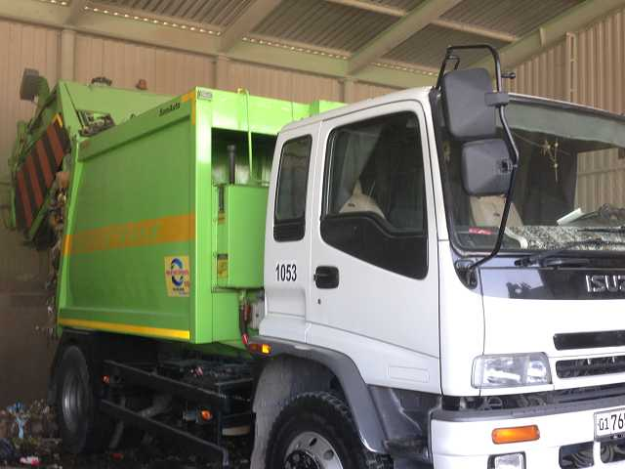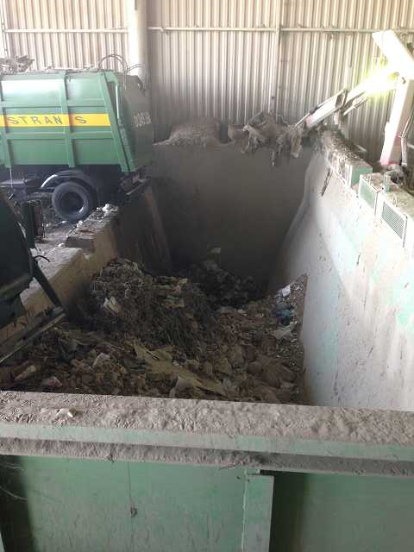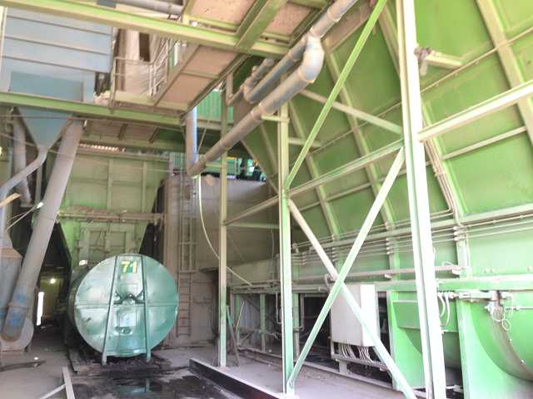

Social Safeguard Monitoring Report
Quarterly report : January - March 2018

CLIENT – IMPLEMENTING AGENCY
State Unitary Enterprise (SUE) “MAXSUSTRANS” (Tashkent, Uzbekistan)

LEAD CONSULTANT
H.P. Gauff Ingenieure GmbH & Co. KG-JBG (Germany)

in association with

ENG-INVEST Consulting Ltd. (Uzbekistan)

April 2018

Social Safeguard Monitoring Report
Quarterly report: January-March 2018

Project No: 45366
ADB Loan 3067-UZB
April 2018

UZB: Solid Waste Management Improvement Project (SWMIP)

Consulting Services for Assistance in Project Implementation, Utility Management and Operations

Tashkent 2018

This document is prepared by: JV «H.P. Gauff Ingenieure GmbH & Co. KG – JBG- (Germany) and ENG-INVEST Consulting Ltd. (Uzbekistan) » for State Unitary Enterprise «Maxsustrans», Khokimiyat of Tashkent city and ADB. This social safeguard monitoring report is a document of the borrower.

Abbreviations
ADB - Asian Development Bank
AH - affected household
AP - affected person
CAP correction action plan
EA - executing agency
GFP - grievance focal point
GOU - Government of Uzbekistan
GRM - grievance redress mechanism
Ha - hectare
IA - implementing agency
IR - involuntary resettlement
IWP - informal waste picker
LARP land acquisition and resettlement plan
MOF - Ministry of Finance
MSW - municipal solid waste
O&M - operation and maintenance
PIU - project implementation unit
PPTA project preparatory technical assistance
SLF - sanitary landfill
SWM - solid waste management

NOTE
In this report, “$” refers to United State dollars (USD) and UZS refers to Uzbekistan sum.

CURRENCY EQUIVALENTS
(as on the day of March-31st, 2018)

Currency Unit - sum (UZS) UZS 1,000.00 = $0.12323
$1.00 = UZS 8114.86

This social safeguard monitoring report is a document of the borrower. The views expressed herein do not necessarily represent those of ADB's Board of Directors, Management, or staff, and may be preliminary in nature.

In preparing any country program or strategy, financing any project, or by making any designation of or reference to a particular territory or geographic area in this document, the Asian Development Bank does not intend to make any judgments as to the legal or other status of any territory or area.

As per ADB Safeguard Policy Statement (2009) and the Operations Manual section on safeguard policy (OM F1), borrowers/clients are required to establish and maintain procedures to monitor the status of implementation of social safeguards management and ensure progress is made towards the desired outcomes.

Glossary

Compensation | Payment in cash or kind for an asset to be acquired or affected by a project at replacement cost.
Affected Persons | Affected persons (APs) are those who experience full or partial, permanent or temporary physical displacement (relocation, loss of residential land, or loss of shelter) and economic displacement (loss of land, assets, access to assets, income sources, or means of livelihoods) resulting from (i) involuntary acquisition of land, or (ii) involuntary restrictions on land use or on access to legally designated parks and protected areas. APs could be of three types: (i) persons with formal legal rights to land lost in its entirety or in part; (ii) persons who lost the land they occupy in its entirety or in part who have no formal legal rights to such land, but who have claims to such lands that are recognized or recognizable under national laws; and (iii) persons who lost the land they occupy in its entirety or in part who have neither formal legal rights nor recognized or recognizable claims to such land.
Entitlement | The range of measures comprising cash or kind compensation, relocation cost, income rehabilitation assistance, transfer assistance, income substitution, and relocation which are due to /business restoration which are due to AH, depending on the type and degree nature of their losses, to restore their social and economic base. All entitlements will be given to all affected households as per the entitlement matrix.
Hokimiyat | Local government authority that interfaces between local communities and the government at the regional and national level. It has ultimate administrative and legal authority over local populations residing within its jurisdiction.
Land  acquisition | The process whereby a person is compelled by a public agency to alienate all or part of the land s/he owns or possesses, to the ownership and possession of that agency, for public purposes, in return for fair compensation.
Mahalla | Is a local level community-based organization recognized official by the GoU that serves as the interface between state and community and is responsible for facilitating a range of social support facilities and ensuring the internal social and cultural cohesiveness of its members. Mahalla leaders are elected by their local communities.
Meaningful  Consultation | A process that (i) begins early in the project preparation stage and is carried out on an ongoing basis throughout the project cycle; (ii) provides timely disclosure of relevant and adequate information that is understandable and readily accessible to affected people; (iii) is undertaken in an atmosphere free of intimidation or coercion; (iv) is gender inclusive and responsive, and tailored to the needs of disadvantaged and vulnerable groups; and (v) enables the incorporation of all relevant views of affected people and other stakeholders into decision making, such as project design, mitigation measures, the sharing of development benefits and opportunities, and implementation issues.
Illegal | HHs that are not registered their business, agriculture, residential and orchard and those who have no recognizable rights or claims to the land that they are occupying and includes people using private or state land without permission, permit or grant i.e. those people without legal lease to land and/or structures occupied or used by them. ADB’s policy explicitly states that such people are entitled to compensation for their  non-land assets.
Replacement  cost | Replacement cost is the principle to be complied with in compensating for lost assets. Calculation of which should include: (i) fair market value; (ii) transaction costs; (iii) interest accrued, (iv) transitional and restoration costs; and (v) other applicable payments, if any. Where market conditions are absent or in a formative stage, APs and host populations will be consulted to obtain adequate information about recent land transactions, land value by types, land titles, land use, cropping patterns and crop production, availability of land in the project area and region, and other related information. Baseline data on housing, house types, and construction materials will also be collected. Qualified and experienced experts will undertake the valuation of acquired assets. In applying this method of valuation, depreciation of structures and assets should not be taken into account.
Significant  impact | 200 people or more will experience major impacts, which are defined as; (i) being physically displaced from housing, or (ii) losing 10% or more of their productive assets (income generating).
Vulnerable  Households | Low-income households, female-headed households with fewer than 2 adult income- earners, the elderly headed with unemployed family members, and disabled.
Leaseholder | Legal entity (registered farm) running agricultural production with the use of land plots granted to him on a long-term lease. Lease term is limited up to fifty years but not less than for ten years. Leaseholder cannot sell - buy, mortgage, sublease, present, exchange the land.

Table of contents

Abbreviations 3
Glossary 4
Executive Summary 7
1. Introduction 9
2. Brief methodology 10
3. Compliance to safeguards provisions in agreements under the project 11
4. Assessment of progress on implementation of Land Acquisition and Resettlement Plan 20
4.1 Progress on implementation of LARP, January – March 2018 20
5. Gender and poverty assessment 26
6. Redress Grievances 27
6.1 Assessment of efficiency of GRM 27
6.2 Monitoring of grievances for the period of January – March 2018 27
7. Public Awareness and Consultations 27
8. Conclusion 28
Annex 1 Inquires to regional and district authorities 30

Executive Summary
- This report is the Quarterly Report on Social Safeguards Monitoring and Evaluation of the Solid Waste Management Improvement Project. It covers the period of January - March 2018.
- Status of project implementation:
At this stage of the project implementation following issues happened:
- Together with the PIU and their direct support detailed data has been requested from Tashkent Regional Hokimiyat and Hokimiyat of the Akhangaran District to the status of resolving the land acquisition and providing of compensation issue to the affected person.
- At present the problem of the decision to transfer the land from the farmer's side to the Hokimiyat of the Akhangaran district of the Tashkent region is on the final stage of settlement, and preparing and receiving the documents confirming the agreement signed between the two parties. Data from the local authorities on this issue are currently not available.
- According to the results of the appeal to these organizations, Consultant was informed that the requests are still under consideration
- The official request which has been submitted in the middle of January 2018 isn’t replied in written form until yet.
- Progress of the Project: The procedures for applying to local authorities for obtaining information on the current status of the decision on the issue of land acquisition and providing compensation are described in detail in this report. Besides that this report includes the corrective actions to for next stage of the implementation of LARP. Implementation of LARP will be completed prior the commencement of construction and procurement tenders. Compensation will be fully paid to the commencement of civil works and ensure full compliance with the requirements of the Entitlement matrix of LARP.
Table 1 Status of LARP implementation, January –March 2018
Indicator | Status | Remarks
Land acquisition | Under consideration | In January 2018, Consultant in close cooperation with PIU submitted the request on the detailed information on the status of land acquisition and compensation for the affected person. to the regional Hokimiyat of Tashkent region and the regional Hokimiyat of Akhangaran district, Tashkent region.  In March 2018, official data from the Hokimiyat on the status of land acquisition and compensation is still not available.  The process of land acquisition is at final stage of completing. Local and regional authorities prepare required documents confirming the completed land allocation.
Compensation “land for land” | Under consideration
Compensation for losses (profit) | Under consideration
Compensation for lost income (workers at the farm) | Under consideration
Income restoration | Under consideration

- Gender and poverty assessment: At present there are no required activities on gender and social indicators.
- Redress grievances: There are no actions on monitoring of complaints. The main complain under the project was considered on issues on land acquisition and compensation. At present the owner of affected farmer has no complaints on land acquisition. The issue on land acquisition is under consideration and allocation of local and regional authorities (Hokimiyat of Akhangaran district and Hokimiyat of Tashkent region).
- Public Awareness and Consultations: There are no actions on public consultations. The agreement between the affected farmer and local authorities on the issues on land acquisition is reached. The local authorities have not still provided the requested documents confirming the completed process of land acquisition and compensation. Consultant will conduct the consultation after receiving the requested documents on completed process of land acquisition.
- Conclusion and recommendations: The implementation of LARP and developed mitigation measures in this project has been started but some older difficulties haven’t been solved until yet. The implementation of LARP and developed mitigation measures is under consideration of regional and local authorities. Consultant applied to the regional and local authorities to provide the information on progress on land acquisition and compensation. At present no sufficient information is has been provided by regional and local authorities. The key issue to finalize the implementation of LARP prior the commencement of construction works is currently unpredictable. The civil works can be commenced only after compensation for land acquisition is fully paid.

- Introduction
- This report is the Quarterly Report on Social Safeguard Monitoring under Solid Waste Management Improvement Project. The report describes the implementation and evaluation of social safeguards activities for January –March 2018. The social safeguard monitoring report covers, in particular, the progress and current status of the implementation of LARP.
- Purpose of this report: The report is prepared to ensure that the project is implemented in compliance with social safeguards according to the ADB’s Safeguard Policy Statement 2009, specifically to ensure that LARP is implemented in compliance with the requirements of ADB. The scope of this monitoring report is assessment of progress on implementation of LARP, including compensation payment, grievance redress procedure, evaluation of income restoration program of affected households, indigenous people and vulnerable people ( if there is any).
- This social safeguard monitoring provides information on: i) evaluation of the implementation progress of the land acquisition and resettlement by establishing social safeguard compliance status, ii) evaluation of the implementation of social safeguard measures for all persons affected by the project taking into account the available and potential social risks resulting from implementation of the project, iii) identification of non-conformances / unanticipated impacts and implement necessary mitigation / remedial measures (in case of adverse impacts), and iv) monitoring and evaluation of implementation of safeguard measures.
- Project implementation status: The ADB safeguard policy also requires that project implementation will subject to the LARP related conditions. The most important conditions are: (i) land acquisition including demolishing of any structure and housing is allowed only after all compensations are fully paid, and (ii) commencement of Civil Works is conditional to the satisfactory implementation of the final LARP to be checked and verified by independent monitoring party and reported in the LARP compliance report.
- Based on the Cabinet of Ministers Resolution # 146 (25.05.2011) of GOU any land acquisition and demolition of the structures only can be carried out after the value of compensation has agreed by the land leaseholder and owner of structures. The GOU’s law and regulations on land acquisition require also that civil works can be commenced only after compensation for land acquisition is fully paid.
- At this stage of the project implementation, during the period January 16-18, 2018, Consultant, with the direct support of the PIU, requested data from the local authorities (Tashkent Regional Hokimiyat and Hokimiyat of the Akhangaran District) as mentioned under “Executive Summery” in the beginning of the report.

- Brief methodology
- This section presents information on general and special methods which is used to prepare the Social safeguard monitoring report, including progress of LARP implementation and CAP (if required).
- The methodology applied for this report includes reviewing and analysis of records and documents as well as contacts with the representatives of local and regional authorities. Consultant did not visit the project site during this period of monitoring. No public consultations were conducted at this stage of project implementation.
- Indicators for monitoring are the followings:
    - Monitoring of implementation of Land acquisition and resettlement plan;
    - Progress on compensation payment;
    - Grievances by type and resolution status;
    - Public consultation (if required);
    - Status of vulnerable and Indigenous APs after project intervention (it there is any);
    - Status of income restoration program;
    - APs satisfaction and perception regarding compensation amount;
    - Implementation of social awareness program (social and gender issues);
    - Compliance status of social and resettlement issues with ADB SPS.

- Compliance to safeguards provisions in agreements under the project
  - Compliance to Project Administration Manual
- The Project Administration Manual (PAM) describes the essential administrative and management requirements to implement the project on time, within budget, and in accordance with Government and Asian Development Bank (ADB) policies and procedures. The PAM is mandatory and serves as the main document describing implementation details. The status of implementing the safeguards requirements set out in PAM are provided in Table below.
Table 3 Compliance to PAM
Details | Compliance Status | Remarks
Section VII - Safeguards b) Social – Involuntary resettlement. | Completed | As previously mentioned (Quarterly Report -1/Bi-annual report January 2018)
Municipality and Maxsustrans ensure that LARP would be implemented, and monitored to ensure that no affected people would suffer by unattended impacts associated with land acquisition. | Under consideration | Information on physical progress of the land acquisition and payments of compensation is under consideration of regional and local authorities. In January 2018, Consultant inquired the detailed information on the progress of work. In March 2018, no information on final status of LARP implementation is provided by local and regional authorities.
Municipality and Maxsustrans ensure that:  (i) The PIU recruit a social development specialist to implement the LARP and address other social concerns of the project, if any. | Completed | Consultant carries out detailed monitoring of the process of LARP implementation as previously mentioned (Quarterly report -1/bi-annual report January 2018)
(ii) The LARP would be updated upon completion. The report should at least indicate any change to land acquisition from the detailed designed, change to affected people, or change to budget for LARP implementation. The updated LARP must be submitted to ADB for concurrence prior to implementation. | Still ongoing according to necessity | The LARP was preliminary updated in 2015. It was not approved and disclosed.
(iv) The LARP would be disclosed to affected people. | Completed | LARP report was disclosed on ADB and Maxsustrans websites. The link to JMRC site is https://www.adb.org/projects/45366-004/main.
(vi) The awarding of civil works any contract would be done only after affected people (including other parties to receive compensation for developing new agricultural land) receive full payment of compensation, and report on full payment of compensation is submitted to ADB. The advance payment to the contractor only can be released by ADB after the report on full payment is received. | Under consideration. | The construction works will not start before the LAPR is implemented. The awarding of civil works will be done after full payments on compensation and other mitigation measures are completed.  The issue on land acquisition and payment of compensation is under consideration at regional and local authorities.
(vii) Report on monitoring the implementation of LARP will be submitted to ADB on a quarterly basis until the payment of compensation to affected parties are fully paid. | On-going | Consultant carries out quarterly monitoring of LARP implementation of LARP. The proper section of the report (LARP implementation) is prepared to assess the progress on payments of compensation to the affected persons and providing other mitigation measures described in LARP.
(viii) The Social development specialist of PIU will develop the implementation plan in close consultation with local government for livelihood improvement program to address impacts to waste pickers and waste collection points due to closure of existing dumpsite. | On-going | Informal waste pickers: The survey conducted for the informal waste pickers during preparation of LARP, it was obtained that all the IWP had their main income source. Picking of waste was alternative additional source of income. The share of this additional income is 10-12% of their total income.  If negative impact on these affected groups is identified during the future actions on project implementation, Consultant will design the recommendations to Mahsustrans (ЕА) to develop action program to address this impact from closure of the existing facility.  Consultant will check up the source and type of income of informal waste pickers and identify the need of preparation of livelihood improvement program for them (if required).  Waste collection points (waste paper, plastic, polyethylene and other): At this stage of project implementation there are no impacts on waste collection points.
Section VII - Safeguards c) Social – Indigenous people  In the proposed project area and affected area, no group of people maintain a separate cultural and social identity from the mainstream Uzbekistan society that would classify them as ethnic group, ethnic minority or indigenous people as described in ADB SPS, 2009. Therefore, the proposed project has been categorized as a “C” project in relation to indigenous peoples. | Not applicable. | N/A
Section VIII - Gender and Social Dimensions a) Gender participation: Women, who are mainly responsible for household waste management, will benefit from cleaner collection points and more regularized waste pick-up services. The project will include specific actions to strengthen women’s roles and capacities as waste minimizers and recycling facilitators, encouraging others within the household to assist in sustainable environmental practices and also to ensure job equity and equal opportunity for those employed by SWM system operators. The project will:  (i) Improve female consumer awareness of SWM issues through citywide public awareness campaigns in coordination with Women’s Committee and municipality (mahalla representatives) at the local level. | Will be implemented. | There is no gender participation at this stage of project implementation.  Now no activities on gender issues are required.  At further stage of project implementation Consultant will conduct the public consultations for the project affected persons, relevant stakeholders and other interesting people (residents of communities, including women) to inform them about the project, LARP implementation progress, ADB’s SPS requirements, local legislation and grievance redress mechanism with detailed data on responsible persons.  The periodically public consultations or workshops will be conducted for female residents of communities (households in Tashkent city) to aware them on SWM system. This activity will be carried out in close cooperation with the Environmental specialist during the project implementation as well as local municipality and other stakeholders. The results of consultations will be given in quarterly Social safeguard monitoring reports.  The proper program / information bulletin will be published on the website of Maxsustrans (EA) and submitted to the local municipality.
(ii) Empower women to establish and maintain acceptable household waste handling and storage practices and optimize recyclable material segregation increased awareness and the development of households waste management guidelines and handbooks. | Will be implemented. | There is no gender participation at this stage of project implementation.
(iii) Improve overall conditions for women operators of collection points throughout the city through ensuring equal pay, equal access to recyclables and providing protective equipment such as gloves and masks. | Will be implemented | There is no gender participation at this stage of project implementation.
(iv) Provide targeted education program for representatives of local communities in the management of proper community based SWM practices. | Will be implemented | There is no gender participation at this stage of project implementation.  Now no activities on gender issues are required.  Consultant will take part in development the education program for the representatives of local community and conduct the public consultations to increase the awareness of the residents of local communities based on proper SWM practice.
(v) Provide school-based educational programs to educate primary and secondary level students in SWM and recycling practice. | Will be implemented | The proper program / information bulletin designed in close cooperation with the Environmental specialist, other specialists of the project team and in assistance with the project stakeholders will be published on the website of Mahsustrans and submitted to the local municipality.
(v) Abandon unsanitary waste picking practices at the existing dumpsite and transition these illegal waste pickers to alternative sources of livelihood and income. | Will be implemented | If it is required at further stage of project implementation Consultant will design the recommendations to Mahsustrans (ЕА) to develop action program to address this impact from closure of the existing facility.
Section VIII - Gender and Social Dimensions b) Contractors of civil works:  Mahsustrans would also include a specific provision in the bidding documents to ensure that civil works contractors (i) comply with core labor standards, applicable laws and regulations in the Uzbekistan and incorporate applicable workplace occupational safety norms, (ii) do not differentiate payment between men and women for work of equal value, (iii) do not employ child labor in the construction and maintenance activities, (iv) eliminate forced or compulsory labor, (v) eliminate employment discrimination, (vi) to the extent possible, maximize employment of local poor and disadvantaged persons for project construction purposes, provided that the requirements for job and efficiency are adequately met, and (vii) disseminate information on the risks of sexually transmitted diseases, including human immunodeficiency virus/acquired immunodeficiency syndrome, to the employees of the contractors under the project and to members of the local communities near the project. | Will be implemented | During the construction period Consultant will visit the construction site to monitor the following social safeguard indicators:  - Labor standards and guaranties;  - Health conditions, risks of sexually transmitted diseases, including human immunodeficiency virus/acquired immunodeficiency syndrome;  - Social and living conditions;  - Safety rules and safeguards etc.  The results of monitoring will be included in the quarterly Social safeguard monitoring reports.
Section VIII - Gender and Social Dimensions c) Gender consultation: The social development specialist of PIU would assist Mahsustrans to implement gender related activities in close consultation with Women’s Committee and mahallas and report the progress and achievements or any issues in routine basis to ADB as part of the quarterly project report. | Will be implemented | At further stage of project implementation the public consultations or workshops will be conducted for female residents of communities (households in Tashkent city) to aware them on SWM system. The consultations will be conducted in close cooperation with the Environmental specialist, other specialists of the project team and in assistance with the project stakeholders.  The results of consultations will be given in quarterly Social safeguard monitoring reports.
Section IX - Performance Monitoring, Evaluation, Reporting and Communication B. Monitoring. Project performance monitoring. Monitoring and evaluation will be based on socio-economic and gender-disaggregated data for social and poverty impact indicators. These indicators will be monitored and evaluated on a quarterly basis to determine the efficiency and effectiveness of the project. Disaggregated baseline data for output and outcome indicators gathered during project processing will be updated in the quarterly reports. | On-going | Consultant carries out quarterly monitoring of social safeguard indicators of project area. Beneficiaries will be involved in project monitoring and evaluation as well.
Section IX - Performance Monitoring, Evaluation, Reporting and Communication B. Monitoring. Safeguards monitoring – Resettlement: Land acquisition completion report would be submitted to ADB before award of civil works contracts which involves land acquisition and resettlement concerns. Monitor the progress on implementation and performance in regards to the safeguards requirements would be carried out before the civil works start. | On-going. | Consultant carries out monitoring of mitigation measures / correction actions on resettlement and relocation issues under the project.
Section IX - Performance Monitoring, Evaluation, Reporting and Communication B. Monitoring. Gender and social dimensions monitoring: Action plans pertaining to social and poverty will be prepared if required. | Being complied. | Consultant will provide guidance to the IA and PIU in developing and establishing effective monitoring and reporting systems and processes on social and gender issues. Baseline surveys will be undertaken at the start of project implementation and all indicators will be monitored and reported. These will be included in quarterly social safeguard monitoring reports.
Section IX - Performance Monitoring, Evaluation, Reporting and Communication B. Monitoring. Disclosure of Monitoring Reports  All the reports prepared within the project must be disclosed at ADB’ website and website of PIU or Mahsustrans. | Being complied.  . | Quarterly social safeguard monitoring reports will disclosed on ADB and PIU or Mahsustrans websites. The link to JMRC site will be given in the reports and public materials.

  - Compliance with Social Safeguard Covenants of Loan Agreement
- The status of Compliance with social Safeguard Covenants of Loan Agreement is presented in below:

Table 4 Compliance to social safeguard covenants
Indicators | Status | Remarks
Resettlement: The Borrower shall ensure that all land and all rights-of-way required for the project are made available to the Works contractor in accordance with schedule agreed under the related Work contract and all land acquisition and resettlement activities are implemented in compliance with (a) all applicable laws and regulation of the Borrower relating to land acquisition and involuntary resettlement, (b) the involuntary Resettlement Safeguards; and (c) all measures and requirements set forth in the LARP, and corrective of preventative action set forth in the Social Safeguards Monitoring Reports. Without limiting the application of the Involuntary Resettlement Safeguards or the LARP, the Borrower shall ensure that no physical or economic displacement takes in connection with the Project until; compensation and other entitlements have been provided to affected people in accordance with LARP; and a comprehensive income and livelihood restoration program has been established in accordance with LARP. | On-going | The project has complied with the ADB Safeguard Policy Statement 2009, Land Code of the Republic of Uzbekistan, Resolution of Cabinet of Ministers of RUz # 97 (29 May 2006), Resolution of Cabinet of Ministers of RUz # 146 (25 May 2011) and other relevant laws and guidelines of the Republic of Uzbekistan.  The compensation payment and other resettlement and rehabilitation activities are under consideration of regional and local authorities.  In January 2018, Consultant applied to the regional and local authorities to obtain the information on progress of land acquisition and payments of compensation. In March 2018, there is no official reply from the authorities; the question is still under consideration.
Indigenous Peoples: The Borrower shall ensure that the preparation, design, construction, implementation and operation of the Project and all project facilities comply with (a) all applicable laws and regulation of the Borrower relating to indigenous people; (b) the Indigenous people Safeguards; and (c) all measure and requirements set forth in the IPP, and any corrective or preventative actions set forth in as Safeguards monitoring Report. | Not applicable. | In the proposed project area and affected area, no group of people maintain a separate cultural and social identity from the mainstream Uzbekistan society that would classify them as ethnic group, ethnic minority or indigenous people as described in ADB SPS, 2009.
Grievance Redress Mechanism: Within 12 months after the Effective Date, Borrower shall prepare a grievance redress mechanism acceptable to ADB and establish a special committee to receive and resolve complaints/grievance or act upon reports from stakeholders on misuse of funds and other irregularities, Including grievance due to resettlement. The special committee shall (i) make public of the existence of this grievance redress mechanism, (ii) review and address grievance of stakeholders of the Project, in relation to either Project, any of the service providers, or any person responsible for carrying out any aspect of the project; and (iii) proactively and constructively responding them. | Complied | The Grievance redress mechanism was designed within the preparation of LARP in 2012.  The effectiveness of the functioning of the designed GRM and analysis of complaints received and solved upon the project is being assessed during the quarterly Social safeguard monitoring reports.
Safeguards Monitoring and Reporting: The Borrower shall do the following: (a) submit quarterly Safeguards monitoring reports to ADB and disclose relevant information from such reports to affected person promptly upon submission; (b) if any unanticipated social risks and impacts arise during construction, implementation or operation of the Project that were not considered in the LARP, promptly inform ADB or the occurrence of such risks or impacts, with detailed description of the event and the proposed corrective action plan; (c) report any actual or potential breach of compliance with the measures and requirements set forth in the LARP promptly after becoming aware of the breach. | On-going | Social safeguard monitoring reports will be prepared on quarterly basis. Any actual or potential breach of compliance with the social safeguard measures and requirements will be reported.  Quarterly reports on social safeguard monitoring will be submitted to ADB and disclosed.
Gender: The Borrower shall ensure that the assessment of gender impacts is in a timely manner during the entire Project period, and that adequate resources are allocated for this purpose. In particular the Borrower shall ensure that gender impacts are closely monitored, and the progress shall be reported to ADB. | Complied | Social safeguard monitoring reports will be prepared on quarterly basis. Gender impacts will be monitored and assessed in quarterly reports. Any actual or potential breach of compliance with the social safeguard measures and requirements on gender issues will be reported.

- Assessment of progress on implementation of Land Acquisition and Resettlement Plan
  - Progress on implementation of LARP, January – March 2018
- The main objective of this section is to determine if the established goals of LARP were achieved, and if not, what actions should be taken. The table below reflects current situation with land acquisition and related issues.
- The LARP was prepared during project preparatory phase which includes landfill designing process and negotiation with GOU. LARP was prepared in December 2012 and disclosed in 2013. The LARP was preliminary updated in February 2015 and based on the field survey conducted to confirm or identify additional AHs and APs, systematic consultation with AHs and APs; disseminated entitlement matrix and grievance redress mechanisms. However the preliminary updated LARP was not approved and disclosed. Consequently, compliance to the LARP is carried out basing on the principles of LARP 2012.
- The table below provides the status of compliance to LARP in January –March 2018.

Table 5 Status of compliance to LARP implementation, January- March 2018
Indicator | Status | Remarks
Involuntary resettlement | Not applicable | No physical relocation of the household is required under the project.
Land acquisition:  30 ha of agricultural lands are to be acquired. 34 ha would have negative impact due to acquisition the land under the irrigation canal. The owner of the land plot is leasehold farm "Shahboz Nuri Ziyo". | Under consideration | Progress on land acquisition in implementation а LARP:  Request submission. During the period of January 16-18, 2018, Consultant, with the direct support of the PIU, requested data from the local authorities (Tashkent Regional Hokimiyat and Hokimiyat of Akhangaran District) on the current status of the issue on land acquisition and compensation to the affected person.  On January 25, 2018, Consultant also submitted requests for documents confirming the status of payment of compensation to the regional hokimiyat of Akhangaran district, Tashkent region and regional hokimiat of Tashkent region. In particular,  1. Decisions of the hokim to land acquisition and compensation;  2 Documents confirming the agreement of the farm with the amount of compensation provided;  3. Cadastral documents confirming the transfer of ownership rights to the land plot to SUE "Mahsustrans";  4. Other relevant documents reflecting the status of solving the issue of land and compensation within the project.  Status on 31st of March, 2018: The reply from these authorities is not available. According to the results of the appeal to these organizations, Consultant was informed that the requests are still under consideration.  The established period for processing applications is 15 days. Due to the fact that the issue of land acquisition and providing compensation is a complex and multi-faceted issue requiring the involvement of other interested organizations, the processing period of the appeal may be about 30 days or more.  The monitoring process included the following actions:  Akhangaran district, Tashkent region  Request submission. The request is submitted to reception of hokimiyat on 16th of January, 2018.  Registration process. Period of 16-30th of January, 2018: registration of request, resolution of hokim, distribution to responsible department and assignment of responsible specialists.  Responsible department. Issue on land acquisition and compensation is under competence of the deputy hokim on economic and business issues, Mr. Miryunusov. The registration number of incoming letter is No. 23-77 / 16.  Process of consideration. The issue of land acquisition is agreed with the affected farmer. At present the relevant preparation works for issuance of hokim’s decree on land acquisition and compensation is implemented. Under the procedure of land allocation the affected land plot passes to the municipality as part of reserve land fund of hokimiyat. After completing these procedures the registration of land plot with the right of ownership of SUE “Mahsustrans” will be considered.  Status: The request is still under consideration.  Tashkent region  Request submission. The request is submitted to reception of Hokimiyat on 18th of January, 2018.  Registration process. Period of 18-31st of January, 2018: registration of request, resolution of Hokim, distribution to responsible department and assignment of responsible specialists.  Responsible department. The issue on land acquisition and compensation is under control of First deputy Hokim of Tashkent region, Mr. Rustamov O. B. Responsible department on land allocation is cadastral department; responsible specialist is specialist on land allocation, H. Khodzhimurodov. Responsible department on compensation is consolidated Financial department of the Hokimiyat. Responsible specialist is F. Kupaikhinov.  Process of consideration. Issue on land acquisition and compensation is under direct competence of district hokimiyat. In period of February- March 2018, specialists of regional hokimiyat submitted the official requests and visited the site to obtain detailed information on status of land acquisition and compensation.  Status: Due to above mentioned status of issue consideration at district level (Hokimiyat of Akhangaran district) the request in Tashkent regional Hokimiyat is under consideration as well.
Compensation ( including severe impact allowance) | Under consideration | The issue on payment of compensation is under consideration at local and regional municipalities. See the details above.
Associated impacts (informal waste pickers) | Completed | At this stage of project implementation no actions is required on this indicator.  The survey conducted for the informal waste pickers during preparation of LARP, it was obtained that all the IWP had their main income source. Picking of waste was alternative additional source of income. The share of this additional income is 10-12% of their total income.
Associated impacts (Waste Collection Points (waste paper, plastic, polyethylene and other) | Not applicable | At this stage of project implementation there is no impacts on waste collection points.  If negative impact on these points will be identified during the future project actions, Consultant will design the recommendations to Maxsustrans (ЕА) to develop action program to address the impacts from closure of existing facility.
Indigenous Peoples: | Not Applicable. | In the proposed project area and affected area, no group of people maintain a separate cultural and social identity from the mainstream Uzbekistan society that would classify them as ethnic group, ethnic minority or indigenous people as described in ADB SPS, 2009.
Grievance Redress Mechanism | On-going | The Grievance redress mechanism designed under LARP 2012 in in force during the period of project implementation.
  - Correction actions for LARP implementation
- Consultant identified two main indicators of LARP to be completed prior the commencement of construction and procurement tenders. Land acquisition and compensation should be fully completed to the commencement of civil works and ensure full compliance with the requirements of the Entitlement matrix of LARP. Consultant developed the correction actions to complete implementation of mentioned indicator.
Table 6 Correction of actions for LARP implementation
Impact, social and resettlement indicator | Correction actions | Success criteria | Responsibility / resources | Deadlines
Land acquisition:  Lawful use of necessary land holdings must be in place prior to commencement of construction and procurement tenders and contracts and the release of loan in order to deliver the new systems.  Existing collection points and existing landfill are on public land | This issue in under the consideration at regional and local authorities. Consultant will continue monitoring of the LARP implementation.  Acquisition of land for development of sanitary landfill will be completed before start of the construction works under the project.  The Consultant monitors the situation and conditions of location of the affected leasehold farm.  The Consultant recommends the EA and local authorities:  - to provide the affected leasehold farm with the designed mitigation measures and compensation for losses;  - land for land compensation. | Proper and timely compensation as defined in the LARP. | Municipality of Akhangaran district (Hokimiyat), Municipality of Tashkent region (hokimiyat), SUE "Maxsustrans", PIU and relevant departments of Health Ministry, Ministry on ecology and natural protection, Ministry of water and agricultural resources, epidemiological departments | Prior to commencement of construction and procurement tenders
Compensation ( including severe impact allowance) | Provide the compensation for the losses defined in LARP. In particularly:  - land for land compensation;  - compensation for lost crops and profit;  - compensation to 4 workers of the affected leasehold farm (Loss of Income/Livelihood of workers).  Taking into account that the LARP was prepared in 2012, calculation of the losses and amount of compensation has to be reassessed at present replacement cost of the losses.  The Consultant recommends the EA and local authorities:  - to provide the affected leasehold farmer with the compensation according to the market value of losses restoration. Evaluation of the affected land plot and losses of the farmer should be carried out by the independent evaluation company. | Proper and timely compensation as defined in the LARP. | Municipality of Akhangaran district (Hokimiyat), Municipality of Tashkent region (Hokimiyat), SUE "Maxsustrans" | Prior to commencement of construction works.

- Gender and poverty assessment
- Gender and poverty assessment: At present there are no other required activities on gender and poverty indicators.
- Ethnicity Minorities and Indigenous People: There is no minority in the project area. Therefore, as described in ADB’s SPS, 2009 no special action is required for this indicator.
- Redress Grievances
  - Assessment of efficiency of GRM
- GRM objective and scope: The GRM under the project was designed in 2012. The main objective of the GRM functioning under the Project is to ensure timely and convenient resolution of grievances received from the citizens/beneficiaries/ Aps is ongoing.
- All other items under this chapter are further under the supervision and corresponding activities of the responsible Social Engineer / Consultant as mentioned in the previous reports.
  - Monitoring of grievances for the period of January – March 2018
- The key complain under the period of project implementation is issue on land acquisition and compensation of the affected leasehold farmer. At this stage of project implementation a mutual agreement between affected farmer and local authorities is reached. This arrangement must now be converted into a legally binding contract. The land acquisition is in process. At present there is no complaining on this issue.
- Consultant will continue monitoring of complains under the project at further stage of project implementation to ensure the proper and timely address any complains under the project.

- Public Awareness and Consultations
- Consultant will conduct individual / public consultation with the project affected farmer to ensure the satisfaction with the provided mitigation measure and develop any additional remedial measures (if required) to provide the pre-project or higher level of farming.

- Conclusion
- The implementation of LARP and developed mitigation measures is under consideration of regional and local authorities. Consultant applied to the regional and local authorities to provide the information on progress on land acquisition and compensation. At present no information is provided by regional and local authorities. The overall progress of implementing LARP and social safeguard measures show a satisfactory level.
Table 8 Overall progress and indicator for next monitoring stage
Indicator | Progress | Next stage of monitoring
LARP Implementation | Under consideration | Under monitoring
Land acquisition | Under consideration | Under monitoring
Compensation payment | Under consideration | Under monitoring
Associated impacts | Not applicable at this stage | Not applicable before construction
Grievance redress mechanism | On-going (functioning efficiently) | Under monitoring
Gender and poverty assessment | Not applicable at this stage | Under monitoring
Social safeguard monitoring at stage of construction work | Not applicable at this stage | Not applicable before construction
- The key issue which should be solved at this stage of project implementation has to be the completion of the implementation of LARP prior the commencement of construction works.
- All other necessary activities should be continued as already previously mentioned.
Table below presents the actions that are proposed in this report to address this problem:
Table 9 Actions suggested addressing the problem of LARP Implementation
Actions recommended | Responsible institutes | Social Safeguard and Development Specialist
(i) Land acquisition and compensation to the project affected household | Municipality of district, Municipality of region, SUE Maxsustrans, PIU | Monitoring of status on LARP implementation.
- Carry out the updated evaluation of the project affected leasehold farm to assess losses in current market replacement cost. The evaluation must be carried out by independent evaluating company. | Municipality of district, Municipality of region, SUE Maxsustrans, PIU | Monitoring and evaluation of status of updated assessment of losses of affected leasehold farmers.
- Recommendation for next Social safeguard monitoring and evaluation report:
- Assess the progress on land acquisition and compensation process;
- Monitoring and assessment of complaints received upon the project;
- Monitoring social, gender and poverty issues; Develop required actions and measures to mitigate any impacts if required;
- Regular coordination with the EA / IA.

Annex 1 Inquires to regional and district authorities

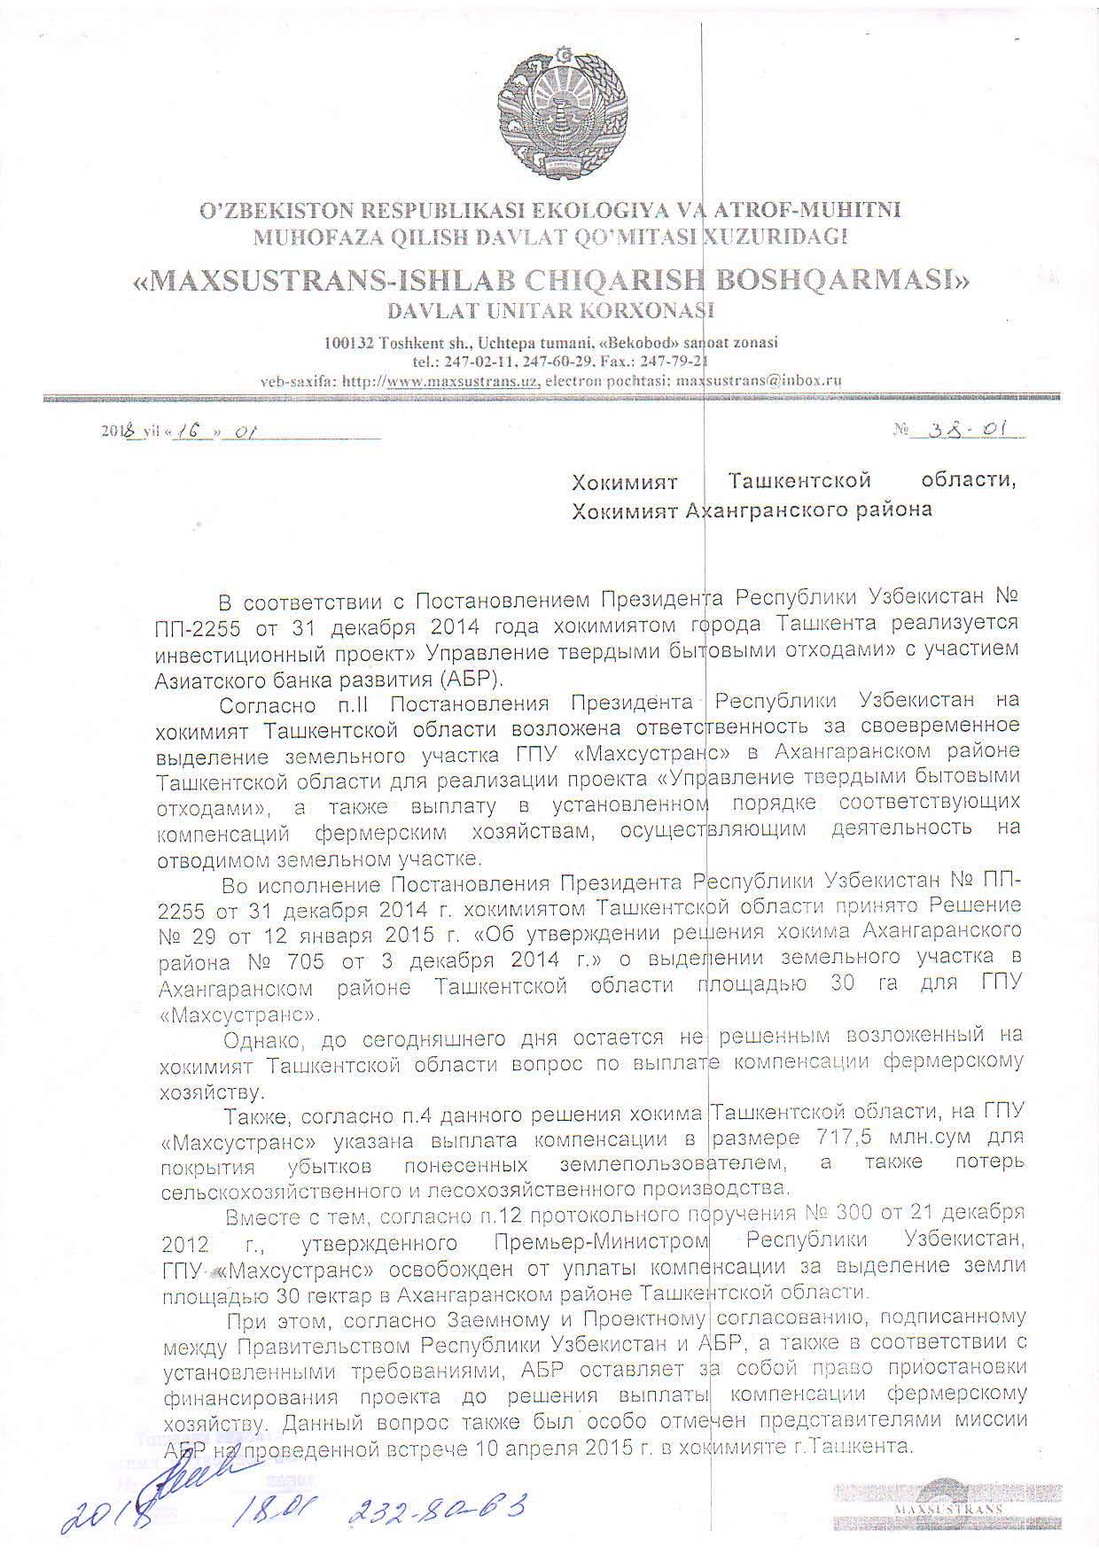
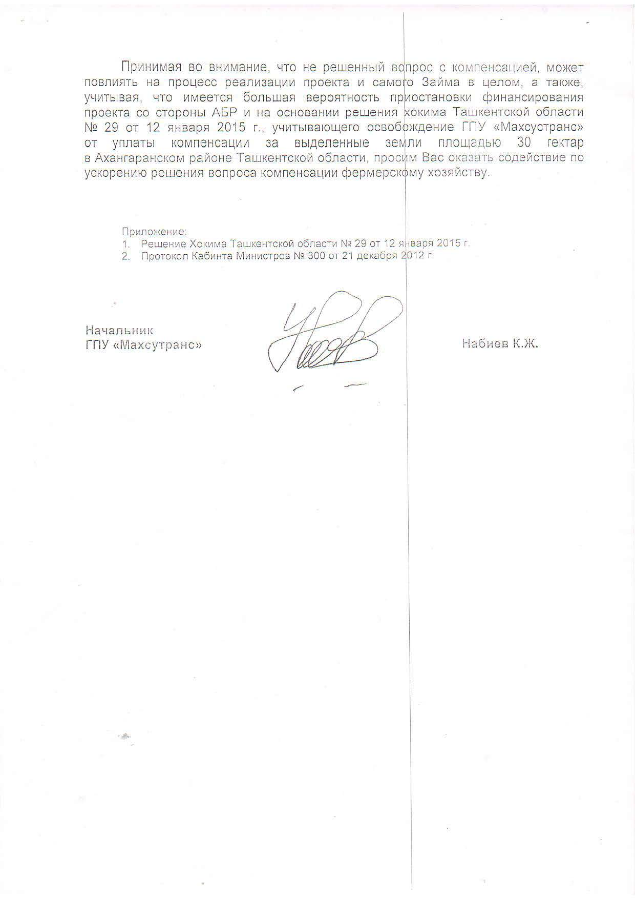

The original document is in Russian, the translation in English is unofficial
To Hokimiyat of Tashkent region
To Hokimiyat of Akhangaran district
In accordance with the Decree of the President of the Republic of Uzbekistan No. PP-2255 of December 31, 2014, the Tashkent city administration has implemented the investment project "Solid Household Waste Management" with the participation of the Asian Development Bank (ADB).
According to paragraph 2 of the Decree of the President of the Republic of Uzbekistan, the Tashkent region Hokimiyat is responsible for the timely allocation of the land plot of the State unitary enterprise "Mahsustrans" in the Akhangaran district of the Tashkent region for the implementation of the project "Management of solid domestic wastes", as well as the payment in due course of appropriate compensation to farms, carrying out activities on the allotted land.
In pursuance of the Resolution of the President of the Republic of Uzbekistan No. PP-2255 of December 31, 2014, the Hokimiyat of the Tashkent region adopted Decision No. 29 of January 12, 2015 "On approval of the decision of the Hokim of Akhangaran district No. 705 of December 3, 2014" on allocation of a land plot in the Akhangaran district of Tashkent an area of 30 hectares for the State Unitary Enterprise "Maxsustrans".
However, until today, the issue of paying compensation to the farming sector, which was assigned to the hokimiyat of the Tashkent region, remains unresolved.
Also, according to paragraph 4 of this decision of the Hokim of the Tashkent region, the state unitary enterprise "Maxsustrans" indicated payment of compensation in the amount of UZS 717.5 million to cover losses incurred by the land user, as well as losses of agricultural and forestry production.
At the same time, according to point 12 of the protocol commission No.300 dated December 21, 2012, approved by the Prime Minister of the Republic of Uzbekistan, the State Unitary Enterprise "Maxsustrans" is exempted from compensation for allocation of land with an area of 30 hectares in the Akhangaran district of the Tashkent region.
At the same time, according to the Loan and Project Agreement signed between the Government of the Republic of Uzbekistan and the ADB, and in accordance with the established requirements, the ADB reserves the right to suspend the financing of the project before the payment of compensation to the farmer. This issue was also specially noted by the representatives of the ADB mission at the meeting held on April 10, 2015 in the Tashkent city administration.
Taking into account that the unresolved issue of compensation may affect the implementation of the project and the Loan itself as a whole, and given that there is a high probability of the project financing suspension by ADB and based on the decision of the hokim of Tashkent region No. 29 of January 2015 year, taking into account the exemption of the state unitary enterprise "Mahsustrans" from payment of compensation for allocated land of 30 hectares in Akhangaran district of Tashkent region, we ask you to assist in speeding up the solution of the issue of farming compensation.
Аpplications:
1. Hokim's Decision of the Tashkent Region No. 29 of January 12, 2015
2. Minutes of the Cabinet of Ministers No. 300 of 21 December 2012.
Head of State Unitary Enterprise "Maxsustrans" Nabiyev K.J
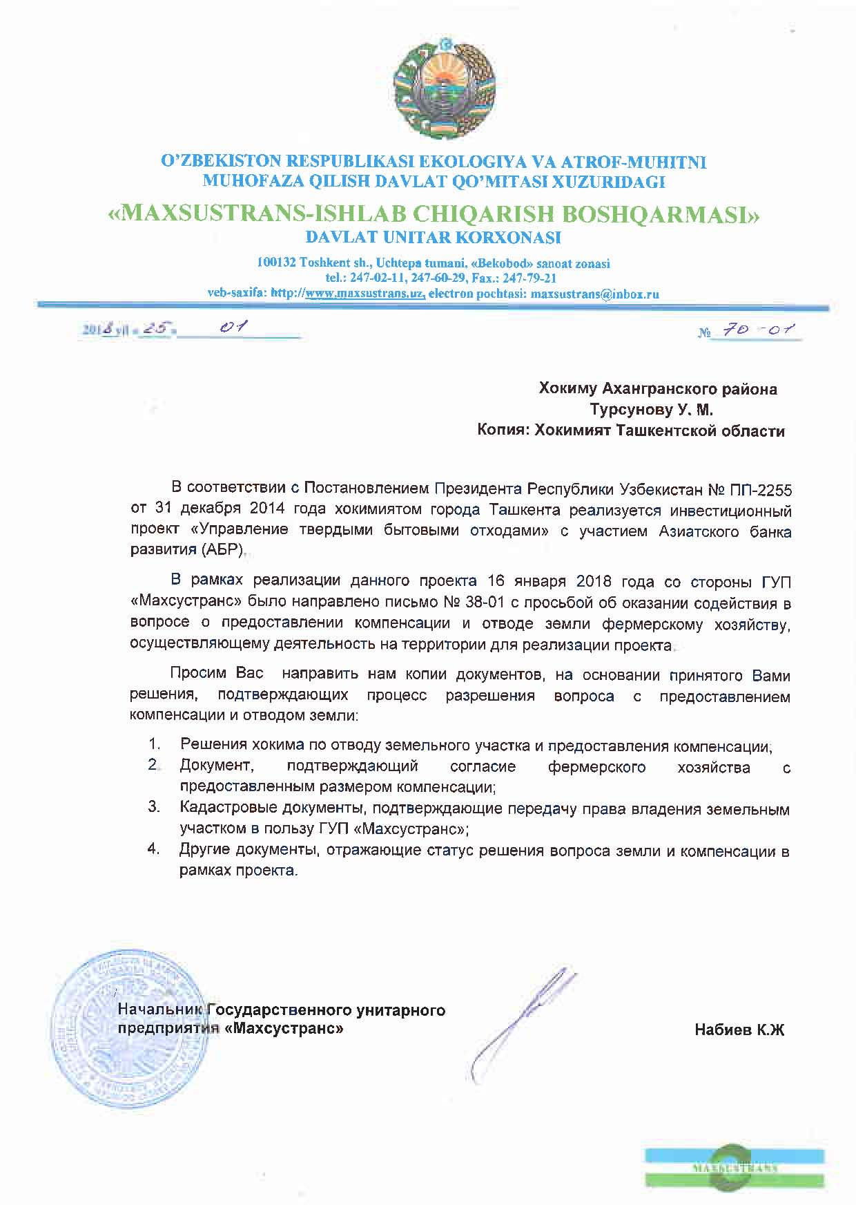

The original document is in Russian, the translation in English is unofficial
То Hokim of Akhangaran district, Tursunov U.M.
Hokimiyat of the Tashkent region

In accordance with the Decree of the President of the Republic of Uzbekistan No. PP-2255 of December 31, 2014, the Tashkent city administration has implemented the investment project "Solid Waste Management" with participation of the Asian Development Bank (ADB).
As part of the project, on January 16, 2018, the letter from the state unitary enterprise "Maxsustrans" was sent to the Ministry of Justice to provide assistance in resolving the outstanding issue with the provision of compensation and the withdrawal of farm land plot that carry out activities in the area required for the project.
We ask you to send us copies of the documents on the basis of your decision confirming the process of resolving the issue with compensation and land allocation:

1. Decisions of the Hokim to allocate land plot and provide compensation;
2. A document confirming the agreement of the leasehold farming with the amount of compensation provided;
3. Cadastral documents confirming the transfer of ownership rights to the land plot in favor of the state unitary enterprise "Maxsustrans"";
4. Other documents reflecting the status of solving the issue of land plot and compensation within the project.

Head of State Unitary Enterprise "Maxsustrans" Nabiyev K.J

Project impact: (a) acquisition of 30 ha of agricultural lands is to be acquired. 34 ha would have negative impact due to acquisition the land under the irrigation canal. (b) one affected households (leasehold farm) and 4 permanent agricultural workers as well as 1 NGO - "Yangi Hayot” Water Consumers Association (destruction of agricultural infrastructure such as irrigation channel); (c) associated impacts on 100 Informal Waste Pickers (at present there is no impact on these groups).
The official period for handling appeals is 15 days, the complexity of this issue increased the time for consideration of the request up to 30 days.
The requests are given in the Annex.

