  

**Solid Waste Management Improvement Project**

**ADB Loan No.: 3067-UZB**

**PROJECT MANAGEMENT, IMPLEMENTATION AND SUPERVISION CONSULTANCY SERVICES**

**Contract No.: SUE/Maxsustrans/QCBS-Cons\_1-2016-01**

**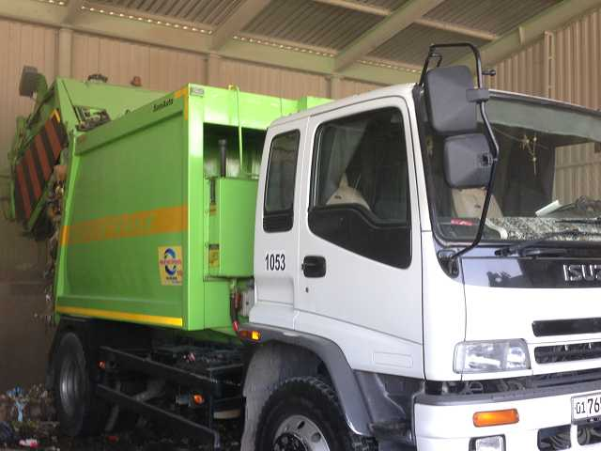** 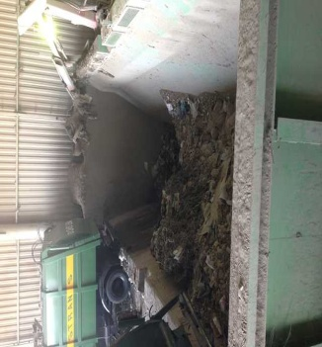 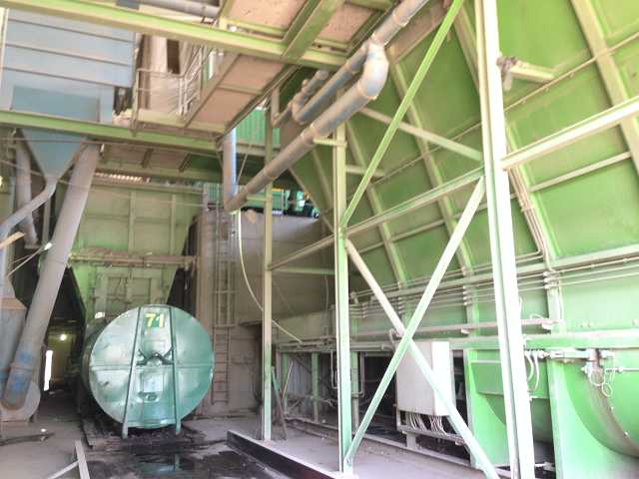

**Semi-annual Environmental Monitoring Report**

**Reporting Period: July - December 2018**

**CLIENT – IMPLEMENTING AGENCY**

**State Unitary Enterprise (SUE) “MAXSUSTRANS” (Uzbekistan)**

**LEAD CONSULTANT**

**H.P. Gauff Ingenieure GmbH & Co. KG-JBG (Germany)**

**in association with**

**Infratech Consulting SDN Ltd. (Uzbekistan)**

**January 2019**

Semi-annual Environmental Monitoring Report

**\_\_\_\_\_\_\_\_\_\_\_\_\_\_\_\_\_\_\_\_\_\_\_\_\_\_\_\_\_\_\_\_\_\_\_\_\_\_\_\_\_\_\_\_\_\_\_\_\_\_\_\_\_\_\_\_\_\_\_\_\_\_\_\_\_**

Project No: 45366

Reporting period: July-December 2018

ADB Loan: 3067-UZB

UZB: Solid Waste Management Improvement Project (SWMIP)

(Financed by the ADB)

**Prepared by:** Mr. Sergey Karandayev, National Environmental Specialist of PIU Consultants - JV «H.P. Gauff Ingenieure GmbH & Co. KG – JBG- (Germany) and Infratech Consulting SDN Ltd. (Uzbekistan)

**For:** State Unitary Enterprise «Maxsustrans», Khokimiyat of Tashkent city and ADB

**Endorsed by:** Mr. Rustam Shukurov - Head of PIU

CONTENTS

[1. Introduction 6](#_Toc534792266)

[1.1. Preamble 6](#_Toc534792267)

[1.2. Headline Information 6](#_Toc534792268)

[2. Project description and current activities 8](#_Toc534792269)

[2.1 Project Description 8](#_Toc534792271)

[2.2. Project Site Description 9](#_Toc534792272)

[2.3. Project Contracts and Management 12](#_Toc534792273)

[2.4. Project Activities During Current Reporting Period 14](#_Toc534792274)

[2.5. Description of Any Changes to Project Design 16](#_Toc534792277)

[2.6. Description of Any Changes to Agreed Construction methods 16](#_Toc534792278)

[3. Environmental Safeguard activities 17](#_Toc534792279)

[3.1. General Description of Environmental Safeguard Activities 17](#_Toc534792283)

[3.2 Site Audits 17](#_Toc534792284)

[3.2.1 ADB Mission 23](#_Toc534792285)

[3.2.2 Issues Tracking (Based on Non-Conformance Notices) 24](#_Toc534792286)

[3.2.3 Trends 24](#_Toc534792287)

[3.2.4 Unanticipated Environmental Impacts or Risks 24](#_Toc534792288)

[4. Results of Environmental Monitoring 25](#_Toc534792289)

[4.1. Overview of Monitoring Conducted during Current Period 25](#_Toc534792291)

[4.2. Trends 27](#_Toc534792292)

[4.3. Summary of Monitoring Outcomes 27](#_Toc534792293)

[4.4. Material Resources Utilisation 27](#_Toc534792294)

[4.5. Waste Management 27](#_Toc534792295)

[4.6. Health and Safety 27](#_Toc534792296)

[4.7. Training 27](#_Toc534792297)

[5. Functioning of the SEMP 28](#_Toc534792298)

[5.1. SEMP Review 28](#_Toc534792300)

[6. Good Practice and Opportunity for Improvement 28](#_Toc534792301)

[6.1. Good Practice 28](#_Toc534792303)

[6.2. Opportunities for Improvement 28](#_Toc534792304)

[7. Summary and Recommendations 29](#_Toc534792305)

[7.1. Summary 29](#_Toc534792307)

Annex 1: Environmental Management Plan

**LIST OF FIGURES**

[Figure 1. Location map of Akhangaran landfill 10](#_Toc534962609)

[Figure 2. Proposed Akhangaran landfill expansion 10](#_Toc534962610)

[Figure 3. Map of acquired land plot and irrigation canal 11](#_Toc534962611)

[Figure 4 Figure Organizational structure of the State Enterprise “Waste Transfer and Utilization” 19](#_Toc534962612)

[Figure 5: Location of Transfer Stations within Tashkent 20](#_Toc534962613)

[Figure 6: Pictures – Transfer Station Yunusobod 21](#_Toc534962614)

[Figure 7: Transfer Stations in Sergeli District 22](#_Toc534962615)

**LIST OF TABLES**

[Table 1: List of contracts under the Project 13](#_Toc534792502)

[Table 2 Role of Agencies towards EMP Implementation 13](#_Toc534792503)

[Table 3: Brief details about project costs 14](#_Toc534792504)

**ABBREVIATIONS**

|  |  |
| --- | --- |
| **ADB** | Asian Development Bank |
| **CDP** | Corporate Development Program |
| **CSC** | Construction Supervision Consultant |
| **EA** | Executing Agency |
| **EHS** | Environmental Health & Safety |
| **EIA** | Environmental Impact Assessment |
| **EIP** | Environmental Impact Permit |
| **EMP** | Environnemental Management Plan |
| **ES** | Environmental Specialist |
| **GoU** | Government of Uzbekistan |
| **GRM** | Grievance Redress Mechanism |
| **IA** | Implementing Agency |
| **IEE** | Initial Environmental Examination |
| **LARP** | Land Acquisition and Resettlement Plan |
| **Maxsustrans** | State Unitary Enterprise “Maxsustrans” |
| **MSW** | Municipal Solid Waste |
| **PIU** | Project Implementation Unit |
| **SC** | Supervision Consultant |
| **SCEEP** | State Committee of the Republic of Uzbekistan of Ecology and Environment Protection |
| **SLF** | Sanitary Landfill Facility |
| **SPS** | Safeguard Policy Statement |
| **SSEMP** | Site-specific Environmental Management Plan |
| **SWM** | Solid Waste Management |
| **SWMIP** | Solid Waste Management Improvement Project |

# Introduction

## Preamble

1. This is the bi-annual environmental monitoring report for Solid Waste Management Improvement Project. The report presents a review of the actions taken by various stakeholders in the project for compliance with the ADB environmental safeguard requirements and further states the actions that would be taken in the due course of the project.
2. This report is the 5-th EMR for the project and covers July - December 2018 reporting period. The main goal of this 6-th Environmental monitoring report is to provide progress on implementation of Environmental Management Plan (EMP), and to report any other environmental concerns occurred during project implementation. The report is also prepared to comply with environmental safeguard requirements of the Government of Uzbekistan and ADB as well as to fulfill the loan covenant as described in the loan agreement No.: 3067-UZB signed between Government and ADB.
3. The project includes a dynamic Sanitary Landfill Facility (SLF) development concept approach. This utilizes the planned SLF as an immediate and effective solution for Tashkent’s waste disposal challenges, with the potential to progressively expand the facility to become a disposal solution that can serve the Tashkent region over the long term. In comparison to the last submitted report here are no changes which has currently influent of the further developing of the SWMIP Project during the last time.
4. In addition, the project includes:

* purchase of garbage trucks for collection and transportation waste;
* procurement of special machines and mechanisms for the sanitary landfill;
* procurement of waste bins for WCPs and containers for transportation of solid waste;
* revamping of two transfer stations in the city of Tashkent;
* construction of 350 units of new collection points for solid waste and reconstruction of 350 units of existing collection points for solid waste;

1. Collection points will be equipped with functional and suitably sized waste bins, with provision for recyclable materials to be segregated and collected. Outdated collection vehicle fleets will be replaced with appropriately sized and highly efficient collection vehicles, dramatically reducing operation and maintenance costs. Transfer stations will be equipped with improved infrastructure and electromechanical components, and the transfer vehicles will be replaced. With these activities an improvement of the environmental impact should be also expected.

## Headline Information

1. The Government of Uzbekistan (GoU) has applied for a loan from the Asian Development Bank (ADB) for the development and improvement of Solid Waste Management (SWM) system of the capital city (Tashkent). The loan reference number is L3067-UZB: Solid Waste Management Improvement Project (SWMIP). The loan was signed between the Republic of Uzbekistan and Asian Development Bank (ADB) dated 27 February 2014 and Project Agreement dated 12 March 2014 signed between ADB, Tashkent City Municipality and the State Unitary Enterprise “MAXSUSTRANS”.
2. The project was prepared to impact an improved urban environment and quality of life for the residents of Tashkent. The project will develop a sanitary landfill that meets international standards, rehabilitate transfer stations, and modernize the waste collection and transfer fleet. It will build capacity in waste management and help formulate a national strategy on solid waste management.
3. The Government of Uzbekistan (GOU) seriously recognizes the need to develop and implement a national Solid Waste Management (SWM) strategy. Therefore, the GOU has requested support from ADB to address the SWM challenges. The proposed Project will contribute to sustainable urban development in Uzbekistan by: (i) modernizing SWM to provide continuous and reliable municipal services; (ii) promoting financial sustainability of municipal services through tariff rationalization and prudent financial management; (iii) supporting policy and institutional reforms for improved sanitation and environmental management; (iv) mitigating climate change through a major reduction of GHG emissions, and through compliance with international standards on waste minimization and material recycling; and through all these measures; (v) improving livability of cities.
4. The volume of the existing dumpsite is exhausted and the original plan of the city was to extend its dumpsite operations to an adjacent lot of additional 30 hectares of area. Being fully aware of the inevitable environmental impacts through the extension of this practice, the city asked the national government for assistance in this matter. Based on these activities, the Cabinet of Ministers approved in summer 2012 the location of new dumpsite on 30 hectares of agricultural area for the utilization for waste management activities.
5. GOU has already decided to start processing land allocation of a 30-hectare land plot immediately to the south of the existing Akhangaran dumpsite (25 ha for Landfill and 5 ha for facilities), on which to develop an interim dumpsite extension and also to upgrade this facility to a sanitary landfill facility, designed to internationally accepted standards of environmental protection.
6. Last option of expansion of landfill to the east, it has the potential for progressive expansion to become a 250-hectare long-term regional landfill, which can serve Tashkent’s disposal needs for at least 50-years. In other words, this initial landfill actually is the first development phase of the much larger regional landfill, should this option be later selected by the city as the long-term disposal solution. Should the alternative long-term option be selected instead however, then this interim facility could be closed, or possibly could switch to serve the disposal needs of nearby communities. A conceptual design has been completed for the interim 25-hectare facility, which is naturally included as a component of the Project.

# Project description and current activities



## 2.1 Project Description

1. The overall objective is to provide an improved solid waste management (SWM) system in Tashkent, the capital city, to upgrade urban infrastructure and services. The project will develop a sanitary landfill that meets international standards, rehabilitate transfer stations, and modernize the waste collection and transfer fleet. It will build capacity in waste management and help formulate a national strategy on solid waste management.
2. Given the current SWM practices, the option converting and allocating an area adjacent to the existing dumpsite to an engineered Sanitary Landfill was decided. The proposed sanitary landfill facility (SLF) concept will be based on the Best Environmental Practices (BEP) resulting to a *state-of–the-art* design consistent with international acceptable standards. This “stand alone” facility will drastically improve the SWM system (i.e. the handling and final disposal of MSW) with a possible integration capability for a long-solution to cover the entire Tashkent Oblast. The inclusion into the design of a multi-barrier system, leachate and gas collection systems will result in a significant reduction of anticipated impacts. Solid Waste Management Improvement Project (hereinafter called “Project”) is to contribute to the following issues:

|  |
| --- |
| * Segregation of Municipal Solid Waste stream; * Proper collection and dumping to appropriate sites * Establishment of modern SWM systems * Remediation of old 'truck and dump' practices in cities and regions |

1. The Government of Uzbekistan has agreed for a loan from the Asian Development Bank (ADB) for the development and improvement of Solid Waste Management system of the capital city Tashkent. The Loan Agreement was signed on 27.02.2014 between the Republic of Uzbekistan and Asian Development Bank and the Project Agreement dated 12.03.2014 was signed between ADB, Tashkent City Municipality and the State Unitary Enterprise “MAXSUSTRANS”. The special Decree of Uzbekistan President No.PP-2255 about the implementation of SWMIP has been issued on 31.10.2014, which specified five years project implementation period (2014-2018) and total project cost - **USD 92,25 mln.,** of which USD 69,0 mln. the loan funds from ADB and USD 23,25 mln. the contribution of SUE “Maxsustrans” and the GoU. The GoU contribution is provided as exemption of tax and customs duties in Uzbekistan for the amount of USD 5,82 mln.
2. The GoU through it Implementing Agency (IA), the State Unitary Enterprise (SUE) “MAXSUSTRANS” utilizes part of this loan proceeds towards the cost of the contract for Consulting Services related to Project Management, Implementation and Supervision, supporting the Project Implementation Unit (PIU).
3. The project was prepared to impact an improved urban environment and quality of life for the residents of Tashkent. The outcome will be improved SWM services and management in Tashkent with the following key outputs:
4. **Output 1 - Rehabilitated and expanded solid waste management (SWM) system in Tashkent**. By the project completion it is expected that (i) rehabilitation of transfer stations and possible closure of an existing transfer station 2 (ii) 3 million tons of disposal capacity established with international environmental standards, and (iii) 1,950 tons per day of disposal and operational capacity established;
5. **Output 2 - Strengthened operational capacity**. By the project completion it is expected that (i) at least 90% of households actively segregating waste at source, (ii) campaign to raise awareness will reach 90% of households on waste segregation with women households members’ participation, (iii) improved management and operations of Maxsustrans, including a 20% improvement (reduction) in cost per ton of waste disposal, and (iv) an IT-supported MSW collection system based on a geographic information system (GIS) database is implemented and 80% of trips monitored by the system is achieved.; and
6. **Output 3 - National SWM strategy**. By 2016, a draft national SWM strategy prepared and submitted to the Government and ADB.
7. There are two executing agencies (EAs) for the project – the Tashkent Municipality (Hokimiyat of Tashkent city) for the overall oversight and monitoring of Outputs 1 and 2 and State Committee of the Republic of Uzbekistan of Ecology and Environment Protection (SCEEP)[[1]](#footnote-1) for execution of Output 3–the national SWM strategy. Outputs 1 and 2 will be implemented by State Unitary Enterprise “MAXSUSTRANS”. A PIU was established within MAXSUSTRANS to support project implementation. This support will include project management, financial management, procurement, contract administration, safeguards implementation, construction and technical supervision, and monitoring and evaluation.

## Project Site Description

1. The Akhangaran landfill is located approximately 35 km south of the center of Tashkent City in the Akhangaran district of Tashkent Province. The facility has been in use since 1967 and is currently handling the wastes collected from Tashkent city and partial from Chirchik. The proposed site for a modern Sanitary Landfill is located at the eastern side of the existing Akhangaran Landfill. The total area for Landfill will cover approximately 25 hectares of agricultural land.Location map of Akhangaran landfill is given on **Figure 1** below.

**Figure 1. Location map of Akhangaran landfill**

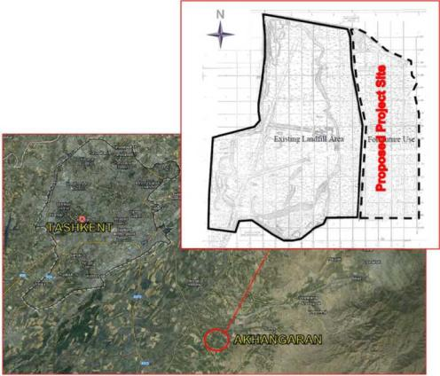

1. Access to the site: Land acquisition for the expansion of existing landfill will not require construction of any additional access road to the site. This is visualized below on given image (**Figure 2** below). Access to land will be through already functioning road. Existing access and other bypass roads should be taken in consideration for repair- and reconstructions works. Buffer zone for the SLF will be within the acquired land plots.

**Figure 2. Proposed Akhangaran landfill expansion**

|  |
| --- |
|  |

\* Yellow line is border of existing landfill; blue line is border of expansion

|  |
| --- |
| **Figure 3. Map of acquired land plot and irrigation canal** |
| C:\Users\Вероника\AppData\Local\Microsoft\Windows\Temporary Internet Files\Content.Word\Новый рисунок (1).bmp |

1. The current situation on project implementation on land issues and compensation is the following:

* The land plot of 30 ha required for the project implementation was allocated to SUE Maxsustrans according to the Decree of Khokimiyat of Akhangaran district #1536 dated August 25, 2018[[2]](#footnote-2).
* The required land plot is now considered as construction site. In August 2018 the owner of leasehold farm, affected by the project under the LARP 2012, applied to the local authorities to return his leasehold land plot to reserve land fund of khokimiyat. The owner of the farm has stopped his farming activity at this plot. [[3]](#footnote-3)

1. According to the mentioned Decree of khokimiyat, SUE Maxsustrans shall:
2. obtain the proper documents from local Architectural and Construction authority prior to start any design works for construction or rehabilitation on the new land;
3. pay agriculture production losses arisen from this land area;[[4]](#footnote-4)
4. ensure keeping the working conditions of the existing irrigation, melioration and engineering infrastructures located in the neighboring farmer and agricultural areas;
5. upon using of this land, do re-cultivation and hand over to the local land authority.
6. be aware that the allocated land shall be used within three years upon issuing this decree.
7. At present, the project implementation is on the stage of registration the documents on the land plot transferred to Maxsustrans for construction. The issues of registration of the documents shall be carried out by the specialists of cadaster department of khokimiyat of the district / region.

## Project Contracts and Management

1. Sanitary Landfill Design and Supervision Consultant "China Urban Construction Design & Research Institute Co., Ltd." has been hired. The commencement, means full mobilization and start with the work according to the ToR of consultants began from 14 December 2018. This consulting company will do design works of closing old landfill and establishing of new sanitary landfill. During the construction work they will supervise all construction works related to Landfill establishment.
2. PIU Consultants (H.P. Gauff Ingenieure GmbH & Co. KG and his JV-Partner Infratech Consulting SDN Ltd (Tashkent) supporting the PIU according to the contract and its Amendment No.2.
3. PIU Consultants has National Environmental Expert – Mr. Sergey Karandayev, who implementing environmental safeguards services.
4. Main organizations involved in the project and related to environmental safeguards are presented in the **Table 1** below:

Table 1: List of contracts under the Project

| **Organization** | **Name of main staff and Environmental Specialist** | **Contact data (including phone and web-site) and address of the organization** | **Employer** | **Contract Signature date** | **Contract Final Date** |
| --- | --- | --- | --- | --- | --- |
| PIU Support Consultant – JV “H.P. Gauff Ingenieure GmbH & Co. KG-JBG and Infratech Consulting SDN Ltd.” | Mr. Ingo Schoebe, Team Leader  Mr. Dilshod Mavlyan-Kariev, Deputy Team Leader  Mr. Sergey Karandaev, Environmental Specialist | [pbox-swmip.uzb@gauff.com](mailto:pbox-swmip.uzb@gauff.com)  [eng-invest@consultant.com](mailto:eng-invest@consultant.com)  [eng-invest@consultant.com](mailto:eng-invest@consultant.com) | SUE “Maxsustrans” | 11.01.2017 | 30.06.2019 |
| Sanitary Landfill Design and Supervision Consultant -China Urban Construction Design & Research Institute Co., Ltd." | Mrs. Yuwei Xue,  Authorized representative  Mr. Mingtao Nie | [cucdconsulting@163.com](mailto:cucdconsulting@163.com)  [hipmo@163.com](mailto:hipmo@163.com) | SUE “Maxsustrans” | November, 2018 | November, 2020 |
| Capacity Development Program Consultant - JV  “GWCC-INTERIVAL-UVP-Dohwa-Al Mar” | Mr. Thomas Derntl, Team Leader  Mr. Thiemo Fellner, Deputy Team Leader  Julia Alekseeva,  Environmental Specialist | [thomas.derntl@gwcc.at](mailto:thomas.derntl@gwcc.at)  [thiemo.fellner@interival.at](mailto:thiemo.fellner@interival.at)  [alekseeva@almarconsulting.org](mailto:alekseeva@almarconsulting.org) | SUE “Maxsustrans” | 12.09.2017 | 15.10.2019 |

1. The role of each agency in the project is presented in the Table 2.

Table 2: Role of Agencies towards EMP Implementation

|  |  |
| --- | --- |
| **Agency** | **Role** |
| **Project Implementation Unit (PIU)** | * Holds Overall responsibility with regard to EMP Implementation * Reporting to various stakeholders (ADB, Regulatory bodies) on status of EMP Implementation * Coordinating with Environmental Experts (PIU Support Consultant, Contractors and External Monitors) * Responsible for obtaining Regulatory Clearances * Review of the progress made by Contractors * Ensure the BoQ items mentioned in EMP are executed as per contract provision |
| **PIU - Support Consultant** | * Assisting PIU in overall implementation of EMP * Review of periodic reports on EMP implementation and advising PIU in taking corrective measures * Conducting periodic field inspection of EMP implementation * Assisting PIU and reporting to various stakeholders (ADB, Regulatory bodies) on status of EMP implementation * Conduct environmental training for field officers and engineers of contractor |
| **Contractor** | * Responsible for ensuring the implementation of EMP as per provision in the document * Discussing various environmental / social issues and environmental / social mitigation, enhancement and monitoring actions with all concerned directly or indirectly * To ensure environmentally sound and safe construction practices * Conducting periodic environmental and safety training for contractor’s engineer, supervisors and workers * Sensitization on social issues that may be arising during the construction stage of the project * Conduct environmental monitoring and control activities including pollution monitoring, safety; and * Preparing and submitting monthly reports to PIU on status of implementation of safeguard measures |

## Project Activities During Current Reporting Period

1. The proposed project was estimated to cost $92.25 million, including taxes and duties, physical and price contingencies and interest charges during implementation. Brief details are shown in the below table and project cost estimates.

Table 3: Brief details about project costs



|  |  |  |
| --- | --- | --- |
| **Total project cost** | **–** | **92,25 mln. USD**, of them: |
| IFI Input/ADB Loan | – | 69,00 million USD (74,79%) |
| Input of the Republic of Uzbekistan  Input of SUE «Maxsustrans»: | – | 5,82 million USD  (in form of customs and tax benefits).  17,43 mln. USD, including: capital investments 1,5 mln.USD and cost of existing fixed assets 15,93 mln.USD. |

1. To be mentioned that to the Commencement Date of the Consultant the IA has arranged the following procurement packages:

**1) Containers for collection of SDW at WCP**

(SUE /Maxsustrans/CB-G\_3-2016-02)&(SUE /Maxsustrans/DC-G\_4-2017)

30. This two Contracts have been finalized in March 2018.

**2) Construction/reconstruction of new waste collection points**

(SUE /Maxsustrans/CB-W5)

31. This Contract has been already finalised.

**3) Waste collection trucks and special machinery**

(SUE /Maxsustrans/CB-G2-2016-02)

32. The contract for delivery of 182 units of waste collection trucks and special machinery for the amount of 12, 99 mln. USD is concluded with the POSCO-DAEWOO company (Korea). For the present, the producer of waste collection trucks and special machinery Hyundai has shipped the whole consignment of goods. Today, 182 units of waste collection trucks and special machinery are put into operation of SUE Makhsustrans and the process of customs clearance and registration for these goods were fully completed. The handing over procedure and training successfully finalized.

**4) Consultant for support of PIU in project implementation**

(SUE /Maxsustrans/QCBS-C1-2016-01)

33. The contract is concluded between SUE "Maxsustrans" and JV "H.P. Gauff Ingenieure GmbH & Co. KG-JBG" (Germany) and LLC "Infratech Consulting SDN" (Uzbekistan). The Consultant has started activities since 01.08.2017 and continues the activities up to date. Current date of the contract finalization is June 30, 2019.

1. **Consultant for support of capacity of SUE “Maxsustrans” and development of National Strategy for Solid Waste Management of the Republic of Uzbekistan**

(SUE/Maxsustrans/QCBS-C3)

34. For the present, the contract is signed with JV "GWCC-INTERIVAL ZT GmbH" (Austria), UVP Environmental Management and Engineering GmbH (Austria), Dohwa Engineering Co., Ltd. (Korea) and LLC "Al Mar Consulting" (Uzbekistan). The Consultant has started the activity since 15.02.2018 and continues the activity. Current date of the contract termination – October 15, 2019. For September 10th the Consultant submitted all 4 documents comprising the National Strategy of the Republic of Uzbekistan for SW management to the State Committee on Ecology and Environmental Protection and SUE "Makhsustrans". Draft versions of these documents are under consideration at the implementing and executing agency and the State Committee on Ecology and Environmental Protection. Current date of the contract finalization is – October 15, 2019.

1. **Consultant for designing and construction supervision of new landfill and closure of old landfill**

(SUE/Maxsustrans/QCBS-C2)

35. On June 22, 2018 the results of technical evaluation of the proposals of 6 consulting firms participating in the bid were approved and financial proposals were opened. For the moment, evaluation of financial proposals and preparation of the evaluation report on the contract award to the winner of the tender takes place. By August 25, 2018, candidacies for members of the new Procurement commission established according to the PP-3857 dated July 16, 2018, were presented from the interested ministries and bodies. The PIU submitted the new structure of the Procurement commission for August 26 of this year to the Khokimiyat of Tashkent city. Current date of the contract finalization is – June 30, 2019.

36. At the meeting of the Procurement Commission of the Tashkent Khokimiyat, the approval of the evaluation report of the financial proposals and the determination of the winner for this component took place on 19 September 2018. The minutes of the meeting were signed by all members of the Procurement Commission on 24 September 2018 and submitted for approval to the Tashkent hokimiyat.

37. To date, the contract was signed between the state unitary enterprise "Mahsustrans" and the Chinese company "China Urban Construction Design & Research Institute Co., Ltd." after the held meeting of contract negotiation on 20.10.2018. The full mobilization of consultants began from 14 December 2018 - the official date of commencement of services.

## Description of Any Changes to Project Design

38. Not applicable.

## Description of Any Changes to Agreed Construction methods

39. Not applicable.

# 3. Environmental Safeguard activities



## General Description of Environmental Safeguard Activities

40. IEE for project was prepared for SUE Maxsustrans in May 2013 and it was published on ADB‘s website.

41. The IEE report covers the general environmental profile of the project and includes an overview of the potential environmental impacts and their magnitude on physical, ecological, economic, and social and cultural resources within the subproject’s influence area during design, construction, and operation stages. Additionally, National Environmental Expert has reviewed this Environmental Management Plan (EMP) as part of this report (**Annex 1**). The level of details and complexity of the EMP and the priority of the identified measures and actions will be commensurate with the Project’s impact and risks.

42. Specific Tasks for the Sanitary Landfill Design and Supervision Consultant, according to Contract No. SUE/Maxsustrans/QCBS-Cons\_2 will be:

* to submit the results of the discussion of policy measures, laws, regulations, standards and guidelines that directly apply or relate to the environmental and social issues of the Project at the national and local level and taking into account ADB requirements. When analyzing the impact, it is necessary to consider all potential environmental impacts and risks of the project. The analysis should cover both unfavorable and favorable consequences of the project. The Consultant should also conduct an analysis of the possibility that specific individuals or groups of individuals may be affected unequally or disproportionately by the potentially harmful environmental impact of the project because of their poorly protected or socially vulnerable status acc. clause 4.2.2.7-Task7 of the contract. The EMP should identify desirable outcomes and actions to address issues related to identified impacts and risks, and to ensure compliance with existing requirements as measurable events. Also, the Consultant should consider information disclosure measures, a mechanism for reviewing and responding to complaints, and a process of ongoing consultation with affected individuals and with their participation during the implementation of the project. Consultations should include the conduct of substantive consultations with persons affected by the project and other relevant parties, including civil society, and facilitating their informed participation.

## Site Audits

43. The construction of the project have not been started yet, but an audit has been undertaken at the existing Dumpsite and Transfer Stations. Pursuant to the Terms of Reference (TOR) for the PIU Consultants, the Consultant undertook environmental monitoring and inspection of the Project and the sites with environmental relevance. Two site visits were done on the Akhangaran Landfill in the past by PIU Consultant, National Environmental Expert, Sergey Karandaev, who implements environmental safeguards services and supports the PIU. The first monitoring was conducted on 04 July 2018, the second one was conducted on 05 July 2018. Further visits will be undertaken on the Landfill and by the Transfer Station during their construction which haven’t been started yet.

44. Environmental Expert visited Yunusobod and Sergeli Transfer Stations.

45. A field site to the Technical Facilities of the State Enterprise «Waste Disposal and Utilization» (WDU) was conducted by PIU Consultant, National Environmental Expert, Sergey Karandaev. First site was one of three Transfer Stations (TS) in Tashkent, the Yunusobod TS. The director of the State Enterprise, Mr. Rafael Bekmullin, guided the inspection. The collected waste from the northern part of Tashkent is delivered to the site by waste collection trucks from Maxsustrans as well as other private waste collection enterprises, weighed, compacted and filled into cylindric containers. These containers are transported to the Akhangaran land fill by special trucks. According to Mr. Bekmullin the facility has a satisfactory performance according to the possible technical data of each TS. All 3 TS are in bad condition and needs urgently a revamping which is also a package according to the procurement schedule.

46. The operator of the transfer stations within Tashkent and the landfill Akhangaran is called “Waste Disposal & Utilization-Company” (WDU); the company will be again like prior 2013 a subsidiary of Maxsustrans (No. of personnel approx. 130). An organizational structure of the enterprise is shown in the figure below:

Figure 4. Organizational structure of the State Enterprise “Waste Transfer and Utilization”

**Director of the State Enterprise “Waste Disposal and Utilization”**

Chief accountant of the State Enterprise “Waste Disposal and Utilization”

Head of the production and technical department

Labour safety and General safety engineer

Energy engineer

Head of the Garage

Shift-based dispatching operator

Operators of special machinery and drivers

Deputy Head of the State Enterprise “Waste Disposal and Utilization”

директора

Chief accountant of the State Enterprise “Waste Disposal and Utilization”

Chief mechanic

Economist

Head of warehouse

Personnel Department

Accounting

Department

Yashnabod Transfer Station

Yakkasaray Transfer Station

Yunusobod Transfer Station

„Akhangaran“ Sanitary Landfill

Legal consultant

Office-manager

47. The Yunusobod transfer station is located in the north of Tashkent (also demonstrated the picture below). The Akhangaran landfill is located about 50 km away from this station.

Figure 5: Location of Transfer Stations within Tashkent



48. Approximately 600 t of solid waste are daily entering into each transfer station. At the entrance there are 2 weighing bridges installed (only 1 is operating at the moment). A special software is used for processing weight data. The software is automatically registering the truck number (every vehicle has a different number) and is using the registered information from a database (e.g. type of vehicle, capacity, etc.) for calculating the net weight. At the moment trucks are only weighed by entering the transfer station (because 1 weighing bridge is out of service). The software is able to print out reports in any form.

49. At the moment State Enterprise «Waste Disposal and Utilization» is operating 22 cylindric containers for waste transportations (11 further cylindric containers are currently under maintenance; in total 33). The volume of these cylindric containers is about 27 m³, the net weight is about 3,5 tons. Waste transfer trucks (with hooklift system) have a maximum weight of about 20-25 tons incl. containers. Taking into account the weight of the truck itself, a maximum of around 26 m3 remain for the transport of solid waste.

50. At the transfer station itself 6 collection trucks can be unloaded at the same time; there are two possibilities for unloading. An auger is used for crushing the waste (at the moment out of order). 2 hydraulic presses located beneath the unloading station are pressing the crushed waste into cylindric containers (by using a pump with 30 bars).

51. The hydraulic unit is the most vulnerable part which have to be maintained regularly (this is also the reason why originally German pumps were replaced by Russian ones – the oil for operation was too expensive). This pumps are leaking and the necessary gaskets are not maintained accordingly. Another problem for Mr. Bekmullin is that 1st floor (hydraulic unit) and 2nd floor (unloading part) is not closed by a suspended ceiling.

52. Metal waste is collected manually during the collection procedure at households; about 78 t are collected monthly (this procedure is according to the state plan).

53. The transfer station has an own fuel station. According to Mr. Bekmullin type of this transfer station is favourable (normally, the whole transfer station and its component + trucks are purchased from one company). Under environmental point of view this station shout be closed or revamped to avoid the seep of diesel into the concrete and the ground there below.

54. According to Mr. Bekmullin, in the current SW ADB project it is foreseen to close 1 transfer station in the south (an international airport is planned; an alternative location is absolutely necessary). The Yunusobod Transfer station will be revamped in accordance with international recognised health and safety requirements and international best practice.

|  |  |
| --- | --- |
| D:\Projekte_lokal\G1704-Tashkent-SW-CDP\Tashkent-March2018\Fotos\Landfill-TS_18-03-10\DSCF2966.JPG  **Unloading section** | D:\Projekte_lokal\G1704-Tashkent-SW-CDP\Tashkent-March2018\Fotos\Landfill-TS_18-03-10\DSCF2971.JPG  **Cylindric containers, roll-on-roll-off system** |

Figure 6: Pictures – Transfer Station Yunusobod

**Transfer station in Sergeli District**

55. There are 22 collection vehicles, four of which are trucks. Vehicle types are 20㎥, 15㎥, 10㎥, 7㎥ and 7-10㎥ collect legal entity wastes.

56. As a result of checking the transfer station, it was found that the leachate was generated during the compression and transport due to the high moisture content of the waste. After leachate was discharged, circular compression containers were transported to the landfill site.

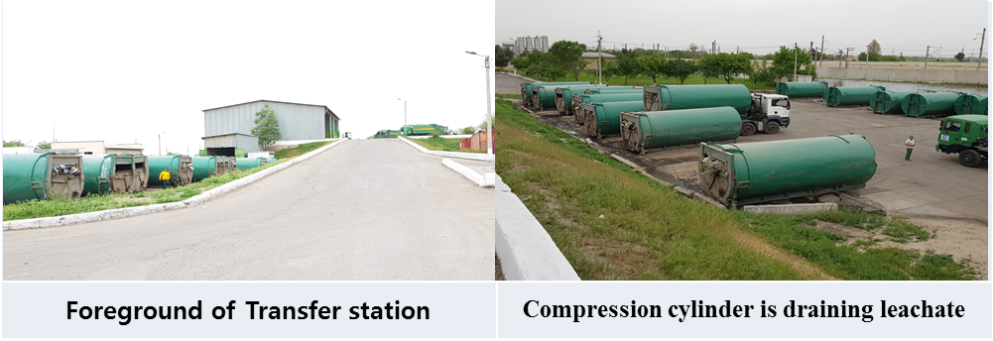

Figure 7: Transfer Stations in Sergeli District

57. Summary of significant findings revealed during the monitoring are described below:

* All containers intended to receive organic waste should have lids, screens, or covers that will prevent access by animals (dogs, cats), rodents, and birds. Alternatively, containers may be placed inside animal-proof enclosures that provide both easy access to users and promote closure after use. Consideration should also be given to washing out containers between uses, either at the transfer station or at the landfill. The installation of a leachate drainage system is a necessary requirement.
* Transfer stations should be provided with a sign (or signs) posted prominently at the entrance, that contains the following information:
* facility name
* owner / operator with phone number and address
* emergency phone numbers for fire, police and medical assistance
* hours of operation
* prohibited materials
* tipping fee schedule (if applicable)
* Transfer station staff should be familiar with procedures involving fire prevention and control. A "FIRE HAZARD - NO SMOKING" sign should be posted at the entrance or at the weigh scales. Fire extinguishers should be available inside all buildings and vehicles.
* The generation of dust can cause unsightly conditions and may be irritating to transfer station staff and users. Dust may arise from roads, and from some refuse, such as ashes, and plaster. Consideration should be given to paving, watering, or brine-sealing unsurfaced roads, and sweeping surfaced roads.
* The bad condition of the used cylindric containers due to not anymore proper closing of the container door and missing fold on the upper part creates more and more problems with the police due to falling garbage.

58. All mentioned non-compliances which have been identified are under responsibility of SUE Maxsustrans. During the currently ongoing preparation of the Bidding and Tender documents for the packages for Goods, Consulting and Construction works the all non-compliances have and will be taken in consideration for elimination during the execution of this packages under supervision of Maxsustrans, the responsible Consultant together with the Contractor/ Manufacturer and PIU-Consultant.

**Fig. 8: Lost container doors**

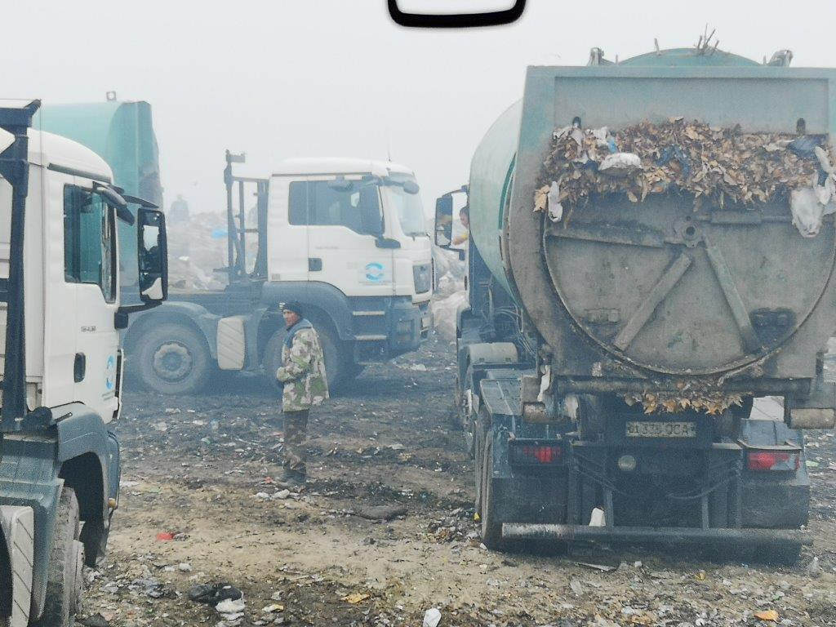 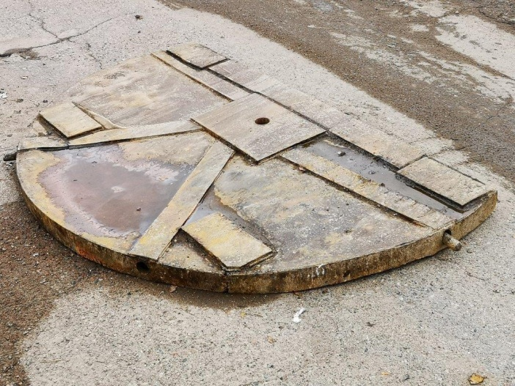

## ADB Missions

59. ADB mission took place from 21-31 August 2018. A mission[[5]](#footnote-5) visited Uzbekistan between 21-31 August 2018 to undertake: (i) a loan review mission for L3067-UZB, and (ii) a reconnaissance mission for the proposed Uzbekistan Solid Waste Development Project. The mission held discussion with (i) the State Committee for Investments, (ii) the State Committee on Ecology and Environmental Protection (SCEEP), (iii) the Ministry of Finance. (iv) the Tashkent City Municipality, (v) the SUE Maxsustrans, and (vi) the Agency francaise de development.

60. The mission’s objectives for L3067-UZB were to (i) review the implementation status of the project, (ii) discuss the progress of draft SWM strategy, and (iii) award the contract for the design and supervision consultant. The mission’s objective for the proposed Uzbekistan Solid Waste Development Project was to hold consultations with the government and agree on (i) the scope of the proposed project, (ii) the possible financing plan, and (iii) the proposed project-processing schedule.

61. On 22.08.2018 a meeting was held in the ADB Office with the TL of the PIU Consultant and the PM of the Capacity Development Consultant to get information to the current stage of their Project work and their opinion to the further progress developing of the project.

62. The mission indicated that the current delay relates to the engagement of the design and supervision consultant for sanitary landfill development. In this regard, although ADB and the Project Implementation Unit (PIU) have jointly progressed the procurement process, and ADB has already reviewed relevant documentation, significant delays are being endured in the award of the contract by the Tender Committee. The mission therefore requested for the government intervention in order to get the project back on track and avoid the project being considered as a problematic project. In response, both SCI and SCEEP committed to immediately resolve this issue, and facilitate the approval of the design and supervision consultant contract by 10 September 2018.

63. A further Mission of the ADB has been arrived at the end of September 2018. A Meeting was held on 29.09.2018. The subject was the further clarification regarding the LAP and the handling with the people (waste picker) and farmer which have been requested compensation due to they expect to lost their income. This issue has been intensively discussed and clarified due to the situation based on new decrees of the President, has been changed rapidly in positive for the affected citizen.

64. On 22.10.2018 also a Mission of the ADB has been arrived to clarify necessary further steps for the extension of the current Project and still outstanding Procurement Packages as well as the current stage of the running ones.

## Issues Tracking (Based on Non-Conformance Notices)

65. Not yet applicable.

## Trends

66. Not yet applicable.

## Unanticipated Environmental Impacts or Risks

67. Not yet applicable.

# 4. Results of Environmental Monitoring



## 4.1. Overview of Monitoring Conducted during Current Period

68. Monitoring and reporting of the project will be conducted prior to construction, during construction, and during operation. The PIU shall monitor the performance and implementation of the EMPs. Monitoring reports on the performance and in implementing the EMPs, shall be prepared prior to construction (detailed engineering design and procurement stages), during construction and during project operation, as follows: i) monthly progress reports; and ii) quarterly monitoring reports to be submitted to ADB. The monitoring report/s shall also document the relevant environmental aspect and its respective mitigation measure, as well as grievances received and resolved, if any.

69. Prior to commencement of any construction work, contractors has to submit an EMP and compliance report to PIU ensuring that all identified impacts detailed in the environmental assessment have been undertaken. The PIU will review reports submitted by CC as soon as construction works commence.

70.The PIU will organize an induction training to discuss the submitted CEMP including environmental monitoring requirements and reporting of unexpected adverse impacts or impractical mitigating measures observed during the construction phase. A monthly report will be prepared by the PIU summarizing compliance with monitoring requirements, details on any noncompliance, remedial actions taken and additional environmental mitigation measures if necessary.

71. Based on monthly reports and measurements, the PIU will draft quarterly EMP implementation report which will include (i) construction activities over the last 3 months; (ii) reporting on EMP implementation; (iii) sampling results (iv) findings on the compliance status; (v) summary of any non-compliance and remedial actions taken; and (vi) recommendations for improvement, revision of the mitigation measures and/ or the EMP if any. The safeguard specialist of the PIU will review the draft EMP implementation report which upon approval by the Project Director will be submitted to ADB. Depending on findings, future modifications in the EMP could be undertaken with the concurrence of the ADB. These will be generally undertaken, if required, upon review of the EMP progress reports submitted by the PIU to ADB for review and further action.

72. The IEE goal was to maximize the use of available secondary data (without baseline instrumental measurements) in the understanding of the present condition of the project site. It should be noted that secondary information made available by pertinent governmental agencies and secondary literature was maximized to establish the baseline for the site. IEE described the baseline environmental conditions, including physical, ecological and socio-economic resources in project site, assesses environmental impacts of the intended project activity, and provides remedial/mitigation measures. The baseline parameters would be established prior to construction for the purpose of monitoring the situations of environment affected during construction. The baseline measurements will become the conditions against which any changes due to project effects will be measured. All data must be collected so that their source can be traced by anyone who picks up the document.

73. Instrumental monitoring of quality of environment during this reporting period was not conducted since construction activities have not been yet commenced. According to Environmental Management Plan and Environmental Monitoring Plan the Contractor would be responsible for conduction monitoring of the following parameters indicated in the **Table 4** below with defined frequency and responsible organizations.

**Table 4. Environmental Monitoring Plan during the Construction**

|  |  |  |  |  |
| --- | --- | --- | --- | --- |
| **Environmental Components** | **Parameters** | **Frequency** | **Responsible Party** | **Station/ Location** |
| **Air Quality** | * Nitrogen Dioxide (NO2), VOCs * Particulates - PM10 and PM2. Nitrogen Dioxide (NO2), Sulfur Oxides (SOx) * Noise / Objectionable Odor | * Quarterly * Bi –annually * Quarterly / Monthly | Contractor / PIU to monitor for compliance and reporting to IA /SCEEP | * On the identified point sources within the premises of the SLF and the old dumpsite   • Within the project site including areas at old dumpsite  • Within and outside the SLF (1-2 Km North-West and West-North-West end) |
| **Groundwater / Leachate Contamination** | * pH * Conductivity * DO * BOD5 * TDS * Salinity * Total Hardness * Alkalinity * Carbonates * Oil and Grease * Trace Metals * Coli form | Quarterly | Contractor / PIU to monitor for compliance and reporting to IA / SCEEP | * Ground Water Monitoring Wells (whenever installed – see discussion) * Leachate Collection and Pump shafts |
| **Residual Wastes** | * Volume / quality * Characterization of wastes / Type * Efficiency of storage facilities | Annually  Quarterly | Contractor / PIU to monitor for compliance and reporting to IA / SCEEP | Within the SLF |
| **Solid Waste / Construction Waste- during construction time** | * Characterization of wastes / Type * Storage place | Quarterly | Contractor to monitor for compliance and reporting to IA / SCEEP | During the construction time |
| **Noise generation** |  | Monthly | Contractor / PIU to monitor for compliance and reporting to IA / SCEEP | At the construction site and near the sensitive receptors |
| The monitoring plan does not claim to be complete and can be expanded at any time according to the need and necessity. | | | | |

## 4.2. Trends

74.Not yet applicable.

## 4.3. Summary of Monitoring Outcomes

75.Not yet applicable.

## 4.4. Material Resources Utilisation

76.Not yet applicable.

## 4.5. Waste Management

77.Not yet applicable.

## 4.6. Health and Safety

78.Not yet applicable.

## 4.7. Training

79.During the reporting period, external training courses on environmental issues have not been conducted.

# 5. Functioning of the SEMP



## 5.1. SEMP Review

80. The assessment of compliance with the Environment Management Plan (EMP) commenced with the review of the environmental management conditions required for compliance during the construction stage of the project. These conditions are meant to be captured in the Specific Environmental Management plan (SEMP).

81. Specific Environmental Management Plan (SEMP) for the project “Solid Waste Management improvement Project” will be prepared by Environmental Specialist of Construction Company before commencement of the civil works. SEMP will be endorsed by SC and approved by PIU, after which Construction Company can start construction activities. Such plans can be further subdivided into Topic Specific and/or Site Specific EMP’s. The number of such plans will depend upon the type of project, complexity and sensitivity of the receiving environment.

82. After submission by the Contractor, it can be possible to compile all conditions in a matrix which will serve as the checklist for further environmental monitoring.

# 6. Good Practice and Opportunity for Improvement



## 6.1. Good Practice

83. Not yet applicable.

## 6.2. Opportunities for Improvement

84. Not yet applicable.

# 7. Summary and Recommendations



## 7.1. Summary

85. As soon as construction works commence (app Q4 2019), environmental monitoring will be conducted.

86. Specific Environmental Management Plan (SEMP) for the project will be prepared by Environmental Specialist of construction company before commencement of the civil works.

87. The preparation of the quarterly environmental reports will be continued but all items / paragraphs, which haven’t changed or developed will not repeated as in the Bi-Annual Report.

88.The Environmental Monitoring Reports upon review and approval by ADB will be posted on the Maxsustrans website and disclosed on ADB web-site as before.

89.The next EMR (reflecting Jan-Jun 2019 reporting period) will be submitted to the Client/ADB in July 2019.

**ANNEXES  
  
Annex 1: Environmental Management Plan**

|  |  |  |  |  |  |
| --- | --- | --- | --- | --- | --- |
| **Sources of Impact** | **Impacts** | **Type / Degree of Effect** | **Mitigation / Enhancement Measures** | **Institutional Responsibilities** | **Cost** |
| **I. Pre-Construction Phase** | | | | | |
| **Land Acquisition** | Loss of Agricultural Land | Significant and Long Term | * Proper appraisal and timely compensation as defined in the LARP. Not anymore necessary   The landlord gives it back to the state for free   * Ensure that irrigation to affected plot/s aside from the allocated area remains unimpeded. * Select optimal location of facilities, access routes and construction sites to minimize temporary or permanent use of land * Ensure clear delineation and fencing of landfill area | PIU for implementation and monitoring | Included in project Cost |
| **Environmental and Social Appraisal and Management** | Organizational capacity and commitment | Temporary and short term | * Establish and maintain Environmental, Social and Health & Safety Management System (ESHS). Employ EHS management staff with the Company. | PIU, PIU consultant | Own resources, Consultant remuneration |
| **Occupational Health and Safety** | PPE provision | Temporary and short term | * Carry out and keep updated OHS risk assessment of work places prepared by authorized consultant * Provide PPE for the staff of Company and include in tender documents the requirement for all contractors including the municipal waste collection company to provide adequate PPE according to OHS assessment of workplaces and the local regulations. | PIU, PIU consultant | Own resources, Consultant remuneration |
| **II. Construction Phase** | | | | | |
| **Land clearing** | Generation of fugitive dusts | Temporary but long term | * Open only one area for development on a by phase basis as planned. * Minimize movement of vehicles inside the construction area * Cover exposed areas with tarps or similar materials / application of slope stabilization materials * Establish buffer zones and fences | Contractor/ PIU Consultant to monitor for compliance and reporting to IA / SCEEP (State Committee on Ecology and Environmental Protection | Include such measure in the Contractor’s TOR |
|  | Noise generation | Temporary and short term | * Notify the affected communities, adequately in advance, about the expected nuisance. * Reduce project traffic routing through community areas wherever possible. * Install mufflers and silencers for machines and equipment * Avoid working during rest periods / night time * Regularly maintain equipment * Establish fences around the work area as barrier * Impose minimum speed limits within the project site | Contractor / PIU Consultant to monitor for compliance and reporting to IA / SCEEP | Include such costs in the Contractor’s contract |
|  | Possible Soil erosion | Short-term and temporary | * Contain excavation and other similar activities within design boundaries * Immediately stabilize areas once cut and fill activities are completed * Introduce vegetative cover in areas that will remain permanently open * Cover with pebbles or gravel areas that are to remain open for a long period of time * Peak Ground Acceleration (PGA) values for the site should be determined and incorporated in the design. | Contractor / PIU Consultant to monitor for compliance and reporting to IA / SCEEP | Include such measure in the Contractor’s TOR |
|  | Waste | Temporary and short term | * Ensure that all hazardous waste from temporary storage facility located at the landfill is sent to an appropriate final disposal facility | Contractor / PIU | Management time, as per con-tract |
|  | Flora | Temporary and short term | * Re-introduce local occurring vegetative cover in areas within the SLF where it would be most appropriate. Shallow rooted vegetation is recommended | Contractor / PIU Consultant to monitor for compliance and reporting to IA / SCEEP | Include such measure in the Contractor’s TOR |
|  | Traffic | Temporary and short term | * Regulate the entry and exit of vehicles and equipment in the construction site * Properly regulate delivery of materials into the project site * Impose minimum speed within the project site * Do not allow vehicles to stay within the project site for a long period of time * Regular monitoring to ensure that traffic flow remains optimal and clean- up of any debris can be undertaken immediately. * Regular maintenance of equipment. | Contractor / PIU Consultant to monitor for compliance and reporting to IA | Include such measure in the Contractor’s TOR |
|  | Occupational health and safety | Temporary and short term | * Induction and orientation meetings will be undertaken by all workers. Tool box talks are also recommended. * Only qualified workers will be hired * Strictly impose and monitor use of PPE by workers. Regular inspections will be conducted. * Provide HSE manuals and require placement of safety signs and placards * Restrict movement of personnel in danger zones * Insurance Policy for Workmen Compensation should be provided. * Conduct awareness and training programs on safety and health issues to be handled by the designated HSE Officer. | Contractor / PIU Consultant to monitor for compliance and reporting to IA | Include such cost / measure in the Contractor’s contract |
| **Community Impacts** | Community health, safety and security | Temporary and short term | * Develop and implement procedures for protecting public health and safety (e.g. traffic management plan, fencing, drivers training program, pedestrian access and trespassing plan, road design, slope stability, clean-up of spills, well visible signage, awareness-raising) | Contractor / PIU Consultant to monitor | Include such cost  / measure in the Contractor’s contract |
| Loss of income of informal waste pickers |  | * Identify alternative livelihood options for the waste pickers in accordance with the principles of livelihood framework prepared as above and in consultation with the affected people. | PIU, PIU consultant | Consultant remuneration |
| **Closure of the existing dumpsite** |  | Temporary and long term | * Conduct a detailed site assessment covering the entire 59 hectares * Development of a ‘safe closure plan’ * Adequate and prompt covering and compaction to prevent exposure of wastes * Induction and orientation meetings with special focus in the use of PPE will be undertaken by all workers. * Require placement of safety signs and placards * Conduct of post-closure environmental monitoring Maintenance of installed facilities. * Precautionary measures should be taken to ensure uncontrolled fires are not started as a consequence of the closure activities. | Contractor / PIU Consultant to monitor for compliance and reporting to IA  / SCEEP  Post closure management shall be handled by the IA / PIU | Include such cost / measure in the Contractor’s contract |
| **III. Operation Phase** | | | | | |
| **Operation of the SLF** | Air Emissions / Air Quality | Permanent and long term | * Gas emission (i.e. generation of objectionable odors) from the landfill is expected to be moderate. * Provide all employees with appropriate PPE * Monitor air quality based on a specified in the monitoring program * Regulate movement of vehicles inside the landfill to minimize emissions | PIU and SCEEP for monitoring | Cost should be included in the operating budget |
|  | Health & Safety | Significant, permanent and long-term | * Strictly impose and monitor use of PPE by personnel especially those engaged in the handling of wastes * Provide and require safety signs and manuals * Restrict movement of personnel in danger zones * HSE manual and Insurance Policy for Workmen Compensation should be provided. * Conduct awareness and training programs on safety and health issues * Make available first aid kits in the landfill area * Make available a vehicle that can bring victims to hospitals * Strictly monitor the entry and exit of outsiders inside the landfill * Precautionary measures should be taken to ensure uncontrolled fires are not started as a consequence operational activities. | PIU and PIU Consultant for monitoring | Cost should be included in the operating budget |
|  | Noise | Insignificant, long term and permanent | * Install mufflers and silencers for machines and equipment * Avoid working during rest periods * Regularly maintain equipment * Impose minimum speed limits within the project site | PIU and SCEEP for monitoring | Cost should be included in the operating budget |
|  | Groundwater quality | Significant, permanent, long term | * Use of HDPE liner and establish leachate collection and treatment system as designed and planned * Monitor leachate quality, if any * Ensure that no leachate percolate into the ground by consistently conducting quality checks of liner prior to disposal. * Ensure that all leachate are collected and treated * Properly cover the landfill after the cell is filled * Introduce vegetative cover in areas where it would be applicable to promote evapo-transpiration and re- direct portions of the precipitation. | PIU Consultant, PIU and SCEEP for monitoring | Cost should be included in the operating budget |
|  | Vermin & other pests | Significant, temporary and short term | * Ensure that all containers are properly enclosed to avoid manifestation * Covering should be done every end of the day’s operations | PIU Consultant, PIU / SCEEP for monitoring | Cost should be included in the operating budget |
| **Operation of the SLF** | Traffic | Significant, long term and permanent | * Regulate the entry and exit of vehicles and equipment in the SLF * All dump trucks should carry a waste manifest / legal papers to avoid long stand by times at the gate. * Impose minimum speed within the project site. * Do not allow vehicles to stay within the project site for a long period of time * Proper maintenance of the internal road network. * Employ a traffic management system at the ingress/egress of the project site. A traffic circulation plan should be developed not to hamper the traffic flow. | PIU Consultant, PIU for monitoring | Cost should be included in the operating budget |
| **Operation of auxiliary facilities (e.g.**  **Leachate Treatment Plant)** | Air Emissions | Significant, permanent and long term | * Foul odors are expected to be a permanent feature of the plant. It is therefore necessary that most appropriate ventilation system is implemented. This system should also maintain the appropriate air exchange ratio to minimize stagnation within the plant. * provide all employees with appropriate PPE * monitor air quality (indoor and outdoor) based on a specified in the monitoring program * Regular monitoring for any leaks (loss in pressure) and/or for spills | PIU, SCEEP for monitoring | Included in the operating budget |
|  | Health & Safety | significant, permanent and long term | * Training for personnel pertinent to operations and maintenance. * Provide the necessary PPE and strictly impose and monitor its use by employees * Provide require safety signs and placards and restrict movement of personnel in danger zones * Conduct awareness and training programs on safety and health issues * Make available first aid kits * Strictly monitor the entry and exit of outsiders inside the facility | PIU Consultant, PIU/ SCEEP for monitoring | Included in the operating budget |
| **Operation of auxiliary facilities (e.g.**  **Leachate Treatment Plant)** | Groundwater quality | Moderate, permanent and long term | * Ensure that all containers and tunnels are properly sealed * Ensure no leakages in the containers and tunnels * Whenever applicable, all floors must be properly sealed * Ensure that leachate and other spills are properly collected and not disposed in sensitive areas * Water usage shall be monitored. | PIU Consultant, PIU/SCEEP for monitoring | Cost should be included in the operating budget |
|  | Noise | Insignificant, negligible and short term | *Note: There are no sources of high level noise from the operation of the plant.*  *Whenever excessive noise is to be generated, this will be short term.* | PIU and SCEEP for monitoring | Cost should be included in the operating budget |
|  | Vermin & other pests | Insignificant, negligible and short term | *The presence of vermin and pest will be very minimal since the facility and its equipment are totally closed. To ensure that employees are not exposed to deleterious materials;*   * All workers and personnel shall be provided with appropriate PPE * Use of the PPE must be strictly implemented and monitored. | PIU Consultant, PIU for monitoring | Cost should be included in the operating budget |
| The environmental management plan [especially for the construction phase] does not claim to be complete and can be expanded at any time according to the need and necessity. | | | | | |

1. Acc. to the President Decree #UP 5024 from 21.04.2017 the State Committee of Uzbekistan for Nature Protection was renamed into the State Committee of the Republic of Uzbekistan of Ecology and Environment Protection (SCEEP) [↑](#footnote-ref-1)
2. This decree became possible upon the Decree of the President of the Republic of Uzbekistan #PP-3874 dated 19.07.2018 “About additional measures on acceleration of implementation of investment and infrastructure projects in 2018-2019”. [↑](#footnote-ref-2)
3. On August 14, 2018, the owner of the land plot of 30 ha (“Shahboz Nuri Ziyo») has applied to the khokimiyat of Akhangaran district and asked to accept his leasehold land plot to the reserve fund of khokimiyat. The khokimiyat of Akhangaran district issued the Decree # 1494 dated August 14, 2018 and accepted the land plot to reserve fund of lands of khokimiyat. [↑](#footnote-ref-3)
4. Compensation for the agricultural losses shall be paid to the local budget of the khokimiyat of Akhangaran district. [↑](#footnote-ref-4)
5. The mission comprised Ruoyu Hu, Urban Development Specialist / Mission Leader, M. Khudayberdiyeva, Senior Social Development Officer (Gender); D.Mukhammadaliyev, Social Sector Officer; and F.Insavalieva, Associate Project Analyst. [↑](#footnote-ref-5)