  

**Solid Waste Management Improvement**

**Project**

**ADB Loan No.: 3067-UZB**

**PROJECT MANAGEMENT, IMPLEMENTATION AND SUPERVISION CONSULTANCY SERVICES**

**Contract No.: SUE/Maxsustrans/QCBS-Cons\_1-2016-01**

**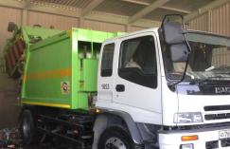** 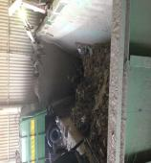 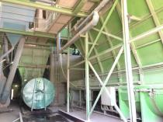

**Due Diligence Report**

**Land acquisition and Resettlement**

**July 2019**

**revision 2 – October 2019**

**CLIENT – IMPLEMENTING AGENCY**

**State Unitary Enterprise (SUE) “MAXSUSTRANS” (Uzbekistan)**

**LEAD CONSULTANT**

**H.P. Gauff Ingenieure GmbH & Co. KG-JBG (Germany)**

**in association with**

**Infratech Consulting SDN Ltd. (Uzbekistan)**

**October 2019**

|  |
| --- |
| Due Diligence report for land acquisition and resettlement |

Project No: 45366

ADB Loan 3067-UZB

October 2019

UZB: Solid Waste Management Improvement Project (SWMIP)

Financed by the ADB

*This document is prepared by JV «H.P. Gauff Ingenieure GmbH & Co. KG – JBG- (Germany) and Infratech Consulting SDN Ltd. (Uzbekistan)» for State Unitary Enterprise «Maxsustrans», Hokimiyat of Tashkent city and ADB. This report is a document of the Borrower.*

*This document was prepared in July 2019. The revision 2 was made in October 2019 as agreed with the responsible expert of ADB.*

**Abbreviations**

ADB - Asian Development Bank

AH - Affected Household

AP - Affected Person

CAP Correction Action Plan

EA - Executing Agency

GFP - Grievance Focal Point

GOU - Government of Uzbekistan

GRM - Grievance Redress Mechanism

Ha - Hectare

IA - Implementing Agency

IR - Involuntary Resettlement

IWP - Informal Waste Picker

LARP Land Acquisition and Resettlement Plan

MOF - Ministry of Finance

MSW - Municipal Solid Waste

O&M - Operation and Maintenance

PIU - Project Implementation Unit

PPTA - Project Preparatory Technical Assistance

SLF - Sanitary Landfill

SSEMP Social safeguard and Environmental Monitoring plan

SWM - Solid Waste Management

**NOTE**

In this report, “$” refers to United State dollars (USD) and UZS refers to Uzbekistan sum.

**CURRENCY EQUIVALENTS**

(as on the day of June 30th, 2019)

Currency Unit - sum (UZS) UZS 1,000.00 = $0.1199

$1.00 = UZS 8562.34

This Due Diligence report is a document of the borrower. The views expressed herein do not necessarily represent those of ADB's Board of Directors, Management, or staff, and may be preliminary in nature.

In preparing any country program or strategy, financing any project, or by making any designation of or reference to a particular territory or geographic area in this document, the Asian Development Bank does not intend to make any judgments as to the legal or other status of any territory or area.

As per ADB Safeguard Policy Statement (2009) and the Operations Manual section on safeguard policy (OM F1), borrowers/clients are required to establish and maintain procedures to monitor the status of implementation of social safeguards management and ensure progress is made towards the desired outcomes.

**Glossary**

|  |  |
| --- | --- |
| **Compensation** | Payment in cash or kind for an asset to be acquired or affected by a project at replacement cost. |
| **Affected Persons** | Affected persons (APs) are those who experience full or partial, permanent or temporary physical displacement (relocation, loss of residential land, or loss of shelter) and economic displacement (loss of land, assets, access to assets, income sources, or means of livelihoods) resulting from (i) involuntary acquisition of land, or (ii) involuntary restrictions on land use or on access to legally designated parks and protected areas. APs could be of three types: (i) persons with formal legal rights to land lost in its entirety or in part; (ii) persons who lost the land they occupy in its entirety or in part who have no formal legal rights to such land, but who have claims to such lands that are recognized or recognizable under national laws; and (iii) persons who lost the land they occupy in its entirety or in part who have neither formal legal rights nor recognized or recognizable claims to such land. |
| **Entitlement** | The range of measures comprising cash or kind compensation, relocation cost, income rehabilitation assistance, transfer assistance, income substitution, and relocation which are due to /business restoration which are due to AH, depending on the type and degree nature of their losses, to restore their social and economic base. All entitlements will be given to all affected households as per the entitlement matrix. |
| **Hokimiyat** | Local government authority that interfaces between local communities and the government at the regional and national level. It has ultimate administrative and legal authority over local populations residing within its jurisdiction. |
| **Land**  **acquisition** | The process whereby a person is compelled by a public agency to alienate all or part of the land s/he owns or possesses, to the ownership and possession of that agency, for public purposes, in return for fair compensation. |
| **Mahalla** | Is a local level community-based organization recognized official by the GoU that serves as the interface between state and community and is responsible for facilitating a range of social support facilities and ensuring the internal social and cultural cohesiveness of its members. Mahalla leaders are elected by their local communities. |
| **Meaningful**  **Consultation** | A process that (i) begins early in the project preparation stage and is carried out on an ongoing basis throughout the project cycle; (ii) provides timely disclosure of relevant and adequate information that is understandable and readily accessible to affected people; (iii) is undertaken in an atmosphere free of intimidation or coercion; (iv) is gender inclusive and responsive, and tailored to the needs of disadvantaged and vulnerable groups; and (v) enables the incorporation of all relevant views of affected people and other stakeholders into decision making, such as project design, mitigation measures, the sharing of development benefits and opportunities, and implementation issues. |

|  |  |
| --- | --- |
| **Replacement**  **cost** | Replacement cost is the principle to be complied with in compensating for lost assets. Calculation of which should include: (i) fair market value; (ii) transaction costs; (iii) interest accrued, (iv) transitional and restoration costs; and (v) other applicable payments, if any. Where market conditions are absent or in a formative stage, APs and host populations will be consulted to obtain adequate information about recent land transactions, land value by types, land titles, land use, cropping patterns and crop production, availability of land in the project area and region, and other related information. Baseline data on housing, house types, and construction materials will also be collected. Qualified and experienced experts will undertake the valuation of acquired assets. In applying this method of valuation, depreciation of structures and assets should not be taken into account. |
| **Leaseholder** | Legal entity (registered farm) running agricultural production with the use of land plots granted to him on a long-term lease. Lease term is limited up to fifty years but not less than for ten years. Leaseholder cannot sell - buy, mortgage, sublease present, exchange the land. |

**Table of contents**

[Abbreviations 3](#_Toc23929265)

[Glossary 4](#_Toc23929266)

[1. Introduction 7](#_Toc23929267)

[2. Project background 9](#_Toc23929268)

[2.1 Project Description 9](#_Toc23929269)

[2.2 Project Objectives and Outputs 9](#_Toc23929270)

[2.3 Project Site 10](#_Toc23929271)

[3 Due Diligence activities 13](#_Toc23929272)

[3.1 Objectives of Due Diligence Report and Methodology 13](#_Toc23929273)

[3.2 Scope of Due Diligence Report (DDR) 13](#_Toc23929274)

[3.3 Due Diligence Findings 13](#_Toc23929275)

[4 Public consultations 21](#_Toc23929276)

[4.1 Public consultations 21](#_Toc23929277)

[4.2 Future consultations and disclosure 22](#_Toc23929278)

[5 Grievance Redress Mechanism 23](#_Toc23929279)

[6 Mitigation of social concerns 24](#_Toc23929280)

[7 Implementation Schedule 25](#_Toc23929281)

[8 Conclusions and Recommendations 26](#_Toc23929282)

[Annex I Decision of khokim of Akhangaran Districts of Tashkent region on allocation the land plots for project needs 28](#_Toc23929283)

[Annex II Information on waste pickers employed at existing Akhangaran landfill 33](#_Toc23929284)

[Annex III Public consultation 35](#_Toc23929285)

[Annex IV Confirmation letter on land acquisition and Involuntary Resettlement avoidance 42](#_Toc23929286)

1. **Introduction**
2. The Government of Uzbekistan (GoU) has applied for a loan from the Asian Development Bank (ADB) for the development and improvement of Solid Waste Management (SWM) system of the capital city (Tashkent). The loan reference number is L3067-UZB: Solid Waste Management Improvement Project (SWMIP). The loan was signed between the Republic of Uzbekistan and Asian Development Bank (ADB) dated 27 February 2014 and Project Agreement dated 12 March 2014 signed between ADB, Tashkent City Municipality and the State Unitary Enterprise “MAXSUSTRANS”.
3. The project was prepared to impact an improved urban environment and quality of life for the residents of Tashkent. The project will develop a sanitary landfill that meets international standards, rehabilitate transfer stations, and modernize the waste collection and transfer fleet. It will build capacity in waste management and help formulate a national strategy on solid waste management. Current stage of project implementation is detailed design of the construction a new landfill.
4. The ADB safeguard policy requires that project implementation will subject to the assessment the following LARP related conditions: (i) land acquisition including demolishing of any structure and housing is allowed only after all compensations are fully paid, and (ii) commencement of civil works is conditional to the satisfactory implementation of the final LARP to be checked and verified by independent monitoring party and reported in the LARP compliance report.

1. Draft LARP for the project impacts was prepared at the stage of developed feasibility study in 2012. The project category was specified as Category B for IR. During the preparation stage of the project the impact of the project included the land acquisition of one leasehold farm.

1. Safeguard monitoring under the project selected through the tender in December 2016 is carried out by PIU Consultants (H.P. Gauff Ingenieure GmbH & Co. KG – JBG- (Germany) and GKW Consult GmbH (Germany) and ENG-INVEST Consulting Ltd (Uzbekistan). Regular quarterly social safeguard monitoring for LAR activities carried out since 2017 year. According to the monitoring results leasehold farmer assessed as affected person in LARP 2012 had 188.5 ha for growing of agricultural crops. In 2018 in compliance with optimization program[[1]](#footnote-1), the size of the land plots used by the leasehold farmer was decreased. The mentioned optimization program requires the rational and efficient use of agriculture land, including increasing financial and labor resources for improving the productivity of lands. However, the farmer does not have sufficient resources to improve land productivity. Farmer returned his allocated land plot sized at 30 ha to the reserve lands fund of the district. Further the land transferred to the reserve land fund of the district may be used for state needs.
2. The detailed design of the project started in December 2018. The contractor for detailed design of new landfill and closure the existing landfill according package C2 for Sanitary Landfill Design and Supervision Consultant – is China Urban Construction Design & Research Institute Co., Ltd." The contractor applied avoidance policy to avoid any LAR impacts from the project.[[2]](#footnote-2) The works on detailed design were completed in August 2019. Currently the document is under assessment by state expertise committee. The final approval is expected by the end of October 2019. The construction period will be 18 months. International Construction Contractor has not been hired yet. No civil works started under the project.
3. Before the start of the construction works it is required to prepare assessment an assessment on the likelihood for land acquisition, resettlement and social issue (if any) as well as to suggest a social mitigation plan for unanticipated social issues that may arise during implementation of construction works. No land acquisition and resettlement impacts were identified during social safeguard monitoring. Due to this the Due Diligence report for land acquisition and resettlement has been prepared as a part of Social safeguard monitoring assignment under Project to confirm whether there are no involuntary land acquisition and resettlement, outstanding grievances or issues for lands allocated for the construction under the project. The report is based on the results of desk review of the documentations, site visit, public consultations and grievances under the project.
4. **Project background**

## Project Description

1. The Government of Uzbekistan (GOU) seriously recognizes the need to develop and implement a national Solid Waste Management (SWM) strategy. Solid Waste Management Improvement Project (L3067-UZB) is implemented for the development and improvement of Solid Waste Management (SWM) system of the capital city (Tashkent). Therefore, the GOU has requested support from ADB to address the SWM challenges. The proposed Project will contribute to sustainable urban development in Uzbekistan by:
2. modernizing SWM to provide continuous and reliable municipal services;
3. promoting financial sustainability of municipal services through tariff rationalization and prudent financial management;
4. supporting policy and institutional reforms for improved sanitation and environmental management;
5. mitigating climate change through a major reduction of GHG emissions, and through compliance with international standards on waste minimization and material recycling; and through all these measures;
6. improving livability of cities.
7. The volume of the existing dumpsite is exhausted and the original plan of the city was to extend its dumpsite operations to an adjacent lot of additional 30 hectares of area. The Cabinet of Ministers approved in summer 2012 the location of new dumpsite on 30 hectares of agricultural area for the utilization for waste management activities.

## Project Objectives and Outputs

1. The project’s overall objective is to provide an improved solid waste management (SWM) system in Tashkent, the capital city, to upgrade urban infrastructure and services. The project will develop a sanitary landfill that meets international standards, rehabilitate transfer stations, and modernize the waste collection and transfer fleet. It will build capacity in waste management and help formulate a national strategy on solid waste management.
2. Given the current SWM practices, the option converting and allocating an area adjacent to the existing dumpsite to an engineered Sanitary Landfill was decided. The proposed sanitary landfill facility (SLF) concept will be based on the Best Environmental Practices (BEP) resulting to a state-of–the-art design consistent with international acceptable standards. This “stand alone” facility will drastically improve the SWM system (i.e. the handling and final disposal of MSW) with a possible integration capability for a long-solution to cover the entire Tashkent region. The inclusion into the design of a multi-barrier system, leachate and gas collection systems will result in a significant reduction of anticipated impacts.

1. There are two executing agencies (EAs) for the project – the Tashkent Municipality (Hokimiyat of Tashkent city) for the overall oversight and monitoring of Outputs 1 and 2 and State Committee of the Republic of Uzbekistan of Ecology and Environment Protection (SCEEP)[[3]](#footnote-3) for execution of Output 3–the national SWM strategy. Outputs 1 and 2 will be implemented by State Unitary Enterprise “MAXSUSTRANS”. A PIU was established within MAXSUSTRANS to support project implementation. This support will include project management, financial management, procurement, contract administration, safeguards implementation, construction and technical supervision, and monitoring and evaluation.

1. GoU through it Implementing Agency (IA), the State Unitary Enterprise (SUE) “MAXSUSTRANS” utilizes part of project loan proceeds towards the cost of the contract for Consulting Services related to Project Management, Implementation and Supervision, supporting the Project Implementation Unit (PIU).

## Project Site

1. The Akhangaran landfill is located approximately 30-35 km south of the center of Tashkent City in the Akhangaran district of Tashkent Province. The facility has been in use since 1967 and is currently handling the wastes collected from Tashkent city and partial from Chirchik.

**Figure 1 Location map of Akhangaran landfill**

|  |
| --- |
| **30 -35 km**  **Existing landfill** |

1. According to the detailed design of the project 30.91hectare land plot located directly to the south of the existing Akhangaran dumpsite are required for the project:

* The landfill area is about 26.51 hectares (including roads), the landfill area is about 24.62 hectares (actual landfill area);
* Regulation point - 0.7 ha;
* Control point - 0.76 ha;
* Other facilities (including water sump) 2.94 ha.
* The content of the construction is the territory of the reservoir, the road, the leaching pool, the control zone and other structures.
* The landfill capacity is 7.66 million cubic meters.
* The expected service life is 12.1 years.

**Figure 2 Designed new landfill site**

|  |
| --- |
| **New landfill (project)**  **Existing landfill** |

1. **Access to the site**: The detailed design developed for the project showed that the new landfill will use the existing access road and require the construction of additional access road to the new site. This is visualized below on given image (Figure below).

|  |
| --- |
| **Figure 3 Access road to new landfill site** |

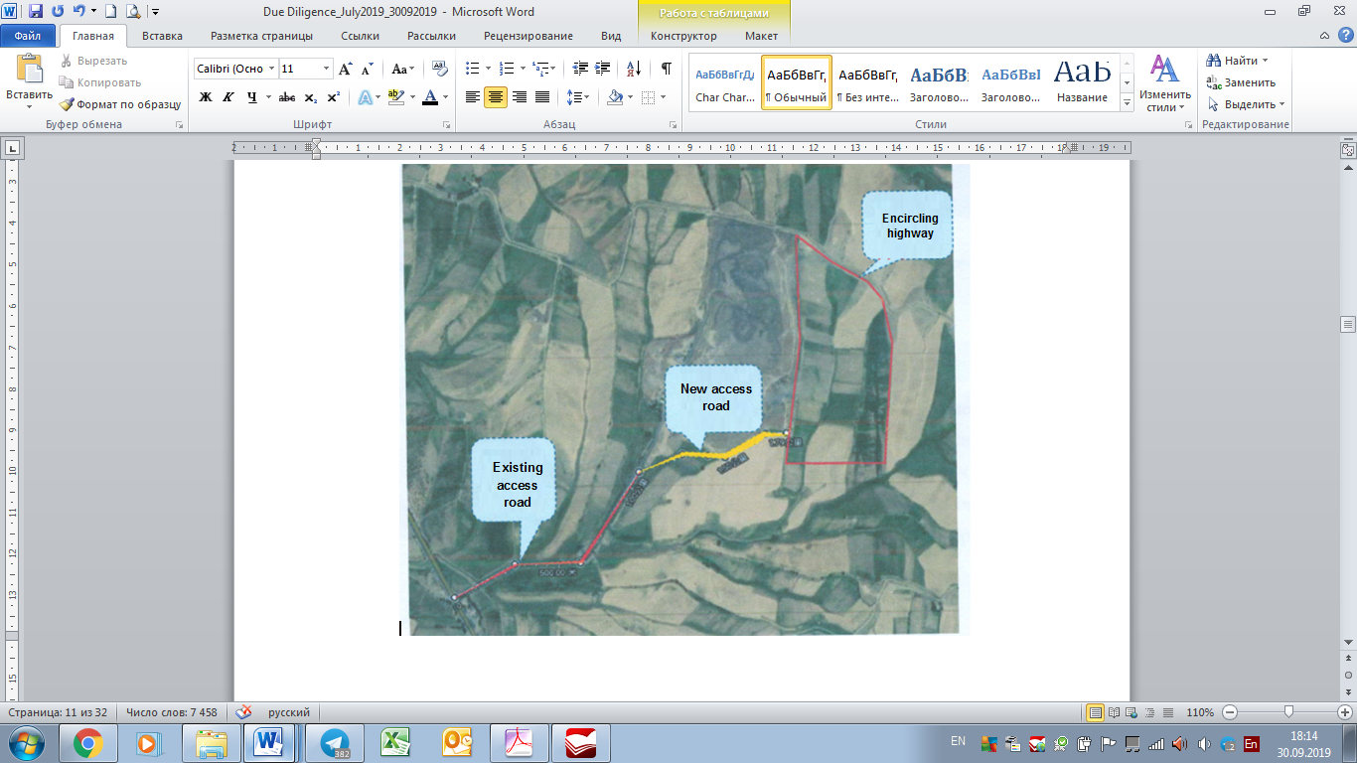

1. **Due Diligence activities**
   1. **Objectives of Due Diligence Report and Methodology**
2. **Objective of DDR:** The objective of the Due Diligence Report (DDR) is to make assessment and confirm that the project the project will not require land acquisition and involuntary resettlement for the construction. Specifically, the DDR confirm that (i) the lands allocated for the development of project is free of any involuntary resettlement impacts, e.g., land acquisition, displacement, and (ii) ascertain if there would be any adverse impacts on income and livelihood on any of people specified in LARP 2012.
3. **Methodology used for Assessing Land Acquisition and Resettlement:** Data collection. Necessary data regarding social, resettlement information has been collected primarily through desk review, check list for involuntary resettlement, field visits to the proposed projects item and public consultations with stakeholders.
   1. **Scope of Due Diligence Report (DDR)**
4. This DDR relates to lands allocated for the construction of new landfill at the existing Akhangaran landfill. This survey was to verify the initial survey findings and to confirmed that no LAR impacts. The DDR has been prepared by Social safeguard consultant as a part of Bi-annual social safeguard monitoring in July 2019. The detailed survey was carried out on the project site in September 2019. This survey was to verify the initial survey findings and to confirm that there is no LAR impact from the construction of a new landfill site.
5. Scope of the DDR is conducted necessary activities, desk reviews and on-site studies, conducted due diligence of land acquisition and resettlement issues. As per the requirements of ADB, it is mandatory that the project under stage of detailed design comply with ADB environmental and social safeguards. This report is prepared to serve the purpose of due diligence with ADB’s social safeguards under Safeguards Policy Statement (SPS), 2009.

1. DDR includes the LAR review and implementation process on land allocation for project needs to assess and confirm that the land required for the new landfill construction has been allocated without any involuntary land acquisition and resettlement. As per detail design and verified due diligence conducted the project will not have an impact full or partial, permanent, physical and economic displacements to people. No safeguard mitigation measures are required under the project (LAR activities) before the start of construction works.
   1. **Due Diligence Findings**
2. To assess the situation with the planned construction and the allocation of land for the construction of a new landfill, Consultant examined all the documents available within the project, made a site visit to the project territory.
3. **Involuntary Resettlement and land allocation:** According to the detailed design the project requires 30.91 ha of lands for construction of new landfill and additional access road to the site. The required lands for the construction of new landfill are allocated by Akhangaran hokimiyat from the district reserve lands. Allocation of lands for project needs was carried out by the issued decrees of hokimiyat in 2018-2019 (See Annex I). Consultant studied the process of allocation of lands in details. The lands were allocated in two stages. First step of allocation of land was in August 2018. In accordance with the decree of hokimiyat of Akhangaran district #1536[[4]](#footnote-4) 30 ha for construction of new landfill were allocated. During the social safeguard monitoring 2018 -2019 it was confirmed that allocation of lands was carried out from the reserved agricultural lands of the district. Reserving of the agricultural lands at district land fund was based on the state optimization program[[5]](#footnote-5). Land optimization program has affected this farmer in view of inefficient use of land or lack of financial and labor resources to cultivate it.
4. During the preparation of detailed design for the project, it was assessed the need of additional lands for the access road for the new landfill. The access to the new landfill will be carried out through the existing road which will connect to new additional road. Based on this option of detailed design additionally 1.2 ha was allocated from the district reserve lands in June 2019[[6]](#footnote-6). (See Annex I)
5. Allocation of lands from the reserve lands of the district does not imply the involuntary land acquisition and resettlement. All required lands are a part of the Sanitary Zone according to Uzbek state regulations.
6. **Site visit:** Consultant visited the project area to conduct visual assessment of the lands allocated for the project needs in May 2019. A new land plot for the landfill was allocated in the south of the existing landfill Akhangaran. The total size of the land is visually approx. 30 hectares. The main access to the new landfill will be through the existing road already exist to the existing landfill and a new access road as junction from the existing road parallel south side of the existing landfill.

1. Site visit also visually confirmed that there are no users / holders on the land where the construction of new landfill and additional access road will be developed. There is currently no agricultural activity or any improvements that have been made in this site. The project area does not have any households occupied the lands allocated for the project. According to the current sanitary-epidemiological standards and norms (“SanPiN”) No. 0350-17 “Sanitary standards and norms of the atmospheric air protection of human settlements of the Republic of Uzbekistan” residential and farming are not allowed at the sanitary protection zone of the landfill.

**Figure 4 Photo of the project site – lands allocated for the construction of new landfill**

|  |
| --- |
|  |
| Land plot for new landfill |
| **D:\Veronika\Проекты\В реализации\Инвестиционный проект по управлению твердыми отходами_Ахангаран_Махсус Транс\2017 ГРП GAUF_Мария и Петряева\Reports\SSMR 8\выезд с китайцами фото май 2019\photo_2019-09-30_18-19-33.jpg** |
| Land plot for additional access road |
| **D:\Veronika\Проекты\В реализации\Инвестиционный проект по управлению твердыми отходами_Ахангаран_Махсус Транс\2017 ГРП GAUF_Мария и Петряева\Reports\SSMR 8\выезд с китайцами фото май 2019\photo_2019-09-30_18-19-48.jpg** |
| View of existing landfill |
| **D:\Veronika\Проекты\В реализации\Инвестиционный проект по управлению твердыми отходами_Ахангаран_Махсус Транс\2017 ГРП GAUF_Мария и Петряева\Reports\Отчеты китайцев проектировщиков\визит 22 05 2019  с китайцами на свалке\DSC_7919.JPG** |
| View of existing landfill |
| **D:\Veronika\Проекты\В реализации\Инвестиционный проект по управлению твердыми отходами_Ахангаран_Махсус Транс\2017 ГРП GAUF_Мария и Петряева\Reports\Отчеты китайцев проектировщиков\визит 22 05 2019  с китайцами на свалке\DSC_7920.JPG** |
| View of existing landfill |
| D:\Veronika\Проекты\В реализации\Инвестиционный проект по управлению твердыми отходами_Ахангаран_Махсус Транс\2017 ГРП GAUF_Мария и Петряева\Фото\DSC_7035.JPG |
| Existing access road |
| D:\Veronika\Проекты\В реализации\Инвестиционный проект по управлению твердыми отходами_Ахангаран_Махсус Транс\2017 ГРП GAUF_Мария и Петряева\Фото\DSC_7039.JPG |
| Existing access road |

1. The completed screening checklist explaining the project’s IR impacts is presented as Table below.

Figure 5: Resettlement Screening Checklist

|  |  |  |  |  |
| --- | --- | --- | --- | --- |
| **Probable Involuntary Resettlement Effects** | **Yes** | **No** | **Not Known** | **Remarks** |
| **Involuntary Acquisition of Land** | | | | |
| 1. Will there be land acquisition? |  | No |  | Subproject will use state reserved land allocated for the landfill site. |
| 2. Is the site for land acquisition known? |  |  |  | N/A |
| 3. Is the ownership status and current usage of land to be acquired known? |  |  |  | N/A |
| 4. Will easement be utilized within an existing Right of Way (ROW)? |  | No |  |  |
| 5. Will there be loss of shelter and residential land due to land acquisition? |  | No |  |  |
| 6. Will there be loss of agricultural and other productive assets due to land acquisition? |  | No |  |  |
| 7. Will there be losses of crops, trees, and fixed assets due to land acquisition? |  | No |  |  |
| 8. Will there be loss of businesses or enterprises due to land acquisition? |  | No |  |  |
| 9. Will there be loss of income sources and means of livelihoods due to land acquisition? |  | No |  |  |
| **Involuntary restrictions on land use or on access to legally designated parks and protected areas** | | | | |
| 10. Will people lose access to natural resources, communal facilities and services? |  | No |  |  |
| 11. If land use is changed, will it have an adverse impact on social and economic activities? |  | No |  |  |
| 12. Will access to land and resources owned communally or by the state be restricted? |  | No |  |  |
| **Information on Displaced Persons:** | | | | |
| Any estimate of the likely number of persons that will be displaced by the Project?  If yes, approximately how many? \_\_\_\_\_ |  |  |  | N/A |
| Are any of them poor, female-heads of households, or vulnerable to poverty risks? |  |  |  | N/A |
| Are any displaced persons from indigenous or ethnic minority groups? |  |  |  | N/A |

1. **Associated project impacts**: The construction will be confined to the distinct project site, there will be no temporary disruption of livelihood of any household or group of community in this area during construction period.

1. At the existing dumpsite sorting of the solid wastes is carried out by the waste pickers. There are 35-40 waste pickers engaged in work. Consultant studied the situation with these waste pickers. Based on the results on survey, Consultant notes that waste pickers are people who are officially employed through the rehabilitation center. The employer is “Mehr Sahovat” Ltd. All these people are ensured with proper social and labor guarantees of their incomes / salaries by the employer. In compliance with the requested information, there are 7 permanent WPs and 30-35 waste pickers with hourly rate wage[[7]](#footnote-7). The rehabilitation center provides these people with the work and guarantees for salary. After the existing landfill is closed these people will be re-employed at the other infrastructural facilities like transfer stations, sorting stations, land and road improvement enterprises etc.
2. **Institutional Arrangements and Role and Responsibilities:** The following agencies are involved in project implementation:

* *State Committee on Ecology and Environmental Protection (SCEEP*[[8]](#footnote-8)) and Tashkent Hokimiyat (Municipality) are the Executing Agencies (EA). Tashkent Hokimiyat responsible for management, coordination and execution of all activities funded under the loan and has overall responsibility for compliance with loan covenants.
* *State Unitary Enterprise “Maxsustrans” (Maxsustrans)* is the implementing agency (IA), which is responsible for administration, implementation (design, construction and operation) and all day-to-day activities under the loan. The PIU coordinates construction of subprojects, and ensures consistency of approach and performance.
* *PIU* was established within MAXSUSTRANS to support project implementation. This support will include project management, financial management, procurement, contract administration, safeguards implementation, construction and technical supervision, and monitoring and evaluation.
* *PIU Support Consultant -* International Project Management and Supervision Consultant (H.P. Gauff Ingenieure GmbH & Co. KG and his JV-Partner Infratech Consulting SDN Ltd (Tashkent) supporting the PIU on social safeguard measures that may occur during the implementation. The selection of a consultant began in December 2017. The contract was awarded on November 16, 2018. The main reasons for the delay are the following: 1) Changes in the legislation of the Republic of Uzbekistan on procurement procedures, including for IFC funds. 2) Process of institutional reforms among the government bodies and executive agencies initiated by the government in 2017; 3) Composition of Tender Commission of Tashkent Khokimiyat responsible for holding a large-scale tenders changes 3 times due to the amendments in order and regulations of tender commissions. This all delayed the process of evaluation, approval of the results of the evaluation and award of the contract.
* *Contractor* (Construction Supervision Company) - Sanitary Landfill Design and Supervision Consultant "China Urban Construction Design & Research Institute Co., Ltd." has been hired on December 14, 2018. This consulting company carries out design works of closing old landfill and establishing of new sanitary landfill. During the construction work they will supervise all construction works related to Landfill establishment.

1. **Grievances and complaints:** The existing GRM developed for the project functions for the whole period of project implementation. For the period of 2018-2019 no complaints or addresses on project are received form the population or any stakeholders. Monitoring of complaints and addresses is carried out by the Social safeguard consultant within the quarterly periods of monitoring.
2. **Indigenous People.** There is no identified indigenous people/ethnic minority communities on the proposed project site, thus no ethnic people will be affected by the project activities. The project has no IP impact and classified as Category C for IP.
3. The detailed information on project LAR activities is given in table below:

Table 1 Due Diligence for LAR activities

|  |  |  |  |  |  |
| --- | --- | --- | --- | --- | --- |
| **Project activity** | **Type of losses** | **Name of APs** | **Possible social impacts** | **Involuntary resettlement** | **Indigenous people** |
| **Construction of new landfill site** | No losses applicable | No losses applicable | * No IR impacts; * No requirements for involuntary land acquisition; * The required lands for construction allocated from the district reserve land; * There is no possibility of any impacts in terms of losing incomes and livelihoods. * No grievance and complaints are received on project activity. | Not required | Not found |
| **Construction of additional access road** |

1. **DD Outcomes:**  As per results of the data gathering, detailed survey of the sites and review of land documents, the project is considered as Category C for IR, i.e., the project does not require temporary or permanent involuntary land acquisition and resettlement and there are no impacts involving the allocation of land, structures, crops and trees, businesses or income.

1. All project facilities at the new landfill will be constructed using the land allocated from the reserve lands of the district and owned by SUE "Maxsustrans". There is sufficient land within the allocated lands required for proposed construction of new landfill and additional access road. SUE "Maxsustrans" with PIU confirmed ownership of the land with the proper cadastral documents in detailed design project.
2. **Public consultations**
   1. **Public consultations**
3. Stakeholders and public consultation was conducted with officials, community people living near by the proposed project site, public representatives and other stakeholders to identify different issues, problems/ constraints and prospects and feedback from the participants in connection to construction of new landfill under the project. The consultation covers mainly information dissemination about the current stage of the project and its scope, possible impacts, involvement of local people in different activities of the Project etc. The public participation process included (i) identifying interested parties (stakeholders); (ii) information and providing the stakeholders with sufficient background and technical information regarding the proposed project development; (iii) describing opportunities and mechanisms whereby they can participate and raise their views (issues, comments and concerns) with regard to the proposed development; (iv) giving the stakeholders feedback on process findings and recommendations; and (v) ensuring compliance to process requirements with regards to the social and related legislations.
4. The safeguard team visited the district administration and had meeting with representatives of hokimiyat, community local public representatives and different stakeholders and local people, community leaders and local government representatives on October 4, 2019. The participants were also informed of the date of the public meeting via the advertisement at local administration and informing the leaders of communities.

**Figure 6 Photo of the public consultation**

**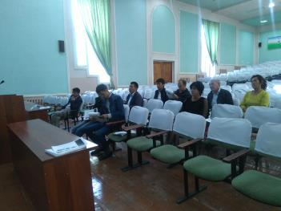**

1. A public meeting was arranged by the district administration. The meeting site was at the building of Akhangaran district hokimiyat. 10 participants were present in the consultation meeting. The following issues were discussed during the meeting:

* Period of construction. Expected start: First quarter of 2020;
* Order of selection of contractor for construction works after evaluation, expected December 2019;
* Order of closure of existing landfill; after evaluation, expected December 2019;
* Power supply of the construction works; local power network and generators;
* Impact from construction work of agricultural lands and roads. It is expected that all the construction works will be carried out inside the allocated lands for project needs.
  1. **Future consultations and disclosure**

1. This due diligence report and other relevant documents will be made available on the websites of SUE "Maxsustrans" and ADB. The same information will be provided to local administration for relevant stakeholders and local people.
2. Future consultation activities will be coordinated by the PIU / SUE Maxsustrans and consultant teams to ensure that the communities are fully aware of the activities at all stages of the Project implementation. During construction phase, engineering team with assistance of social and environmental consultant teams will conduct (i) public meetings with local communities to discuss and plan work programs and allow issues to be raised and addressed once construction has started; and (ii) smaller-scale meetings to discuss and plan construction work with individual communities to reduce disturbance and other impacts, and to provide a mechanism through which stakeholders can participate in Project monitoring and evaluation. The PIU will coordinate the schedule with the contractors and will ensure proper public consultations are held prior to start of civil works and during implementation. Documentation should be included in the social safeguard monitoring report.
3. The relevant information in this due diligence report together with following information on GRM will be translated to local language and disclosed to people in the project area. Documentation will be included during social safeguard monitoring report. The social safeguard specialist will disclose information within public consultations.
4. **Grievance Redress Mechanism**
5. **Grievance Redress Mechanism**. Grievance Redress Mechanism. A Project-specific grievance redress mechanism (GRM) has been established in LARP 2012 to receive, evaluate, and facilitate the resolution of AP’s concerns, complaints, and grievances about the social and environmental performance at the level of the Project. The GRM aims to provide a time-bound and transparent mechanism to voice and resolve social and environmental concerns linked to the Project. Figure below gives the details of the grievance redress mechanism:

Figure 7 Grievance Redress Mechanism\*

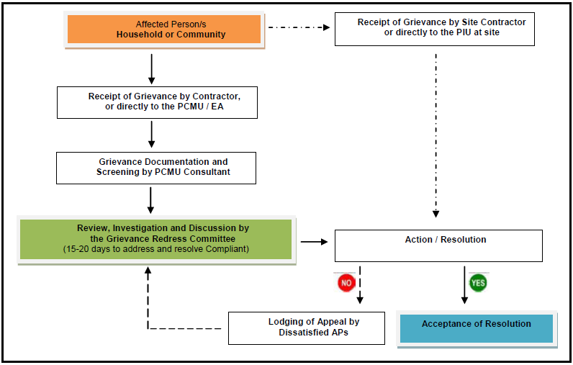

\* PIU – responsible person for GRM is the director of PIU, Mr. Rustam Shukurov, tel: +99871 2477923

EA is SUE Maxsustrans. The responsible person for GRM is Mr. Shukhrat Inogamov, tel: +99871 2473599, email: [maxsustrans@inbox.ru](mailto:maxsustrans@inbox.ru)

PCMU Consultant is social and resettlement specialist, Mrs. Maria Malinovskaya, tel: +99871 1508887, email: [malinovskaya@almarconsulting.org](mailto:malinovskaya@almarconsulting.org)

1. **Mitigation of social concerns**
2. The Social Safeguard Specialist of PIU will continue to conduct quarterly monitoring to verify that there are no impacts during implementation and that information disclosure and meaningful consultation are continued throughout construction period. The result will be compiled as part of the Quarterly Safeguard Monitoring Report prepared by the PIU Consultant. The PIU will review the report and submit to ADB for review and disclosure.
3. Although the design and construction are not expecting any land acquisition and involuntary resettlement, physical or economic displacement, or temporary restrictions to land use. However, some assumptions were made that during civil works that the following measures should be suggested to eliminate any impacts:

* Informing all the residents, local households and traders about the nature and duration of works in advance, so that they can make necessary preparation to face the situation;
* Increasing the workforce and using the appropriate equipment to complete the work in a minimum timeframe.
* Increasing the workforce attracted from local residents.
* Other social concern, if any, shall be properly solved by the Grievance Redress Committee (GRC) under the Grievance Redress Mechanism (GRM) of the Project to be formed by the PIU.
* Any other preventive measures to be adopted as required considering the situation during construction.

1. The above mitigation measures during construction activities will ease the temporary disturbances in connection to movement and operation activities of the local residents.
2. **Implementation Schedule**
3. Implementation Schedule. The detailed design of the project in completed and under assessment of state expertise committee. The preliminary period of start of construction works is first quarter of 2020. The planned period of construction is 20 months.

1. A tentative time-schedule for implementation (only as an indication) is shown Figure below:

Figure 8 Implementation schedule

|  |  |  |  |  |  |  |  |  |  |  |  |  |  |  |  |  |  |  |  |  |  |  |  |  |  |  |
| --- | --- | --- | --- | --- | --- | --- | --- | --- | --- | --- | --- | --- | --- | --- | --- | --- | --- | --- | --- | --- | --- | --- | --- | --- | --- | --- |
| **Item of works** | **YEAR** | | | | | | | | | | | | | | | | | | | | | | | | | |
| **2019** | | | | | | **2020** | | | | | | | | | | | | | | **2021** | | | | | |
| 7 | 8 | 9 | 10 | 11 | 12 | | 1 | 2 | 3 | 4 | 5 | 6 | 7 | 8 | 9 | 10 | 11 | 12 | 1 | | 2 | 3 | 4 | 5 | 6 |
| Preparation of bid documents |  |  |  |  |  |  | |  |  |  |  |  |  |  |  |  |  |  |  |  | |  |  |  |  |  |
| Approval of detailed design |  |  |  |  |  |  | |  |  |  |  |  |  |  |  |  |  |  |  |  | |  |  |  |  |  |
| Tendering and evaluation of contractor for the construction works |  |  |  |  |  |  | |  |  |  |  |  |  |  |  |  |  |  |  |  | |  |  |  |  |  |
| Executing of physical works |  |  |  |  |  |  | |  |  |  |  |  |  |  |  |  |  |  |  |  | |  |  |  |  |  |

1. **Conclusions and Recommendations**
2. A due diligence for involuntary resettlement impacts for the project was undertaken to ensure that the project will not cause any LAR impacts. Both permanent and temporary impacts were considered and analyzed during this assessment. The due diligence process was conducted for the project to examine the LAR impacts with respect to the requirements of the SPS-2009 of ADB. The results of this Due Diligence study conclude that, as per ADB Safeguard Policy Statement, the project is considered as "no involuntary land acquisition and resettlement". Important findings of the study in connection to social safeguard issues are (i) construction of new landfill will be carried on reserve lands of the district and will not require land acquisition thus no IR will be occurred due to construction works; (ii) no landfill site or access road need resettlement, dislocation or relocation; (iii) there are no structures, houses, shops, trees or any other establishments on the ROWs of the proposed landfill site and access road; (iv) the required land for construction work is owned by SUE Maxsustrans (v) there is no possibility of any adverse impact in terms of losing income or livelihood; (vi) as a result no dislocation, demolition of houses or structures will be required due to the construction activities.
3. As the results of the study suggest that the impact of this project does not incur any land acquisition, resettlement or economic displacement. This project can be categorized as “C” for Involuntary Resettlement (IR) impact as per the ADB’s Safeguard Policy Statement, 2009 (SPS). In case any claims or complaints are submitted during the project implementation period, an effective and efficient Grievance Redress Mechanism will enhance provision of timely and sensible hearings and facilitate solutions.
4. Social Safeguard Specialist of PIU will continue to conduct quarterly monitoring to verify that there are no project impacts caused by the project implementation.
5. The Contractor engaged in sanitary landfill civil works will also consider implementation and monitoring of the following social and gender issues during the construction period specified at their assignments.
6. Recommendations: Although no LAR impacts are expected under the project, the following recommendations are made to ensure steadiness execution of work and adopting mitigation measure to avoid or minimize potential LAR impacts if any and to minimize illegal occupancy in future[[9]](#footnote-9).

* Public consultation with local communities and nearby households / mahalla residents will be held on regular basis at all stages of project implementation for information dissemination, record any concerns / complaints and prompt resolution of the concerns / complaints within GRM established for the project.
* During the construction SUE "Maxsustrans" with support of Construction Supervision Consultant will monitor temporary land use and ensure that in case the additional land plots are required for temporary use during construction activities, the Construction Contractor obtains relevant agreements allowing use of such lands. Moreover, after completion of civil works the lands taken for temporary use (if any) will be restored to their pre project conditions by Construction Contractor and rent fees shall be fully paid to the users of those land plots.
* If unanticipated IR impacts emerge during implementation of project works are due to restriction of access to the land due to contractor activities, it will be immediately reported to the supervision consultant and contract will stop the civil work activities in the affected areas until the corrective action plan is prepared in consultation with ADB safeguards team. Nonetheless in such sections the project works will be kept on hold till ADB cleared CAP is implemented and confirmed as such.
* Social and environmental safeguard monitoring will be conducted on quarterly basis during the construction period and after the civil works are completed in order to make assessment of project impacts and develop mitigation measures for any other negative impacts on lands or local communities and nearby households / mahalla residents ( if any).

Page 23

Annex IDecision of khokim of Akhangaran Districts of Tashkent region on allocation the land plots for project needs



|  |
| --- |
|  |
|  |

Translation in English is unofficial

**REPUBLIC OF UZBEKISTAN**

**KHOKIM**

**OF AKHANGARAN DISTRICT**

**OF TASHKENT REGION**

**DECISION**

August «25», 2018 № 1536 Akhangaran town

**On the allocation of land plot for improvement the solid waste management system for SUE “Maxsustrans”of Hokimiyat of Tashkent city out of the land plots in the possession of the regional public stock in the territory of the collection of citizens of “Yangi Hayot” mahalla of Akhangaran district of Tashkent region**

On the basis of paragraph 4 of Annex 2 of the Resolution of the President of the Republic of Uzbekistan №3874 as of July 19, 2018 “On additional measures to accelerate the implementation of investment and infrastructure projects in 2018-2019”, having considered the submitted documents on the land management related to the allocation of land plot for the organization of production electricity from gas obtained received from solid waste for SUE “Maxsustrans” of Hokimiyat of Tashkent city out of the land plots in the possession of the regional public stock in the territory of the collection of citizens of “Yangi Hayot” mahalla of Akhangaran district, on the basis of Article 6 of the Law of the Republic of Uzbekistan “On Local State Administration”

**I AM DECIDING:**

1. To approve the Act of the commission on allocating land for non-agricultural needs in the district Hokimiyat as of August 16, 2018 about allocating a land plot in the area of ​​30,0 hectares, including 26,8 hectares of irrigated land, 1,1 hectares of meadows and pastures, 1,9 hectares irrigation ditches and drainage ditches and 0,2 hectares of roads for the organization of electricity production from gas obtained from solid waste for the Production Directorate of “Maxsustrans” of Hokimiyat of Tashkent city out of the land plots in the possession of the regional public stock in the territory of the collection of citizens of “Yangi Hayot” mahalla of Akhangaran district.

2. To allocate a land plot in the area of ​​30,0 hectares, including 26,8 hectares of irrigated land, 1,1 hectares of meadows and pastures, 1,9 hectares irrigation ditches and drainage ditches and 0,2 hectares of roads located on the contours of 337k, 338, 340, 342, 343, 344 and 345 of the agricultural map for the organization of electricity production from gas obtained from solid waste for the Production Directorate of “Maxsustrans” of Hokimiyat of Tashkent city out of the land plots in the possession of the regional public stock in the territory of the collection of citizens of “Yangi Hayot” mahalla of Akhangaran district.

3. Production Directorate of “Maxsustrans” of Hokimiyat of Tashkent city shall:

А) Note, that to design the construction project for the organization of electricity production from gas obtained from solid waste, first of all, it is necessary to order for assignments (ART-1-2 parts) for architectural planning in the Main Department of Architecture and Civil Engineering of Tashkent region,

B) Approve, that the loss of agricultural production (cash indemnification for losses) from the land plot allocated for permanent use for the organization of electricity production from gas obtained from solid waste for the Production Directorate of “Maxsustrans” of Hokimiyat of Tashkent city out of the land plots in the possession of the regional public stock in the territory of the collection of citizens of “Yangi Hayot” mahalla of Akhangaran district will be paid for by the Production Directorate of “Maxsustrans”.

C) Remind the Production Directorate of “Maxsustrans” of Hokimiyat of Tashkent city that, with the condition of transferring used land plots at the disposal of the district public stocks where the electricity manufacturing has been organized from gas from solid waste, with preliminary remediation, and keeping in working condition functioning irrigation and melioration networks, engineering communications in gradually additionally allocated land plots and border areas in the construction period used by farms and agricultural enterprises.

4. On the basis of this decision the head of the district department of Land Resources and the State Cadastre (B. Sotiboldiyev) is assigned to introduce appropriate changes in the district land fund.

5. To make official warning to the Production Directorate of “Maxsustrans” that on the basis of Article 10 of the Law of the Republic of Uzbekistan “On Local State Administration”, if the allocated land plot is not developed within three years, this decision loses its validity.

6. To introduce the discussion of this decision into the agenda of the regular session of the Council of People’s Deputies of Akhangaran district.

7. To ask khokim of Tashkent region to approve this decision.

8. Control over the execution of this decision shall be assigned to the first deputy of khokim of district M. Miryunusov.

Khokim of the district U. Tursunov

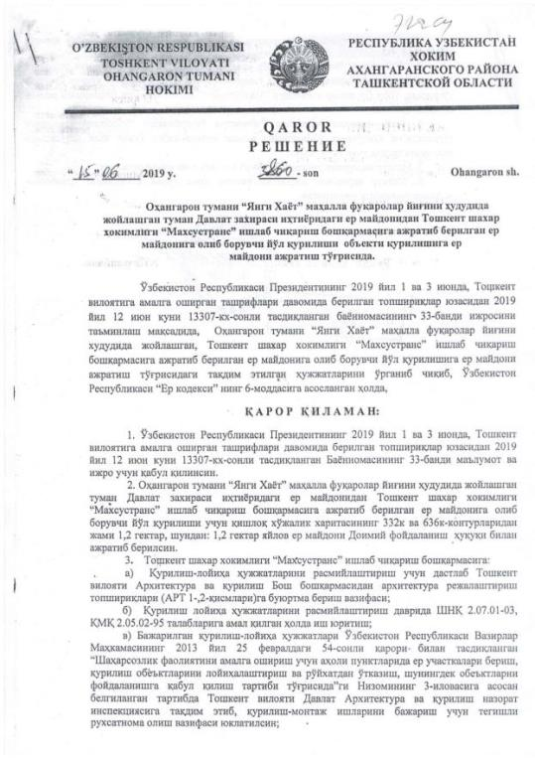

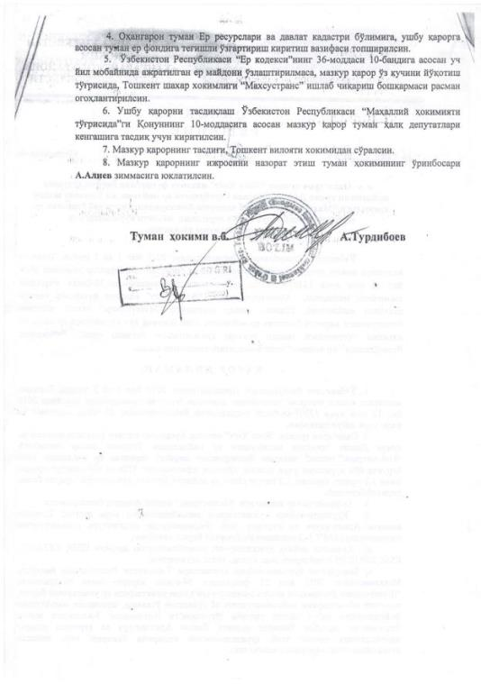

**Annex II Information on waste pickers employed at existing Akhangaran landfill**

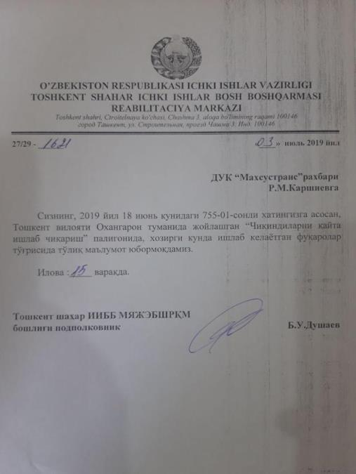

Translation in English is unofficial

Department of internal affairs of the Republic of Uzbekistan, Tashkent city

Rehabilitation Center

#27/29 -1621

Date: July 3, 2019

To head of SUE “Maxsustrans”,

Mr. Karshiev R.

In order to reply on your request #755-01 dated June 18, 2019 we give you the information on citizents working at the landfill at Akhangaran district, Tashkent region.

Department of internal affairs of the Republic of Uzbekistan, Tashkent city

Head of Rehabilitation center, lieutenant colonel Dushaev B.

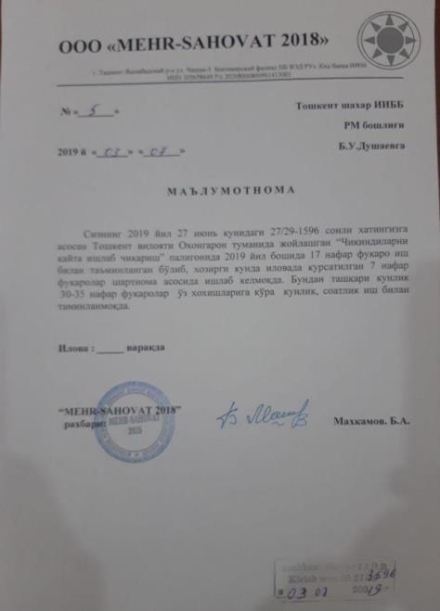

Translation in English is unofficial

Mehr Sahovat LTD

#5

Date: July 3, 2019

TO Department of internal affairs of the Republic of Uzbekistan, Tashkent city

Head of Rehabilitation center, lieutenant colonel Dushaev B.

In order to reply on your request #27/29-1596 dated June 27, 2019 we give you the information on citizents working at the landfill at Akhangaran district, Tashkent region: there are 17 waste pickers were emplyed at the landfill at the beginning of 2019 year by labor contract; Now there are 7 workers who are work there by the labor contarct. 30-35 citizents work at the landfill at their own wishes every day or several hours per day.

Head of Rehabilitation center,

lieutenant colonel Dushaev B.

Annex III P**ublic consultation**

Notification on public consultations for local government

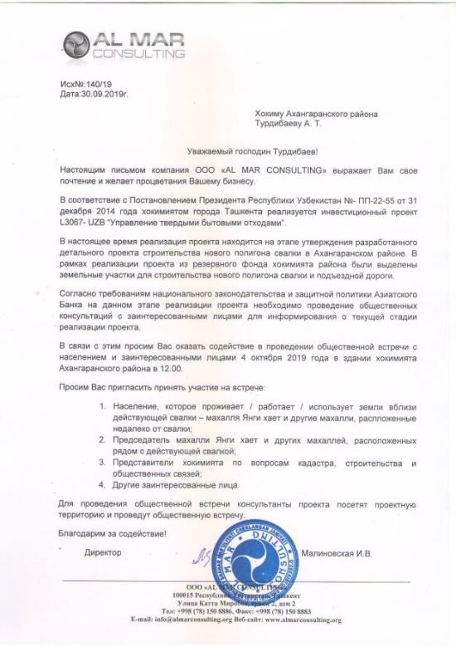

Out coming number: 140/19

Date: 30.09.2019

To khokim of Akhangaran district,

Mr. Turdibaev A.

Dear Mr. Turdibaev!

Al Mar Consulting LLC expresses you respect and wishes prosperity to your business

In accordance with the Decree of the President of the Republic of Uzbekistan No. PP-22-55 dated December 31, 2014, “Solid Waste Management Improvement” Investment Project L3067-UZB is being implemented in Tashkent city.

Currently, the implementation of the project is at the stage of approving the developed detailed project for the construction of a new landfill in Akhangaran district. As part of the project, land plots were allocated from the state land fund for the construction of a new landfill and access roads.

In accordance with the requirements of national legislation and the ADB’s safeguard policy, the public consultations / meetings should be conducted to inform the stakeholders and other interested people about the current stage of project implementation.

In this regard, we ask you to assist in holding a public meeting with the population and stakeholders on October 4, 2019 at the building of Akhangaran district khokimiyat at 12.00.

We ask you to invite to participate in the meeting the following people:

1. The population that live / work / use the land near the existing landfill – mahalla Yangi hait and other mahallas located near the landfill;
2. The chairman of the mahalla Yangi hayat and other mahallas located next to the existing landfill;
3. Representatives of the hokimiyat on cadastre, construction and public relations;
4. Other stakeholders.

To conduct a public meeting, project consultants will visit the project site and hold a public meeting.

Thank you for cooperation!

Director Malinovskaya I.

**Minutes of the public consultation**

Solid Waste Management Improvement Project

Date: October 4, 2019

Time: 12.00 a.m.

Venue: Hokimiyat of Akhangaran district, Tashkent region

Participants:

1. Specialties of cadaster department of hokimiyat of Akhangaran district, Mr. Gulomov N.;
2. Specialties of architecture department of hokimiyat of Akhangaran district, Mr. Isroilov S.;
3. Specialties of investment department of hokimiyat of Akhangaran district, Mr. Hudoykulov U.;
4. Specialties of economic department of hokimiyat of Akhangaran district, Mr. Akramov;
5. Specialties of ecological department of hokimiyat of Akhangaran district, Mr. Holmatov A.;
6. Specialties of communal service department of hokimiyat of Akhangaran district, Mr. Gafurov F.;
7. Specialties of agricultural department of hokimiyat of Akhangaran district, Ms.Yuldasheva M.;
8. Specialist of SUE “Toza Hudud” of Akhangaran district; Ms. Usmanova J.
9. Chairmen of “Yangi hayot ” makhalla, Mr. Uralov I.
10. Assistant of the Chairmen of “Yangi hayot ” makhalla, Ms. Urazkulova M.

**Purpose of the meeting:** informing stakeholders and population persons about the current stage of the project implementation and the main social and environmental issues within the project.

The meeting was held with stakeholders and representatives of local government bodies involved in the project implementation process, especially cadaster, architecture, investment, economic departments. Representatives of makhalla committee located near the existing and planned for construction landfill also took part at the meeting.

During the meeting, information was provided on the current stage of project implementation (detailed design), activities planned for further project stages of construction as well as issues on environmental and social monitoring and mitigation measures for activities related to future construction period. Grievance redress mechanism also presented to the meeting’s participants.

Brochures with the information presented during the public meeting were distributed to the participants.

During the meeting, information was presented on the planned project for the construction of a new landfill, the use of allocated land, the timing of the planned start of construction and the length of the construction period.

At the public meeting, the main indicators of social and environmental monitoring were presented, which were necessary for analysis and assessment of the impact of the project on the environment and the population.

The table below presents questions from the participants:

|  |  |
| --- | --- |
| **Question** | **Answer** |
| When will the construction works start? | Current stage of the project is approving the developed detailed design. Once the detailed design is approved, tender for selection of contractor for construction works will start. The construction works will start in first quarter of 2020. |
| What company is the contractor for construction works? | The contractor for construction will be selected through the tender. It is expected that the tender will be conducted in future next months. |
| Will the existing landfill be closed? When will it be closed? | Existing landfill will be closed once new one is completed. It will be closed in compliance with the international standards of waste disposal. The existing landfill is also used for biogas production. |
| There is biogas production at the existing landfill. The burning of wastes in a biogas plant has a very unpleasant odor. This smells are spread by wind into residential villages. In particular, residents of the mahalla Yangi hayot suffer very much from such odors. What can we do with this? | In this case, it is necessary to use the project complaints mechanism. You need to collect complaints from the people in your community who suffer from such odors. In the application it is should be indicated the time and time at which this all happens. A collective complaint should be submitted to the district hokimiyat and the regional department of environmental protection. The review period is 15 working days.  Based on the results of the appeal, a commission of environmental protection specialists and other specialists who will study the situation on the site should be created within 15 working days. The specialists should make their expert conclusion on this issue. |
| Will the construction works will use the power lines within the main road for the construction period. There are a lot of power cutoffs due to the overloading the power line. The construction works will increase the frequency of power cutoffs in homes. | This issue will be redirected to the engineers developed the access to power supply during the construction period. |

**Annex 1 List of participants**

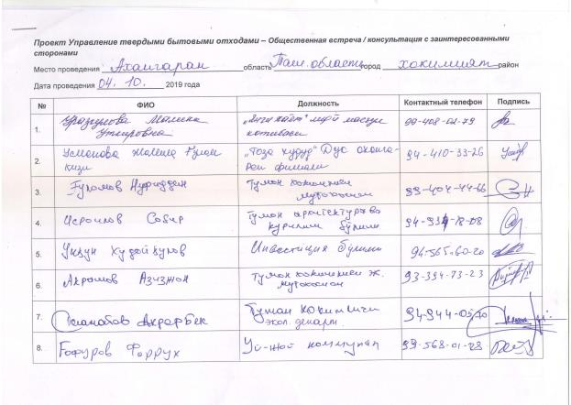

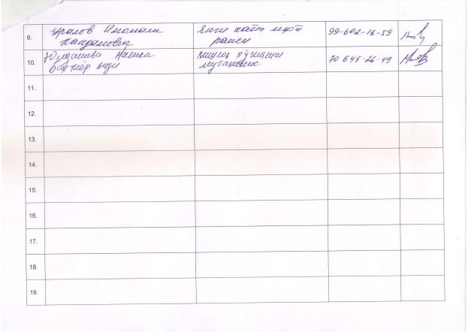

**Annex 2 Photo of stakeholders meeting**

**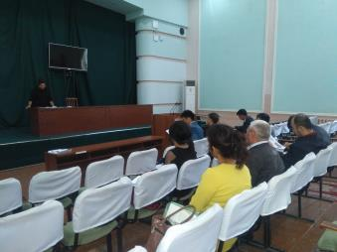**

****

**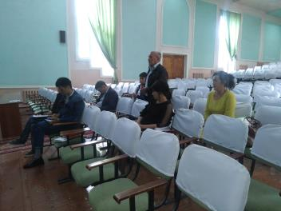**

# **Annex IV Confirmation letter on land acquisition and Involuntary Resettlement avoidance**

**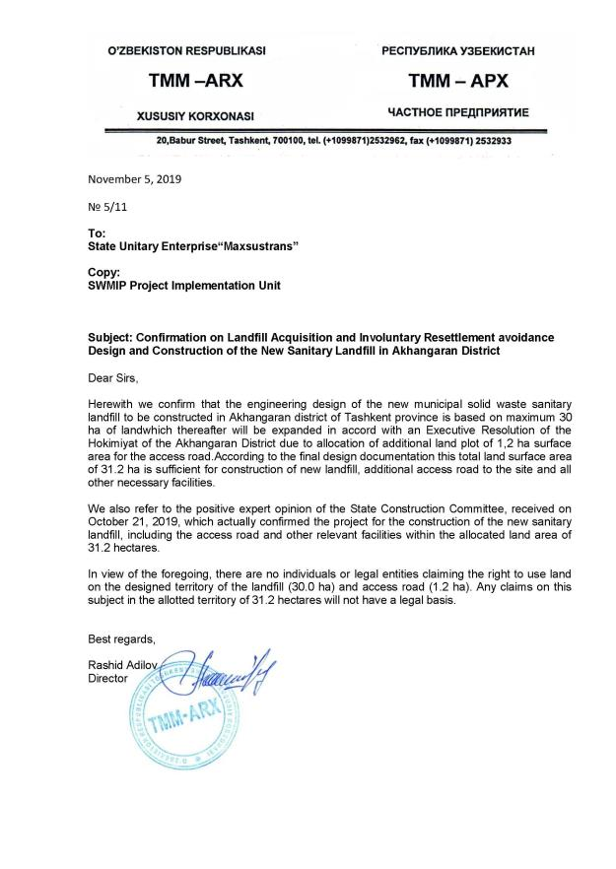**

1. Resolution of the Cabinet of Ministers of RUz No 362 «Measures on optimization of size of land plots allocated for leasehold farming» dated December 15, 2015. The program is aimed at improving the efficiency of land use based on the analysis of the rationality of land use, the financial and economic condition of farms, the availability of material and technical resources, labor resources and working capital, the fulfillment of the terms of the land lease agreement and contracting agreements for the producing agricultural products for state needs. Land optimization has affected farms that have inefficient use of land or do not have enough resources to use the land. [↑](#footnote-ref-1)
2. Confirmation letter on avoidance land acquisition and involuntary resettlement is given in Annex IV [↑](#footnote-ref-2)
3. According to the President Decree # 5024 as of 21.04.2017 the State Committee of Uzbekistan for Nature Protection was renamed into the State Committee of the Republic of Uzbekistan of Ecology and Environment Protection (SCEEP) [↑](#footnote-ref-3)
4. Decree of Hokimiyat of Akhangaran district, Tashkent region #1536 dated August 25, 2018 on allocated 30 ha lands from reserve land fund for project needs. See Annex I. [↑](#footnote-ref-4)
5. Resolution of the Cabinet of Ministers of RUz No 362 «Measures on optimization of size of land plots allocated for leasehold farming» dated December 15, 2015 [↑](#footnote-ref-5)
6. Decree of Hokimiyat of Akhangaran district, Tashkent region #3860 dated June 15, 2019 on allocated 1,2 ha lands from reserve land fund for project needs. See Annex I. [↑](#footnote-ref-6)
7. Official letter on total number and working conditions of waste pickers provided by State rehabilitation center / Mehr Sahovat Ltd [↑](#footnote-ref-7)
8. According to the President Decree # 5024 as of 21.04.2017 the State Committee of Uzbekistan for Nature Protection was renamed into the State Committee of the Republic of Uzbekistan of Ecology and Environment Protection (SCEEP) [↑](#footnote-ref-8)
9. Confirmation letter on avoidance land acquisition and involuntary resettlement is given in Annex IV [↑](#footnote-ref-9)