Solid Waste Management Improvement Project
ADB Loan No.: 3067-UZB

PROJECT MANAGEMENT, IMPLEMENTATION AND SUPERVISION CONSULTANCY SERVICES

Contract No.: SUE/Maxsustrans/QCBS-Cons_1-2016-01

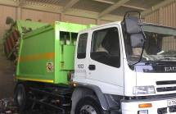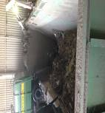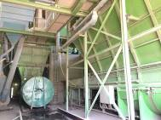

Semi-Annual Environmental
Monitoring Report
Reporting Period: July – December 2020

CLIENT – IMPLEMENTING AGENCY
State Unitary Enterprise (SUE) “MAXSUSTRANS” (Uzbekistan)

LEAD CONSULTANT
Infratech Consulting SDN Ltd. (Uzbekistan)

January 2020

Semi-Annual Environmental Monitoring Report
_________________________________________________________________

Project No: 45366
Reporting period: July – December 2020
ADB Loan: 3067-UZB

UZB: Solid Waste Management Improvement Project (SWMIP)
(Financed by the ADB)

Prepared by: Mr. Sergey Karandayev, Environmental Specialist of PIU Consultants - Infratech Consulting SDN Ltd. (Uzbekistan)

For: State Unitary Enterprise «Maxsustrans», Khokimiyat of Tashkent city and ADB

Endorsed by: Mr. Jasur Khamidov - Head of PIU

CONTENTS

1. Introduction 6
1.1. General 6
1.2. Headline Information 7
2. Project description and current activities 8
2.1 Project Description 8
2.2. Project Site Description 9
2.3. Necessity of Project Construction 12
2.4. Project Contracts and Management 13
2.5. Project Activities During Current Reporting Period 16
2.6. Description of benefit of the final Project Design 19
2.7. Description of any Changes to Agreed Construction methods 19
3. Environmental Safeguard activities 20
3.1. General Description of Environmental Safeguard Activities 20
3.2 Site Inspections 22
3.2.1 ADB Missions 24
3.2.2 Issues Tracking (Based on Non-Conformance Notices) 25
3.2.3 Trends 25
3.2.4 Unanticipated Environmental Impacts or Risks 25
4. Results of Environmental Monitoring 26
4.1. Overview of Monitoring Conducted during Current Period 26
4.2 Environmental protection measures during design stage 33
4.4. Trends 35
4.5. Summary of Monitoring Outcomes 36
4.6. Material Resources Utilization 36
4.7. Waste Management 36
4.8. Health and Safety 36
4.9. Training 36
5. Functioning of the SEMP 37
5.1. SEMP Review 37
6. Good Practice and Opportunity for Improvement 39
6.1. Good Practice 39
6.2. Opportunities for Improvement 39
7. Summary and Recommendations 40
7.1. Summary 40

Annex 1: Environmental Management Plan

LIST OF FIGURES

Figure 1 Location map of Akhangaran landfill 9
Figure 2 Designed new landfill site 10
Figure 3 Access road to new landfill site 11
Figure 4 Photo of the project site – lands allocated for the construction of new landfill 22
Figure 5. Environment monitoring locations during construction 29
Figure 6. Permanent environment monitoring locations during operation 30

LIST OF TABLES

Table 1: Response table of proposed site according to general requirements 12
Table 2: List of organizations involved in environmental management under the Project 15
Table 3: Role of Agencies towards EMP Implementation 15
Table 4: Overview on project costs 17
Table 5. Environmental monitoring item table 28

ABBREVIATIONS
ADB | Asian Development Bank
CDP | Corporate Development Program
CSC | Construction Supervision Consultant
EA | Executing Agency
EHS | Environmental Health & Safety
EIA | Environmental Impact Assessment
EIP | Environmental Impact Permit
EMP | Environmental Management Plan
ES | Environmental Specialist
GoU | Government of Uzbekistan
GRM | Grievance Redress Mechanism
IA | Implementing Agency
IEE | Initial Environmental Examination
LARP | Land Acquisition and Resettlement Plan
Maxsustrans | State Unitary Enterprise “Maxsustrans”
MSW | Municipal Solid Waste
PIU | Project Implementation Unit
SCEEP | State Committee of the Republic of Uzbekistan of Ecology and Environment Protection
SLF | Sanitary Landfill Facility
SPS | Safeguard Policy Statement
SSEMP | Site-specific Environmental Management Plan
SWM | Solid Waste Management
SWMIP | Solid Waste Management Improvement Project

1. PREAMBLE

General
- As per the Loan and Project Agreements for the L3067-UZB: Solid Waste Management Improvement Project (SWMIP), State Unitary Enterprise “MAXSUSTRANS” and Project Implementation Unit (PIU) is bound to ensure that (i) the project is constructed and operated in accordance with the national and local environmental regulations and guidelines, ADB's Environment Policy (2002) and the initial environmental examination (IEE) report; (ii) any adverse environmental impacts arising from the construction and operation of the project facilities are minimized by implementing the mitigation measures. Environmental monitoring program and other recommendations presented in the IEE report; and (iii) the implementation of the Environmental Management Plan (EMP) and violations of safety or environmental standards, if any, be regularly reported to ADB.

- This report is the 10-th EMR for the project and covers July – December 2020 reporting period. This Environmental Monitoring Report describes the implementation of the environmental monitoring and mitigation measures recommended in the IEE reports, analyzes environmental data collected from the related sub-projects during the period of June – December 2020, and provides recommendations for the resolution of identified issues.

- To be more specific, this environmental monitoring report covers the following areas: (i) documentation review and compliance assessment with the applicable environmental regulations, (ii) environmental management institutional structure and responsibilities, (iii) mitigation measures undertaken to minimize adverse environmental impacts arising from the construction, (iv) environmental monitoring results and analyses, and (v) conclusions and recommendations.

- Uzbekistan took tough measures against COVID-19 and has taken all necessary preventive measures to prevent the spread of coronavirus infection from March 2020. In particular, all transport communication has been limited. Tashkent went into quarantine mode, and most organizations and institutions were transferred to remote work. Thus, during the reporting period there were no progress or any changes in the project implementation.

- The project includes a dynamic Sanitary Landfill Facility (SLF) development concept approach. This utilizes the planned SLF as an immediate and effective solution for Tashkent’s waste disposal challenges, with the potential to progressively expand the facility to become a disposal solution that can serve the Tashkent region over the long term. In comparison to the last submitted report here are no changes which has currently influent of the further developing of the SWMIP Project during the last time.

- In addition, the project finances:

- procurement of garbage trucks for collection and transportation household solid waste;
- procurement of equipment and machinery for the sanitary landfill;
- procurement of waste bins for waste collection points and containers for transportation of solid waste;
- revamping of two transfer stations in the city of Tashkent;
- reconstruction of two garages of Maxsustrans;
- construction of new landfill.

- Collection points are equipped with functional and suitably sized waste bins, with provision for recyclable materials to be segregated and collected. Outdated collection vehicle fleets will be replaced with appropriately sized and highly efficient collection vehicles, dramatically reducing operation and maintenance costs. Transfer stations will be equipped with improved infrastructure and electromechanical components, and the transfer trucks to the landfill will be replaced by new. With these activities an improvement of the environmental impact should be also expected.

Headline Information
- The Government of Uzbekistan (GoU) has applied for a loan from the Asian Development Bank (ADB) for the development and improvement of Solid Waste Management (SWM) system of the capital city (Tashkent). The loan reference number is L3067-UZB: Solid Waste Management Improvement Project (SWMIP). The loan was signed between the Republic of Uzbekistan and Asian Development Bank (ADB) dated 27 February 2014 and Project Agreement dated 12 March 2014 signed between ADB, Tashkent City Municipality and the State Unitary Enterprise “MAXSUSTRANS”.

- The project was prepared to impact an improved urban environment and quality of life for the residents of Tashkent. The project will develop a sanitary landfill that meets international standards, rehabilitate transfer stations, and modernize the waste collection and transfer fleet. It will build capacity in waste management and help formulate a national strategy on solid waste management.

- The Government of Uzbekistan (GOU) seriously recognizes the need to develop and implement a national Solid Waste Management (SWM) strategy The proposed Project will contribute to sustainable urban development in Uzbekistan by: (i) modernizing SWM to provide continuous and reliable municipal services; (ii) promoting financial sustainability of municipal services through tariff rationalization and prudent financial management; (iii) supporting policy and institutional reforms for improved sanitation and environmental management; (iv) mitigating climate change through a major reduction of GHG emissions, and through compliance with international standards on waste minimization and material recycling; and through all these measures; (v) improving livability of cities.

- The volume of the existing dumpsite is exhausted and the original plan of the city was to extend its dumpsite operations to an adjacent lot of additional 30 hectares of area. Being fully aware of the inevitable environmental impacts through the extension of this practice, the city asked the national government for assistance in this matter. Based on these activities, the Cabinet of Ministers approved in summer 2012 the location of new dumpsite on 30 hectares of agricultural area for the utilization for waste management activities.

- GOU has already allocated a 30-hectare land plot immediately to the south of the existing Akhangaran dumpsite (25 ha for landfill and 5 ha for facilities), to develop this facility to a sanitary landfill facility, designed to internationally accepted standards of environmental protection.

- Last option of expansion of landfill to the east, has the potential for progressive expansion to become a 250-hectare long-term regional landfill, which can serve Tashkent’s disposal needs for at least 50-years. In other words, this initial landfill actually is the first development phase of the much larger regional landfill, should this option be later selected by the city as the long-term disposal solution. Should the alternative long-term option be selected instead however, then this interim facility could be closed, or possibly could switch to serve the disposal needs of nearby communities. A conceptual design has been completed for the interim 25-hectare facility, which is naturally included as a component of the Project.

2. Project description and current activities

2.1 Project Description
- The overall objective is to provide an improved solid waste management (SWM) system in Tashkent, the capital city, to upgrade urban infrastructure and services. The project will develop a sanitary landfill that meets international standards, rehabilitate transfer stations, and modernize the waste collection and transfer fleet. It will build capacity in waste management and help formulate a national strategy on solid waste management.

- Given the current SWM practices, the option converting and allocating an area adjacent to the existing dumpsite to an engineered Sanitary Landfill was decided. The proposed sanitary landfill facility (SLF) concept will be based on the Best Environmental Practices (BEP) resulting to a state-of–the-art design consistent with international acceptable standards. This “stand alone” facility will drastically improve the SWM system (i.e. the handling and final disposal of MSW) with a possible integration capability for a long-solution to cover the entire Tashkent Oblast. The inclusion into the design of a multi-barrier system, leachate and gas collection systems will result in a significant reduction of anticipated impacts. Solid Waste Management Improvement Project (hereinafter called “Project”) is to contribute to the following issues:

- Segregation of municipal solid waste stream;
- Proper collection and dumping to appropriate sites;
- Establishment of modern SWM systems;
- Remediation of old 'truck and dump' practices in cities and regions

- The GoU through its Implementing Agency (IA), the State Unitary Enterprise (SUE) “MAXSUSTRANS” utilizes part of this loan proceeds towards the cost of the contract for Consulting Services related to Project Management, Implementation and Supervision, supporting the Project Implementation Unit (PIU).

- ADB approved the project on 27 November 2013 with a loan amount of $69 million from its ordinary capital resources. The total project cost is $76.3 million equivalent, inclusive of taxes and duties, and financial charges during implementation. The Loan and Project Agreements were signed on 27 February 2014. The loan became effective on 29 December 2014. The project is designed for five years of implementation with a loan closing date of 30 June 2019. On 17 December 2018, ADB approved a two-year loan extension with the revised Loan Closing Date of 30 June 2021 to complete all ongoing contracts and planned civil works, delayed due to start-up delays (including 10 months’ delay in effectiveness) and procurement delays (the first contract was awarded in 2016 only) because of the executing agency’s insufficient capacity and government’s prolonged contract registration process.

- The project impact is improved urban environment and quality of life for the residents of Tashkent. The expected outcome is improved SWM services and management in Tashkent. The project has three outputs: output 1 - rehabilitated and expanded solid waste management (SWM) system in Tashkent; output 2 - strengthened operational capacity; and output 3 - national SWM strategy. Tashkent Municipality is the executing agency (EA) for the outputs 1&2, with State Committee of the Republic of Uzbekistan of Ecology and Environment Protection (SCEEP) being the EA for output 3. Maxsustrans is the implementing agency (IA) responsible for the day-to-day project implementation.

Project Site Description
- The Akhangaran landfill is located approximately 30-35 km south of the center of Tashkent City in the Akhangaran district of Tashkent Province. The facility has been in use since 1967 and is currently handling the wastes collected from Tashkent city and partial from Chirchik.

Figure 1 Location map of Akhangaran landfill
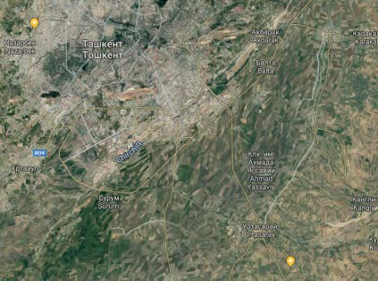
30 -35 km
Existing
landfill
- According to the detailed design of the project 30.91-hectare land plot located directly to the South of the existing Akhangaran dumpsite are required for the project. The following facilities shall be located in this new area:

- The landfill area is about 26.51 hectares (including roads);
- Regulation pound - 0.7 ha;
- Check point - 0.76 ha;
- Other facilities (including water sump) 2.94 ha.

The landfill capacity is 7.66 million cubic meters in total, the expected service period is 12.1 years.

Figure 2 Designed new landfill site
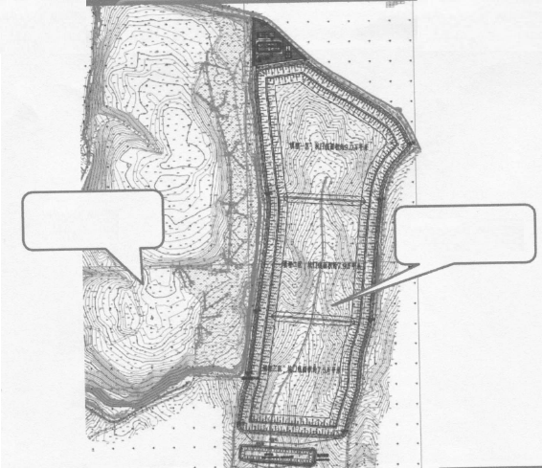
Existing
landfill
New landfill
(project)

- Access to the site: The detailed design developed for the project showed that the new landfill will use the existing access road and require the construction of additional access road to the new site. This is visualized below on given image (see Figure 3 below).

Figure 3. Access road to new landfill site
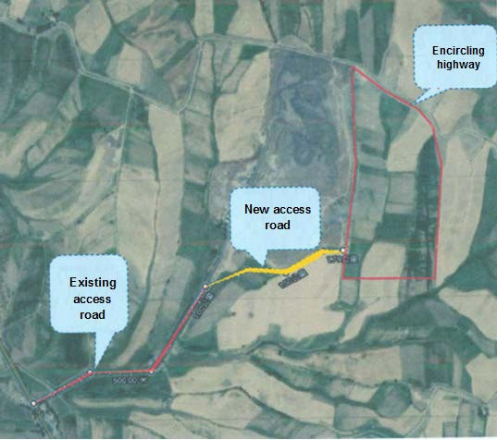
- According to the mentioned Decree of Hokimiyat, SUE Maxsustrans shall:
- obtain the proper documents from local Architectural and Construction authority prior to start any design works for construction or rehabilitation on the new landfill;
- ensure keeping the working conditions of the existing irrigation, melioration and engineering infrastructures located in the neighboring farmer and agricultural areas;
- upon using of this land, do re-cultivation according to Regulation on land reclamation, removal, conservation and rational use of the fertile soil layer.
- be aware that the allocated land shall be used within three years upon issuing this decree.
- In 2019 the detailed design of the project was prepared and approved (October 2019). As the results of Due Diligence conducted and approved by ADB in October 2019 there are no the involuntary land acquisition and resettlement impacts within the project. The project is at the preconstruction stage. There was no real project progress during July-December 2020 reporting period, due to quarantine measures COVID-19 which began to weaken only at the end of June 2020.

- According to the general requirements for the selection of landfill sites, the response to the site selection of this sanitary landfill is shown in Table 1 below.

Table 1: Response table of proposed site according to general requirements
№ | Requirement | Compliance | Remark
1 | The landfill shall be set up in accordance with the overall planning for urban construction, and meet the requirements of overall planning for local urban regional environmental and the requirements of development planning for local urban environmental health; | Accordant | The planning department agreed to use the land for environmental sanitation facility- [New SLF];
2 | The landfill shall not affect the surrounding environment or affect the surrounding environment not exceeding current national standards. It is located in the down prevailing wind direction in summer, and is 500m away from the habitat of humans and livestock; | Accordant | There are no industrial enterprises, residential areas, water sources and key scenic spots and historical sites within 500m below and near the maximum frequency wind direction downstream;
3 | The requirements for the landfill shall be consistent with the local atmospheric protection, water and soil resources protection, nature protection and ecological balance. The landfill shall be located in area with poor underground water, and shall be kept away from water sources and located in the downstream area of underground water flow direction to the greatest extent; | Accordant | The urban area is located on the side of the maximum frequency wind direction, where the underground water is less.
4 | The landfill shall have a corresponding storage capacity. Its service life shall be more than 10 years. In special cases, it shall not be less than 8 years; | Accordant | After calculation, the sanitary landfill can serve for about 12 years;
5 | It has convenient transportation, reasonable transportation distance, convenient water supply and power supply conditions; | Accordant | It is about 30km average away from each garbage station in the service area. The water is supplied by drilling wells, and the power supply is convenient;
6 | The land acquisition cost is low and the land use value is low. | Accordant | The use value of hilly area and land is low.

- Thus, it can be seen that the site meets the general requirements for landfills, and has good engineering conditions for water supply, power supply, road traffic and others, so the site is suitable as a construction site.

Necessity of Project Construction
- The necessity of the construction of the project is mainly embodied in the following aspects:
- Garbage sanitary landfills are essential as urban environmental infrastructure. If the garbage is piled up disorderly, it is difficult to match the modern city or meet the requirements of sustainable urban development. Harmless disposal of garbage is a civil project to maintain environmental health and ensure people's health.
- The population of Tashkent has increased rapidly in recent years, and the daily output of garbage has reached about 1,700 tons. The existing irregular landfills have a long service life, and the storage capacity is tight. Meanwhile, the new regular landfills are about to be built and put into use, so the closure of the old landfills is imminent. This goal will also enable the execution of the President Decree of the Republic of Uzbekistan dated April 17, 2019 No. PP-4291 approving Strategy for Solid Household Waste Management in the Republic of Uzbekistan for the period 2019-2028.
- Tashkent has rich tourism resources such as natural and human landscapes. Its designated function is a modern ecological city with a good living environment suitable for leisure tourism. Therefore, how to effectively protect the ecological environment will become an important issue in Tashkent.
- The current domestic garbage disposal facility in Tashkent is an informal landfill in the southeastern of Tashkent. The capacity of the landfill is near saturating and will be closed within the project. The closing of the old dumpsite can guarantee that the domestic garbage generated in Tashkent is harmlessly disposed of basically to reduce its serious pollution to the environment and serious threat to soil and underground water. It is an important livelihood project to protect the landscape of Tashkent, so the project is an important infrastructure for Tashkent, and an indispensable link in the development of Tashkent.

- In general, the domestic waste treatment facility is a major infrastructure of the city, and the closure of the existing landfill site is related to the ecological environment and sustainable development of Tashkent, as well as the vital interests of the general public. The construction of the project will create the necessary basic conditions for the development of Tashkent, and is of great significance to protect the ecological and tourism environment of the region, perfect the investment environment and improve people's living quality.

- The construction will be confined to the distinct project site, there will be no temporary disruption of livelihood of any household or group of community in this area during construction period.

- At the existing dumpsite sorting of the solid wastes is carried out by the waste pickers. There are 35-40 waste pickers engaged in work. Consultant studied the situation with these waste pickers. Based on the results of survey, Consultant notes that waste pickers are people who are officially employed through the rehabilitation center. The employer is “Mehr Sahovat” Ltd. All these people are ensured with proper social and labor guarantees of their incomes / salaries by the employer. In compliance with the requested information, there are 7 permanent waste collection points (WCPs) and 30-35 waste pickers with hourly rate wage. The rehabilitation center provides these people with the work and guarantees for salary. After the existing landfill is closed these people will be re-employed at the other infrastructural facilities like transfer stations, sorting stations, land and road improvement enterprises etc.

Project Contracts and Management
- The project is being administered by the Project Implementation Unit (PIU), which is currently represented by the Head of PIU (Mr. Jasur Hamidov).

- PIU has received аn official letter from H.P. Gauff Ingenieure GmbH & Co. KG. dated 24.07.2020 about оrdеr of the local court of Nurеmbеrg оn opening of insoIvency proceedings according to Gегmап Law regarding H.P. Gauff Ingenieure GmbH & Co. KG. PIU has also received аn official letter from H.P. Gauff Ingenieure GmbH & Co. KG.dated 17.09.2020 about declaration of non-entry of the соmраnу in the соntгасt No. SUE/Maxsustrans/QCBS-Cons 1-2016-01.

- Considering the necessity to соntinue the PIU Consultant sеrviсеs in огdеr to еnsurе uninterrupted implementation of the ADB’s Solid Waste Management lmprovement Project the obligations under the Соntrасt No. SUE/Maxsustrans/QCBS-Cons 1-2016-01 is assigned to the local partner of the Joint Venture - Infratech Consulting SDN Ltd. (Uzbekistan). Maxsustrans has signed Amendment No. 5 to the a.m. contract on December 9, 2020 with extension of the Consultant’s service until 30.06.2021.

- The full rеsроnsibility of the Consultant to регfоrm this Соntrасt against the Client is handed over to lnfratech Consulting SDN Ltd. Mr. Dilshod Mavlyan-Kariev, K-4 national SWM Specialist (Deputy Team Leader) is in charge in the overall project administration and reporting for the Project.

- PIU Consultants has National Environmental Expert – Mr. Sergey Karandayev, who implementing environmental safeguards services. He is personnel in charge of environmental affairs. He is responsible for arranging on-field monitoring activities, providing inputs to this quarterly monitoring reports and making sure the protection measures are implemented accordingly.

- SUE Maxsustrans has hired "China Urban Construction Design & Research Institute Co., Ltd." (CUCD) for Sanitary Landfill Design and Construction Supervision services. CUCD is responsible to serve as the “Engineer” within the context of the Conditions of Contract (COC) and will be responsible for the design drawings/documents till completion of the construction period. The CUCD is also responsible to monitor the Environmental, Resettlement, and other Social Safeguard issues of the Contract along with monitoring the Gender issues and for alleviation of grievances.

- Engineer started with the work according to the ToR of CUCD since14 December 2018. CUCD has already completed the design works of closure of old dumpsite and establishment of new sanitary landfill in Akhangaran district. During the construction works they will supervise all construction works to be performed under package CW1 – Landfill Construction and Dumpsite Closure.

- The Team Leader reports directly to the Project Director (Client’s representative). The CUCD are working under the overall guidance, coordination and directions of the Project Director. Resident Engineers are coordinating with the Team Leader. CUCD staff including the Team Leader and other key and non-key staff mobilized during the month of December 2018 and January 2019. The other expert and support personnel of CUCD was mobilized progressively to the site.

- Due to the pending tender for the selection of the contractor for the construction of the landfill and the closure of the old dumpsite (package CW1), the civil works could not be commenced during the reporting period. Up to date no decision has been taken regarding contract award under this package CW1.

- Main organizations involved in the project and related to environmental safeguards are presented in the Table 2 below:

Table 2: List of organizations involved in environmental management under the Project
Organization | Name of main staff and Environmental Specialist | Contact data (including phone and web-site) and address of the organization | Employer | Contract Signature date | Contract Final Date
PIU Support Consultant –Infratech Consulting SDN Ltd.” | Mr. Dilshod Mavlyan-Kariev, Deputy Team Leader  Mr. Sergey Karandaev, Environmental Specialist | dilshod75@mail.ru  infratech_consulting@asia.com  +998712563901 | SUE “Maxsustrans” | 11.01.2017 | 30.06.2021
Lender (ADB) | Kyoko Uematsu – Country Focal for UZB  Feruza Insavalieva – Uzbekistan Resident Mission, Safeguards Officer;  Ketevan Dgebuadze – ADB RETA International Environmental Consultant | kuematsu@adb.org  +998711401920  finsavalieva@adb.org  ketdgeb@yahoo.com  kdgebuadze.consultant@adb.org
Sanitary Landfill Design and Supervision Consultant –China Urban Construction Design & Research Institute Co., Ltd.” | Mrs. Yuwei Xue,  Authorized representative  Mr. Mingtao Nie  Environmental Specialist | icc@cucd.cn+861057365133 | SUE “Maxsustrans” | 16.11.2018 | 07.12.2020  Extension of Contract period is under discussion

- The role of each agency in the project is presented in the Table 3.
Table 3: Role of Agencies towards EMP Implementation
Agency | Role
Project Implementation Unit (PIU) | - Holds Overall responsibility with regard to EMP Implementation  - Reporting to various stakeholders (ADB, Regulatory bodies) on status of EMP Implementation  - Coordinating with Environmental Experts (PIU Support Consultant, Contractors and External Monitors)  - Responsible for obtaining Regulatory Clearances  - Review of the progress made by Contractors  - Ensure the BoQ items mentioned in EMP are executed as per contract provision
PIU Support Consultants | - Assisting PIU in overall implementation of EMP  - Review of periodic reports on EMP implementation and advising PIU in taking corrective measures  - Conducting periodic field inspection of EMP implementation  - Assisting PIU and reporting to various stakeholders (ADB, Regulatory bodies) on status of EMP implementation  - Conduct environmental training for field officers and engineers of contractor
Engineer | - Supervise the implementation of the environmental protection and impact mitigating measures by the contractors  - Supervise construction activities to ensure minimum impact on the natural and socioeconomic environment,  - Regularly monitoring the performance of the Contractor(s) environment staff, verifying monitoring methodologies and results;  - Review of the construction design to ensure compliance with project engineering design and the EMP with regard to environmental protection and impact mitigation;  - Prepare the necessary remedial actions for any unforeseen impacts  - Instructing the Contractor(s) to take corrective actions within timeframe as determined by the ES of CSC  - Address complaint related with environmental aspect of the project through GRM
Contractor | - Responsible for ensuring the implementation of EMP as per provision in the document  - Discussing various environmental / social issues and environmental / social mitigation, enhancement and monitoring actions with all concerned directly or indirectly  - To ensure environmentally sound and safe construction practices  - Conducting periodic environmental and safety training for contractor’s engineer, supervisors and workers  - Sensitization on social issues that may be arising during the construction stage of the project  - Conduct environmental monitoring and control activities including pollution monitoring, safety; and  - Preparing and submitting monthly reports to PIU on status of implementation of safeguard measures  - During the Covid-19 pandemic, the contractor will ensure necessary protection to the deployed WORK FORCE and minimize the risk of spread of infection.

- The working environment among SWMIP and Engineer has remained sound during this reporting period. Depending on the Corona Pandemic regular meetings couldn’t be held between PIU, Maxsustrans and Engineer. Currently the movement is not possible.

Project Activities During Current Reporting Period
- The civil works for collection points rehabilitation and construction had been completed using Maxsustrans own funds.
- During 2013-2017, SUE Maxsustrans independently built 150 units of new waste collection points (WCPs) and reconstructed more than 300 units of existing WCPs at the expense of Ipoteka Bank credit funds in the amount of 4.5 billion sum. All works at the expense of the Ipoteka Bank loan has been completed. In 2018, at the expense of SUE Maxsustrans’ own funds, another 50 WCPs were built. ADB funds of $3.124 million for these purposes were saved and in August 2019 were reallocated to other project components in agreement with the Ministry of Finance and ADB.

- The status of three civil works packages is as follows: (i) package CW1 - Sanitary landfill and dumpsite closure (estimated cost $23.5 million), bid evaluation is not yet completed, decision on contract award is still pending; (ii) package CW2 - Transfer station rehabilitation (estimated cost $7.0 million), bids opened on 3 August 2020, the bid evaluation report (first draft) was sent to ADB review on December 29, 2020; and (iii) package CW4 - Garage rehabilitation (estimated cost $0.8 million), contract was signed Indigo Baraka Servis LLC Uzbekistan on December 7, 2020, the works commencement date – December 16, 2020. The reconstruction works are started in Mirabad garage facility. The reconstruction works in Bektemir garage facility will be started in the first quarter of 2021.

Table 4: Overview on project costs

Source of Financing | Total  (million USD) | %
Asian Development Bank Financing
Loan 3067-UZB (Ordinary Capital Resources) | 69.00 | 90.79%
Governmental Financing
Government of Uzbekistan (GoU) | 7.00 | 9.21%
Total | 76.00 | 100%

- Since the beginning of the assignment the PIU Consultant has arranged the following procurement packages of the Project:

Subproject/Contract No. | Category (works, goods or services) | Contract Amount  ($ equiv.) | Contract Completion
Capacity Development Program Consultant | Consultant services | 1,377,600.00 | 31-Dec-19
Sanitary Landfill Design & Supervision Consultants | Consultant services | 2,028,425.00 | 7-Dec-20
Financial Audit FY 2018 - FY 2021 | Consultant services | 32,000.00 | 30-Jun-21
Transfer Station Rehabilitation Design and Supervision Consultant | Consultant services | 81,600.00 | 30-Jun-21
Garage Rehabilitation Design and Supervision Consultant | Consultant services | 97,600.00 | 30-Jun-21
Supply of 59 Units of Waste Collection Trucks | Goods | 4,189,000.00 | 31-Dec-20
Sanitary Landfill & Machinery Lot 1: Crawler Excavator, Bulldozer, Wheel Loader | Goods | 1,977,422.00 | 31-Mar-21
Sanitary Landfill & Machinery Lot 2: Landfill Waste Compactor | Goods | 1,582,934.00 | 30-Apr-21
CW4: Garage Rehabilitation | Civil Works | 957,284.94 | 30-Jun-21

- Project implementation delays. The current delay relates to the government internal procurement review process, which has negatively affected the project implementation. For CW1, the original schedule for contract award is December 2019, IFB was posted on 15 October 2019 after 3.5 months’ delay, on 26 November 2019, bid opening was conducted. Initial bid evaluation was completed by 10 December 2019. However, the bid evaluation report was not reviewed by the Tender Committee of Tashkent Khokimiyat until 17 February 2020 despite ADB’s reminders through mission in December 2019, emails, and letters. No decision was made in the meeting because the EA did not attend.

- ADB through letter, emails and video conference (due to travel restriction caused by COVID-19, no mission can be fielded since March) requested government intervention to complete the review and submit BER. On 23 May 2020, the Tender Committee was convened however, instead of submitting BER, the EA sent a letter requesting rebidding without justifications on 28 May 2020. ADB responded to the EA on 19 June 2020 requesting submission of BER to justify the request and extension of bid validity. The BER was submitted on 25 June 2020 which is 7 months after the bid opening. After receiving ADB’s comments, the revised BER was submitted on 15 September 2020 proposing to award the contract to the noncompliant bidder. On 30 September 2020, ADB sent objection letter to the revised BER. Maxsustrans advised the Tender Committee reviewing the bid proposals and attempting to find justifications to justify a request for rebidding called by the first deputy Mayor of Tashkent Municipality.

- ADB reminded Maxsustrans that significant delays in procurement would cause huge risks on the project completion, Maxsustrans should clarify the procedures and requirements of ADB’s Procurement Guidelines to the members of the Tender Committee, and the requirement of compliance with the Procurement Guidelines as agreed in the loan and project agreements between the government of Uzbekistan and ADB. ADB advised Maxsustrans to attend the procurement training organized by ADB and learn the FIDIC conditions which are internationally adopted for the contracts procured through international competitive bidding.

- The revised BER for package CW1 with the last decision of Tender Commission to conduct the rebidding was sent to ADB at the end of December 2020. Due to significant change in the scope of work of the contract, the EA and IA would like to rebid this package for new landfill construction only. In particular, they intend to remove from this package all works related to dumpsite closure in Akhangaran District, referring to the recent letter from SCEEP that the old dumpsite is given for implementation of other investment project with the South-Korean company SEJIN.

- ADB reminded Maxsustrans and PIU that in accordance with paragraph 2.59 of the Procurement Guidelines, the borrower shall award the contract, within the period of the validity of bids, to the bidder who meets the appropriate standards of capability and resources and whose bid has been determined (i) to be substantially responsive to the bidding documents and (ii) to offer the lowest evaluated cost. A bidder shall not be required, as a condition of award, to undertake responsibilities for work not stipulated in the bidding documents or otherwise to modify the bid as originally submitted.

Issues with waste collection points

- There were odours associated with the waste collection points. The collection bins were often open, some of the collection points were not well cleaned.
- New containers were lidded euro containers and large bulky containers to reduce access to feral dogs and to reduce odours and visual nuisance at the collection points.

Description of benefit of the final Project Design
- CUCD designed following New Sanitary Landfill with following main data:

- 24,62 ha for the clean storing of solid waste
- Expected lifetime based on current and delivering waste quantities in the future by approximately 12 years. TOR requested minimum 10 years.
- Optimized liner system to reduce the thickness for more waste space
- Enlargement of the depth
- Using a PS for leachate collection, pump sump below the surface (-20m)
- Max. hight by 30 m over ground
- Part of the topsoil and other excavation material will be used for closure of the old landfill
- For emergency cases (fire) in the new Landfill
- Intermediate cover of sections for the new Landfill according to the operational plan

- These variant gives the best impute for an ecological protection and increasing of the lifetime of the new landfill.

Description of any Changes to Agreed Construction methods
- No changes to agreed construction methods during the July-December 2020 reporting period.

3. Environmental Safeguard activities

General Description of Environmental Safeguard Activities
- IEE for project was prepared for SUE Maxsustrans in May 2013 and it was published on ADB‘s website.

- The IEE report covers the general environmental profile of the project and includes an overview of the potential environmental impacts and their magnitude on physical, ecological, economic, and social and cultural resources within the subproject’s influence area during design, construction, and operation stages. Additionally, National Environmental Expert has reviewed this Environmental Management Plan (EMP) as part of this report (Annex 1). The level of details and complexity of the EMP and the priority of the identified measures and actions will be commensurate with the Project’s impact and risks.

- Specific Tasks for the Sanitary Landfill Design and Supervision Consultant, according to Contract No. SUE/Maxsustrans/QCBS-Cons_2 are:

Phase I – Detailed Engineering Design

- As already mentioned in the last report (valid for C2 Consultant)

- to provide a detailed description of the scope of construction and installation works and make up a calculation of "Initial cost estimate of construction at current prices" as cost estimation as part of the Detail Design, BoQ etc. together with the preparation of the Bidding documents together with the C_1 Consultant.;
- to provide a technological scheme for operating the new landfill, and also to develop the necessary measures for the period after the closure of the landfill and its handover for further use;
- to obtain a positive conclusion from the state expertise of the authorized body of the Republic of Uzbekistan on design documentation for construction of the new landfill and closure of the existing dumpsite. If necessary, SUE "Maxsustrans" should assist the Consultant in obtaining approval from the state bodies and organizations for conducting detailed design and during it;
- to support SUE "Maxsustrans" and PIU in general management and implementation of the Civil Works contract, including coordination of activities, monitoring, record keeping, certification of contractor's work and reporting on work progress.

Phase II – Supervision of Construction Works

- to be responsible for supervision of the new landfill construction and closure of the existing dumpsite, including regular supervision over contractors, performed works quality, installation of equipment, deadlines and costs from start to completion;
- to ensure that construction works are carried out in accordance with international and national standards, technical specifications and approved design documents;
- to ensure that construction is carried out by the contractor in accordance with environmental and social norms and regulations of Uzbekistan and Safeguard Policy of ADB;
- to carry out planning and analysis of the final commissioning tests conducted at the completion of each section of works;
- to carry out planning of monitoring activities to be performed during the Defects Liability Period and advising SUE "Maxsustrans" and PIU at issuing the Works Completion Certificate;
- to advise the SUE "Maxsustrans" and PIU on all matters relating to construction of the new landfill and closure of the existing dumpsite;
- to prepare documents and regular reports for SUE "Maxsustrans" and PIU as per TOR;
- to evaluate the quantity and value of the completed works as well as payments to the Contractors;
- to ensure implementation of Quality Assurance Plan, Environmental Monitoring Program, Occupational Safety Plan on works site of the Contractors;
- to communicate and support SUE "Maxsustrans" and PIU if any changes or deviations from the originally approved design during the Works;
- to conduct an Initial Environmental Evaluation (IEE), an Environmental Impact Assessment (EIA), an Environmental Management Plan (EMP) and an Resettlement Program / Social Impact Assessment (RP / SIA) program. The Consultant should submit an EIA for review and approval by SCEEP and receive a positive opinion;
- to submit the results of the discussion of policy measures, laws, regulations, standards and guidelines that directly apply or relate to the environmental and social issues of the Project at the national and local level and taking into account ADB requirements. When analyzing the impact, it is necessary to consider all potential environmental impacts and risks of the project. The analysis should cover both unfavorable and favorable consequences of the project. The Consultant should also conduct an analysis of the possibility that specific individuals or groups of individuals may be affected unequally or disproportionately by the potentially harmful environmental impact of the project because of their poorly protected or socially vulnerable status. The EMP should identify desirable outcomes and actions to address issues related to identified impacts and risks, and to ensure compliance with existing requirements as measurable events. Also, the Consultant should consider information disclosure measures, a mechanism for reviewing and responding to complaints, and a process of ongoing consultation with affected individuals and with their participation during the implementation of the project. Consultations should include the conduct of substantive consultations with persons affected by the project and other relevant parties, including civil society, and facilitating their informed participation.

- The technical route of new landfill project is as follows:

- The type of the domestic garbage sanitary landfill: “Valley Landfill”
The construction site of the project is a valley, so it is designed according to the design method for valley landfills.
- Domestic garbage disposal process: “Improved Anaerobic Landfill Process”
The landfill uses an improved anaerobic landfill process to make corresponding engineering design, and set up a bottom impermeable system, a leachate collection system, and a landfill gases drainage system, so as to facilitate the operations and standardized management of sanitary landfill.
- Landfill operation process: “Sanitary Landfill Operation”
Domestic garbage in the sanitary landfill needs to be dumped, paved, compacted, covered and disinfected in accordance with certain procedures to reduce or eliminate the impact of domestic garbage on the surrounding environment.

- Entry requirements for domestic garbage sanitary landfill: the waste entering the domestic garbage sanitary landfill shall be domestic garbage. It is strictly forbidden to mix domestic garbage with the following materials to enter the domestic garbage sanitary landfill:

- Toxic industrial products and their residues;
- Toxic reagents and medicines;
- Substances that have chemical reactions and produce harmful substances;
- Corrosive or radioactive materials;
- Dangerous goods such as flammables and explosives;
- Biohazards and hospital waste;
- Other substances that seriously pollute the environment.

- In order to ensure that the above substances do not enter the landfill area, sampling inspection of the incoming garbage shall be organized regularly by the operating company.

Site Inspections
- Consultant visited the project area to conduct visual assessment of the lands allocated for the project needs in July 2020. A new land plot for the landfill was allocated in the south of the existing landfill Akhangaran. The total size of the land is visually approx. 30 hectares. The main access to the new landfill will be through the existing road already exist to the existing landfill and a new access road as junction from the existing road parallel south side of the existing landfill.

Figure 4. Photo of the project site – lands allocated for the construction of new landfill
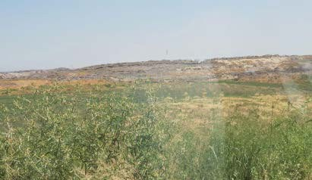 | 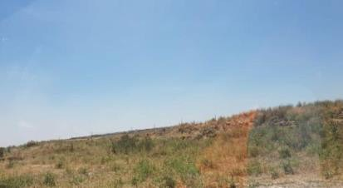
Land plot for new landfill | Land plot for additional access road
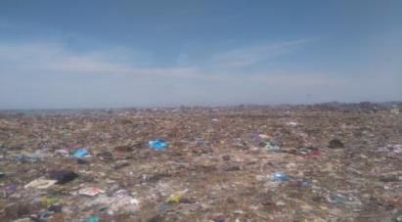 | 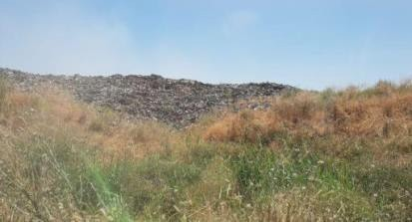
View of existing landfill | View of existing landfill
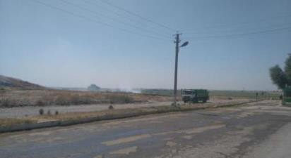
Existing access road

- Site visit also visually confirmed that there are no users / holders on the land where the construction of new landfill and additional access road will be developed. There is currently no agricultural activity or any improvements that have been made in this site. The project area does not have any households occupied the lands allocated for the project. According to the current sanitary-epidemiological standards and norms (“SanPiN”) No. 0350-17 “Sanitary standards and norms of the atmospheric air protection of human settlements of the Republic of Uzbekistan” residential and farming are not allowed at the sanitary protection zone of the landfill.

Site visit 1 – WCP No. 15

- At the Waste Collection Point (WCP) No. 15 there are 4 containers, each with a volume of 1.000 litres, two containers are marked for the usage for waste fractions (composite plastic materials and paper). Other two containers are for residual waste. The separation of the waste is done mainly by the caretaker of the facility (who lives in the hut inside the collection point) or by the people on site. But according to his point of view - as the area is inhabited by educated and relatively wealthy people - there is already a certain readiness to separate the waste within the households. Some people even bring their waste separated in the specific fractions. Since two years the containers for recyclables are marked with a scheme, which helped to clarify the purpose of the containers and to motivate the people to separate their waste.

- In addition to the two containers for recycling materials the caretaker also separates plastic bags and (in one bag) smaller papers and Tetra packs (liquid packaging boards).

- The waste fractions are collected by Maxsustrans. For the two recycling containers he needs to fulfil a certain quota, exceeding amounts are sold by him to private recycling companies. For the achievement of the quota as well as for tidiness and order of the WCP he is earning a bonus from Maxsustrans. The caretaker is keeping records about waste collection by Maxsustrans.

- The WCP was re-built in March 2020 (before the WCP was in a far worse condition). The civil works for collection points rehabilitation and construction will have a major positive impact on odours from the waste system though better provision of collection points.
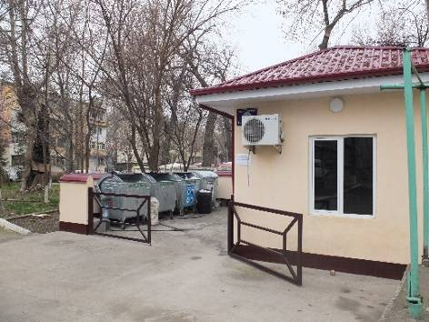 | 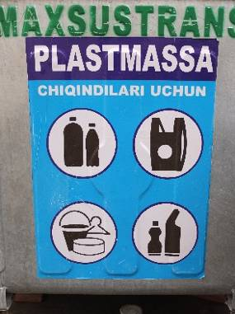 | 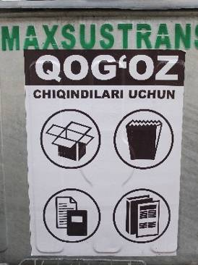
Figure 5: Pictures - Waste Collection Point 15
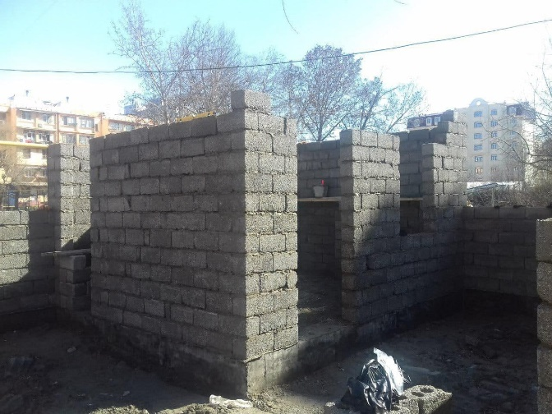 | 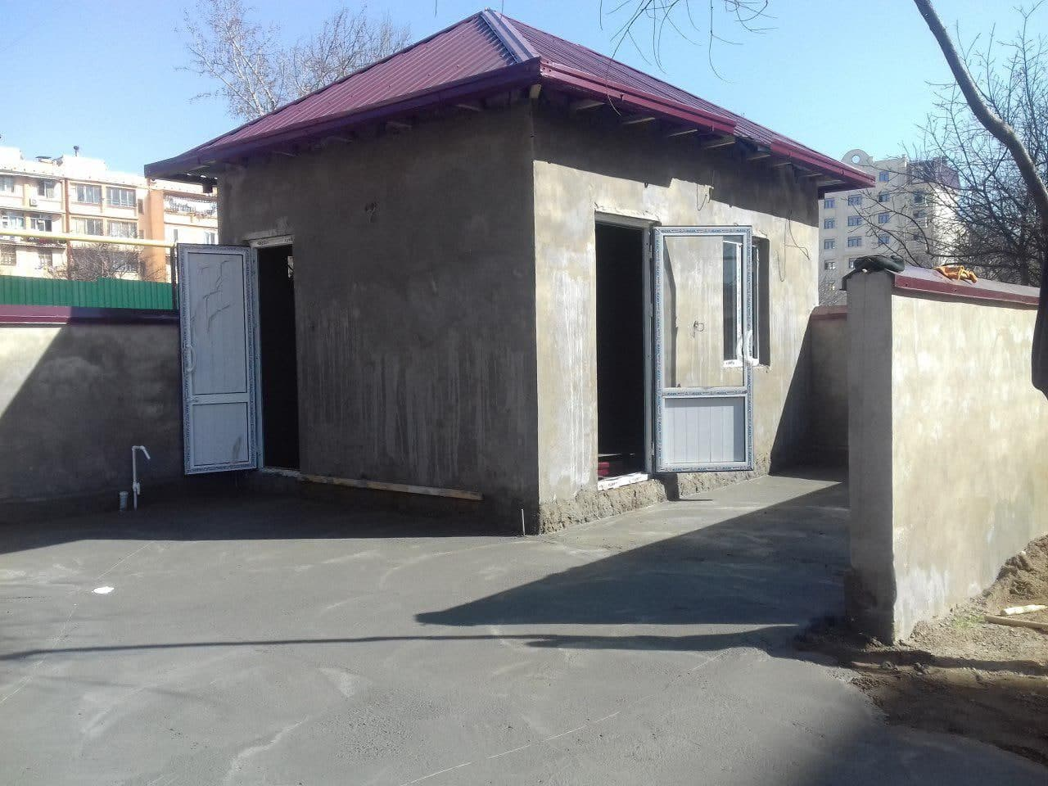
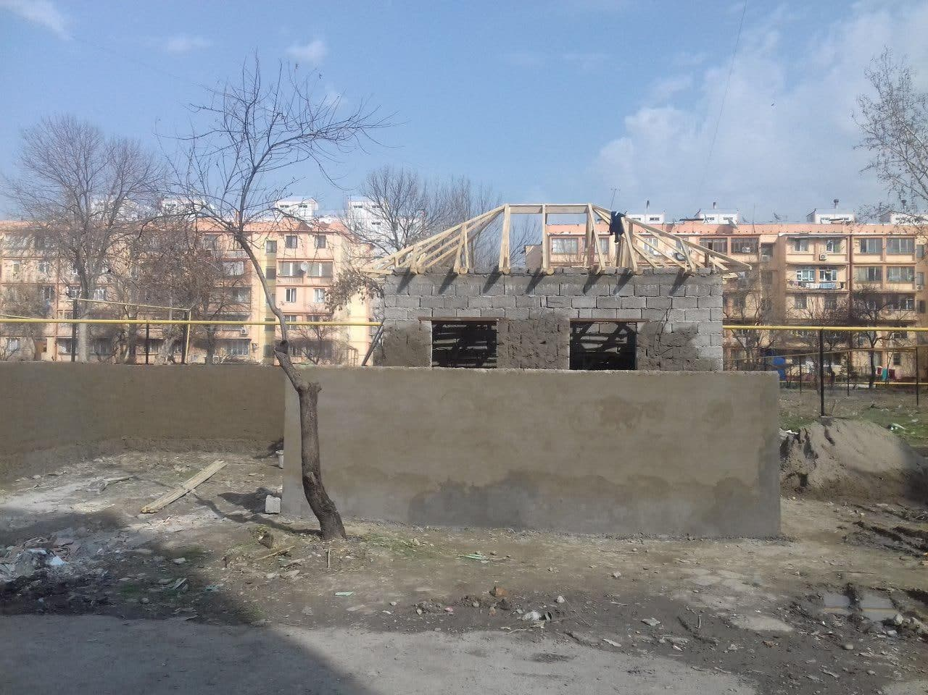
Figure 6 Different stages of WCP construction

3.2.1 ADB Missions
- A loan review mission conducted loan review through video conference intermittently from 3 to 9 November 2020. The Mission held discussions with the Ministry of Finance (MOF), the Ministry of Investment and Foreign Trade (MIFT), the Tashkent Municipality, and Maxsustrans. The contents of this Aide Memoir (AM) were subsequently discussed and broadly agreed. The AM, together with its findings, recommendations and general agreements are subject to further confirmation from higher authorities of the Government of Uzbekistan (government) and the Asian Development Bank (ADB).

3.2.2 Issues Tracking (Based on Non-Conformance Notices)
- Not yet applicable.

3.2.3 Trends
- Not yet applicable.

Unanticipated Environmental Impacts or Risks
- The detailed directions which must be followed as precaution to COVID-19 should be reflected in SSEMP to be submitted by the Construction Contractor before commencement of construction activities.
- In addition, the EHS management plan should be prepared and aligned with relevant government regulations and guidelines on COVID-19 prevention and control, and with international good practice guidelines. The plan should include COVID-19 prevention and control measures, including disinfection/cleaning of offices, construction sites and labor camps, on-site temperature checks, social distancing measures, mandatory use of personal protective equipment such as facemasks, provision of handwashing stations and hand sanitizers etc., and procedures to be adopted in the event any worker is infected with COVID-19.

4. Results of Environmental Monitoring

4.1. Overview of Monitoring Conducted during Current Period
- Initial Environmental Examination (IEE) report designed for all phases (design, construction and operation) for SWMIP was prepared in 2013. However, this ‘Environmental Monitoring Report’ covers only the design phase impact monitoring, as there is no construction activity.

- Current Situation depend on the Corona Pandemic: No significant environmental issues were flagged and no complaints received from the local residents and no adverse impacts occurred as a result of no construction activities during the reporting period.

- Within the reporting period, Team Leader and Local Environment Specialist of PIU Support Consultant, International Environment Specialist of the Sanitary Landfill Design and Supervision Consultant have inspected the Akhangaran landfill. During the inspection, overall methodology to assess and monitor EMP implementation for future construction activity was conducted. Several on-going works were reviewed and meetings to validate environmental performances by International Environment Specialist.

- Most of the environmental monitoring requirements are for the construction period of project site. At the construction stage, the SWMIP site engineer is responsible for the preparation and submission of monthly environmental supervision reports. Meanwhile, the PIU is responsible for the monitoring of environmental parameters and preparing environmental results reports. The Environmental Expert of PIU is responsible for compiling the Semi-annual environmental monitoring reports.

- Monitoring and reporting of the project will be conducted prior to construction, during construction, and during operation. The PIU shall monitor the performance and implementation of the EMPs. Monitoring reports on the performance and in implementing the EMPs, shall be prepared prior to construction (detailed engineering design and procurement stages), during construction and during project operation, as follows: i) monthly progress reports; and ii) quarterly monitoring reports to be submitted to ADB. The monitoring report/s shall also document the relevant environmental aspect and its respective mitigation measure, as well as grievances received and resolved, if any.

- Prior to commencement of any construction work, contractor has to submit an SEMP and compliance report to PIU ensuring that all identified impacts detailed in the environmental assessment have been undertaken. The PIU will review reports submitted by CC as soon as construction works commence.

- The PIU supposed to organize an induction training to discuss the submitted SEMP including environmental monitoring requirements and reporting of unexpected adverse impacts or impractical mitigating measures observed during the construction phase.

- Based on monthly reports and measurements, the PIU will draft quarterly EMP implementation report which will include

(i) construction activities over the last 3 months;
(ii) reporting on EMP implementation;
(iii) sampling results
(iv) findings on the compliance status;
(v) summary of any non-compliance and remedial actions taken; and
(vi) recommendations for improvement, revision of the mitigation measures and/ or the EMP if any.

- The environmental safeguard specialist of the PIU Consultant will review the draft EMP implementation report which upon approval by the Project Director will be submitted to ADB. Depending on findings, future modifications in the EMP could be undertaken with the concurrence of the ADB. These will be generally undertaken, if required, upon review of the EMP progress reports submitted by the PIU to ADB for review and further action.

- The IEE goal was to maximize the use of available secondary data (without baseline instrumental measurements) in the understanding of the present condition of the project site. It should be noted that secondary information made available by pertinent governmental agencies and secondary literature was maximized to establish the baseline for the site. IEE described the baseline environmental conditions, including physical, ecological and socio-economic resources in project site, assesses environmental impacts of the intended project activity, and provides remedial/mitigation measures. The baseline parameters would be established prior to construction for monitoring the situations of environment affected during construction. The baseline measurements will become the conditions against which any changes due to project effects will be measured. All data must be collected so that their source can be traced by anyone who picks up the document.

- The operation management of domestic garbage treatment facilities involves many aspects, and environmental monitoring is one of the important links of operation management. It is an important mark of the standardized operation management of domestic waste sanitary landfills. Environmental monitoring is the evaluation level of the operation status of domestic waste treatment facilities. Environmental monitoring involves all environmental factors such as atmosphere, groundwater, sewage, leachate, noise, biogas and various pollutants, which can fully reflect the environmental situation. The environmental monitoring project of domestic waste treatment facilities must be carried out periodically and in stages according to standards. The main environmental monitoring projects are shown in Table 5.

- In accordance with the geographical environment and characteristics of the project, the existing monitoring department of State Committee of the Republic of Uzbekistan of Ecology and Environment Protection (SCEEP) can be responsible for the environmental management and monitoring. At this stage, the background values of the site environment shall be tested and investigated immediately.

- Background environmental monitoring of the site

- Before the domestic garbage sanitary landfill is put into operation, the environmental protection department and the Sanitation and Anti-epidemic Station shall carry out background monitoring for various environmental and microbial indicators, as well as the groundwater and surface water, and put them into the archives.

- Environmental quality monitoring of the site

- To ensure that the anticipated environmental protection objectives are achieved, a sound environmental monitoring system shall be established and improved at the site. Environmental monitoring items are provided in Tale 5 below. Environmental monitoring locations during construction are provided in Figures 4 and 5.

Table 5. Environmental monitoring item table
Monitoring item |  | Note ( see also paragraph 88 etc.)
Surface water | pH、SS、DO、BOD5、CODcr、NH3-N、NO2-N、NO3-N、CL-、TP etc. | Three background monitoring shall be conducted for the landfill, once in dry season, flood season and normal season, and twice in peak month.
Groundwater | 13 items of PH, total hardness, chloride, COD, ammonia nitrogen, volatile phenol, cyanide, Escherichia coli, etc. Water level shall be monitored at the same time | The monitoring wells shall be cleaned three days before sampling. The amount of water taken out during well washing is 3-5 times the amount of water stored in the wells, and the monitoring indicators will be adjusted when necessary. The monitoring points are groundwater monitoring wells and domestic water wells. It shall be monitored three times a year, the sampling time is in April, August and November, respectively.
Leachate | SS、COD、BOD5、NH4-N、coliform value | Monitoring points are: leachate collection wells, leachate treatment facilities outlet. It shall be monitored three times a year, the sampling time is in April, August and November, respectively.
Atmosphere | TSP, odor intensity, ammonia, hydrogen sulfide, methyl mercaptan | There is a monitoring point in both upper and lower wind directions. When the wind direction is not fixed, the monitoring point can be increased appropriately. It shall be monitored twice a year, the sampling time is in April and August, respectively.
Landfill gas | CH4、CO2、CO、N2、O2、H2、H2S | The monitoring point is the methane collection orifice, which can monitor one point. It shall be monitored once a year in August.
Fly breeding monitoring | Field boundary noise | Within 1~3 years after the landfill is opened, it shall be monitored 4 times a year, preferably in July ~ December
Noise | Field boundary noise

Figure 7. Environment monitoring locations during construction
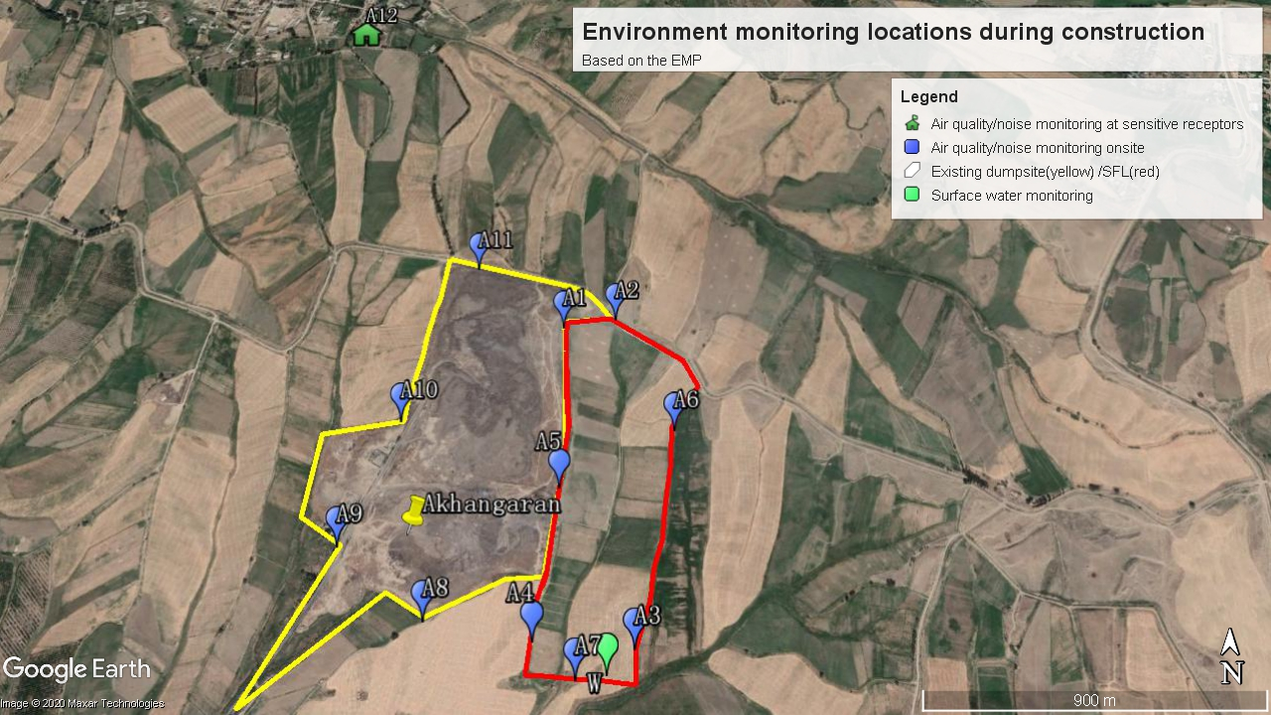

Figure 8. Permanent environment monitoring locations during operation
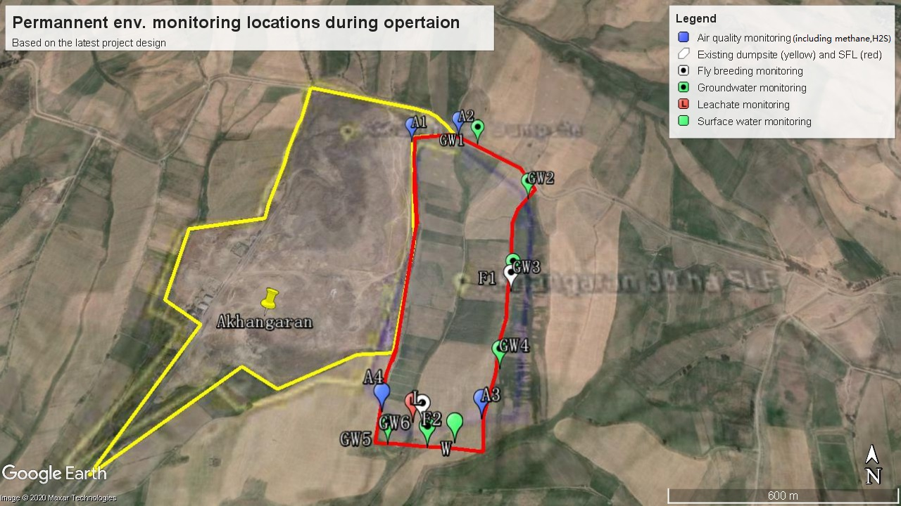
- Monitoring institution, personnel
- According to the needs of the project, the existing environmental protection institution can be responsible for the environmental management and monitoring of the plant, and the full-time environmental supervisor shall be equipped to be responsible for the environmental quality management of the landfill and the entire plant.

- Monitoring content and distribution

- Monitoring of surface water around the site

(i)Sampling point layout
Three points are laid in the landfill zone.
(ii)Water sample collection

- Instantaneous sampling shall be the main method, and the sampling tool for the water sample at the horizontal point can be determined according to the specific project; the vertical point water sample at the seepage layer shall be collected by the vertical water collector. The sampling frequency is: the background monitoring can be sampled 3 times; in the first year after the landfill is opened, the dry season, the flood season and the normal season are sampled one time, and the dry season and the flood season in the second year are sampled one time.

  - Groundwater monitoring

(i) Monitoring well setting
There are six groundwater monitoring wells in the landfill, which are:

- One background well, which is set at 20m upstream of groundwater flow in slag yard.
- Two contaminated diffusion wells, which are set at 50m on each side of the vertical trend of groundwater respectively.
- Two pollution monitoring wells, which are set at 30m and 50m downstream of groundwater flow in slag yard respectively.
- One leachate monitoring well, which is set at the outlet of the leachate pipeline.

The borehole diameter of the monitoring well is not less than Φ110mm.

Before the slag yard is put into use, the groundwater background quality shall be monitored. When the slag yard is put into use, the groundwater shall be monitored continuously until the concentration of sewage pollutants produced by the slag yard is lower than the corresponding limit for two consecutive years.

The groundwater monitoring indicators include pH, total hardness, total dissolved solids, permanganate index, ammonia nitrogen, nitrate, nitrite, sulfate, chloride, volatile phenols, cyanide, arsenic, mercury, hexavalent chromium, lead, fluoride, cadmium, iron, manganese, copper, zinc and fecal coliform.

(ii) Sampling method
Pump the well water 1~3 times to clean the sampler.
(iii) Sampling frequency
  - According to the actual situation, it is not less than once a year in flood season, normal season and dry season. Atmospheric monitoring of the site

(i) Sampling point layout

One point is arranged in the upper wind direction of the site, and one point is arranged in the downwind wind direction of the site; three points are arranged in the site. The gas-conducting system is arranged at the outer discharge port.
(ii) Atmospheric sampling

Sampling frequency: background monitoring gas-collection once before landfill, continuous monitoring after start-up, CO and CH4 monitoring once a month.

  - Soil monitoring

(i) Sampling point layout

Shallow-layer layout: Arrange several sampling points at the surface of the landfill at 15~20cm. Deep-layer layout: Take 1 mixed sample at the filling depth of 2m as point 1, and determine the number of sampling points according to the difference of depth.

(ii) Soil sampling

After arranging several points on the surface soil according to diagonal method, plum blossom method, chessboard method and meandering method, the topsoil of 15cm is excavated with a small shovel at each point, and then 1000g soil sample is taken at each point; the deep soil shall be sampled by empty pipe dry drilling, and a 1000g mixed sample is taken every 2m. The sampling frequency is: in the background monitoring before landfill, the topsoil shall be taken as the background value once; after the landfill, the deep waste samples shall be drilled once a year, and a mixed sample shall be taken at a depth of 2m.

  - Gas production monitoring of the landfill

(i) Sampling point layout

The outward discharge port of the gas-conducting system shall be taken as the sampling point.

(ii) Atmospheric sampling

Sampling shall be carried out using airbags or air pockets. If it cannot be sampled by natural methods, it can be pumped out; the sampling frequency is continuous monitoring. When it is necessary to make CH4 curve, it shall be sampled once a month.

  - Leachate monitoring

(i) Sampling point layout

Leachate sampling points are set in each monitoring well.

(ii) Leachate sampling

A rigid plastic bucket shall be used as the water extractor. Pumps shall not be used to pump water. Each time, 500~1000 ml of water shall be taken. The sampling frequency is: once a month after the landfill is opened, and after the second year, it shall be sampled every quarter and continuously monitored.

  - Landfill gas monitoring

In addition to the above sampling monitoring projects, key online monitoring of some projects is implemented, including methane concentration.

4.2 Environmental protection measures during design stage
(1) Coverage

- Coverage operation is an important part of landfill operations, which play an extremely important role in the surrounding ecology and the working environment of workers. The site is in an environmentally sensitive area located, and garbage coverage is not only the requirement of landfill operation process, but also the need to protect the surrounding ecological environment and improve the living environment of the surrounding residents. Therefore, in this project, the actual situation of the landfill and the surrounding area is combined, so that the coverage and final coverage of the landfill operation are designed in more detail.

- The coverage is usually divided into daily coverage, intermediate coverage and final coverage. Daily coverage is timely coverage after daily landfill operation. Clay or HDPE membrane with a certain thickness can be used as the coverage material. Temporary coverage material can be used to cover the slope of landfill garbage the next day, and then the landfill operation will continue after uncovering the coverage material the next day. The intermediate coverage refers to the surface coverage of the garbage after the landfill heap has reached a certain height (generally 5 meters), and the coverage material is generally HDPE membrane. The final coverage refers to the surface coverage of the garbage landfilled to the design elevation. The coverage material is usually natural soil, the thickness shall be according to the requirements of the closure design, usually about 1 meter. HDPE membrane can also be used to cover the closure.

- The coverage material can be determined according to the process requirements and local conditions. In general, poorly permeable clay or other synthetic materials are selected. According to the actual international use situation of the current garbage dump operation, the following coverage scheme is recommended.

- During the operation of this landfill, 0.5mm HDPE membrane is suggested to use to replace the clay layer and the associated increased work and transport costs for daily coverage and/or temporary coverage of permanent slope. HDPE membrane is used for intermediate coverage, which combines with leachate, odor and fly control in operation.

- Impacts on Biological and Ecological Resources, including vermin

- The proposed developments and mitigation measures will have a targeted specifically negative influence on the number of species of fauna that are using the existing waste management system as an easy source of food and as a breeding area. These negative effects are very desirable and wanted for hygienic reasons. The same species will try to continue to use the landfill area and associated facilities as a food resource, the numbers that can be supported by the waste activities will drastically reduce. These are generally the species classed as vermin or nuisance and improved control of these species is a positive social impact.

- The unloading area for the waste will include flies brought to the site within the waste vehicles, and a range of flies attracted to the odor of the waste across the whole dump area. Birds and rats and maybe dogs too will try to access the waste before it is processed, during processing, the organic fraction and the waste residues going to landfill. Larger scavengers such as dogs will also be attracted to the waste.

- Fencing and gates will control the larger scavengers and prevent their access to the site. It is required to ensure that diseases never “run out” from the landfill, especially into surface- and groundwater, cared out by rodents or birds, etc.

- Rats will be able to access the waste piles easily and need active and passive controls and measures of combat through good management of the site to minimize stored waste on the site, clean the working areas and ensure that recyclaed bays and storage areas for recycled bins do not become nesting areas. The site requires a hard standing to avoid rodents digging holes in through the base. It is likely that additional controls in the form of chemical baiting will be needed at commencement of operations to avoid a build-up of rodents digging nests in the area of the plant. This includes the site of the closed old dump as well. Each site needs a vermin control plant to monitor and manage insects, rodents and dogs. Exterminate rodents on site at least once every 3 months and exterminate mosquitoes and flies at least twice each year.

- The problem of dogs, birds, rats and flies feeding and breeding on the landfill is partially the unpleasant working conditions for those employed on the site, partly the ability of the landfill to provide a continuous source of new vermin to move out into the city, but also the potential for any bacteria, viruses or fungi from the waste being carried into local settlements and the city on feet or in faeces and hence spreading disease.

- Rats will require a specific elimination program prior to commencement of recultivation. These demand special operations to reduce the excessive numbers of and prevent a large movement of rats into the near villages and maybe nearby cities after destruction of the current nests.

- Chemical baiting or poison on the landfill is unlikely to be effective due to the large amount of available food and the hectarage involved. Baiting should take place in the surrounding settlements and service ducts to control rat movements from the site. An ongoing monitoring and management plan is required. After the areas of open waste are reduced (closing of the old dump), it looks practical than to use chemical baits on the closed areas.

- All animals which touch the landfill can be a potential transmitter for any bacteria, viruses or fungi from the waste. Likewise, the “Waste Trucks and lorries” are a potential risk which unlike animals predictable and can be permanently suppressed by regular disinfection and other appropriate measures. Which can be washing and disinfection of tires, vehicle underbody, container etc. prior leaving of the landfill side. A other aspect is the protection of the workers on the landfill and all labors which are handling waste or passing the landfill with necessary actions like change their work suit, cleaning the shoes and boots etc..

- It is the task of the Environmental expert from Landfill Supervisor (Consultants side), Contractor and as well from Maxsustrans/ PIU side to monitor and to include all necessary measures during and after the construction in the corresponding manuals.

- Flies are important pollutants in landfills, which have a great impact on the surrounding environment of the landfills. Temporary not operated landfill areas can be covered with 0.5mm thick HDPE membrane in combination with other landfill operation process can help to eradicate the flies. Excavated material can be used as well but it will reduce the capacity of the landfill.

- Systematic fly eradication in landfills requires the following steps:

- Garbage collection and transportation in landfills is treated in a sealed way, which can not only prevent adult flies from breeding, but also kill fly maggots.
- Landfill operations are arranged in a reasonable way, which can reduce the exposed area, increase the compaction density of garbage, and control odor and fly breeding.
- Regularly eliminate flies by drugs and alternate medication is adopted. The adult flies are killed directly to control the density of the adult flies.

- The fly eradication design in the above steps is to change the environmental conditions of the fly and prevent its growth to achieve the fly eradication.

(3) Control of dust float

- Fly dust and floating materials come mainly from waste paper, dust, plastics and other light materials that can be blown by the wind in the landfill. The following methods are proposed to control the fly dust and floating materials.

1) All vehicles used to transport garbage in the site are sealed vehicles;
2) Clean vehicles are equipped, and regular cleaning measures are taken for public roads;
3) The operation surface in the landfill is covered in time;
4) Both the temporary closure and the final closure shall be covered in time;
5) In the case of strong winds, although the landfill operation is still in progress, only one working area shall be reserved, and other exposed parts shall be temporarily covered with coverage materials;
6) The installed fence should have special measures to avoid a.m.a.p. flying plastic bags

(4) Collection and treatment of exhaust gas

- When the domestic waste in the landfill is buried more than 10m, the landfill gas in the landfill shall be collected and treated to prevent pollution to the surrounding environment caused by gas leakage. The treatment method shall be determined according to the amount of gas collected and the local actual situation.

4.4. Trends
- Not yet applicable.

4.5. Summary of Monitoring Outcomes
- Not yet applicable.

4.6. Material Resources Utilization
- Not yet applicable.

4.7. Waste Management
- Not yet applicable.

4.8. Health and Safety
- During the Covid-19 pandemic, the contractor will ensure necessary protection to the deployed WORKFORCE and minimize the risk of spread of infection.

- These are exceptional circumstances and the contractor must always remain abreast of and comply with the latest Government advice on COVID-19.

- The health and safety requirements of any construction activity must also not be compromised at this time. If an activity cannot be undertaken safely due to a lack of suitably qualified personnel being available or social distancing being implemented, it should not take place.

- It is to be noted that emergency services are also under great pressure and may not be in a position to respond as quickly as usual.

- The Contractor site in charge should remind the workforce at every opportunity of the Worksite Procedures which are aimed at protecting them, their colleagues, their families and the population residing in the vicinity.

4.9. Training
- During the reporting period, external training courses on environmental issues have not been conducted.

- The Contractor will be obliged to hold, at regular intervals, training sessions with all work forces (including engineers and supervisors) that will address the following aspects:

a. General aspects on work safety and environmental awareness building
b. Worker’s responsibilities in case of emergency and spills
c. General work safety in relation to common work risks, demonstration and use of protective equipment (first aid, fire extinguishers, handling explosives,)
d. Environmentally harmful activities
e. First aid assistance and medical assistance in emergency cases
f. Emergency/rescue action training, incl. use of towing equipment

Also, it’s recommended to PIU to ensure all workers get training on COVID 19 requirements before start of any construction activity and during construction period frequent visual and verbal reminders to workers can improve compliance with hand hygiene practices and thus reduce rates of infection. Hand washing posters should also be displayed at work site and labor camp

5. Functioning of the SEMP

5.1. SEMP Review
- The assessment of compliance with the Environment Management Plan (EMP) commenced with the review of the environmental management conditions required for compliance during the construction stage of the project. These conditions are meant to be captured in the Specific Environmental Management plan (SEMP). In adding to previous explanation following items should be also taken in consideration by the upcoming monitoring.

- The Specific Environment Management Plan (SEMP) is likely to have a requirement that detailed management plans are developed on a topic by topic basis (Waste Management Plans; Traffic Management Plans; Water Management Plans and etc.) Beside environmental management actions, SEMP defined what kind of mitigation measures have to be implemented by Contractor/Sub-contractor and how to conduct environmental monitoring during the construction work. SEMP will define place, time, parameters and responsibility of environmental monitoring. Sub-clauses of SEMP will also include Contractor’s schedule of submitting reports to CUCD – Consultant and PIU as EA.

- Construction of WCPs. Construction phase activities will include initial site preparation and civil works. The potential environmental impacts are likely to be localized and temporary: (a) traffic, exhaust emissions, and noise generated by vehicles and equipment; (b) generation of construction-related waste; (c) temporary pollution of air, soil, ground, and surface water; and (d) occupational noise and dust exposure of workers. However, these impacts can be mitigated by applying good international practices in construction and planning, including: proper signage; traffic management plan; use of PPE; restricted work hours to daytime.

- Occupational health and safety issues for the workers and nearby residents during the proposed works will be addressed according to international standards to prevent exposure to spills, gas emissions, and fires, or explosions.

- The construction of the closed type waste collection points is carried out in accordance with a typical or individual design (sketch), developed and agreed in accordance with the established procedure. Areas for installation of containers are removed from residential buildings, children's institutions, and from recreation places of the population at a distance of at least 20 m, but not more than 100 m.

- The territory of the WCP adjoins the driveways, but does not interfere with the entrance of a special vehicle. With separate location of the site (away from the driveways), it is possible to easily access a special vehicle for emptying containers and the presence of turning platforms.

- The distance of WCPs and containers from the windows and entrances of residential premises is established strictly in accordance with sanitary rules, norms and hygienic standards.

- Waste collection points have landscaped access roads, night outdoor lighting, supply of drinking cold water supply and waste water to the sewage system, as well as storm sewers for the removal of rainwater.
- The surface of the container installation site is asphalt or concreted. In order to prevent stagnation of water and rolling of containers, the slope of the site cover is set at 5-10% towards the roadway and convenient to the entrance of a special vehicle.

- The following information is placed on the territory of the waste collection point:
- name or number of waste collection point;
- name of the organization and its contact details, including telephone numbers of the dispatch service operating the waste collection point;
- telephone number of the regional environmental authorities, as well as the schedule of removal of municipal solid waste.

- The transportation of the excavated materials and construction related debris will be moderate because most of the material will be disposed off at the landfill site where the facility will be constructed. Transport vehicles used to carry construction machinery and materials could be a source of noise and exhaust emissions. Installation of facility structures and related equipment will also generate temporary noise and dust. Earthworks envisaged during construction could have potentially negative environmental impacts that include generation of dust or silt-runoff from exposed soil surfaces during rain.

- The outcomes of the risk assessments, along with any existing mitigation or monitoring requirements set out in the EMP will be developed into the Site Specific EMP covering COVID-19 risks and providing suitable mitigation measures.

- The EMPs indicated that Contractor would be responsible for conduction visual monitoring of above indicated parameters. No more requirements on environmental monitoring were included in EMP and as following in Site-specific Environmental Management Plan (SSEMP). Instrumental monitoring of quality of environment was not conducted.

- Currently, monitoring of the above parameters was not carried out due to the fact that construction work did not begin

Public Awareness Activities:
- No public awareness activities among population who lived along project sites were carried out within the project during the period of June – December 2020.

- An awareness raising program went on during the reporting period. An awareness raising orientation on environmental safeguards was held for PMU staff.

- A program for the whole year which reflects the Plan and Schedule of implementing the health and safety awareness for all the workers will be prepared in SEMP.

- The consultation with affected people and other concerned stakeholders, including local persons, will be continued on an ongoing basis during the construction stage to provide timely disclosure of relevant and adequate information that is understandable and accessible to affected people and responsive to the needs of disadvantaged and vulnerable groups; and should enable to incorporate all relevant views of affected people and other stakeholders into the mitigation measures and implementation issues. The consultation process and its results will be documented.

6. Good Practice and Opportunity for Improvement

6.1. Good Practice
- Not yet applicable.

6.2. Opportunities for Improvement
- Not yet applicable.

7. Summary and Recommendations

7.1. Summary
- In general, the implementation of environmental and social safeguards measures across different projects under SWMIP is in accordance with the loan covenants, contract specification and EMP stipulated in the contract and mostly found to be satisfactory during the reporting period.

- The project is compiled in accordance with the planning of Tashkent, which can meet the landfill demand of domestic waste within the scope of service. From a technical and economic perspective, the project is feasible.

- The landfill capacity is about 7.66 million m3, which can meet the landfill requirements in 12 years.

- The construction of the landfill has improved the utilization rate of land, prevented the domestic waste from landfilling, and reduced the secondary pollution to the surrounding environment.

- The project has convenient transportation, suitable transportation distance, suitable terrain, convenient water and electricity supply, and good construction conditions.

- The landfill adopts improved anaerobic landfill treatment technology and single-layer horizontal composite seepage control method. Flood control facilities are arranged with flood intercepting trenches. The whole engineering design process is mature and reliable.

- CUCD have mobilized their Environmental Officer in their respective packages to ensure effective implementation of EMP, identification of additional environmental issues as well as record keeping on environmental safeguards.

- The detail design (DD) for the New Sanitary Landfill has been finalized in August 2019. All documents have been submitted to the state expertise committee for their assessment and approval. This is necessary prior announcing the project for international tendering and submitting the corresponding bidding documents.

- Due to the conditions that not sufficient land is allocated to new SLF this item will be not a part of the DD of CUCD. If the Client insist on building the plant later CUCD suggest to invite other expert to develop the design for a composting plant.

- As soon as construction works commence (estimated Q2 2021), environmental monitoring will be continued.

- Action plan for the reporting period from January-June 2021 and after:
# | Action | Time frame | Responsibility
1. | Safeguard Compliance and Monitoring Report | Q1, 2021 | PIU Consultants National Social Safeguards and Development Specialist
2. | Collect and provide the relevant information on environmental indicators to PIU. | Permanent ongoing | PIU Consultants National Social Safeguards and Development Specialist
3. | Other routine issues like unscheduled site visits, follow up of the detected defects, environmental assessment of designs. | Upon the need | PIU Consultants National Social Safeguards and Development Specialist
4. | Reporting on environmental safeguards | Monthly  Semi-annual  (acc. Contract) | PIU Consultants National Social Safeguards and Development Specialist
5. | Sanitary Landfill Facility Establishment and Dumpsite Closure, Reporting on environmental safeguards, Other routine issues like unscheduled site visits, follow up of the detected defects, environmental assessment etc. |  | CUCD Consultant  Contracted Construction Company

- Specific Environmental Management Plan (SEMP) will be prepared before commencement of construction activities, during mobilization stage, before commencement of construction activities by Environmental Specialist of the construction company.

- The preparation of the quarterly and semi-annual environmental reports will be continued but all items / paragraphs, which haven’t changed or developed will not repeated as in the Report.

- The Environmental Monitoring Reports upon review and approval by ADB will be posted on the Maxsustrans website and disclosed on ADB web-site as before.

- The next Semi-annual EMR (reflecting January-June 2021 reporting period) will be submitted to the Client/ PIU/ ADB in July 2021.

ANNEXES
Annex 1: Environmental Management Plan (as before)
Sources of Impact | Impacts | Type / Degree of Effect | Mitigation / Enhancement Measures | Institutional Responsibilities | Cost
I. Pre-Construction Phase
Land Acquisition | Loss of Agricultural Land | Significant and Long Term | - Not necessary  - The landlord gives it back to the No IR impacts;  - No mitigation measures for involuntary land acquisition;  - The required lands for construction allocated from the district reserve land;  - There is no possibility of any impacts in terms of losing incomes and livelihoods.  - No grievance and complaints are received on project activity.  - Ensure clear delineation and fencing of landfill area | PIU for implementation and monitoring | Included in project Cost
Environmental and Social Monitoring and Assessment | Organizational capacity and commitment | Temporary and short term | - Establish and maintain Environmental, Social and Health & Safety Management System (ESHS). Employ EHS management staff with the Company. | CUCD | Own resources, Consultant remuneration
Occupational Health and Safety | PPE provision | Temporary and short term | - Carry out and keep updated OHS risk assessment of work places prepared by authorized consultant  - Provide PPE for the staff of Company and include in tender documents the requirement for all contractors including the municipal waste collection company to provide adequate PPE according to OHS assessment of workplaces and the local regulations. | PIU, CUCD | Own resources, Consultant remuneration
II. Construction Phase
Land clearing | Generation of fugitive dusts | Temporary but long term | - Open only one area for development on a by phase basis as planned.  - Minimize movement of vehicles inside the construction area  - Cover exposed areas with tarps or similar materials / application of slope stabilization materials  - Establish buffer zones and fences | Contractor/ CUCD to monitor for compliance and reporting to IA / SCEEP (State Committee on Ecology and Environmental Protection | Include such measure in the Contractor’s TOR
 | Noise generation | Temporary and short term | - Notify the affected communities, adequately in advance, about the expected nuisance.  - Reduce project traffic routing through community areas wherever possible.  - Install mufflers and silencers for machines and equipment  - Avoid working during rest periods / night time  - Regularly maintain equipment  - Establish fences around the work area as barrier  - Impose minimum speed limits within the project site | Contractor / CUCD  to monitor for compliance and reporting to IA / SCEEP | Include such costs in the Contractor’s contract
 | Possible Soil erosion | Short-term and temporary | - Contain excavation and other similar activities within design boundaries  - Immediately stabilize areas once cut and fill activities are completed  - Introduce vegetative cover in areas that will remain permanently open  - Cover with pebbles or gravel areas that are to remain open for a long period of time  - Peak Ground Acceleration (PGA) values for the site should be determined and incorporated in the design. | Contractor / CUCD  to monitor for compliance and reporting to IA / SCEEP | Include such measure in the Contractor’s TOR
 | Waste | Temporary and short term | - Ensure that all hazardous waste from temporary storage facility located at the landfill is sent to an appropriate final disposal facility | Contractor / PIU | Management time, as per con-tract
 | Flora | Temporary and short term | - Re-introduce local occurring vegetative cover in areas within the SLF where it would be most appropriate. Shallow rooted vegetation is recommended | Contractor / CUCD  to monitor for compliance and reporting to IA / SCEEP | Include such measure in the Contractor’s TOR
 | Traffic | Temporary and short term | - Regulate the entry and exit of vehicles and equipment in the construction site  - Properly regulate delivery of materials into the project site  - Impose minimum speed within the project site  - Do not allow vehicles to stay within the project site for a long period of time  - Regular monitoring to ensure that traffic flow remains optimal and clean- up of any debris can be undertaken immediately.  - Regular maintenance of equipment. | Contractor / CUCD to monitor for compliance and reporting to IA | Include such measure in the Contractor’s TOR
 | Occupational health and safety | Temporary and short term | - Induction and orientation meetings will be undertaken by all workers. Tool box talks are also recommended.  - Only qualified workers will be hired  - Strictly impose and monitor use of PPE by workers. Regular inspections will be conducted.  - Provide HSE manuals and require placement of safety signs and placards  - Restrict movement of personnel in danger zones  - Insurance Policy for Workmen Compensation should be provided.  - Conduct awareness and training programs on safety and health issues to be handled by the designated HSE Officer. | Contractor / CUCD to monitor for compliance and reporting to IA | Include such cost / measure in the Contractor’s contract
Community Impacts | Community health, safety and security | Temporary and short term | - Develop and implement procedures for protecting public health and safety (e.g. traffic management plan, fencing, drivers training program, pedestrian access and trespassing plan, road design, slope stability, clean-up of spills, well visible signage, awareness-raising) | Contractor / CUCD  to monitor | Include such cost  / measure in the Contractor’s contract
 | Loss of income of informal waste pickers |  | - Identify alternative livelihood options for the waste pickers in accordance with the principles of livelihood framework prepared as above and in consultation with the affected people. | Local Hokimiyat | Consultant remuneration
Closure of the existing dumpsite |  | Temporary and long term | - Conduct a detailed site assessment covering the entire 59 hectares  - Development of a ‘safe closure plan’  - Adequate and prompt covering and compaction to prevent exposure of wastes  - Induction and orientation meetings with special focus in the use of PPE will be undertaken by all workers.  - Require placement of safety signs and placards  - Conduct of post-closure environmental monitoring Maintenance of installed facilities.  - Precautionary measures should be taken to ensure uncontrolled fires are not started as a consequence of the closure activities. | Contractor / CUCD  to monitor for compliance and reporting to IA  / SCEEP  Post closure management shall be handled by the IA / PIU | Include such cost / measure in the Contractor’s contract
III. Operation Phase
Operation of the SLF | Air Emissions / Air Quality | Permanent and long term | - Gas emission (i.e. generation of objectionable odors) from the landfill is expected to be moderate.  - Provide all employees with appropriate PPE  - Monitor air quality based on a specified in the monitoring program  - Regulate movement of vehicles inside the landfill to minimize emissions | PIU and SCEEP for monitoring | Cost should be included in the operating budget
 | Health & Safety | Significant, permanent and long-term | - Strictly impose and monitor use of PPE by personnel especially those engaged in the handling of wastes  - Provide and require safety signs and manuals  - Restrict movement of personnel in danger zones  - HSE manual and Insurance Policy for Workmen Compensation should be provided.  - Conduct awareness and training programs on safety and health issues  - Make available first aid kits in the landfill area  - Make available a vehicle that can bring victims to hospitals  - Strictly monitor the entry and exit of outsiders inside the landfill  - Precautionary measures should be taken to ensure uncontrolled fires are not started as a consequence of operational activities. | PIU and PIU Consultant for monitoring | Cost should be included in the operating budget
 | Noise | Insignificant, long term and permanent | - Install mufflers and silencers for machines and equipment  - Avoid working during rest periods  - Regularly maintain equipment  - Impose minimum speed limits within the project site | PIU and SCEEP for monitoring | Cost should be included in the operating budget
 | Groundwater quality | Significant, permanent, long term | - Use of HDPE liner and establish leachate collection and treatment system as designed and planned  - Monitor leachate quality, if any  - Ensure that no leachate percolate into the ground by consistently conducting quality checks of liner prior to disposal.  - Ensure that all leachate are collected and treated  - Properly cover the landfill after the cell is filled  - Introduce vegetative cover in areas where it would be applicable to promote evapo-transpiration and re- direct portions of the precipitation. | PIU Consultant, PIU and SCEEP for monitoring | Cost should be included in the operating budget
 | Vermin & other pests | Significant, temporary and short term | - Ensure that all containers are properly enclosed to avoid manifestation  - Covering should be done every end of the day’s operations | PIU / SCEEP for monitoring | Cost should be included in the operating budget
Operation of the SLF | Traffic | Significant, long term and permanent | - Regulate the entry and exit of vehicles and equipment in the SLF  - All dump trucks should carry a waste manifest / legal papers to avoid long stand by times at the gate.  - Impose minimum speed within the project site.  - Do not allow vehicles to stay within the project site for a long period of time  - Proper maintenance of the internal road network.  - Employ a traffic management system at the ingress/egress of the project site. A traffic circulation plan should be developed not to hamper the traffic flow. | Local authorities | Cost should be included in the operating budget
Operation of auxiliary facilities (e.g.  Leachate Treatment Plant) | Air Emissions | Significant, permanent and long term | - Foul odors are expected to be a permanent feature of the plant. It is therefore necessary that most appropriate ventilation system is implemented. This system should also maintain the appropriate air exchange ratio to minimize stagnation within the plant.  - provide all employees with appropriate PPE  - monitor air quality (indoor and outdoor) based on a specified in the monitoring program  - Regular monitoring for any leaks (loss in pressure) and/or for spills | SCEEP for monitoring | Included in the operating budget
 | Health & Safety | significant, permanent and long term | - Training for personnel pertinent to operations and maintenance.  - Provide the necessary PPE and strictly impose and monitor its use by employees  - Provide require safety signs and placards and restrict movement of personnel in danger zones  - Conduct awareness and training programs on safety and health issues  - Make available first aid kits  - Strictly monitor the entry and exit of outsiders inside the facility | Consultant, PIU/ SCEEP for monitoring | Included in the operating budget
Operation of auxiliary facilities (e.g.  Leachate Treatment Plant) | Groundwater quality | Moderate, permanent and long term | - Ensure that all containers and tunnels are properly sealed  - Ensure no leakages in the containers  - Whenever applicable, all floors must be properly sealed  - Ensure that leachate and other spills are properly collected and not disposed in sensitive areas  - Water usage shall be monitored. | Consultant, PIU/ SCEEP for monitoring | Cost should be included in the operating budget
 | Noise | Insignificant, negligible and short term | Note: There are no sources of high level noise from the operation of the plant.  Whenever excessive noise is to be generated, this will be short term. | PIU and SCEEP for monitoring | Cost should be included in the operating budget
 | Vermin & other pests | Insignificant, negligible and short term | The presence of vermin and pest will be very minimal since the facility and its equipment are totally closed. To ensure that employees are not exposed to deleterious materials;  - All workers and personnel shall be provided with appropriate PPE  - Use of the PPE must be strictly implemented and monitored. | PIU Consultant, PIU for monitoring | Cost should be included in the operating budget
The Environmental Management Plan [especially for the construction phase] does not claim to be complete and can be expanded at any time according to the need and necessity.

Decree of Hokimiyat of Akhangaran district, Tashkent region #1536 dated August 25, 2018 on allocated 30 ha lands from reserve land fund for project needs. Decree of Hokimiyat of Akhangaran district, Tashkent region #3860 dated June 15, 2019 on allocated 1,2 ha lands from reserve land fund for project needs.
4 SCEEP, the State Committee on Land Resources, Geodesy, Cartography and the State Cadastre, and the State Inspectorate “Sanoatgeokontekhnazorat” and other authorized bodies, in accordance with their competencies, will have to ensure effective control and monitoring of quality and timeliness of work on the re-cultivation of disturbed lands and restoration of their fertility, removal, conservation and use fertile soil layer.
Instruction Manual for New construed landfill developed by CUCD
The Mission comprised of Mr. Ruoyu Hu, Urban Development Specialist and Mission Leader; Ms. Mekhri Khudayberdiyeva, Senior Social Development Officer (Gender), Ms. Feruza Insavalieva, Associate Safeguard Officer, Mr. Doniyor Mukhammadaliyev, Senior Social Sector Officer, and Mr. Charles Felix Simbillo, Operations Analyst; The Mission received guidance and support from Ms. Cindy Malvicini, Country Director, Uzbekistan Resident Mission (URM).

