Environmental Monitoring Report
_________________________________________________________________

11th Semi-annual Environmental Monitoring Report

Reporting period: January – June 2021

Revision No. 1 – July 2021
Revision No. 2 – August 2021
Revision No. 3 – October 2021
Revision No. 4 – November 2021

UZB: Solid Waste Management Improvement Project (SWMIP)

Prepared by “State Unitary Enterprise “Maxsustrans” for Tashkent Municipality, State Committee of the Republic of Uzbekistan of Ecology and Environment Protection (SCEEP) and the Asian Development Bank.

Solid Waste Management Improvement Project
ADB Loan No.: 3067-UZB

PROJECT MANAGEMENT, IMPLEMENTATION AND SUPERVISION CONSULTANCY SERVICES

Contract No.: SUE/Maxsustrans/QCBS-Cons_1-2016-01

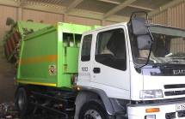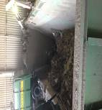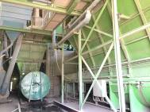

Semi-Annual Environmental
Monitoring Report
Reporting Period: January – June 2021

CLIENT – IMPLEMENTING AGENCY
State Unitary Enterprise (SUE) “MAXSUSTRANS” (Uzbekistan)

PIU SUPPORT CONSULTANT
Infratech Consulting SDN Ltd. (Uzbekistan)

TABLE OF CONTENTS

1 PREAMBLE 4
1.1 General 4
1.2 Headline Information 4
2 PROJECT DESCRIPTION AND CURRENT ACTIVITIES 6
2.1 Project Description 6
2.2. Project Contracts and Management 7
2.3. Project Activities During Current Reporting Period 11
2.4. Description of any Changes to Agreed Construction methods 14
3 COMPLIANCE WITH ADB LOAN COVENANTS 15
4 ENVIRONMENTAL SAFEGUARD ACTIVITIES 21
4.1 General Description of Environmental Safeguard Activities 21
4.2 Site Inspections 21
4.3 ADB Missions 23
4.4 Issues Tracking (Based on Non-Conformance Notices) 23
4.5 Trends 24
4.6 Unanticipated Environmental Impacts or Risks 24
5 RESULTS OF ENVIRONMENTAL MONITORING 26
5.1 Overview of Monitoring Conducted during Current Period 26
5.2 Trends 26
5.3 Summary of Monitoring Outcomes 27
5.4 Material Resources Utilization 29
5.5 Waste Management 29
5.6 Health and Safety 29
5.7 Training 29
6 FUNCTIONING OF THE SEMP 32
6.1. SEMP Review 32
7 GOOD PRACTICE AND OPPORTUNITY FOR IMPROVEMENT 33
7.1. Good Practice 33
7.2. Opportunities for Improvement 33
8 SUMMARY AND RECOMMENDATIONS 34
8.1. Summary 34
Annex 1: Environmental Management Plan (as before) 37

LIST OF FIGURES
No table of figures entries found.
LIST OF TABLES
Table 1: Summary of Civil Works Contracts and works’ progress 8
Table 2: List of organizations involved in environmental management under the Project 10
Table 3: Role of Agencies towards EMP Implementation 10
Table 4 Work schedule within Garage rehabilitation Contract 11
Table 5: Overview on project costs 12
Table 6: Ongoing Contracts of the Project No. L3067 - UZB 12
Table 7. Status of compliance with ADB’s Loan Covenants 15
Table 8. Issues Identified during the Previous Monitoring Period (before December 2020) 23
Table 9. Implementation Status of EMP during the pre-construction and construction period (Packages CW2, CW4) 28
Table 10 Material Mobilization 29
Table 11: Institutional Strengthening and Training Program 30
Table 12. Issues Identified During the Monitoring Period January – June 2021 (the same like in the previous SAEMR for July – December 2020) 34

ABBREVIATIONS
ADB | Asian Development Bank
BER | Bid Evaluation Report
CDP | Corporate Development Program
CSC | Construction Supervision Consultant
EHS | Environmental Health & Safety
EIA | Environmental Impact Assessment
EIP | Environmental Impact Permit
EMP | Environmental Management Plan
GoU | Government of Uzbekistan
GRM | Grievance Redress Mechanism
IEE | Initial Environmental Examination
LARP | Land Acquisition and Resettlement Plan
Maxsustrans | State Unitary Enterprise “Maxsustrans”
MSW | Municipal Solid Waste
PIU | Project Implementation Unit
SCEEP | State Committee of the Republic of Uzbekistan of Ecology and Environment Protection
SLF | Sanitary Landfill Facility
SPS | Safeguard Policy Statement
SSEMP | Site-specific Environmental Management Plan
SWM | Solid Waste Management
SWMIP | Solid Waste Management Improvement Project

PREAMBLE

General
- As per the Loan and Project Agreements for the L3067-UZB: Solid Waste Management Improvement Project (SWMIP), State Unitary Enterprise “MAXSUSTRANS” and Project Implementation Unit (PIU) is bound to ensure that (i) the project is constructed and operated in accordance with the national and local environmental regulations and guidelines, ADB's Environment Policy (2002) and the initial environmental examination (IEE) report; (ii) any adverse environmental impacts arising from the construction and operation of the project facilities are minimized by implementing the mitigation measures. Environmental monitoring program and other recommendations presented in the IEE report; and (iii) the implementation of the Environmental Management Plan (EMP) and violations of safety or environmental standards, if any, be regularly reported to ADB.
- This report is the 11-th environmental monitoring report (EMR) for the project and covers January-June 2021 reporting period. This Environmental Monitoring Report describes the implementation of the environmental monitoring and mitigation measures recommended in the IEE reports, analyzes environmental data collected from the projects during the period of January-June 2021, and provides recommendations for the resolution of identified issues.
- To be more specific, this EMR covers the following areas: (i) documentation review and compliance assessment with the applicable environmental regulations, (ii) environmental management institutional structure and responsibilities, (iii) mitigation measures undertaken to minimize adverse environmental impacts arising from the construction, (iv) environmental monitoring results and analyses, and (v) conclusions and recommendations.
- The Government of Uzbekistan (GoU) took tough measures against COVID-19 and has taken all necessary preventive measures to prevent the spread of coronavirus infection from March 2020. In particular, all transport communication has been limited. Tashkent went into quarantine mode, and most organizations and institutions were transferred to remote work.
- The project includes a dynamic Sanitary Landfill Facility (SLF) development concept approach. This utilizes the planned SLF as an immediate and effective solution for Tashkent’s waste disposal challenges, with the potential to progressively expand the facility to become a disposal solution that can serve the Tashkent region over the long term.
- In addition, the project finances:
- procurement of garbage trucks for collection and transportation household solid waste;
- procurement of equipment and machinery for the sanitary landfill;
- procurement of waste bins for waste collection points and containers for transportation of solid waste;
- revamping of two transfer stations in the city of Tashkent;
- reconstruction of two garages of Maxsustrans;
- construction of new landfill.
- Collection points are equipped with functional and suitably sized waste bins, with provision for recyclable materials to be segregated and collected. Outdated collection vehicle fleets will be replaced with appropriately sized and highly efficient collection vehicles, dramatically reducing operation and maintenance costs. Transfer stations will be equipped with improved infrastructure and electromechanical components, and the transfer trucks to the landfill will be replaced by new ones. With these activities an improvement of the environmental impact should be also expected.

Headline Information
- The GoU has applied for a loan from the Asian Development Bank (ADB) for the development and improvement of Solid Waste Management (SWM) system of the capital city (Tashkent). The loan reference number is L3067-UZB: Solid Waste Management Improvement Project (SWMIP). The loan was signed between the Republic of Uzbekistan and ADB dated 27 February 2014 and Project Agreement dated 12 March 2014 signed between ADB, Tashkent City Municipality and the State Unitary Enterprise “MAXSUSTRANS”.
- The project was prepared to impact an improved urban environment and quality of life for the residents of Tashkent. The project will develop a sanitary landfill that meets international standards, rehabilitate transfer stations, and modernize the waste collection and transfer fleet. It will build capacity in waste management and help formulate a national strategy on SWM.
- The GoU seriously recognizes the need to develop and implement a national SWM strategy. The Project will contribute to sustainable urban development in Uzbekistan by: (i) modernizing SWM to provide continuous and reliable municipal services; (ii) promoting financial sustainability of municipal services through tariff rationalization and prudent financial management; (iii) supporting policy and institutional reforms for improved sanitation and environmental management; (iv) mitigating climate change through a major reduction of Green House Gas emissions, and through compliance with international standards on waste minimization and material recycling; and through all these measures; (v) improving livability of cities.
- The volume of the existing dumpsite is exhausted and the original plan of the city was to extend its dumpsite operations to an adjacent lot of additional 30 hectares (ha) of area. Being fully aware of the inevitable environmental impacts through the extension of this practice, the city asked the national government for assistance in this matter. Based on these activities, the Cabinet of Ministers approved in summer 2012 the location of new dumpsite on 30 ha of agricultural area for the utilization for waste management activities.
- The GoU has already allocated a 30-ha land plot immediately to the south of the existing Akhangaran dumpsite (25 ha for landfill and 5 ha for facilities), to develop this facility to a SLF, designed to internationally accepted standards of environmental protection. A conceptual design has been completed for the interim 25-ha facility, which is naturally included as a component of the Project.

PROJECT DESCRIPTION AND CURRENT ACTIVITIES

Project Description
- The overall objective is to provide an improved SWM system in Tashkent, the capital city, to upgrade urban infrastructure and services. The project will develop a sanitary landfill that meets international standards, rehabilitate transfer stations, and modernize the waste collection and transfer fleet. It will build capacity in waste management and help formulate a national strategy on SWM.
- Given the current SWM practices, the option converting and allocating an area adjacent to the existing dumpsite to an engineered Sanitary Landfill was decided. The proposed SLF concept will be based on the Best Environmental Practices (BEP) resulting to a state-of–the-art design consistent with international acceptable standards. This “stand alone” facility will drastically improve the SWM system (i.e. the handling and final disposal of MSW) with a possible integration capability for a long-solution to cover the entire Tashkent Oblast. The inclusion into the design of a multi-barrier system, leachate and gas collection systems will result in a significant reduction of anticipated impacts. The Project is to contribute to the following issues:
- Segregation of municipal solid waste stream;
- Proper collection and dumping to appropriate sites;
- Establishment of modern SWM systems;
- Remediation of old 'truck and dump' practices in cities and regions
- The GoU through its Implementing Agency, the State Unitary Enterprise (SUE) “MAXSUSTRANS” utilizes part of this loan proceeds towards the cost of the contract for Consulting Services related to Project Management, Implementation and Supervision, supporting the Project Implementation Unit (PIU).
- ADB approved the project on 27 November 2013 with a loan amount of $69 million from its ordinary capital resources. The total project cost is $76.3 million equivalent, inclusive of taxes and duties, and financial charges during implementation. The Loan and Project Agreements were signed on 27 February 2014. The loan became effective on 29 December 2014. The project is designed for five years of implementation with a loan closing date of 30 June 2019. On 17 December 2018, ADB approved a two-year loan extension with the revised Loan Closing Date of 30 June 2021 to complete all ongoing contracts and planned civil works, delayed due to start-up delays (including 10 months’ delay in effectiveness) and procurement delays (the first contract was awarded in 2016 only) because of the executing agency’s insufficient capacity and government’s prolonged contract registration process.
- The project impact is improved urban environment and quality of life for the residents of Tashkent. The expected outcome is improved SWM services and management in Tashkent. The project has three outputs: output 1 - rehabilitated and expanded SWM system in Tashkent; output 2 - strengthened operational capacity; and output 3 - national SWM strategy. Tashkent Municipality is the executing agency for the outputs 1&2, with State Committee of the Republic of Uzbekistan of Ecology and Environment Protection (SCEEP) being the executing agency for output 3. Maxsustrans is the implementing agency responsible for the day-to-day project implementation.
- According to the Loan Agreement dated on 27 February 2014, the Project shall comprise:
Part A – National Municipal Solid Waste Strategy
(a) preparation of a draft national strategy for the management of solid waste, including a draft sector investment program;
Part B – Solid Waste Management in Tashkent Municipality
(b) construction and rehabilitation of municipal solid waste collection facilities;
(c) procurement of municipal solid waste collection bins;
(d) procurement of municipal solid waste collection vehicles and municipal solid waste transfer vehicles;
(e) rehabilitation of municipal solid waste transfer stations and possible closure of an existing municipal solid waste transfer station;
(f) design and construction of a new sanitary landfill, solid waste facility and closure of an existing landfill solid waste dumpsite;
(g) capacity development support for Maxsustrans, including in the areas of operation and management and Project implementation; and
(h) development and implementation of a waste minimization and recycling program and a parallel media and public awareness campaign about waste minimization and recycling.
- However, «construction and rehabilitation of municipal solid waste collection facilities» was financed by Maxsustrans own funds. In addition, «closure of an existing landfill solid waste dumpsite» will be financed by Sejin G&E Co. Ltd. Company (Republic of Korea) (See explanation below). Therefore these components are no longer part of the Project.

Project Contracts and Management
- Summary of civil works contracts and works’ progress is summarized in
- Table 1. All awarded contracts included EMPs cleared by ADB and any conditions of applicable national EIA/IEE clearance.

Table 1: Summary of Civil Works Contracts and works’ progress
Contractor | Scope | Contract  Signed | Approval Date |  |  | Environmental personnel |  | Civil Works |  | Progress
 |  |  | SSEMP | COVID-19 HSMP | ERP | Environmental officer | Health and safety officer | Start | End | As of 31 Dec 2020 | As of 30 Jun 2021
CW1: To be selected | Establishment of sanitary landfill | (Dec 2021) | - | - | - |  |  | (Jan 2022) | (Jun 2023) | - | -
CW2: JV of Future Growth Ltd., VBN Engineering Ltd and Eastern construction Ltd. (Uzbekistan) | Transfer station rehabilitation | 12 Apr 2021 | Apr 2021 | Apr 2021 | Apr 2021 | Mr. Nozimhon Saydullayev | Mr. Xasan Bashirov | 15 Apr 2021 | (14 Apr 2022) | 0% | 5%
CW3: Cancelled | Dumpsite closure
CW4: Indigo Baraka Servis LLC (Uzbekistan) | Garage rehabilitation | 7 Dec 2020 | 21 Dec 2020 | 21 Dec 2020 | Jan 2021 | Mr. Khabibulla Mukhtarov | Mr. Rakhmatilla Normatov | 16 Dec 2020 | 15 Aug 2021 | 5% | 75%
CW5: Various local contractors | Construction and rehabilitation of municipal solid waste collection facilities | Various contracts |  |  |  | n/a | n/a | Various dates | Various dates | 100% | 100%
Note: The Month/Years in brackets are planned schedule.
COVID-19 HSMP = COVID-19 Health and Safety Management Plan, ERP = Emergency Response Plan, SSEMP = site-specific environmental management plan
- The project is being administered by the Project Implementation Unit (PIU), which is currently represented by the Head of PIU (Mr. Jasur Hamidov).
- PIU has received аn official letter from H.P. Gauff Ingenieure GmbH & Co. KG. dated 24 July 2020 about оrdеr of the local court of Nurеmbеrg оn opening of insoIvency proceedings according to Gегmап Law regarding H.P. Gauff Ingenieure GmbH & Co. KG. PIU has also received аn official letter from H.P. Gauff Ingenieure GmbH & Co. KG.dated 17 September 2020 about declaration of non-entry of the соmраnу in the соntгасt No. SUE/Maxsustrans/QCBS-Cons 1-2016-01.
- Considering the necessity to соntinue the PIU Consultant sеrviсеs in огdеr to еnsurе uninterrupted implementation of the Project, the obligations under the Соntrасt No. SUE/Maxsustrans/QCBS-Cons 1-2016-01 is assigned to the local partner of the Joint Venture - Infratech Consulting SDN Ltd. (Uzbekistan). Maxsustrans has signed Amendment No. 5 to the a.m. contract on 9 December 2020 with extension of the Consultant’s service until 30 June 2021.
- The full rеsроnsibility of the Consultant to регfоrm this Соntrасt against the Client is handed over to lnfratech Consulting SDN Ltd. Mr. Dilshod Mavlyan-Kariev, K-4 national SWM Specialist (Deputy Team Leader) is in charge in the overall project administration and reporting for the Project.
- PIU Consultants has National Environmental Expert – Mr. Sergey Karandayev, who implements environmental safeguards services. He is personnel in charge of environmental affairs. He is responsible for arranging on-field monitoring activities, providing inputs to this semi-annual monitoring reports and making sure the protection measures are implemented accordingly.
- SUE Maxsustrans has recruited "China Urban Construction Design & Research Institute Co., Ltd." (CUCD) for Sanitary Landfill Design and Construction Supervision services. The design services of CUCD started in December 2018 and completed in October 2019. Based on design documents elaborated separately for sanitary landfill and dumpsite closure works, Maxsustrans has prepared the bidding documents und conducted the first bidding for the Works package CW1 – Establishment of Sanitary Landfill and Dumpstie Closure. The construction supervision services of CUCD are not started yet, because up to date Maxsustrans did not select the Contractor under package CW1. The service period of CUCD ended by 7 December 2020, and prolongation until 30 June 2021 (ADB Loan Closing Date) is currently considered by amendment to the Contract. To be noted that during construction period CUCD Consultants will serve as the “Engineer” with responsibility for design compliancy and construction supervision. Originally, the supervision task was estimated for 18 months.
- Engineer started with the work according to the ToR of CUCD since14 December 2018. CUCD has already completed the design works of closure of old dumpsite and establishment of new sanitary landfill in Akhangaran district. During the construction works they will supervise all construction works to be performed under package CW1 – Landfill Construction.
- According to Terms of Reference, Task 3 – Safeguard Management and Administration CUCD Consultants should conduct Environmental Impact Assessment (EIA) related to the proposed project - sanitary landfill and dumpsite closure designs and submit this for review and approval by SCEEP and obtain a positive conclusion. Referring to the Project’s Initial Environmental Examination from May 2013 (page 7 and page 8, Figure 1 – Uzbekistan National EIA Process) and national legislation on environmental protection, for proposed projects, EIA documentation shall include a declaration on environmental impacts / consequences. Declaration on environmental impacts (Russian abbreviation “ZVOS”) shall be prepared after design of the proposed project and Declaration on environmental consequences (Russian abbreviation “ZEP”) shall be prepared before construction works. Commencement of the construction works under the Works package CW1-R is scheduled by January 2022, so preparation of the EIA will be requested from CUCD Consultants during the 4th Quarter of 2021 – after prolongation of CUCD’s contract for works supervision phase.
- Due to the pending tender for the selection of the contractor for the construction of the landfill (package CW1), the civil works could not be commenced during the reporting period. Up to date, no decision has been taken regarding contract award under this package CW1.
- Main organizations involved in the project and related to environmental safeguards are presented in Table 2:
Table 2: List of organizations involved in environmental management under the Project
Organization | Name of main staff and Environmental Specialist | Contact data (including phone and web-site) and address of the organization | Employer | Commence-ment of Services | Completion of Services
PIU Support Consultant –Infratech Consulting SDN Ltd. | Mr. Dilshod Mavlyan-Kariev, Deputy Team Leader  Mr. Sergey Karandaev, Environmental Specialist | dilshod75@mail.ru  infratech_consulting@asia.com  +998 71 2477923 | SUE Maxsustrans | 01.08.2017 | 30.06.2021  Extension of Service period for 30 months until 31.12.2023 is under review
Sanitary Landfill Design and Supervision Consultant –China Urban Construction Design & Research Institute Co., Ltd.” | Mrs. Yuwei Xue,  Authorized representative  Mr. Mingtao Nie  Environmental Specialist | icc@cucd.cn +861057365133 | SUE Maxsustrans | 08.12.2018 | 07.12.2020  Extension of Service period until 30.09.2023 is under review
- The role of each agency in the project is presented in Table 3.
Table 3: Role of Agencies towards EMP Implementation
Agency | Role
Project Implementation Unit (PIU) | - Holds Overall responsibility with regard to EMP Implementation  - Reporting to various stakeholders (ADB, Regulatory bodies) on status of EMP Implementation  - Coordinating with Environmental Experts (PIU Support Consultant, Contractors and External Monitors)  - Responsible for obtaining Regulatory Clearances  - Review of the progress made by Contractors  - Ensure the BoQ items mentioned in EMP are executed as per contract provision
PIU Support Consultants | - Assisting PIU in overall implementation of EMP  - Review of periodic reports on EMP implementation and advising PIU in taking corrective measures  - Conducting periodic field inspection of EMP implementation  - Assisting PIU and reporting to various stakeholders (ADB, Regulatory bodies) on status of EMP implementation  - Conduct environmental training for field officers and engineers of contractor
Engineer | - Supervise the implementation of the environmental protection and impact mitigating measures by the contractors  - Supervise construction activities to ensure minimum impact on the natural and socioeconomic environment,  - Regularly monitoring the performance of the Contractor(s) environment staff, verifying monitoring methodologies and results;  - Review of the construction design to ensure compliance with project engineering design and the EMP with regard to environmental protection and impact mitigation;  - Prepare the necessary remedial actions for any unforeseen impacts  - Instructing the Contractor(s) to take corrective actions within timeframe as determined by the Environmental Specialist of CSC  - Address complaint related with environmental aspect of the project through GRM
Contractor | - Responsible for ensuring the implementation of EMP as per provision in the document  - Discussing various environmental / social issues and environmental / social mitigation, enhancement and monitoring actions with all concerned directly or indirectly  - To ensure environmentally sound and safe construction practices  - Conducting periodic environmental and safety training for contractor’s engineer, supervisors and workers  - Sensitization on social issues that may be arising during the construction stage of the project  - Conduct environmental monitoring and control activities including pollution monitoring, safety; and  - Preparing and submitting monthly reports to PIU on status of implementation of safeguard measures  - During the Covid-19 pandemic, the contractor will ensure necessary protection to the deployed WORK FORCE and minimize the risk of spread of infection.
- The working environment among SWMIP and Engineer has remained sound during this reporting period. Depending on the Corona Pandemic regular meetings couldn’t be held between PIU, Maxsustrans and Engineer. Currently the movement is not possible. Also, the contract final service date for Sanitary Landfill Design and Supervision Consultant was 07.12.2020. Extension of the service period is under discussion and additional agreement has not been signed during this reporting period.
- Control over execution of the Decree of the Cabinet of Ministers of the Republic of Uzbekistan № 895 dated November 1, 2018 was assigned to the First Deputy Prime Minister of the Republic of Uzbekistan - Chairman of the Board of "Uzbekistontemiryullari" JSC A.J. Ramatov, Deputy Prime Minister of the Republic of Uzbekistan - Chairman of the State Committee of the Republic of Uzbekistan on investments S.R. Kholmuradov and Chairman of the State Committee of the Republic of Uzbekistan on ecology and environment protection B.T. Kuchkarov. The overall responsibility for EMP implementation and compliance with Investment Agreement lies with the Executing Agency, which is SCEEP, responsible for general project implementation. Thus, SCEEP fulfills all responsibilities for environmental monitoring of this component. However, PIU Consultant will continue to carry out environmental monitoring of this component.

Project Activities During Current Reporting Period
- The status of three civil works packages of the Project is as follows: (i) package CW1 - Sanitary landfill and dumpsite closure (estimated cost $23.5 million), bid was cancelled by decision of Tashkent City’s Tender Commission , contract award is still pending; (ii) package CW2 - Transfer station rehabilitation (estimated cost $7.0 million), Contract award was approved by ADB on 25 March 2021, the contract SUE/ Maxsustrans/ICB/W2 was signed with the Contractor (JV of Future Growth Ltd., VBN Engineering Ltd and Eastern construction Ltd., Uzbekistan) on 12 April 2021; and (iii) package CW4 - Garage rehabilitation, Contract № 15/02-20 was signed with Indigo Baraka Servis LLC (Uzbekistan) on December 7, 2020, the works commencement date – December 16, 2020. The civil works are going on in both garages of Maxsustrans: Mirabad and Bektemir district.
- Work schedule within Contract No. 15/02-20 - Garage rehabilitation is provided in Table 4:
Table 4 Work schedule within Garage rehabilitation Contract
№ | Name of works | Works start date | Works finish date
1 | Territory preparation | 16.12.2020 | 20.12.2020
2 | Civil works | 18.12.2020 | 20.04.2021
3 | Finishing works | 10.03.2021 | 20.06.2021
4 | Electric installation work | 10.04.2021 | 01.06.2021
5 | Plumbing work | 10.04.2021 | 10.05.2021
6 | Special works, etc. | 10.04.2021 | 01.06.2021
7 | Landscaping | 21.06.2021 | 30.07.2021
Table 5: Overview on project costs

Source of Financing | Total (million USD) | %
Asian Development Bank Financing
Loan 3067-UZB (Ordinary Capital Resources) | 69.00 | 90.79%
Governmental Financing
Government of Uzbekistan (GoU) | 7.00 | 9.21%
Total | 76.00 | 100%
- Since the beginning of the assignment the PIU Consultant has arranged the following procurement packages of the Project:
Table 6: Ongoing Contracts of the Project No. L3067 - UZB
Subproject/Contract No. | Category (works, goods or services) | Contract Amount  ($ equiv.) | Contract Completion
Sanitary Landfill Design & Supervision Consultant | Services | 2,028,425.00 | 30-Jun-21
Financial Audit FY 2018 - FY 2021 | Services | 32,000.00 | 30-Jun-21
Transfer Station Rehabilitation Design and Supervision Consultant | Services | 81,600.00 | 30-Jun-21
Garage Rehabilitation Design and Supervision Consultant | Services | 97,600.00 | 30-Jun-21
CW4: Garage Rehabilitation | Works | 957,284.94 | 30-Jun-21
CW2: Transfer Station Rehabilitation | Works | 6,982,746.00 | 11-Apr-22

- Package CW2 - Transfer station rehabilitation. The contract SUE/ Maxsustrans/ICB/W2 was signed with the Contractor (JV of Future Growth Ltd., VBN Engineering Ltd and Eastern construction Ltd., Uzbekistan) on 12 April 2021. The following scope of work under package CW2 - Transfer station rehabilitation ( is valid for both transfer stations, but not limited to:

- Dismantling of the existing machinery and associated equipment and supporting steel construction;
- Dismantling of the ventilation / dust exhauster system;
- Hydraulic system and pipes;
- E-power cable system;
- Informatic sensors and IT-system & cable;
- Leachate collection and drainage system from both press;
- Rehabilitation of the surface (profile steel plates);
- Rehabilitation of existing fire prevention system, new hydrants etc.;
- Rehabilitation of the concrete surface of the unloading area;
- Rehabilitation of the concrete surface prior the press & container docking place;
- Electric engineering system;
- Emergency system;
- Steering container to rehabilitate;
- Other facilities

- Contract SUE/ Maxsustrans/ICB-G1 (Lot 1) and Contract SUE/ Maxsustrans/ICB-G1 (Lot 2) – Machinery and equipment. As part of these contracts, machinery and equipment for the sanitary dumpsite was delivered.
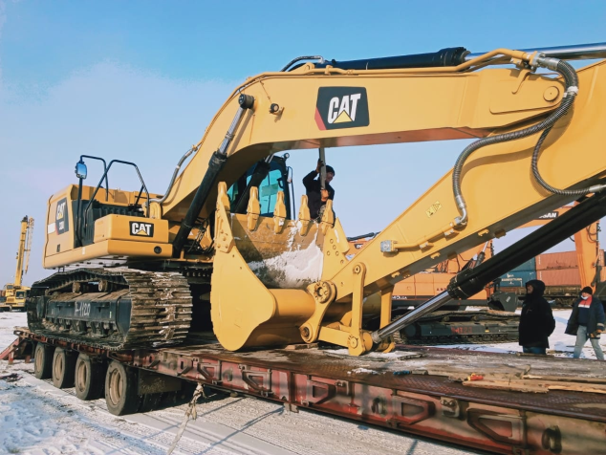 | 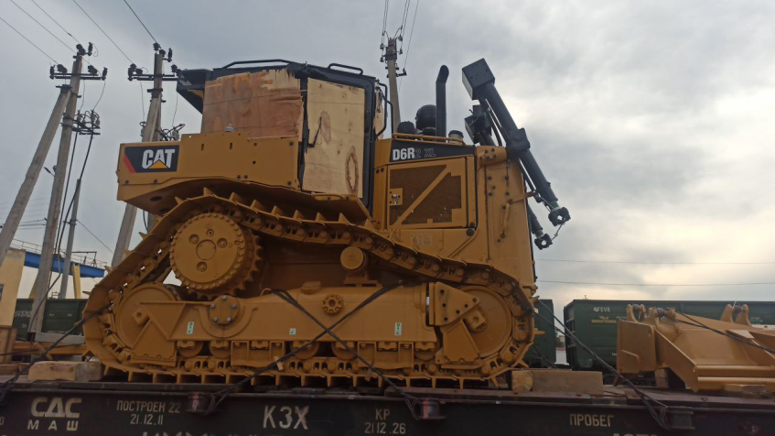
Photo 1 New machinery | Photo 2 New machinery
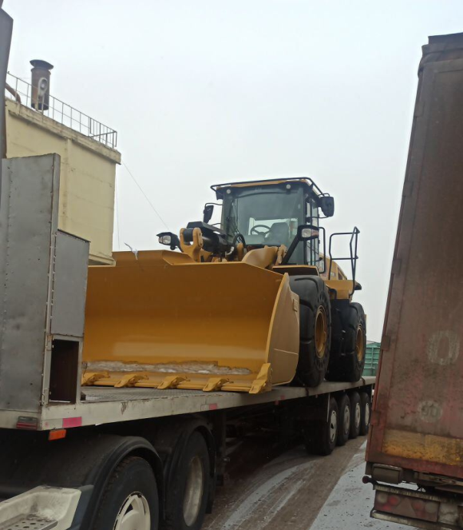 | 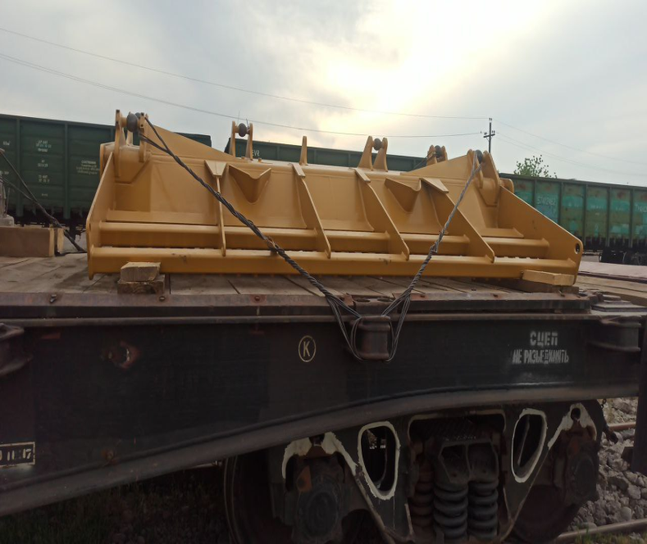
Photo 3 Special machinery for dumpsite | Photo 4 Special equipment for dumpsite
- Project implementation delays. The current delay relates to the government internal procurement review process, which has negatively affected the project implementation. For CW1, the original schedule for contract award is December 2019, IFB was posted on 15 October 2019 after 3.5 months’ delay, on 26 November 2019, bid opening was conducted. Initial bid evaluation was completed by 10 December 2019. However, the bid evaluation report was not reviewed by the Tender Committee of Tashkent Khokimiyat until 17 February 2020 despite ADB’s reminders through mission in December 2019, emails, and letters. No decision was made in the meeting because the executing agency did not attend.
- ADB through letter, emails and video conference (due to travel restriction caused by COVID-19, no mission can be fielded since March 2020) requested government intervention to complete the review and submit Bid Evaluation Report (BER). On 23 May 2020, the Tender Committee was convened however, instead of submitting BER, the executing agency sent a letter requesting rebidding without justifications on 28 May 2020. ADB responded to the executing agency on 19 June 2020 requesting submission of BER to justify the request and extension of bid validity. The BER was submitted on 25 June 2020 which is 7 months after the bid opening. After receiving ADB’s comments, the revised BER was submitted on 15 September 2020 proposing to award the contract to the noncompliant bidder. On 30 September 2020, ADB sent objection letter to the revised BER. Maxsustrans advised the Tender Committee reviewing the bid proposals and attempting to justify a request for rebidding called by the first deputy Mayor of Tashkent Municipality.
- ADB reminded Maxsustrans that significant delays in procurement would cause huge risks on the project completion, Maxsustrans should clarify the procedures and requirements of ADB’s Procurement Guidelines to the members of the Tender Committee, and the requirement of compliance with the Procurement Guidelines as agreed in the loan and project agreements between the government of Uzbekistan and ADB. ADB advised Maxsustrans to attend the procurement training organized by ADB and learn the FIDIC conditions which are internationally adopted for the contracts procured through international competitive bidding.
- The revised BER for package CW1 with the last decision of Tender Commission to conduct the rebidding was sent to ADB at the end of December 2020. Due to significant change in the scope of work of the contract, the executing agency and Maxsustrans would like to rebid this package for new landfill construction only. In particular, they intend to remove from this package all works related to dumpsite closure in Akhangaran District, referring to the recent letter from SCEEP that the old dumpsite is given for implementation of other investment project with the South-Korean company SEJIN.
- ADB reminded Maxsustrans and PIU that in accordance with paragraph 2.59 of the Procurement Guidelines, the borrower shall award the contract, within the period of the validity of bids, to the bidder who meets the appropriate standards of capability and resources and whose bid has been determined (i) to be substantially responsive to the bidding documents and (ii) to offer the lowest evaluated cost. A bidder shall not be required, as a condition of award, to undertake responsibilities for work not stipulated in the bidding documents or otherwise to modify the bid as originally submitted.

Description of any Changes to Agreed Construction methods
- No changes to agreed construction methods took place. «construction and rehabilitation of municipal solid waste collection facilities» was financed by Maxsustrans own funds. In addition, «closure of an existing landfill solid waste dumpsite» will be financed by Sejin G&E Co. Ltd. Company (Republic of Korea) (See explanation below). Therefore these components are no longer part of the Project.

COMPLIANCE WITH ADB LOAN COVENANTS
- The Environment Loan Covenants under SWMIP requires the design, construction, operation and implementation of all sub-project facilities is carried out in accordance with the environmental assessment and review procedures and Initial Environmental Examinations (IEEs) for core sub-components agreed upon between the Government and ADB, and complies with the Government’s environmental laws and regulations and ADB’s Environment Policy (2002). Any adverse environmental impacts arising from the construction, operation and implementation of sub-component facilities will be minimized by implementing the environmental mitigation and management measures, and other recommendations specified in environmental assessment reports (e.g., IEE etc.). The Government will ensure environmental requirements will be incorporated in bidding documents and civil works contracts. Issuance of bid documents will be made after review and clearance of IEE/EIA by ADB and SCEEP. PIU will prepare and submit semi-annual environmental report to ADB that describes progress in implementation of the EMP and issues encountered and measures adopted; and compliance with the relevant assurances and loan covenants.
- Table 7 shows the status of compliance with ADB’s loan covenants relating to environment, health and safety during the monitoring period: June to December 2020.
Table 7. Status of compliance with ADB’s Loan Covenants
Covenants | Reference to  Loan and Project Agreement | Status of Compliance (as of 30 June 2021)
Conditions for Award of Contract
6. The Borrower shall ensure that Maxsustrans shall not award any Works contract which involves environmental impacts until:  (a) SCNP has issued a statement of ecological expertise; and  (b) the Borrower has incorporated the relevant provisions from the EMP into the Works contract. | LA Schedule 4, para 6 | To be complied.  The EIA of construction of landfill site required by the national regulation will be prepared and approved before its works contract is awarded.
Consulting Services
The Borrower shall recruit the individual consultants for capacity development in the areas of project management, procurement, safeguards, financial management and monitoring and evaluation in accordance with procedures acceptable to ADB for recruiting individual consultants. | LA Schedule 4, para 10 | Complied.  In July and August 2015 the Borrower has recruited four individual consultants (two international and two national specialists) for capacity development of the IA and PIU in the areas of project management, procurement, safeguards, financial management and monitoring and evaluation in accordance with procedures of ADB. The individual service contracts were completed in the beginning of 2017, when the PIU Support Consultant has been selected and the Contract Cons_1 was signed.
Implementation Arrangements
- On or before the date that is 6 months after the Effective Date {29 December 2014}, the Borrower shall cause Maxsustrans to establish a website for the Project on which key information about the Project will be made available. The Project website will be accessible to the public and will include the following information about the Project:  - Project scope, structure, responsible agencies, impact, outcome and outputs;  - Status of Project targets;  - Procurement and consulting services information, including announcement of bidding processes, bidding procedures, list of participating bidders, names of winning bidders, amount of contract awards and a description of the goods or services procured; and  - All key safeguards related documentation, including the EMP and RP.  The Project website will be updated regularly, and its content will be presented in the English, Russian and Uzbek languages. | LA Schedule 5, para 2 | Partially Complied.  Project website is www.maxsustrans.uz. Project information is available in Uzbek, Russian and some key information on English as well.  c. As of 30 June 2021, the following procurement related information has been posted:  1) Contract award announcement:  - SUE/Maxsustrans/ICB-W2 Transfer Station Rehabilitation  2) Bid announcement:  - None  d. As of 30 June 2021, the following safeguards related documentation are disclosed in English and Russian languages:  - Environment Impact Assessment for New Landfill, 2013 (Russian language)  - SAEMR for July – December 2020  - SAEMR for January – June 2020  - SAEMR for July - December 2019  - SAEMR for January – June 2019  - SAEMR for July - December 2018  - Quarterly EMR for July - September 2018  - Quarterly EMR for April - June 2018  - Quarterly EMR for January - March 2018  The IEE of the Project (including the EMP) has been not disclosed in an accessible place and in a form and language(s) understandable to affected people and other stakeholders as of 30 June 2021.  Up to date the documentations listed in item (d) above and IEE including EMP were not disclosed in Uzbek language. Maxsustrans will prepare and disclose the Uzbek translation of the documents mentioned above until 31 January 2022.
- The Borrower shall cause Tashkent Municipality and Maxsustrans to: (i) use their best endeavors to ensure that critical Project staff remain in their position on a full-time basis for a reasonable duration to ensure continuity in the implementation of the Project; and (ii) ensure that all Project Executing and Implementing Agencies are adequately staffed and provided with the necessary financial, technical, and other resources to perform their functions under the Project. | LA Schedule 5, para 3 | Complied.  Since 1 August 2018, Mr. Rakhmatilla Karshiev has been appointed as Director and Mr. Sherzod Kattakhodjaev as Deputy Director of Maxsustrans.  On 30 June 2020 Mr. Rustam Shukurov, Acting Head of SWMI Project Implementation Unit has retired and since 7 July 2020, Mr. Jasur Khamidov was appointed as Acting Head of SWMI Project Implementation Unit.
Environment
- The Borrower shall cause Maxsustrans to ensure that the preparation, design, construction, implementation, operation and decommissioning of the Project and the Project Facilities comply with (a) applicable laws and regulations of the Borrower relating to environment, health, and safety; (b) the Environment Safeguards; and (c) all measures, and requirements set forth in the IEE, the EMP, and any corrective or preventative actions set forth in a Safeguards Monitoring Report. | LA Schedule 5, para 5 | NOT complied  The borrower is required to disclose IEE (including the EMP) in an accessible place and in a form and language(s) understandable to affected people and other stakeholders. But this has not been done as of 30 June 2021. (See Table 7)  Currently two companies are engaged by Maxsustrans, in particular:  - Sanitary Landfill Design and Supervision Consultant (China Urban Construction Design & Research Institute Co., Ltd., China)  - Transfer Stations Rehabilitation Design and Supervision Consultant (Quality Planning Ltd., Uzbekistan)  - Garage Rehabilitation Design and Supervision Consultant (Quality Planning Ltd., Uzbekistan)  These Сonsultants have prepared the design documentation in compliance with applicable laws and regulations of Uzbekistan relating to environment, health, and safety; the Environment Safeguards; and all measures, and requirements set forth in the IEE, the EMP. The corrective or preventative actions, if any, are provided in Safeguard Monitoring Reports submitted by PIU Consultants to PIU and Maxsustrans.  However, CW2 contractor started the civil works before the SSEMP, COVID-19 HSMP and ERP were prepared based on Table 2.
Human and Financial Resources to Implement Safeguards Requirements
- The Borrower shall make available or cause Maxsustrans to make available necessary budgetary and human resources to fully implement the EMP and the RP. | LA Schedule 5, para 9 | Complied. Ongoing  To implement the EMP and the RP Maxsustrans has recruited:  - Mr. Irakli Kaviladze (Georgia) as International safeguard specialist (contract signing date: 19-Aug-2015; contract completion date: 23-Jan-2017)  - JV “H.P. Gauff Eng. & Infratech Consulting SDN Ltd.” as PIU Support Consultant (JV’s contract signing date: 11-Jan-2017; contract completion date: ongoing). The Consultant employed the National environmental specialist Ms. Julia Alekseeva (UZB) and replaced by Mr. Sergey Karandaev (UZB) and also the National social safeguard and development specialist Ms. Maria Malinovskaya. All national specialists were responsible up to date for monitoring of EMP and RP according to TOR of the PIU Support Consultant. The safeguard monitoring and reporting will be continued by PIU Support Consultant until commencement of the Works under the package CW1-R: Sanitary Landfill Establishment.  - China Urban Construction Design & Research Institute Co., Ltd. as Sanitary Landfill Design and Supervision Consultant (contract signing date: 16-Nov-2018; contract completion date: ongoing). The Consultant employed the international key specialists: Mr. Mingtao NIE (CHN), Environmental specialist and Ms. Dajiang SUN (CHN), Social Safeguard Specialist. According to TOR of the Consultant, one of the key tasks of the Consultant’s safeguard specialists is to ensure that construction work is carried out by the Contractor in accordance with environmental and social norms and regulations of Uzbekistan and ADB.
Safeguards–Related Provisions in Bidding Documents and Works Contracts
- The Borrower shall ensure or cause Maxsustrans to ensure that all bidding documents and contracts for Works contain provisions that require contractors to:  - comply with the measures relevant to the contractor set forth in the IEE, the EMP and the RP (to the extent they concern impacts on affected people during construction), and any corrective or preventative actions set forth in a Safeguards Monitoring Report;  - make available a budget for all such environmental and social measures;  - provide Maxsustrans and the Borrower with a written notice of any unanticipated environmental, resettlement or indigenous peoples risks or impacts that arise during construction, implementation or operation of the Project that were not considered in the IEE, the EMP and the RP;  - adequately record the condition of roads, agricultural land and other infrastructure prior to starting to transport materials and construction; and  - reinstate pathways, other local infrastructure, and agricultural land to at least their pre-project condition upon the completion of construction. | LA Schedule 5, para 10 | Complied. Ongoing  The provisions listed in this covenant have been considered and included in the Bidding Documents for the Works packages, which are currently in bid stage:  - CW1: Sanitary Landfill Establishment and Dumpsite  - CW2: Transfer Station Rehabilitation
Safeguards Monitoring and Reporting
- The Borrower shall do the following or cause Maxsustrans to do the following:  - submit semi-annual Safeguards Monitoring Reports to ADB and disclose relevant information from such reports to effected persons promptly upon submission;  - if any unanticipated environmental and/or social risks and impacts arise during construction, implementation or operation of the Project that were not considered in the IEE, the EMP and the RP, promptly inform ADB of the occurrence of such risks or impacts, with detailed description of the event and proposed corrective action plan; and  - report any actual or potential breach of compliance with the measures and requirements set forth in the EMP or the RP promptly after becoming aware of the breach. | LA Schedule 5, para 11 | Complied. Ongoing  - Maxsustrans submitted to ADB the following Safeguards Monitoring Reports, which have been disclosed on Maxsustrans website: https://maxsustrans.uz/uz/project/dokumenty-po-proektu in English and Russian languages:  • Environment Impact Assessment for New Landfill, 2013 (Russian language only)  • SAEMR for July – December 2020  • SAEMR for January – June 2020  • SAEMR for July - December 2019  • SAEMR for January – June 2019  • SAEMR for July - December 2018  Up to date the above mentioned documentations were not disclosed in Uzbek language. Maxsustrans will prepare and disclose the Uzbek translation of the documents listed in item (a) until 31 December 2021.  - Complied. Ongoing;  - Complied. Ongoing.
Prohibited List of Investments
- The Borrower shall ensure that no proceeds of the Loan are used to finance any activity included in the list of prohibited investment activities provided in Appendix 5 of the SPS. | LA Schedule 5, para 12 | Complied.
Health and Labor Standards
- The Borrower shall cause Maxsustrans to ensure that contractors engaged under contracts for Works:  - comply with all applicable labor laws;  - use their best efforts to employ women and local people, including disadvantaged people, living in the vicinity of the Works;  - provide equal pay to men and women for work of equal type;  - provide and adequately equip first-aid, health and sanitation, and personal hygiene facilities for male and female workers at the Works sites;  - maximize female training and employment;  - conduct an information and education campaign on sexually transmitted diseases and HIV/AIDS for construction workers as part of the health and safety program at campsites and adjacent communities during Works implementation; and  - abstain from child labor.  Relevant Works contracts must include specific clauses on these undertakings. | LA Schedule 5, para 13 | Complied. Ongoing  - In the Works Contract No. SUE/Maхsustrans/NCB-W4 “Garage Rehabilitation” dated 07.12.2020, paragraph 81 stipulates to:  (a) comply with all applicable labor laws;  (b) make every effort to recruit women and local residents, including the poor living in the immediate vicinity of the Works;  (c) ensure equal pay for men and women for work of the same type;  (d) provide and adequately equip first aid, health and sanitation and personal hygiene facilities for men and women at work sites;  (e) maximizing the qualifications and employment of women;  (f) conduct an information and education campaign on sexually transmitted diseases and HIV / AIDS for construction workers as part of the health and safety program in campsites and surrounding communities during work; and  (g) refrain from child labor.  The Contractor is “Indigo Baraka Servis” LLC, Tashkent, Uzbekistan.

ENVIRONMENTAL SAFEGUARD ACTIVITIES

General Description of Environmental Safeguard Activities
- During the reporting period, there were no any changes in the organizational structure of the project. The PIU Consultant has supervised and monitored the project implementation process.
- During the monitoring period, the National Environment Specialist of PIU Consultant prepared environmental monitoring report(s) required by PIU and ADB and visited the project area to conduct visual assessment of the lands allocated for the project needs in July 2020. As mentioned in Table 7 of this report (item: Human and Financial Resources to Implement Safeguards Requirements) to implement the EMP and to monitor the environmental safeguard activities Maxsustrans has recruited:
- the international environmental specialist Mr. Irakli Kaviladze and after completion his services in January 2017,
- the national environmental specialist of PIU Support Consultant (JV “H.P. Gauff Eng. & Infratech Consulting SDN Ltd.”) has continued to monitor and report on environmental safeguard activities since August 2017 up to date, and
- starting from January 2022 (the indented commencement of the Works on the new landfill site) the international environmental specialist of Sanitary Landfill Design and Supervision (China Urban Construction Design & Research Institute Co., Ltd.) will be responsible for monitoring of implementation of EMP (i.e. SSEMP) and report to Maxsustrans/PIU accordingly.

Site Inspections

- There was no audit visit for contract CW2 - Transfer Station Rehabilitation as at the time of report submission (June 30, 2021), only 5% of the Works has been performed. The Contractor did not start the main part of the Works, just mobilization and minor site preparatory activities.

Garage Rehabilitation (Contract CW4)
- Mr. Karandaev, PIU Support Consultant Environmental Specialist visited Mirabad and Bektemir garages where the civil works under the contract No. SUE/Maxsustrans/NCB-W4 - Garage Rehabilitation signed on December 7, 2020 were commenced on December 16, 2020. Mr. Karandaev conducted visual assessment of impacts related to garage reconstruction in February, March and May 2021. The civil works are going on in both garages of Maxsustrans: Mirabad and Bektemir district. At the moment, civil works are being carried out at both facilities. Necessary precautions are taken to ensure effectiveness of environmentally appropriate systems of collecting, transporting and depositing of wastes.

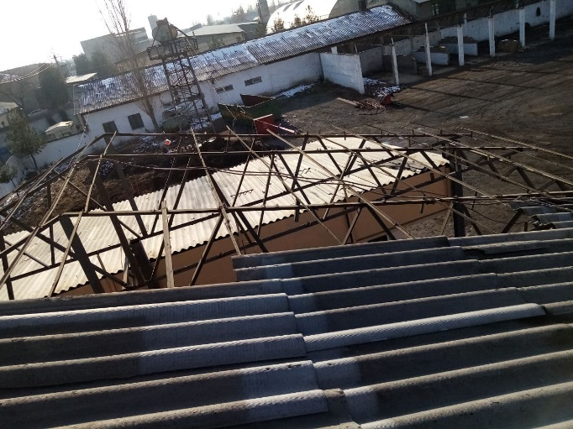 | 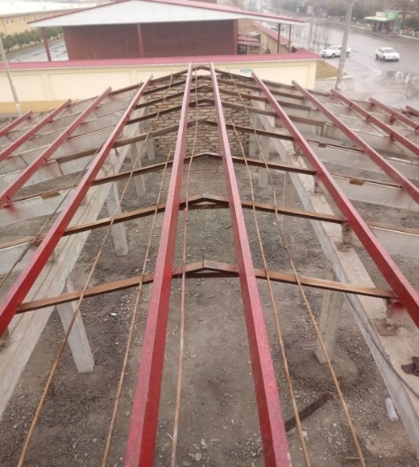
Photo 5 Rehabilitation work. Roof of Bektemir Administrative and household complex | Photo 6 New Roof of Bektemir Administrative and household complex
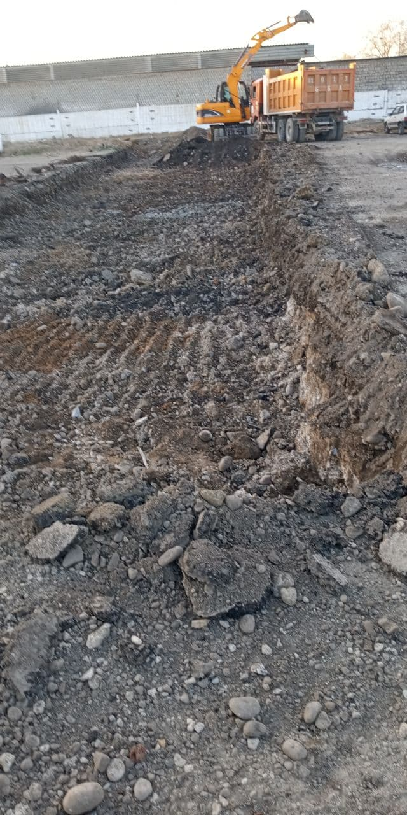 | 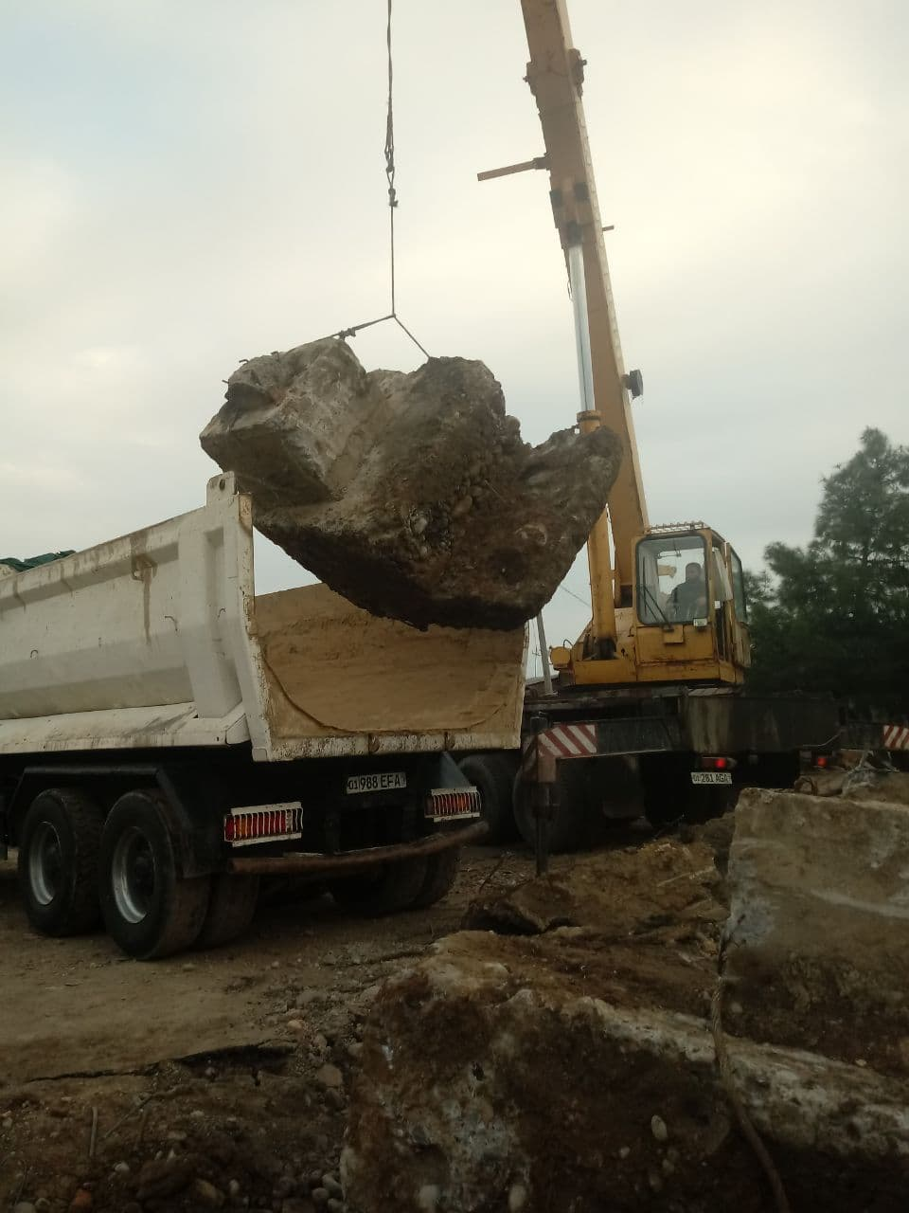
Photo 7 Preparatory work. Clearance of territory | Photo 8 Preparatory work. Clearance of territory
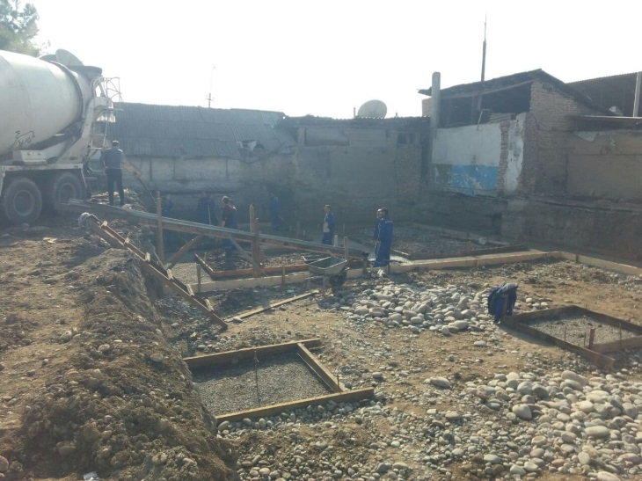 | 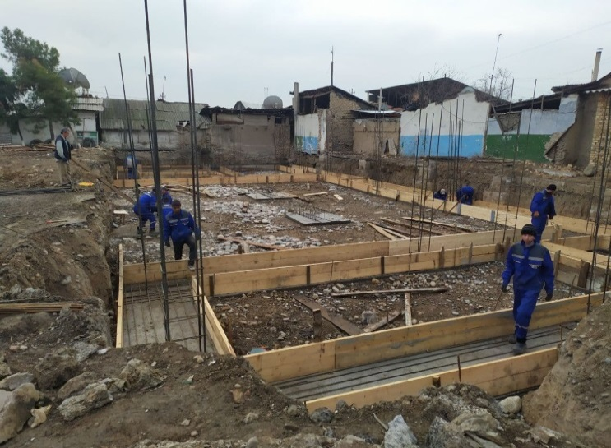
Photo 9 Foundation Fill | Photo 10 Construction works (garages, car wash)

ADB Missions
- There were not any ADB environmental & safeguard related field mission in this period. However, compliancy of safeguard issues on the old dumpsite due to starting of civil works (soil recovering) by Korean company Sejin was discussed at video conference with ADB team conducted during the reporting period.

Issues Tracking (Based on Non-Conformance Notices)
- There was no issue identified during the previous monitoring period (before December 2020).
Table 8. Issues Identified during the Previous Monitoring Period (before December 2020)
Issue | Required Action | Responsibility | Timing (Target Dates) | Description of Resolution and Timing (Actual) | If not yet resolved, indicate the reason why and specify further required action and timeframe.
1. The updated EIA of construction of new landfill site required by the national regulation has not been prepared. | An updated EIA of construction of new landfill should be prepared for further approval by the State Committee of Ecology and Environmental Protection (SCEEP) before construction works. | Maxsustrans together with recruited local firm and with support by CUCD Consultant | November 2021 | NOT DONE YET: Scheduled for November 2021 after signing and contract extension for the CUCD Consultant
2. Approval of the updated EIA by SCEEP has not been obtained | Approval of the updated EIA of construction of new landfill should be received from SCEEP. | Maxsustrans (with CUCD Consultant’s support) | December 2021 | NOT DONE YET: Scheduled for December 2021 after signing and contract extension for the CUCD Consultant
3. The PAM (Solid Waste Management Improvement Project: Project Administration Manual | Asian Development Bank (adb.org)) requires “international safeguards specialist” to implement and monitor the environmental safeguard activities of the Project | During the construction works on new landfill site, which is scheduled from January 2022 + 18 months, monitoring and reporting on environmental safeguard activities should be performed by international environmental specialist of Landfill Design and Supervision Consultant (CUCD).  Note: Up to date this task has been performed by national environmental specialist of PIU Support Consultant. In the beginning of the Project (until January 2017) this task was performed by international environmental specialist Mr. Irakli Kaveladze. | CUCD Consultant | January 2022 | NOT DONE YET: Scheduled for January 2022 after signing and contract extension for the CUCD Consultant

Trends
- During the reporting period, monitoring and audits of construction sites did not reveal any issues and complaints from the public regarding non-compliance with environmental safeguards.

Unanticipated Environmental Impacts or Risks
- COVID-19 pandemic is unanticipated impact. The detailed directions which must be followed as precaution to COVID-19 should be reflected in SSEMP to be submitted by the Construction Contractor before commencement of construction activities.
- According to the ADB letter dated 01.09.2020 about the necessity of conducting COVID-19 risk assessment at the project level and updating the respective plans such as Health and Safety Plan (HSP) and Emergency Response Plan (ERP), as well as Environmental Management Plan (EMP), the PIU Support Consultant gave consultation for updating plans above.
- All H&S procedures associated with COVID-19 pandemic and recommended by WHO and Uzbek government are addressed and followed. H&S plan has been updated accordingly ADB request. Special COVID 19 Emergency Response plan has been elaborated.
- The health and safety requirements of any construction activity must also not be compromised at this time. If an activity cannot be undertaken safely due to a lack of suitably qualified personnel being available or social distancing being implemented, it should not take place.
- Due to the outbreak of CORONAVIRUS (COVID 19) all over the world, the ongoing Contractors were very much conscious and proactive about the pandemic of the COVID and took necessary precautionary and preventive measures. They organized special awareness meeting and training to the workers. They also adjusted work plan according to the situation and carried out appropriate precautionary and safeguard measured against spreading and infection of Coronavirus Pandemic during the reported period.
- The ongoing Contractor has taken additional protective measures against its employees. Thus, all Contractor's employees were provided with protective/medical masks, medical gloves, and antiseptics. Every day, before the start of the working day, as well as at the end of the working day, the employee's body temperature was measured. Additional wet cleaning was carried out in the office.
- In addition, the EHS management plan should be prepared by Contractor within contract CW1 before commencement of civil works and aligned with relevant government regulations and guidelines on COVID-19 prevention and control, and with international good practice guidelines. The plan should include COVID-19 prevention and control measures, including disinfection/cleaning of offices, construction sites and labor camps, on-site temperature checks, social distancing measures, mandatory use of personal protective equipment such as facemasks, provision of handwashing stations and hand sanitizers etc., and procedures to be adopted in the event any worker is infected with COVID-19.

RESULTS OF ENVIRONMENTAL MONITORING

Overview of Monitoring Conducted during Current Period
- Initial Environmental Examination (IEE) report designed for all phases (design, construction and operation) for SWMIP was prepared in 2013. However, this ‘Environmental Monitoring Report’ covers only the design phase impact monitoring, as there is no construction activity.
- Current Situation depend on the Corona Pandemic: No significant environmental issues were flagged and no complaints received from the local residents and no adverse impacts occurred as a result of no construction activities during the reporting period.
- No specific environmental monitoring program was suggested for the closed dumpsite. In the technical specification a groundwater monitoring program (composition and level) is included covering both the closed dumpsite and the new sanitary landfill.
- There are no surface water streams in the valley where the existing dumpsite is located and no traces of surface erosion in the bottom of the valley are visible. As the precipitation in the area is very low an attempt to monitor surface water run-off (and potential leak of leachate through the slopes) from the closed dumpsite is deemed inappropriate.
- Other environmental monitoring such as noise and dust is not relevant as no activities take place at the site.
- Meteorological monitoring should be included in the monitoring program and this should cover both the new landfill and the closed dumpsite.
- Most of the environmental monitoring requirements are for the construction period of project site. At the construction stage, the Contractor’s site engineer is responsible for the preparation and submission of monthly environmental supervision reports. Meanwhile, the PIU is responsible for the monitoring of environmental parameters and preparing environmental results reports. The National Environmental Specialist of PIU Support Consultant is responsible for compiling the environmental monitoring reports.
- Monitoring and reporting of the project will be conducted prior to construction, during construction, and during operation. The PIU shall monitor the performance and implementation of the EMPs. Monitoring reports on the performance and in implementing the EMPs, shall be prepared prior to construction (detailed engineering design and procurement stages), during construction and during project operation, as follows: i) monthly progress reports; and ii) quarterly monitoring reports to be submitted to ADB. The monitoring report/s shall also document the relevant environmental aspect and its respective mitigation measure, as well as grievances received and resolved, if any.
- Prior to commencement of any construction work, contractor has to submit a Site-specific EMP and compliance report to PIU ensuring that all identified impacts detailed in the environmental assessment have been undertaken. The PIU will review reports submitted by CC as soon as construction works commence.
- The PIU supposed to organize an induction training to discuss the submitted SSEMP including environmental monitoring requirements and reporting of unexpected adverse impacts or impractical mitigating measures observed during the construction phase.

Trends
- Contractor’s HSE performance is generally satisfactory, relevant trainings are provided to the site staff, required documents and reports submitted, waste segregation and disposal procedure acceptable. Work will be carried out on periodic monitoring of the construction site for compliance with the SSEMP requirements by the PIU Consultant. During the monitoring, special attention will be paid to the organization of timely waste removal, dust suppression, dump storage, health safety of workers and the local population.

Summary of Monitoring Outcomes
- Table 9 summarizes the implementation status of EMP during the monitoring period on Package CW2 and CW4.

Table 9. Implementation Status of EMP during the pre-construction and construction period (Packages CW2, CW4)
Impacts | Mitigation/Enhancement Measures | Compliance Attained |  | Comment on Reasons for Partial or Non-Compliance | Required Action and Target Dates to Achieve Compliance
 |  | CW2 | CW4
Pre-Construction Phase
Health & safety | - Proper appraisal and timely compensation as defined in the LARP. | Yes | Yes
 | - Ensure that irrigation to affected plot/s aside from the allocated area remains unimpeded. | Yes | Yes
Construction Phase
Noise generation | - Install mufflers and silencers for machines and equipment
 | - Avoid working during rest periods / nighttime | Yes | Yes
 | - Regularly maintain equipment | Yes | Yes
 | - Establish fences around the work area as barrier | Yes | Yes
 | - Impose minimum speed limits within the project site | Yes | Yes
Flora | Re-introduce local occurring vegetative cover in areas within the SLF where it would be most appropriate. Shallow rooted vegetation is recommended | N/A | N/A
Traffic | - Regulate the entry and exit of vehicles and equipment in the construction site | Yes | Yes
 | - Properly regulate delivery of materials into the project site | Yes | Yes
 | - Impose minimum speed within the project site | Yes | Yes
 | - Do not allow vehicles to stay within the project site for a long period of time | Yes | Yes
 | - Regular monitoring to ensure that traffic flow remains optimal and clean-up of any debris can be undertaken immediately. | Yes | Yes
 | - Regular maintenance of equipment. | Yes | Yes

Material Resources Utilization
- No special licenses/permits are required for Contractors CW2 and CW4.
- Surveying and identification of all utilities were done with the participation of the relevant Stakeholder. Information about use of electricity, water and construction materials during the civil works were not provided in the SSEMP, because they are not subject of regular monitoring.
- As for June 2021 following materials were mobilized on site by the Contractor CW4:
Table 10 Material Mobilization
N | Materials | Unit | Quantity
1 | Cement | T | 25.7
2 | Sand | T | 14.5
3 | Steel strip details | T | 3.4
4 | Reinforcement | T | 20

- For storing and utilization scrap material the Contractor is using specially equipped site. Periodically, it is sold to the different companies according to the market price of metal.

Waste Management
- According to EMP and SSEMP, all wastes from the construction sites should be disposed of in accordance with national environmental regulation. In the course of construction work, waste sometimes accumulates, including both construction and domestic waste. Waste management is organized by Contractors according to the developed Site-specific EMP. Waste segregation and disposal procedure established.

Health and Safety
- During the Covid-19 pandemic, the contractor will ensure necessary protection to the deployed WORKFORCE and minimize the risk of spread of infection.
- These are exceptional circumstances and the contractor must always remain abreast of and comply with the latest Government advice on COVID-19.
- The health and safety requirements of any construction activity must also not be compromised at this time. If an activity cannot be undertaken safely due to a lack of suitably qualified personnel being available or social distancing being implemented, it should not take place.
- It is to be noted that emergency services are also under great pressure and may not be in a position to respond as quickly as usual.
- The Contractor site in charge should remind the workforce at every opportunity of the Worksite Procedures which are aimed at protecting them, their colleagues, their families and the population residing in the vicinity.

Training
- To increase the public safety, the Contractors provided training and awareness rising to its personnel and workers about safety at work sites before the commencement of the civil works.
- Due to the outbreak of COVID-19) all over the world, the Contractors were very much conscious and proactive about the pandemic of the COVID-19 and took necessary precautionary and preventive measures. They organized special awareness meeting and training to the workers. They also adjusted work plan according to the situation and carried out appropriate precautionary and safeguard measured against spreading and infection of Coronavirus Pandemic during the reported period.
- To ensure effective implementation of the EMP, the capacity of the PIU, contractors will be strengthened, and all parties involved in implementing mitigation measures and monitoring of environmental performance must have an understanding of the goals, methods, and the best practices of project environmental management. It will be offered series of trainings to strengthen the capacity of the PMO and IAs concerned for EMP implementation. The main training emphasis will be to ensure that the contractors and PIUs are well versed in environmentally sound practices and are able to undertake all construction and operation with the appropriate environmental safeguards.
- The training program also addresses long-term capacity building and awareness raising needs, i.e. for the operational phase of the sanitary MSW landfills. Training and awareness raising campaigns will be provided by qualified operation and maintenance experts and the consultants.
- An evaluation questionnaire will be used to assess the effectiveness of the training and the training program will be adjusted based on feedbacks. Training will be provided throughout the implementation of the project and the training program is summarized in Table 10.
Table 11: Institutional Strengthening and Training Program
Training topic | Scope of Training
Procurement and contract management | - ADB’s procurement guideline and bidding procedure  - Bidding document preparation, including EMP clauses  - Risk of improper procurement and mitigation measures  - Handling variation orders and contract management
Implementation of EMP and other health and safety requirements | - EMP contents and EMP implementation, including implementation responsibilities, environmental monitoring, supervision, inspection and reporting, consultation and participation, mechanism of EMP review, feedback and adjustment;  - Site EMP preparation and implementation reporting procedures,  - EHS considerations during project construction and operation;  - Monitoring and inspection methods, data collection and processing, interpretation of data, reporting system;  - Communication with the public by different means (innovative community-based advocacy campaigns);
Grievance redress mechanism (GRM) | - GRM structure, responsibilities and timeframe  - Types of grievances, eligibility assessment;  - Use and purpose of GRM;  - Subproject level GRM;  - ADB requirements for GRM;  - GRM procedures;  - Roles and responsibilities;
Municipal solid waste management | - Integrated MSW management system  - Kitchen waste management  - Construction waste management  - MSW reduce, reuse, and recycle  - Policies and regulations for MSW management  - MSW sorting and recycling  - MSW source utilization  - New technologies in MSW treatment and management  - Waste charging to incentivize higher waste minimization, waste reuse, and recyclingrates  - Public awareness program
Emergency preparedness and response planning | - Response mechanism to incidents such as spills  - Response plan development  - Mitigation measures for similar events  - Emergency response team, procedure and actions  - Drills of emergency response plan
Construction safety | - International and national good practice for safety at construction sites  - Policies for improving construction safety  - Safety risk and hazard assessment  - Safety training program development and implementation  - Public awareness program and education
Operation of sanitary landfill and leachate facility | - Good practice of sanitary MSW landfill management;  - O&M of sanitary MSW landfills;  - O&M of leachate facilities  - Effluent monitoring from the leachate facilities

FUNCTIONING OF THE SEMP

6.1. SEMP Review
- Site-Specific Environmental Management Plan (SSEMP) for CW2 and CW4 were prepared to ensure compliance with the ADB’s environmental safeguard requirements and all applicable laws, regulations, and standards for environmental protection in Republic of Uzbekistan. The SSEMPs contains the measures to mitigate and prevent the unwanted effects that may arise during the Project implementation, as well as the monitoring actions to check the compliance of construction works implementation process to the planned mitigation measures. The Contractor is responsible for implementation of SSEMP during construction works.
- At this stage, presented mitigation measures are effective and there is no need for corrections or alternatives. So, no changes needed in the mitigation measures of the Environmental Management Plan at the moment.
Public Awareness Activities:
- No public awareness activities among population who lived along project sites were carried out within the project during the period of January – June 2021.
The impact of the restrictive measures of the Government of Uzbekistan due to COVID-19 pandemic has affected the work of environmental specialist on the sites in terms of ensuring disclosure of information on the EMP activities. The environmental specialist on the site was not able to fully carry out his work according to the developed environmental impact management system of the project. The public awareness activities were not carried out within the monitoring period to population who living along project sites.
Public awareness activities on the new landfill site (package CW1-R) will be conducted by the Contractor, in case of commencement of civil works in January/February 2022. The environmental specialist of the Landfill Design and Supervision Consultant (CUCD team) will be responsible for monitoring and reporting on these activities on this site.

GOOD PRACTICE AND OPPORTUNITY FOR IMPROVEMENT

7.1. Good Practice
- Any activity assessed as a good practice was not recorded. The mitigation measures outlined in the SSEMP are sufficient, effective and acceptable.

7.2. Opportunities for Improvement
- At the moment, such areas for this construction project have not been identified.

SUMMARY AND RECOMMENDATIONS

8.1. Summary
- The issues identified during this monitoring period is summarized in Table 12.
Table 12. Issues Identified During the Monitoring Period January – June 2021 (the same like in the previous SAEMR for July – December 2020)
Issue | Required Action | Responsibility | Timing (Target Dates)
The updated EIA of construction of new landfill site required by the national regulation has not been prepared (raised in the SAEMR for July - December 2020). | An updated EIA of construction of new landfill should be prepared for further approval by the State Committee of Ecology and Environmental Protection (SCEEP) before construction works. | Maxsustrans together with recruited local firm and with support by CUCD Consultant | November 2021
Approval of the updated EIA by SCEEP has not been obtained (raised in the SAEMR for July - December 2020). | Approval of the updated EIA of construction of new landfill should be received from SCEEP. | Maxsustrans (with CUCD Consultant’s support) | December 2021
The PAM (Solid Waste Management Improvement Project: Project Administration Manual | Asian Development Bank (adb.org)) requires “international safeguards specialist” to implement and monitor the environmental safeguard activities of the Project (raised in the SAEMR for July -December 2020). | During the construction works on new landfill site, which is scheduled from January 2022 + 18 months, monitoring and reporting on environmental safeguard activities should be performed by international environmental specialist of Landfill Design and Supervision Consultant (CUCD).  Note: Up to date this task has been performed by national environmental specialist of PIU Support Consultant. In the beginning of the Project (until January 2017) this task was performed by international environmental specialist Mr. Irakli Kaveladze. | CUCD Consultant | January 2022
The borrower is required to disclose IEE (including the EMP) in an accessible place and in a form and language(s) understandable to affected people and other stakeholders. But this has not been done as of 30 June 2021 (see Table 7). | The IEE including EMP shall be translated in Uzbek language which is understandable to affected people and other stakeholders. The IEE including EMP shall be disclosed in the website of Maxsustrans. | Maxsustrans together with PIU and PIU Support Consultants | January 2022
Relevant information from environmental monitoring reports has not been disclosed in an accessible place and in a form and language(s) understandable to affected people. | In addition to disclosed English and Russian languages the following reports will be disclosed in the corporate website of Maxsustrans in Uzbek language understandable to affected people:  - Environment Impact Assessment report for New Landfill, 2013 (Russian language only)  - SAEMR for July – December 2020  - SAEMR for January – June 2020  - SAEMR for July - December 2019  - SAEMR for January – June 2019  - SAEMR for July - December 2018 | Maxsustrans together with PIU and PIU Support Consultants | January 2022
- The project is compiled in accordance with the planning of Tashkent, which can meet the landfill demand of domestic waste within the scope of service. From a technical and economic perspective, the project is feasible.
- The landfill capacity is about 7.66 million m³, which can meet the landfill requirements in 12 years.
- The construction of the landfill has improved the utilization rate of land, prevented the domestic waste from landfilling, and reduced the secondary pollution to the surrounding environment.
- The project has convenient transportation, suitable transportation distance, suitable terrain, convenient water and electricity supply, and good construction conditions.
- The landfill adopts improved anaerobic landfill treatment technology and single-layer horizontal composite seepage control method. Flood control facilities are arranged with flood intercepting trenches. The whole engineering design process is mature and reliable.
- CUCD have mobilized their Environmental Officer in their respective packages to ensure effective implementation of EMP, identification of additional environmental issues as well as record keeping on environmental safeguards.
- The detail design (DD) for the New Sanitary Landfill has been finalized in August 2019. All documents have been submitted to the state expertise committee for their assessment and approval. This is necessary prior announcing the project for international tendering and submitting the corresponding bidding documents.
- Due to the conditions that not sufficient land is allocated to new SLF this item will be not a part of the DD of CUCD. If the Client insist on building the plant later CUCD suggest to invite other expert to develop the design for a composting plant.
- As soon as construction works commence (estimated Q1 2022), environmental monitoring will be continued.
- Action plan for the reporting period from July – December 2021 and after:
# | Action | Time frame | Responsibility
1. | Safeguard Compliance and Monitoring Report | Q4, 2021 | PIU Consultants National Social Safeguards and Development Specialist
2. | Collect and provide the relevant information on environmental indicators to PIU. | Permanent ongoing | PIU Consultants National Social Safeguards and Development Specialist
3. | Other routine issues like unscheduled site visits, follow up of the detected defects, environmental assessment of designs. | Upon the need | PIU Consultants National Social Safeguards and Development Specialist
4. | Reporting on environmental safeguards | Monthly  Semi-annual  (acc. Contract) | PIU Consultants National Social Safeguards and Development Specialist
5. | Sanitary Landfill Facility Establishment and Dumpsite Closure, Reporting on environmental safeguards, Other routine issues like unscheduled site visits, follow up of the detected defects, environmental assessment etc. |  | CUCD Consultant  Contracted Construction Company
- Site-Specific Environmental Management Plan (SSEMP) will be prepared before commencement of construction activities, during mobilization stage, before commencement of construction activities by Environmental Specialist of the Contractor.
- The preparation of the semi-annual environmental reports will be continued but all items / paragraphs, which haven’t changed or developed will not repeated as in the Report.
- The Environmental Monitoring Reports upon review and approval by ADB will be posted on the Maxsustrans website and disclosed on ADB web-site as before.
- The next Semi-annual EMR reflecting July - December 2021 reporting period will be submitted in January 2022.

Annex 1: Environmental Management Plan (as before)
Sources of Impact | Impacts | Type /  Degree of Effect | Mitigation / Enhancement Measures | Institutional Responsibilities | Cost
I. Pre-Construction Phase
Land Acquisition | Loss of Agricultural Land | Significant and Long Term | - Not necessary  - The landlord gives it back to the No IR impacts;  - No mitigation measures for involuntary land acquisition;  - The required lands for construction allocated from the district reserve land;  - There is no possibility of any impacts in terms of losing incomes and livelihoods.  - No grievance and complaints are received on project activity.  - Ensure clear delineation and fencing of landfill area | PIU for implementation and monitoring | Included in project Cost
Environmental and Social Monitoring and Assessment | Organizational capacity and commitment | Temporary and short term | - Establish and maintain Environmental, Social and Health & Safety Management System (ESHS). Employ EHS management staff with the Company. | CUCD | Own resources, Consultant remuneration
Occupational Health and Safety | PPE provision | Temporary and short term | - Carry out and keep updated OHS risk assessment of work places prepared by authorized consultant  - Provide PPE for the staff of Company and include in tender documents the requirement for all contractors including the municipal waste collection company to provide adequate PPE according to OHS assessment of workplaces and the local regulations. | PIU, CUCD | Own resources, Consultant remuneration
II. Construction Phase
Land clearing | Generation of fugitive dusts | Temporary but long term | - Open only one area for development on a by phase basis as planned.  - Minimize movement of vehicles inside the construction area  - Cover exposed areas with tarps or similar materials / application of slope stabilization materials  - Establish buffer zones and fences | Contractor/ CUCD to monitor for compliance and reporting to IA / SCEEP (State Committee on Ecology and Environmental Protection | Include such measure in the Contractor’s TOR
 | Noise generation | Temporary and short term | - Notify the affected communities, adequately in advance, about the expected nuisance.  - Reduce project traffic routing through community areas wherever possible.  - Install mufflers and silencers for machines and equipment  - Avoid working during rest periods / night time  - Regularly maintain equipment  - Establish fences around the work area as barrier  - Impose minimum speed limits within the project site | Contractor / CUCD  to monitor for compliance and reporting to IA / SCEEP | Include such costs in the Contractor’s contract
 | Possible Soil erosion | Short-term and temporary | - Contain excavation and other similar activities within design boundaries  - Immediately stabilize areas once cut and fill activities are completed  - Introduce vegetative cover in areas that will remain permanently open  - Cover with pebbles or gravel areas that are to remain open for a long period of time  - Peak Ground Acceleration (PGA) values for the site should be determined and incorporated in the design. | Contractor / CUCD  to monitor for compliance and reporting to IA / SCEEP | Include such measure in the Contractor’s TOR
 | Waste | Temporary and short term | - Ensure that all hazardous waste from temporary storage facility located at the landfill is sent to an appropriate final disposal facility | Contractor / PIU | Management time, as per con-tract
 | Flora | Temporary and short term | - Re-introduce local occurring vegetative cover in areas within the SLF where it would be most appropriate. Shallow rooted vegetation is recommended | Contractor / CUCD  to monitor for compliance and reporting to IA / SCEEP | Include such measure in the Contractor’s TOR
 | Traffic | Temporary and short term | - Regulate the entry and exit of vehicles and equipment in the construction site  - Properly regulate delivery of materials into the project site  - Impose minimum speed within the project site  - Do not allow vehicles to stay within the project site for a long period of time  - Regular monitoring to ensure that traffic flow remains optimal and clean- up of any debris can be undertaken immediately.  - Regular maintenance of equipment. | Contractor / CUCD to monitor for compliance and reporting to IA | Include such measure in the Contractor’s TOR
 | Occupational health and safety | Temporary and short term | - Induction and orientation meetings will be undertaken by all workers. Tool box talks are also recommended.  - Only qualified workers will be hired  - Strictly impose and monitor use of PPE by workers. Regular inspections will be conducted.  - Provide HSE manuals and require placement of safety signs and placards  - Restrict movement of personnel in danger zones  - Insurance Policy for Workmen Compensation should be provided.  - Conduct awareness and training programs on safety and health issues to be handled by the designated HSE Officer. | Contractor / CUCD to monitor for compliance and reporting to IA | Include such cost / measure in the Contractor’s contract
Community Impacts | Community health, safety and security | Temporary and short term | - Develop and implement procedures for protecting public health and safety (e.g. traffic management plan, fencing, drivers training program, pedestrian access and trespassing plan, road design, slope stability, clean-up of spills, well visible signage, awareness-raising) | Contractor / CUCD  to monitor | Include such cost  / measure in the Contractor’s contract
 | Loss of income of informal waste pickers |  | - Identify alternative livelihood options for the waste pickers in accordance with the principles of livelihood framework prepared as above and in consultation with the affected people. | Local Hokimiyat | Consultant remuneration
Closure of the existing dumpsite |  | Temporary and long term | - Conduct a detailed site assessment covering the entire 59 ha  - Development of a ‘safe closure plan’  - Adequate and prompt covering and compaction to prevent exposure of wastes  - Induction and orientation meetings with special focus in the use of PPE will be undertaken by all workers.  - Require placement of safety signs and placards  - Conduct of post-closure environmental monitoring Maintenance of installed facilities.  - Precautionary measures should be taken to ensure uncontrolled fires are not started as a consequence of the closure activities. | Contractor / CUCD  to monitor for compliance and reporting to IA  / SCEEP  Post closure management shall be handled by the IA / PIU | Include such cost / measure in the Contractor’s contract
III. Operation Phase
Operation of the SLF | Air Emissions / Air Quality | Permanent and long term | - Gas emission (i.e. generation of objectionable odors) from the landfill is expected to be moderate.  - Provide all employees with appropriate PPE  - Monitor air quality based on a specified in the monitoring program  - Regulate movement of vehicles inside the landfill to minimize emissions | PIU and SCEEP for monitoring | Cost should be included in the operating budget
 | Health & Safety | Significant, permanent and long-term | - Strictly impose and monitor use of PPE by personnel especially those engaged in the handling of wastes  - Provide and require safety signs and manuals  - Restrict movement of personnel in danger zones  - HSE manual and Insurance Policy for Workmen Compensation should be provided.  - Conduct awareness and training programs on safety and health issues  - Make available first aid kits in the landfill area  - Make available a vehicle that can bring victims to hospitals  - Strictly monitor the entry and exit of outsiders inside the landfill  - Precautionary measures should be taken to ensure uncontrolled fires are not started as a consequence of operational activities. | PIU and PIU Consultant for monitoring | Cost should be included in the operating budget
 | Noise | Insignificant, long term and permanent | - Install mufflers and silencers for machines and equipment  - Avoid working during rest periods  - Regularly maintain equipment  - Impose minimum speed limits within the project site | PIU and SCEEP for monitoring | Cost should be included in the operating budget
 | Groundwater quality | Significant, permanent, long term | - Use of HDPE liner and establish leachate collection and treatment system as designed and planned  - Monitor leachate quality, if any  - Ensure that no leachate percolate into the ground by consistently conducting quality checks of liner prior to disposal.  - Ensure that all leachate are collected and treated  - Properly cover the landfill after the cell is filled  - Introduce vegetative cover in areas where it would be applicable to promote evapo-transpiration and re- direct portions of the precipitation. | PIU Consultant, PIU and SCEEP for monitoring | Cost should be included in the operating budget
 | Vermin & other pests | Significant, temporary and short term | - Ensure that all containers are properly enclosed to avoid manifestation  - Covering should be done every end of the day’s operations | PIU / SCEEP for monitoring | Cost should be included in the operating budget
Operation of the SLF | Traffic | Significant, long term and permanent | - Regulate the entry and exit of vehicles and equipment in the SLF  - All dump trucks should carry a waste manifest / legal papers to avoid long stand by times at the gate.  - Impose minimum speed within the project site.  - Do not allow vehicles to stay within the project site for a long period of time  - Proper maintenance of the internal road network.  - Employ a traffic management system at the ingress/egress of the project site. A traffic circulation plan should be developed not to hamper the traffic flow. | Local authorities | Cost should be included in the operating budget
Operation of auxiliary facilities (e.g.  Leachate Treatment Plant) | Air Emissions | Significant, permanent and long term | - Foul odors are expected to be a permanent feature of the plant. It is therefore necessary that most appropriate ventilation system is implemented. This system should also maintain the appropriate air exchange ratio to minimize stagnation within the plant.  - provide all employees with appropriate PPE  - monitor air quality (indoor and outdoor) based on a specified in the monitoring program  - Regular monitoring for any leaks (loss in pressure) and/or for spills | SCEEP for monitoring | Included in the operating budget
 | Health & Safety | significant, permanent and long term | - Training for personnel pertinent to operations and maintenance.  - Provide the necessary PPE and strictly impose and monitor its use by employees  - Provide require safety signs and placards and restrict movement of personnel in danger zones  - Conduct awareness and training programs on safety and health issues  - Make available first aid kits  - Strictly monitor the entry and exit of outsiders inside the facility | Consultant, PIU/ SCEEP for monitoring | Included in the operating budget
Operation of auxiliary facilities (e.g. leachate treatment plant) | Groundwater quality | Moderate, permanent and long term | - Ensure that all containers and tunnels are properly sealed  - Ensure no leakages in the containers  - Whenever applicable, all floors must be properly sealed  - Ensure that leachate and other spills are properly collected and not disposed in sensitive areas  - Water usage shall be monitored. | Consultant, PIU/ SCEEP for monitoring | Cost should be included in the operating budget
 | Noise | Insignificant, negligible and short term | Note: There are no sources of high level noise from the operation of the plant.  Whenever excessive noise is to be generated, this will be short term. | PIU and SCEEP for monitoring | Cost should be included in the operating budget
 | Vermin & other pests | Insignificant, negligible and short term | The presence of vermin and pest will be very minimal since the facility and its equipment are totally closed. To ensure that employees are not exposed to deleterious materials;  - All workers and personnel shall be provided with appropriate PPE  - Use of the PPE must be strictly implemented and monitored. | PIU Consultant, PIU for monitoring | Cost should be included in the operating budget
IA = Implementing Agency
The Environmental Management Plan [especially for the construction phase] does not claim to be complete and can be expanded at any time according to the need and necessity.

Upon decision of the Government of Uzbekistan this Works contract was removed from ADB Project and implemented by other investment project managed by SCEEP/MIFT.
Financed by Maxsustrans own funds and removed from ADB Project
ADB. Loan Agreement for L3067-UZB: Solid Waste Management Improvement Project (SWMIP). https://www.adb.org/projects/documents/loan-agreement-solid-waste-management-improvement-project
Based on Table 9 of the previous monitoring report: Solid Waste Management Improvement Project: Environmental Monitoring Report (July-December 2020) | Asian Development Bank (adb.org)
The original EIA of construction of new landfill in Akhangaran district of Tashkent province has been prepared and approved by SCEEP in 2013. According to Decree of the Cabinet of Ministers of Uzbekistan from 07.09.2020 No. 541 “About further improvement of environmental impact assessment mechanism” a positive conclusion of the State ecological expertise is not legally valid, when the construction works has been not implemented during the three years since its issuing. In this case, the conclusion of the State ecological expertise shall be reviewed by the specialized expert branch office of the State Committee of Ecology and Environmental Protection of Uzbekistan (SCEEP), which has issued the previous conclusion before. The specialized firm shall examine (update) the environmental impact assessment items and environmental norms based on design outputs and current status on the site to the date of submission of the application to SCEEP.
The Contract (CW1-Establishment of sanitary landfill) is planned to be signed in December 2021. EHS management plan to be prepared after contract signing.
The original EIA of construction of new landfill in Akhangaran district of Tashkent province has been prepared and approved by SCEEP in 2013. According to Decree of the Cabinet of Ministers of Uzbekistan from 07.09.2020 No. 541 “About further improvement of environmental impact assessment mechanism” a positive conclusion of the State ecological expertise is not legally valid, when the construction works has been not implemented during the three years since its issuing. In this case, the conclusion of the State ecological expertise shall be reviewed by the specialized expert branch office of the State Committee of Ecology and Environmental Protection of Uzbekistan (SCEEP), which has issued the previous conclusion before. The specialized firm shall examine (update) the environmental impact assessment items and environmental norms based on design outputs and current status on the site to the date of submission of the application to SCEEP.

