Environmental Monitoring Report
_________________________________________________________________
#12th Semi-annual Environmental Monitoring Report
Reporting period: July – December 2021
March 2022
(The version No. 1 – 15.02.2022)
(Revision No. 1 – 28.02.2022)
(Revision No. 2 – 22.03.2022)
UZB: Solid Waste Management Improvement Project (SWMIP)
Prepared by the State Unitary Enterprise “Maxsustrans” for Tashkent Municipality, State Committee of the Republic of Uzbekistan of Ecology and Environment Protection (SCEEP) and the Asian Development Bank

Solid Waste Management Improvement Project
ADB Loan No.: 3067-UZB

PROJECT MANAGEMENT, IMPLEMENTATION AND SUPERVISION CONSULTANCY SERVICES

Contract No.: SUE/Maxsustrans/QCBS-Cons_1-2016-01

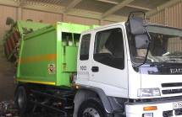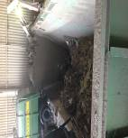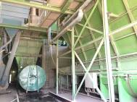

Semi-Annual Environmental
Monitoring Report
Reporting Period: July – December 2021

CLIENT – IMPLEMENTING AGENCY
State Unitary Enterprise (SUE) “MAXSUSTRANS” (Uzbekistan)

PIU SUPPORT CONSULTANT
Infratech Consulting SDN Ltd. (Uzbekistan)

TABLE OF CONTENTS

1 PREAMBLE 1
1.1 General 1
1.2 Headline Information 1
2 PROJECT DESCRIPTION AND CURRENT ACTIVITIES 3
2.1 Project Description 3
2.2. Project Contracts and Management 4
2.3. Project Activities During Current Reporting Period 8
2.4. Description of any Changes to Agreed Construction methods 10
3 COMPLIANCE WITH ADB LOAN COVENANTS 11
4 ENVIRONMENTAL SAFEGUARD ACTIVITIES 17
4.1 General Description of Environmental Safeguard Activities 17
4.2 Site Inspections 17
4.3 ADB Missions 25
4.4 Issues Tracking (Based on Non-Conformance Notices) 25
4.5 Trends 28
4.6 Unanticipated Environmental Impacts or Risks 28
5 RESULTS OF ENVIRONMENTAL MONITORING 29
5.1 Overview of Monitoring Conducted during Current Period 29
5.2 Trends 29
5.3 Summary of Monitoring Outcomes 30
5.4 Material Resources Utilization 32
5.5 Waste Management 32
5.6 Health and Safety 32
5.7 Training 33
6 FUNCTIONING OF THE SEMP 36
6.1. SEMP Review 36
7 GOOD PRACTICE AND OPPORTUNITY FOR IMPROVEMENT 37
7.1. Good Practice 37
7.2. Opportunities for Improvement 37
8 SUMMARY AND RECOMMENDATIONS 38
8.1. Summary 38
Annex 1: Environmental Management Plan (as BEFORE PROVIDED IN IEE) 41

LIST OF FIGURES
Figure 1 Grievance Redress Mechanism* 35

LIST OF TABLES
Table 1: Summary of Civil Works Contracts and works’ progress 5
Table 2: List of organizations involved in environmental management under the Project 7
Table 3: Role of Agencies towards EMP Implementation 7
Table 4: Overview on project costs 9
Table 5: Ongoing Contracts of the Project No. L3067 - UZB 9
Table 6. Status of compliance with ADB’s Loan Covenants 11
Table 7. Implementation Status of Corrective Actions proposed in the previous monitoring report(s) 26
Table 8. Implementation Status of EMP during the construction period (Packages CW2, CW4) 31
Table 9. Material Mobilization CW4 Contractor 32
Table 10 Material Mobilization CW2 Contractor 32
Table 11: Institutional Strengthening and Training Program 33
Table 12. Issues Identified During the Monitoring Period (including the pending issues from the previous report(s)) 38

ABBREVIATIONS
ADB  AP | Asian Development Bank  Affected people
BER | Bid Evaluation Report
CDP | Corporate Development Program
CSC | Construction Supervision Consultant
EHS | Environmental Health & Safety
EIA | Environmental Impact Assessment
EIP | Environmental Impact Permit
EMP | Environmental Management Plan
GoU | Government of Uzbekistan
GRM | Grievance Redress Mechanism
IEE | Initial Environmental Examination
LARP | Land Acquisition and Resettlement Plan
Maxsustrans | State Unitary Enterprise “Maxsustrans”
MSW | Municipal Solid Waste
PIU | Project Implementation Unit
SCEEP | State Committee of the Republic of Uzbekistan of Ecology and Environment Protection
SLF | Sanitary Landfill Facility
SPS | Safeguard Policy Statement
SEMP | Site-specific Environmental Management Plan
SWM | Solid Waste Management
SWMIP | Solid Waste Management Improvement Project

PREAMBLE

General
- As per the Loan and Project Agreements for the L3067-UZB: Solid Waste Management Improvement Project (SWMIP), State Unitary Enterprise “MAXSUSTRANS” and Project Implementation Unit (PIU) is bound to ensure that (i) the project is constructed and operated in accordance with the national and local environmental regulations and guidelines, ADB's Environment Policy (2002) and the initial environmental examination (IEE) report; (ii) any adverse environmental impacts arising from the construction and operation of the project facilities are minimized by implementing the mitigation measures. Environmental monitoring program and other recommendations presented in the IEE report; and (iii) the implementation of the Environmental Management Plan (EMP) and violations of safety or environmental standards, if any, be regularly reported to ADB.
- This report is the 12th Environmental Monitoring Report (EMR) for the project and covers July – December 2021 reporting period. This Environmental Monitoring Report describes the implementation of the environmental monitoring and mitigation measures recommended in the IEE reports, analyzes environmental data collected from the projects during the period of January-June 2021, and provides recommendations for the resolution of identified issues.
- To be more specific, this EMR covers the following areas: (i) documentation review and compliance assessment with the applicable environmental regulations, (ii) environmental management institutional structure and responsibilities, (iii) mitigation measures undertaken to minimize adverse environmental impacts arising from the construction, (iv) environmental monitoring results and analyses, and (v) conclusions and recommendations.
- The Government of Uzbekistan (GoU) took tough measures against COVID-19 and has taken all necessary preventive measures to prevent the spread of coronavirus infection since March 2020. In particular, all transport communication and public activities have been limited or prohibited. Tashkent city and also other regions went into quarantine mode, and most companies, organizations and institutions were transferred to remote work.
- The project includes a dynamic Sanitary Landfill Facility (SLF) development concept approach. This utilizes the planned SLF as an immediate and effective solution for Tashkent’s waste disposal challenges, with the potential to progressively expand the facility to become a disposal solution that can serve the Tashkent region over the long term.
- The project finances:
- procurement of garbage trucks for collection and transportation household solid waste;
- procurement of equipment and machinery for the sanitary landfill;
- procurement of waste bins for waste collection points and containers for transportation of solid waste;
- revamping of two transfer stations in the city of Tashkent;
- reconstruction of two garages of Maxsustrans;
- construction of new sanitary landfill.
- Collection points are equipped with functional and suitably sized waste bins, with provision for recyclable materials to be segregated and collected. Outdated collection vehicle fleets will be replaced with appropriately sized and highly efficient collection vehicles, dramatically reducing operation and maintenance costs. Transfer stations will be equipped with improved infrastructure and electromechanical components, and the transfer trucks to the landfill will be replaced by new ones. With these activities an improvement of the environmental impact should be also expected.

Headline Information
- The GoU has applied for a loan from the Asian Development Bank (ADB) for the development and improvement of Solid Waste Management (SWM) system of the capital city (Tashkent). The loan reference number is L3067-UZB: Solid Waste Management Improvement Project (SWMIP). The loan was signed between the Republic of Uzbekistan and ADB dated 27 February 2014 and Project Agreement dated 12 March 2014 signed between ADB, Tashkent City Municipality and the State Unitary Enterprise “MAXSUSTRANS”.
- The project was prepared to impact an improved urban environment and quality of life for the residents of Tashkent. The project will develop a sanitary landfill that meets international standards, rehabilitate transfer stations, and modernize the waste collection and transfer fleet. It will build capacity in waste management and help formulate a national strategy on SWM.
- The GoU seriously recognizes the need to develop and implement a national SWM strategy. The Project will contribute to sustainable urban development in Uzbekistan by: (i) modernizing SWM to provide continuous and reliable municipal services; (ii) promoting financial sustainability of municipal services through tariff rationalization and prudent financial management; (iii) supporting policy and institutional reforms for improved sanitation and environmental management; (iv) mitigating climate change through a major reduction of Green House Gas emissions, and through compliance with international standards on waste minimization and material recycling; and through all these measures; (v) improving livability of cities.
- The volume of the existing dumpsite is exhausted and the original plan of the city was to extend its dumpsite operations to an adjacent lot of additional 30 hectares (ha) of area. Being fully aware of the inevitable environmental impacts through the extension of this practice, the city asked the national government for assistance in this matter. Based on these activities, the Cabinet of Ministers of the Republic of Uzbekistan has approved in summer 2012 the location of new dumpsite on 30 ha of agricultural area for the utilization for waste management activities.
- The GoU has already allocated a 30-ha land plot immediately to the south of the existing Akhangaran dumpsite (25 ha for landfill and 5 ha for facilities), to develop this facility to a SLF, designed to internationally accepted standards of environmental protection. A detailed engineering design has been completed for the interim 25-ha facility, which is naturally included as a component of the Project.

PROJECT DESCRIPTION AND CURRENT ACTIVITIES

Project Description
- The overall objective is to provide an improved SWM system in Tashkent, the capital city, to upgrade urban infrastructure and services. The project will develop a sanitary landfill that meets international standards, rehabilitate transfer stations and garage facilities and also modernize the waste collection and transfer fleet. It will build capacity in waste management and help formulate a national strategy on SWM.
- Given the current SWM practices, the option converting and allocating an area adjacent to the existing dumpsite to an engineered Sanitary Landfill was decided. The proposed SLF concept will be based on the Best Environmental Practices (BEP) resulting to a state-of–the-art design consistent with international acceptable standards. This “stand alone” facility will drastically improve the SWM system (i.e. the handling and final disposal of MSW) with a possible integration capability for a long-solution to cover the entire Tashkent Oblast. The inclusion into the design of a multi-barrier system, leachate and gas collection systems will result in a significant reduction of anticipated impacts. The Project is to contribute to the following issues:
- Segregation of municipal solid waste stream;
- Proper collection and dumping to appropriate sites;
- Establishment of modern SWM systems;
- Remediation of old 'truck and dump' practices in cities and regions
- The GoU through its Implementing Agency, the State Unitary Enterprise (SUE) “MAXSUSTRANS” utilizes part of this loan proceeds towards the cost of the contract for Consulting Services related to Project Management, Implementation and Supervision, supporting the Project Implementation Unit (PIU).
- ADB approved the project on 27 November 2013 with a loan amount of $69 million from its ordinary capital resources. The total project cost is $76.3 million equivalent, inclusive of taxes and duties benefits, and financial charges during implementation covered by the GOU. The Loan and Project Agreements were signed on 27 February 2014. The loan became effective on 29 December 2014. The project was designed for five years of implementation with a loan closing date of 30 June 2019. On 17 December 2018, ADB approved a two-year loan extension with the revised Loan Closing Date of 30 June 2021 to complete all ongoing contracts and planned civil works, delayed due to start-up delays (including 10 months’ delay in effectiveness) and procurement delays (the first contract was awarded in 2016 only) because of the executing agency’s insufficient capacity and government’s prolonged contract registration process.
- Referring to letters dated 26 March 2021 and 17 July 2021 of the Ministry of Finance of Uzbekistan, on 23 July 2021, ADB approved a 30-months loan extension with the revised Loan Closing Date from 30 June 2021 to 31 December 2023 to ensure successful and timely completion of the project. This approval letter was provided by ADB on a post-facto-basis considering the GOU’s commitment to strictly adhering to the time-bound action plan and mitigation measures submitted to ADB and to be implemented by Tashkent Municipality, Maxsustrans, and by the project implementation unit.
- The project impact is improved urban environment and quality of life for the residents of Tashkent. The expected outcome is improved SWM services and management in Tashkent. The project has three outputs: output 1 - rehabilitated and expanded SWM system in Tashkent; output 2 - strengthened operational capacity; and output 3 - national SWM strategy. Tashkent Municipality is the executing agency for the outputs 1&2, with State Committee of the Republic of Uzbekistan of Ecology and Environment Protection (SCEEP) being the executing agency for output 3. Maxsustrans is the implementing agency responsible for the day-to-day project implementation.
- According to the Loan Agreement dated on 27 February 2014, the Project shall comprise:
Part A – National Municipal Solid Waste Strategy
(a) preparation of a draft national strategy for the management of solid waste, including a draft sector investment program;
Part B – Solid Waste Management in Tashkent Municipality
(b) construction and rehabilitation of municipal solid waste collection facilities;
(c) procurement of municipal solid waste collection bins;
(d) procurement of municipal solid waste collection vehicles and municipal solid waste transfer vehicles;
(e) rehabilitation of municipal solid waste transfer stations and possible closure of an existing municipal solid waste transfer station;
(f) construction and rehabilitation of municipal solid waste collection facilities
(g) design and construction of a new sanitary landfill, solid waste facility and closure of an existing landfill solid waste dumpsite;
(h) capacity development support for Maxsustrans, including in the areas of operation and management and Project implementation; and
(k) development and implementation of a waste minimization and recycling program and a parallel media and public awareness campaign about waste minimization and recycling.
- However, «Construction and rehabilitation of municipal solid waste collection facilities» was financed by Maxsustrans own funds. In addition, «Closure of an existing landfill solid waste dumpsite» is financed by Sejin G&E Co. Ltd. Company (Republic of Korea), for details please refer to the next chapter below. Therefore these components are no longer part of the Project.

Project Contracts and Management
- Summary of civil works contracts and works’ progress is summarized in Table 1. All awarded contracts (CW2, CW4, and CW5) included EMPs cleared by ADB (For the civil works of the awarded contracts, environmental assessment was not required under national/local regulations.). For CW1 package (Establishment of sanitary landfill), the contract will include the EMP cleared by ADB and conditions of national EIA clearance (para. 29 on page 6).

Table 1: Summary of Civil Works Contracts and works’ progress
Contractor | Scope | Contract  Signed | Approval Date |  |  | Environmental personnel |  | Civil Works |  | Progress
 |  |  | SEMP | COVID-19 HSMP | ERP | Environmental officer | Health and safety officer | Start | End | As of 30 Jun 2021 | As of 31 Dec 2021
CW1: JV «STECOL-POWERCHINA GUIYANG» (China) | Establishment of sanitary landfill | (Feb 2022) | - | - | - | - | - | (Mar 2022) | (Aug 2023) | - | -
CW2: JV of Future Growth Ltd., VBN Engineering Ltd and Eastern construction Ltd. (Uzbekistan) | Transfer station rehabilitation | 12 Apr 2021 | Apr 2021 | Apr 2021 | Apr 2021 | Mr. Nozimhon Saydullayev | Mr. Xasan Bashirov | 01 May 2021 | (30 Apr 2022) | 5% | 50.88%
CW3: Cancelled | Dumpsite closure
CW4: Indigo Baraka Servis LLC (Uzbekistan) | Garage rehabilitation | 7 Dec 2020 | 21 Dec 2020 | 21 Dec 2020 | Jan 2021 | Mr. Khabibulla Mukhtarov | Mr. Rakhmatilla Normatov | 16 Dec 2020 | 31 Dec 2021 | 75% | 100%
CW5: Various local contractors | Construction and rehabilitation of municipal solid waste collection facilities | Various contracts |  |  |  | n/a | n/a | Various dates | Various dates | 100% | 100%
Note: The Month/Years in brackets are planned schedule.
COVID-19 HSMP = COVID-19 Health and Safety Management Plan, ERP = Emergency Response Plan, SEMP = site-specific environmental management plan
- The project is being administered by the Project Implementation Unit (PIU), which is currently represented by the Head of PIU (Mr. Jasur Hamidov).
- PIU has received аn official letter from H.P. Gauff Ingenieure GmbH & Co. KG. dated 24 July 2020 about оrdеr of the local court of Nurеmbеrg оn opening of insolvency proceedings according to Gегmап Law regarding H.P. Gauff Ingenieure GmbH & Co. KG. PIU has also received аn official letter from H.P. Gauff Ingenieure GmbH & Co. KG.dated 17 September 2020 about declaration of non-entry of the соmраnу in the соntгасt No. SUE/Maxsustrans/QCBS-Cons 1-2016-01.
- Considering the necessity to соntinue the PIU Consultant sеrviсеs in огdеr to еnsurе uninterrupted implementation of the Project, the obligations under the Соntrасt No. SUE/Maxsustrans/QCBS-Cons 1-2016-01 is assigned to the local partner of the Joint Venture - Infratech Consulting SDN Ltd. (Uzbekistan). Maxsustrans has signed Amendment No. 5 to the a.m. contract on 9 December 2020 with extension of the Consultant’s service until 30 June 2021.
- As the Loan Closing Date was extended until 31 December 2023, by Amendment No. 6 dated 9 December 2021 the PIU Consultant services have been prolonged from 30 June 2021 until 31 December 2023. To strength the financial management and contract administration capacities of the Project, the Consultant’s team was extended by two additional non-key national experts: Financial Management Specialist/Accountant and Contract Administration Specialist.
- The full rеsроnsibility of the Consultant to регfоrm this Соntrасt against the Client is handed over to lnfratech Consulting SDN Ltd. Mr. Dilshod Mavlyan-Kariev, K-4 national SWM Specialist (Deputy Team Leader) is in charge in the overall project administration and reporting for the Project.
- PIU Consultants has National Environmental Expert – Mr. Sergey Karandayev, who implements environmental safeguards services. He is personnel in charge of environmental affairs. He is responsible for arranging on-field monitoring activities, providing inputs to this semi-annual monitoring reports and making sure the protection measures are implemented accordingly.
- SUE Maxsustrans has recruited "China Urban Construction Design & Research Institute Co., Ltd." (CUCD) for Sanitary Landfill Design and Construction Supervision services (Contract Cons_2). The design services of CUCD started in December 2018 and completed in October 2019. Based on the detailed design for sanitary landfill and dumpsite closure works, developed by CUCD Consultants, in 2019 Maxsustrans has launched the bid under the package CW1 – Establishment of Sanitary Landfill and Dump Site Closure. The package was retendered in October 2021 due to excluding the dumpsite closure works upon decision of the GOU. Once the civil works under the contract CW1R is commenced (expected in March 2022), the supervision services of CUCD will be effective and continue within 18 months. Currently, Maxsustrans is negotiating with CUCD to amend the Contract with extension of the service period from 30 June 2021 until 30 September 2023 covering the procurement support and works/design supervision services. The CUCD Consultants will act as the “Engineer” under the Contract CW1-R.
- According to the revised Terms of Reference of CUCD Consultants will monitor the implementation of Site-Specific Environmental Management Plan (SEMP) to be prepared by the Contractor according to requirements of the national Environmental Impact Assessment (EIA = the Russian abbreviation “ZVOS”) and the Environmental Management Plan cleared by ADB as part of the Project’s Initial Environmental Examination dated May 2013.
- To the time being the local EIA is prepared based on the detailed design of CUCD, however, Maxsustrans has not submitted the EIA to the State Committee of Ecology and Environmental Protection (SCEEP) because set of appropriate documents needed for formal submission to SCEEP is not ready yet. The reason for delay is a long time for agreement procedures and signing the minutes of meeting with local community of residents (Mahalla) and Akhangaran district administration, which delayed formal submission of EIA to SCEEP’s review and expertise. Full set of documents is scheduled for submission to SCEEP by the end of February 2022. The obtaining State Ecological Expertise of EIA from SCEEP is expected until the end of March 2022, if no further comments or questions will be provided by SCEEP. It is scheduled that before commencement of civil works on new landfill site, the national EIA shall be approved and effective. Initial Environmental Examination (IEE) was prepared according to ADB SPS 2009 requirements and disclosed on AB website in May 2013.
- Main organizations involved in the project and related to environmental safeguards are presented in Table 2:
Table 2: List of organizations involved in environmental management under the Project
Organization | Name of main staff and Environmental Specialist | Contact data (including phone and web-site) and address of the organization | Employer | Commence-ment of Services | Completion of Services
PIU Support Consultant –Infratech Consulting SDN Ltd. | Mr. Dilshod Mavlyan-Kariev, Deputy Team Leader  Mr. Sergey Karandaev, Environmental Specialist | dilshod75@mail.ru  infratech_consulting@asia.com  +998712477923  Address: 16a, Shahrisabz street, 100015 Tashkent, Uzbekistan | SUE Maxsustrans | 01.08.2017 | 31.12.2023
Sanitary Landfill Design and Supervision Consultant –China Urban Construction Design & Research Institute Co., Ltd.” | Mrs. Yuwei Xue,  Authorized representative  Mr. Mingtao Nie  Environmental Specialist | icc@cucd.cn +861057365133  Address: 36 Deshengmenwai Street, Xicheng District, Beijing 100120, PR China | SUE Maxsustrans | 08.12.2018 | 30.06.2021  Extension until 30.09.2023 is under review
- The role of each agency in the project is presented in Table 3.
Table 3: Role of Agencies towards EMP Implementation
Agency | Role
Project Implementation Unit (PIU) | - Holds Overall responsibility with regard to EMP Implementation  - Reporting to various stakeholders (ADB, Regulatory bodies) on status of EMP Implementation  - Coordinating with Environmental Experts (PIU Support Consultant, Contractors and External Monitors)  - Responsible for obtaining Regulatory Clearances  - Review of the progress made by Contractors  - Ensure the BoQ items mentioned in EMP are executed as per contract provisions
PIU Support Consultants | - Assisting PIU in monitoring of overall implementation of EMP  - Review of periodic reports on EMP implementation and advising PIU in taking corrective measures  - Conducting periodic field inspection of EMP implementation  - Assisting PIU and reporting to various stakeholders (ADB, Regulatory bodies) on status of EMP implementation  - Conduct environmental training for field officers and engineers of contractor
Engineer | - Supervise the implementation of the environmental protection and impact mitigating measures by the contractors  - Supervise construction activities to ensure minimum impact on the natural and socioeconomic environment,  - Regularly monitoring and reporting on performance of the Contractor(s) environment staff, verifying monitoring methodologies and results;  - Review of the construction design to ensure compliance with project engineering design and the EMP with regard to environmental protection and impact mitigation;  - Prepare the necessary remedial actions for any unforeseen impacts  - Instructing the Contractor(s) to take corrective actions within timeframe as determined by the Environmental Specialist  - Address complaint related with environmental aspect of the project through GRM  - Provide trainings to the Contractor regarding the implementation of the safeguard activities and plans on the construction site  - Contribute to the final report on safeguard aspects upon completion of construction
Contractor | - Responsible for development of Site-specific Environmental Management Plan (SEMP)  - Responsible for ensuring the implementation of SEMP as per provisions in the document  - Discussing various environmental / social issues and environmental / social mitigation, enhancement and monitoring actions with all concerned directly or indirectly  - To ensure environmentally sound and safe construction practices  - Conducting periodic environmental and safety training for contractor’s engineer, supervisors and workers  - Sensitization on social issues that may be arising during the construction stage of the project  - Conduct environmental monitoring and control activities including pollution monitoring, safety; and  - Preparing and submitting monthly reports on status of implementation of safeguard measures  - During the Covid-19 pandemic, the Contractor(s) will ensure necessary protection to the deployed WORK FORCE and minimize the risk of spread of infection.
- During the civil works under the contract CW1-R, the Design and Supervision Consultant will be responsible for monitoring of implementation of SEMP by the Contractor and regularly report to PIU/Employer on compliance with the safeguard requirements of the Project. Starting from January 2022 PIU Support Consultant will be responsible for overall monitoring of all Supervision Consultants and Contractors involved under the Project at implementation of their safeguard compliance tasks and responsibilities.

Project Activities During Current Reporting Period
- The status of three civil works packages of the Project is as follows:
- Package CW1 - Sanitary landfill establishment (estimated cost $18.50 million), the package was retendered by decision of Tashkent City’s Tender Commission and consent of the GOU, no-objection of ADB for contract award to JV «STECOL-POWERCHINA GUIYANG» (PRC) with the bid price of $15,691,566.66 was provided on 27 January 2022, the contract negotiations are in progress, signing the contract is scheduled in February 2022;
- Contract CW2 - Transfer station rehabilitation, the Contractor - JV of Future Growth Ltd., VBN Engineering Ltd and Eastern construction Ltd. (Uzbekistan), the Contract’s value is $6.98 million, the Contract signing date – 12 April 2021, civil works commenced on 1 May 2021, construction completion is scheduled for 30 April 2022; and
- Contract CW4 - Garage rehabilitation, the Contractor - Indigo Baraka Servis LLC (Uzbekistan), the revised Contract’s value is equiv. $962 thousands, the Contract signing date – 7 December 2020, civil works commenced on 16 December 2020 and completed on 31 December 2021, final commissioning of works is in progress. Through Amendment No. 1 the construction completion date has been extended from 15 August to 31 December 2021.

Table 4: Overview on project costs

Source of Financing | Total (million USD) | %
Asian Development Bank Financing
Loan 3067-UZB (Ordinary Capital Resources) | 69.00 | 90.79%
Governmental Financing
Government of Uzbekistan (GoU) | 7.00 | 9.21%
Total | 76.00 | 100%
- Currently on-going contracts (works, goods and services) of the Project are provided in the table below. Currently, no on-going contracts for supply of the goods.
Table 5: Ongoing Contracts of the Project No. L3067 - UZB
Name of Contract | Category (works, goods or services) | Contract Amount  ($ equiv.) | Contract Completion
C1: PIU Support Consultant | Services | 2,410,000.00 | 31-Dec-23
C2: Sanitary Landfill Design & Supervision Consultant | Services | 2,332,650.00 | 31-Oct-23
C7: Transfer Station Rehabilitation Design and Supervision Consultant | Services | 81,600.00 | 30-Apr-22
C8: Garage Rehabilitation Design and Supervision Consultant | Services | 97,600.00 | 31-Mar-22
CW4: Garage Rehabilitation | Works | 962,000.00 | 31-Dec-21
CW2: Transfer Station Rehabilitation | Works | 6,982,746.00 | 30-Apr-22

- Package CW2 - Transfer station rehabilitation. The contract No. SUE/Maxsustrans/ICB/W2 for Transfer station rehabilitation was signed with the Contractor - JV of Future Growth Ltd., VBN Engineering Ltd and Eastern construction Ltd., Uzbekistan on 12 April 2021. The scope of works under the contract is as follows:
- Dismantling of the existing machinery and associated equipment and supporting steel construction;
- Dismantling of the ventilation / dust exhauster system;
- Hydraulic system and pipes;
- E-power cable system;
- Informatic sensors and IT-system & cable;
- Leachate collection and drainage system from both press;
- Rehabilitation of the surface (profile steel plates);
- Rehabilitation of existing fire prevention system, new hydrants etc.;
- Rehabilitation of the concrete surface of the unloading area;
- Rehabilitation of the concrete surface prior the press & container docking place;
- Electric engineering system;
- Emergency system;
- Steering container to rehabilitate;
- Other facilities
- Project implementation delays. The package CW1 – Sanitary Landfill Establishment is under significant delay compared to the original implementation schedule of the Project. It is reasoned by the prolonged procurement process for selection of the contractor in late 2019 and 2020 years. After a number of communications between ADB, Maxsustrans and the Tender Commission of the Tashkent City Municipality, a new bid only for establishment of new sanitary landfill has been launched in October 2021 that is completed by no-objection of ADB for contract award received on 27 January 2022. Currently, Maxsustrans and PIU are going to the contract negotiations with the successful bidder - JV «STECOL-POWERCHINA GUIYANG» (PRC) who proposed bid price $15,691,566.66.
- During the monitoring period, the national environmental specialist of PIU Consultant has conducted the site inspections and visual assessments in two garages (CW4) and transfer stations (CW2). The main focus of activities was: in garages - safeguard monitoring at finishing the works, demobilization of the Contractor, site cleaning, HS and COVID-19 HSMP issues. In transfer stations – HS and COVID-19 HSMP issues and monitoring of environmental issues during the works. Photographing, recording and reporting the findings during the site inspections as detailed in this EMR. The international environmental specialist of SLF Supervision Consultant was not mobilized yet (expected from April 2022).

Description of any Changes to Agreed Construction methods
- No changes to agreed construction methods took place. The works package «Construction and rehabilitation of municipal solid waste collection facilities» was financed by Maxsustrans own funds and the works package «Dump Site Closure» is financed by Sejin G&E Co. Ltd. Company (Republic of Korea) according to the decree of the GOU. Therefore these components are no longer part of the Project.

COMPLIANCE WITH ADB LOAN COVENANTS
- The Environmental Loan Covenants under SWMIP requires the design, construction, operation and implementation of all sub-project facilities is carried out in accordance with the environmental assessment and review procedures and Initial Environmental Examination (IEE) for core sub-components agreed upon between the Government and ADB, and complies with the Government’s environmental laws and regulations and ADB’s Environment Policy (2002). Any adverse environmental impacts arising from the construction, operation and implementation of sub-component facilities will be minimized by implementing the environmental mitigation and management measures, and other recommendations specified in environmental assessment reports (e.g., IEE etc.). The Government will ensure environmental requirements will be incorporated in bidding documents and civil works contracts. Issuance of bid documents will be made after review and clearance of IEE/EIA by ADB and SCEEP. PIU will prepare and submit semi-annual environmental report to ADB that describes progress in implementation of the EMP and issues encountered and measures adopted; and compliance with the relevant assurances and loan covenants.
- Table 6 shows the status of compliance with ADB’s loan covenants relating to environment, health and safety during the monitoring period: June to December 2020.
Table 6. Status of compliance with ADB’s Loan Covenants
Covenants | Reference to  Loan and Project Agreement | Status of Compliance (as of 31 December 2021)
Conditions for Award of Contract
6. The Borrower shall ensure that Maxsustrans shall not award any Works contract which involves environmental impacts until:  (a) SCNP (SCEEP) has issued a statement of ecological expertise; and  (b) the Borrower has incorporated the relevant provisions from the EMP into the Works contract. | LA Schedule 4, para 6 | Partially complied.  a) On-going. The EIA for construction of new landfill required by the national regulation is prepared in November 2021. Maxsustrans shall submit to SCEEP the revised EIA for the state ecological expertise in February 2022, currently the completion of the formal request according to local procedures is in progress. Issuing the statement of ecological expertise is planned until the end of March 2022.  b) Complied. All Works contracts (CW1, CW2 and CW4) are procured based on the bidding documents including the relevant provisions from the EMP of the Project.
Consulting Services
The Borrower shall recruit the individual consultants for capacity development in the areas of project management, procurement, safeguards, financial management and monitoring and evaluation in accordance with procedures acceptable to ADB for recruiting individual consultants. | LA Schedule 4, para 10 | Complied with.  In July and August 2015 the Borrower has recruited four individual consultants (two international and two national specialists) for capacity development of the IA and PIU in the areas of project management, procurement, safeguards, financial management and monitoring and evaluation in accordance with procedures of ADB. These contracts were completed in the beginning of 2017, when the PIU Support Consultant has been selected and the Contract Cons_1 was signed in January 2017.
Implementation Arrangements
- On or before the date that is 6 months after the Effective Date {29 December 2014}, the Borrower shall cause Maxsustrans to establish a website for the Project on which key information about the Project will be made available. The Project website will be accessible to the public and will include the following information about the Project:  - Project scope, structure, responsible agencies, impact, outcome and outputs;  - Status of Project targets;  - Procurement and consulting services information, including announcement of bidding processes, bidding procedures, list of participating bidders, names of winning bidders, amount of contract awards and a description of the goods or services procured; and  - All key safeguards related documentation, including the EMP and RP.  The Project website will be updated regularly, and its content will be presented in the English, Russian and Uzbek languages. | LA Schedule 5, para 2 | Partially complied.  Maxsustrans has the company’s website www.maxsustrans.uz, where the Project related all key information can be disclosed. During the reporting period the Project website has been updated by the following documents (as of 31 December 2021):  a) General information on the Project, including the EAs and IA (English and Russian)  b) None, the Project targets status as per 31.12.2021 is still in progress  c) Bid announcement: Rebid Works package CW1R – Sanitary Landfill Establishment  d) During the reporting period as of 31 December 2021, the following safeguards related documentation are disclosed on the Project’s website:  - Semi-annual Environmental Monitoring (SAEMR) for January - June 2021 (English, Russian). Due to large-scale Uzbek translation of the previous SAEMRs this report could be not translated into Uzbek within the reporting period. It will be translated and disclosed within the next reporting period.  - SAEMR for July – December 2020 (English, Russian and Uzbek)  - SAEMR for January – June 2020 (English, Russian and Uzbek)  - SAEMR for July - December 2019 (English, Russian and Uzbek)  - SAEMR for January – June 2019 (English, Russian and Uzbek)  - SAEMR for July - December 2018 (English, Russian and Uzbek)  - Semi-annual Social Safeguard Monitoring Report for January - June 2021 (English, Russian). Uzbek translation could be not completed within the reporting period. It will be translated and disclosed within the next reporting period.  Note: The updated EIA for Sanitary Landfill Establishment prepared in Russian language according to the national legislation in November 2021, will be disclosed on the Project’s website after obtaining the state ecological expertise, which is scheduled by March 2022. The Uzbek translation will be prepared at latest in May 2022.
- The Borrower shall cause Tashkent Municipality and Maxsustrans to: (i) use their best endeavors to ensure that critical Project staff remain in their position on a full-time basis for a reasonable duration to ensure continuity in the implementation of the Project; and (ii) ensure that all Project Executing and Implementing Agencies are adequately staffed and provided with the necessary financial, technical, and other resources to perform their functions under the Project. | LA Schedule 5, para 3 | Complied with.  On 1 November 2021 Mr. Rakhmatilla Karshiev has retired from the position of Director of Maxsustrans. Mr. Sanjar Umatov was appointed as Director of Maxsustrans according to the order of the Tashkent City Mayor No. 501-14-0-Q/21 dated 29 November 2021.  On 26 November 2021 Mr. Sherzod Kattakhodjaev has retired from the position of Deputy Director of Maxsustrans. Mr. Botir Mamataxunov was appointed as Deputy Director of Maxsustrans according to the order of the Maxsustrans director.
Environment
- The Borrower shall cause Maxsustrans to ensure that the preparation, design, construction, implementation, operation and decommissioning of the Project and the Project Facilities comply with (a) applicable laws and regulations of the Borrower relating to environment, health, and safety; (b) the Environment Safeguards; and (c) all measures, and requirements set forth in the IEE, the EMP, and any corrective or preventative actions set forth in a Safeguards Monitoring Report. | LA Schedule 5, para 5 | NOT complied  Since the Project’s IEE (May 2013) includes 156 pages in total, the Borrower has initiated to translate into Uzbek language (understandable to affected people and other stakeholders) the EMP only (Annex 6 of IEE). The Uzbek translation of EMP will be disclosed on the Project website in April 2022.  Currently four consultants are engaged by Maxsustrans, in particular:  - PIU Support Consultant (Infratech Consulting SDN Ltd., Uzbekistan)  - Sanitary Landfill Design and Supervision Consultant (China Urban Construction Design & Research Institute Co., Ltd., China)  - Transfer Stations Rehabilitation Design and Supervision Consultant (Quality Planning Ltd., Uzbekistan)  - Garage Rehabilitation Design and Supervision Consultant (Quality Planning Ltd., Uzbekistan)  The design and supervision consultants have prepared the design documentation in compliance with applicable laws and regulations of Uzbekistan relating to environment, health, and safety and also the Environment Safeguards of ADB and measures/requirements set forth in the IEE. The corrective or preventative actions, if any, are provided in Safeguard Monitoring Reports submitted so far by PIU Support Consultant to PIU and Maxsustrans.  However, CW2 contractor started the civil works before the SEMP, COVID-19 HSMP and ERP were prepared based on Table 1.
Human and Financial Resources to Implement Safeguards Requirements
- The Borrower shall make available or cause Maxsustrans to make available necessary budgetary and human resources to fully implement the EMP and the RP. | LA Schedule 5, para 9 | Complied with (ongoing).  To implement the EMP and the RP Maxsustrans has recruited:  - Mr. Irakli Kaviladze (Georgia) as International safeguard specialist (contract signing date: 19-Aug-2015; contract completion date: 23-Jan-2017)  - JV “H.P. Gauff Eng. & Infratech Consulting SDN Ltd.” as PIU Support Consultant (JV’s contract signing date: 11-Jan-2017; contract completion date: ongoing). The Consultant employed the National environmental specialist Ms. Julia Alekseeva (UZB) and replaced by Mr. Sergey Karandaev (UZB) and also the National social safeguard and development specialist Ms. Maria Malinovskaya. All national specialists were responsible up to date for monitoring of EMP and RP according to TOR of the PIU Support Consultant. The role and responsibility on the safeguard monitoring and reporting during the construction on new SLF is still under discussion and shall be clarified by Maxsustrans, PIU Support Consultant and SLF Design/Supervision Consultant  - China Urban Construction Design & Research Institute Co., Ltd. as Sanitary Landfill Design and Supervision Consultant (contract signing date: 16-Nov-2018; contract completion date: ongoing). The Consultant employed the international key specialists: Mr. Mingtao NIE (CHN), Environmental specialist and Ms. Dajiang SUN (CHN), Social Safeguard Specialist. According to TOR of the Consultant, one of the key tasks of the Consultant’s safeguard specialists is to ensure that the construction works are carried out by the Contractor in accordance with environmental and social norms and regulations of Uzbekistan and ADB.
Safeguards–Related Provisions in Bidding Documents and Works Contracts
- The Borrower shall ensure or cause Maxsustrans to ensure that all bidding documents and contracts for Works contain provisions that require contractors to:  - comply with the measures relevant to the contractor set forth in the IEE, the EMP and the RP (to the extent they concern impacts on affected people during construction), and any corrective or preventative actions set forth in a Safeguards Monitoring Report;  - make available a budget for all such environmental and social measures;  - provide Maxsustrans and the Borrower with a written notice of any unanticipated environmental, resettlement or indigenous peoples risks or impacts that arise during construction, implementation or operation of the Project that were not considered in the IEE, the EMP and the RP;  - adequately record the condition of roads, agricultural land and other infrastructure prior to starting to transport materials and construction; and  - reinstate pathways, other local infrastructure, and agricultural land to at least their pre-project condition upon the completion of construction. | LA Schedule 5, para 10 | Complied with (ongoing).  The provisions listed in this covenant have been considered and included in the bidding documents and contracts for Works, which were in bid or implementation stage:  - CW1R: Sanitary Landfill Establishment (bid is completed, in mobilization & pre-construction phase);  - CW2: Transfer Station Rehabilitation (in construction phase)  - CW4: Garage Rehabilitation (in commissioning phase)
Safeguards Monitoring and Reporting
- The Borrower shall do the following or cause Maxsustrans to do the following:  - submit semi-annual Safeguards Monitoring Reports to ADB and disclose relevant information from such reports to effected persons promptly upon submission;  - if any unanticipated environmental and/or social risks and impacts arise during construction, implementation or operation of the Project that were not considered in the IEE, the EMP and the RP, promptly inform ADB of the occurrence of such risks or impacts, with detailed description of the event and proposed corrective action plan; and  - report any actual or potential breach of compliance with the measures and requirements set forth in the EMP or the RP promptly after becoming aware of the breach. | LA Schedule 5, para 11 | Complied with (ongoing).  - Maxsustrans submitted to ADB the following Safeguards Monitoring Reports, which have been disclosed on the Project’s website on Uzbek, Russian and English languages: https://maxsustrans.uz/uz/project/dokumenty-po-proektu:  • SAEMR for January – June 2021  • SAEMR for July – December 2020  • SAEMR for January – June 2020  • SAEMR for July - December 2019  • SAEMR for January – June 2019  • SAEMR for July - December 2018  • EIA for New SLF, 2013 (Russian language)  All above mentioned reports were disclosed on the website in Uzbek language, excluding: i) SAEMR for January – June 2021, which will be translated in Uzbek and disclosed in March 2022, and ii) EIA dated 2013, which will be translated in Uzbek and disclosed in April 2022.  - Complied. Ongoing;  - Complied. Ongoing.
Prohibited List of Investments
- The Borrower shall ensure that no proceeds of the Loan are used to finance any activity included in the list of prohibited investment activities provided in Appendix 5 of the SPS. | LA Schedule 5, para 12 | Complied with.
Health and Labor Standards
- The Borrower shall cause Maxsustrans to ensure that contractors engaged under contracts for Works:  - comply with all applicable labor laws;  - use their best efforts to employ women and local people, including disadvantaged people, living in the vicinity of the Works;  - provide equal pay to men and women for work of equal type;  - provide and adequately equip first-aid, health and sanitation, and personal hygiene facilities for male and female workers at the Works sites;  - maximize female training and employment;  - conduct an information and education campaign on sexually transmitted diseases and HIV/AIDS for construction workers as part of the health and safety program at campsites and adjacent communities during Works implementation; and  - abstain from child labor.  Relevant Works contracts must include specific clauses on these undertakings. | LA Schedule 5, para 13 | Complied with (ongoing)  - In the Works Contract No. SUE/Maхsustrans/NCB-W4 “Garage Rehabilitation” dated 07.12.2020, clause 81 stipulates to:  (a) comply with all applicable labor laws;  (b) make every effort to recruit women and local residents, including the poor living in the immediate vicinity of the Works;  (c) ensure equal pay for men and women for work of the same type;  (d) provide and adequately equip first aid, health and sanitation and personal hygiene facilities for men and women at work sites;  (e) maximizing the qualifications and employment of women;  (f) conduct an information and education campaign on sexually transmitted diseases and HIV/AIDS for construction workers as part of the health and safety program in campsites and surrounding communities during work; and  (g) refrain from child labor.  - In the Works Contract No. SUE/Maxsustrans/ICB-W2 “Transfer Station Rehabilitation” dated 12.04.2021 (GCC 4.18, the Employers requirements para 1.9.4)

ENVIRONMENTAL SAFEGUARD ACTIVITIES

General Description of Environmental Safeguard Activities
- During the reporting period, there were no any changes in the organizational structure of the project. The PIU Consultant has supervised and monitored the overall project implementation process. However, when the construction phase will start according to the Works Contract CW1(R) – Establishment of New Landfill, the safeguard monitoring and reporting task related to SLF site will be performed by the SLF Supervision Consultant. PIU Consultant will use data of the safeguard monitoring reports of SLF Supervision Consultant at preparation of the Semi-annual Safeguard Monitoring Reports covering the safeguard monitoring issues of the entire project.
- During the monitoring period, the National Environment Specialist of PIU Consultant prepared environmental monitoring report(s) required by PIU and ADB and visited the project area to conduct visual assessment of the lands allocated for the project needs in December 2021. As mentioned in Table 6 of this report (item: Human and Financial Resources to Implement Safeguards Requirements) to implement the EMP and to monitor the environmental safeguard activities Maxsustrans has recruited:
- the international environmental specialist Mr. Irakli Kaviladze and after completion his services in January 2017,
- the national environmental specialist of PIU Support Consultant (JV “H.P. Gauff Eng. & Infratech Consulting SDN Ltd.”) has continued to monitor and report on environmental safeguard activities since August 2017 up to date, and
- It is expected that from March 2022 (the indented commencement of the Works on new SLF) the international environmental specialist of SLF Design and Supervision Consultant (China Urban Construction Design & Research Institute Co., Ltd.) will be responsible for monitoring of implementation of SEMP and report to Maxsustrans/PIU accordingly.

Site Inspections

Transfer Station Rehabilitation (Contract CW2)
- PIU Support Consultant’s Environmental Specialist visited Yakkasaray and Yunusabad transfer stations where the works under the contract No. SUE/Maxsustrans/ICB-W2 are continued. The civil works in Yakkasaray transfer station have been almost finished and the site is prepared for installation of equipment. The civil works in Yunusabad transfer station have slowly started in November 2021. In the pictures below there are on-going works in both transfer stations.

Yakkasaray Transfer Station (the construction phase):
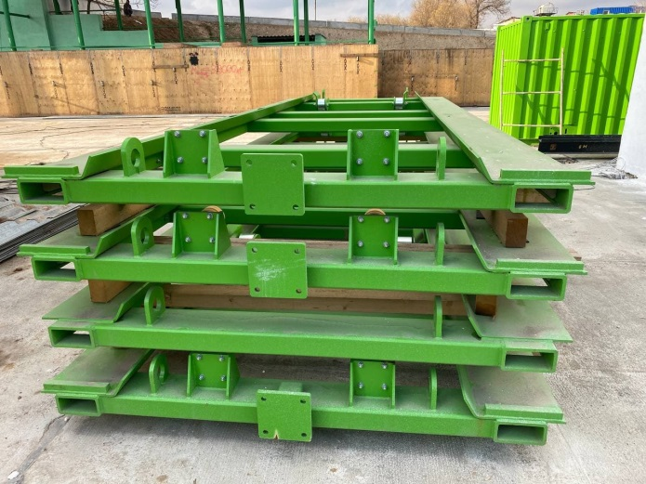 | 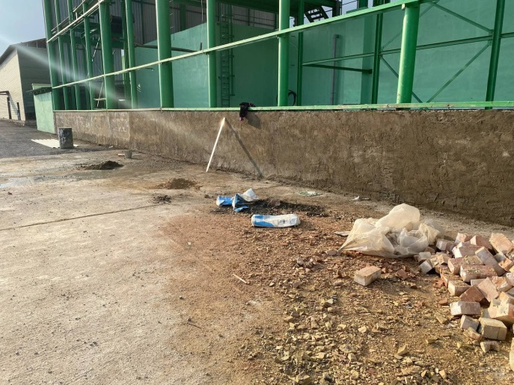
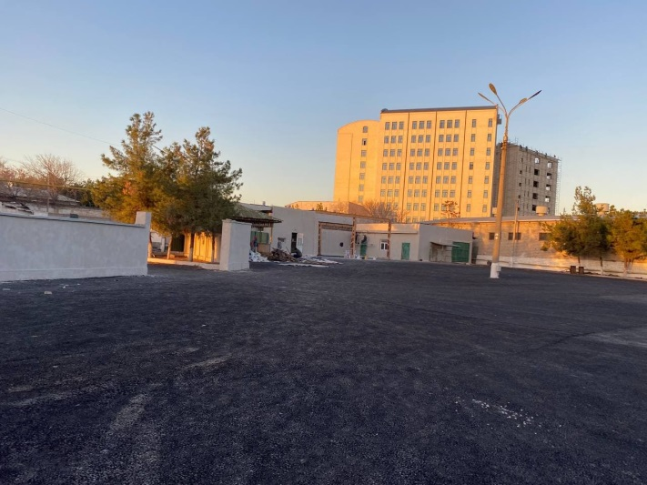 | 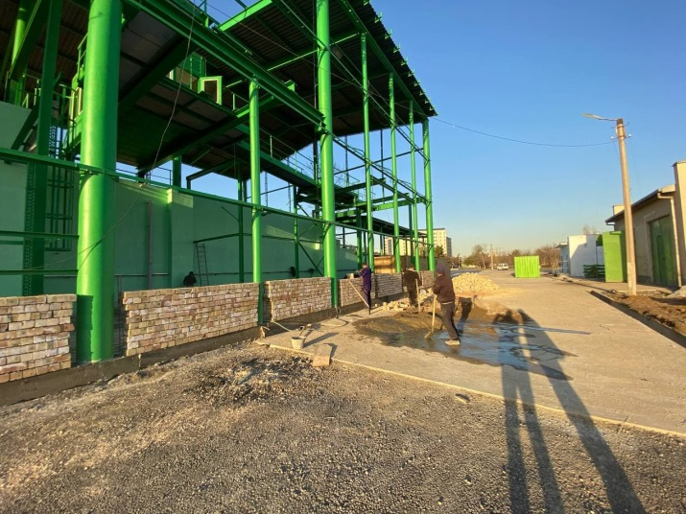
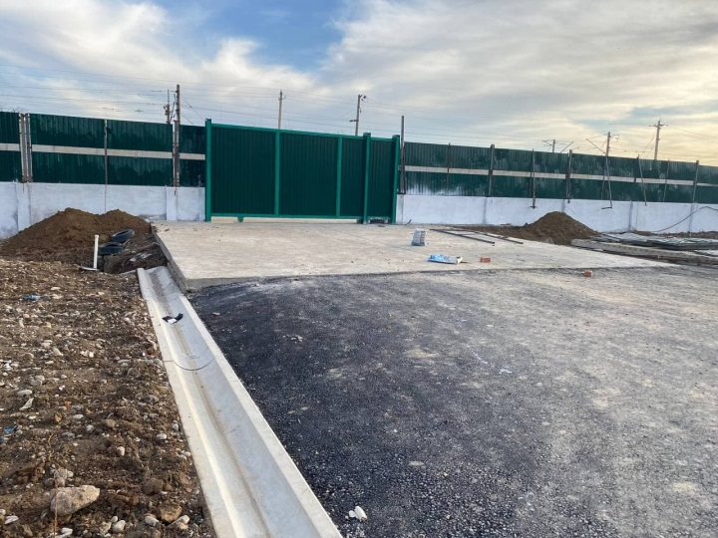 | 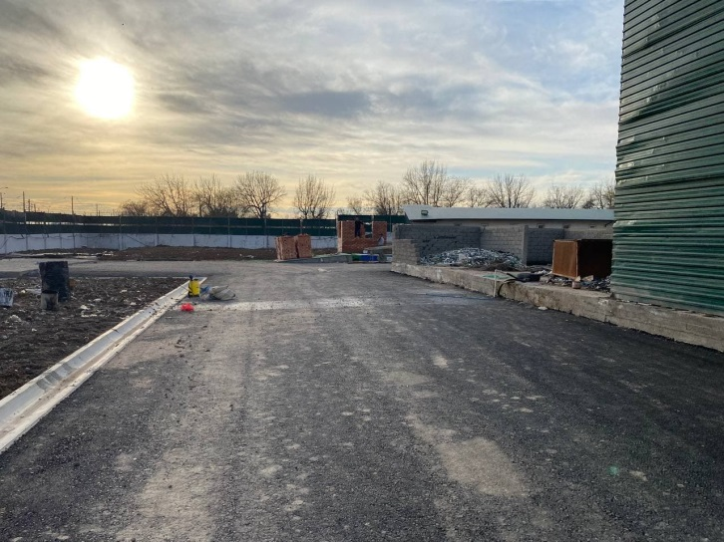
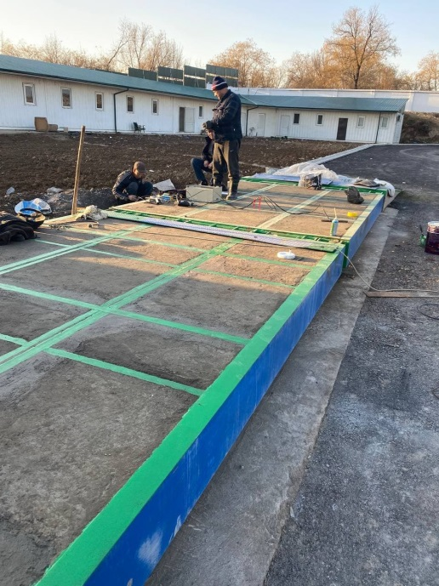 | 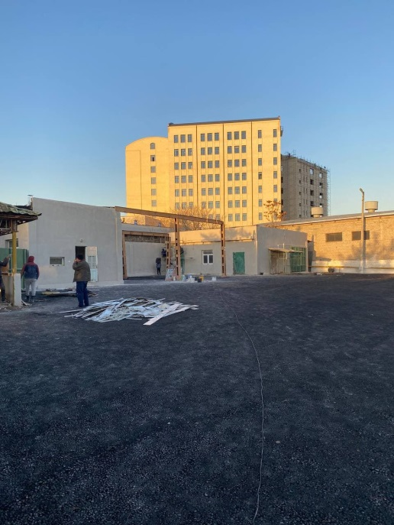
Yakkasaray Transfer Station (the completed facilities):
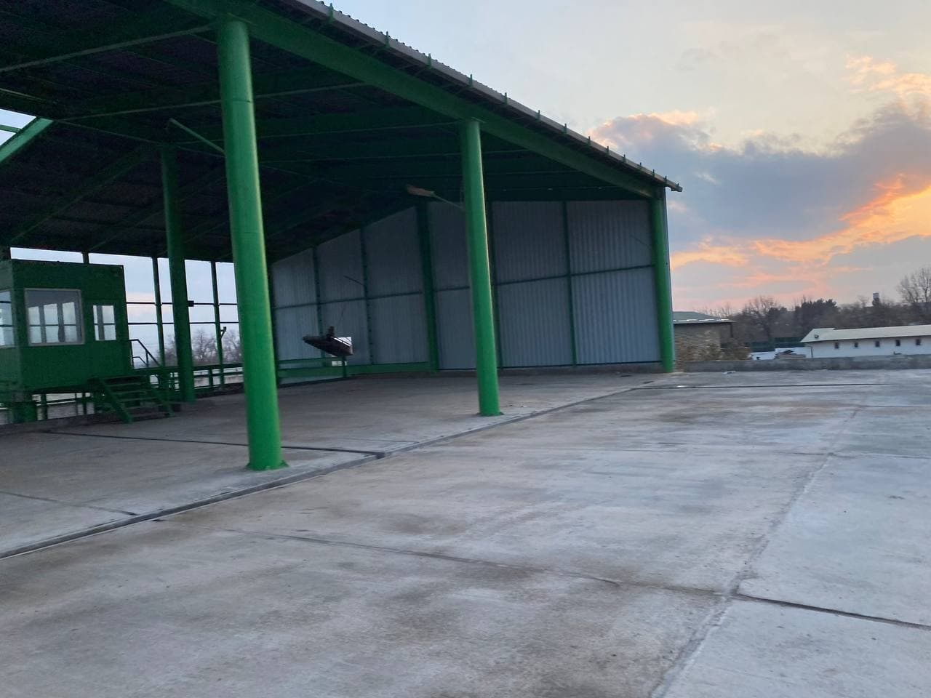 | 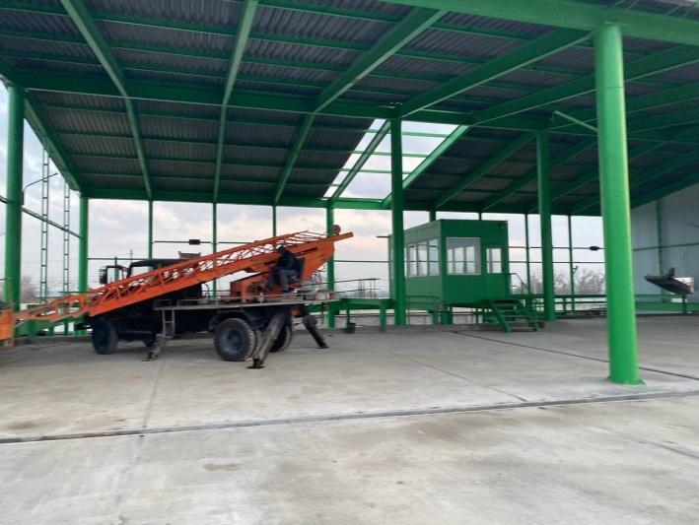
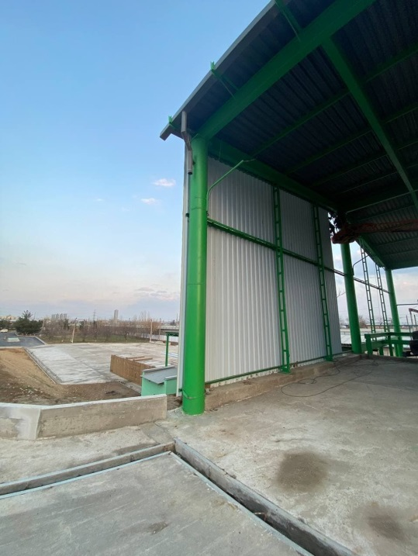 | 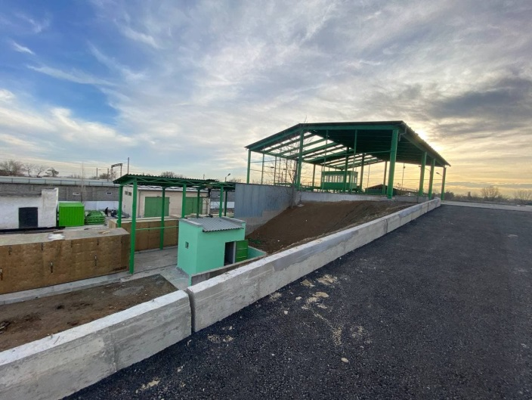
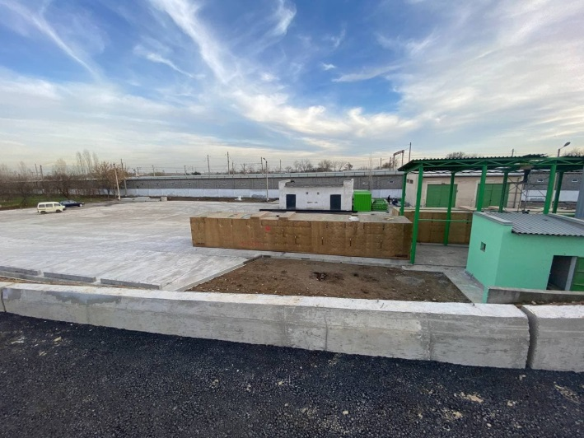 | 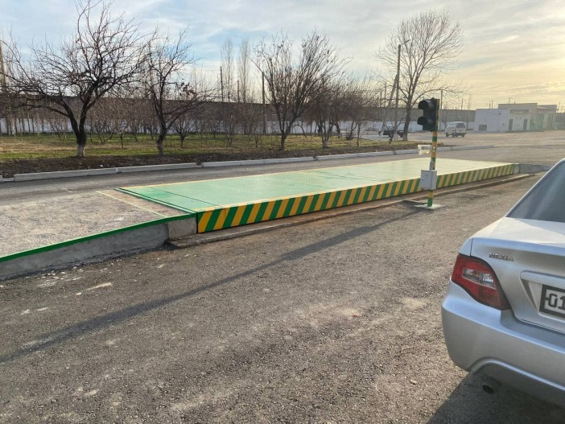
Yunusabad Transfer Station (the construction phase):
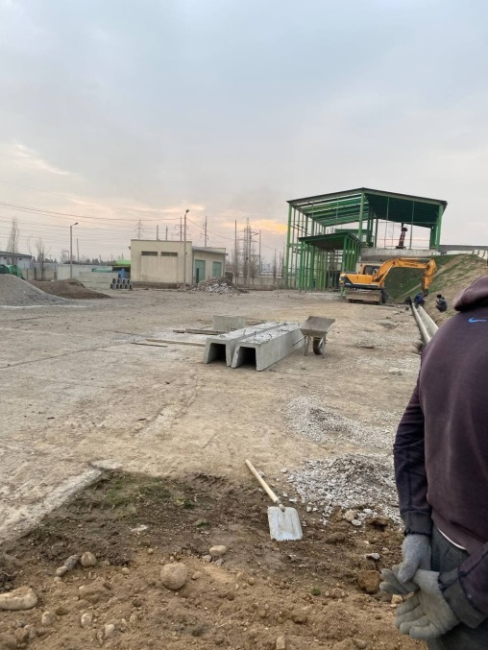 | 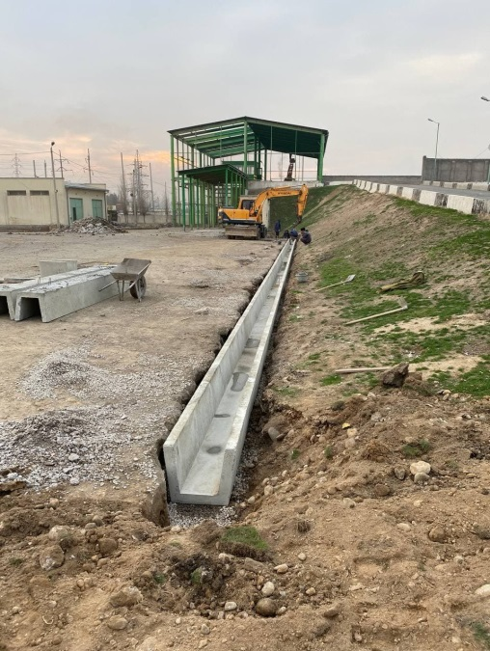
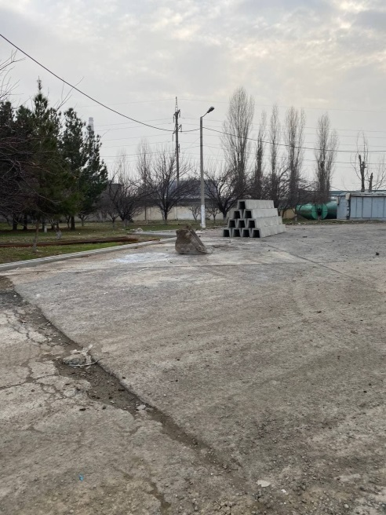 | 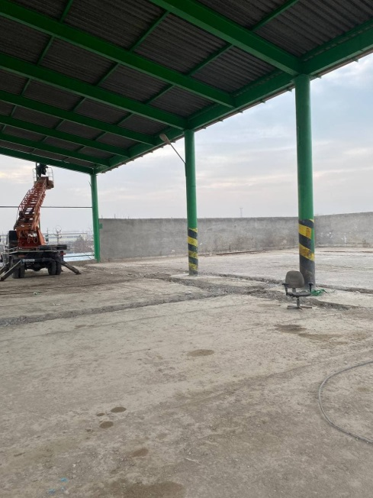
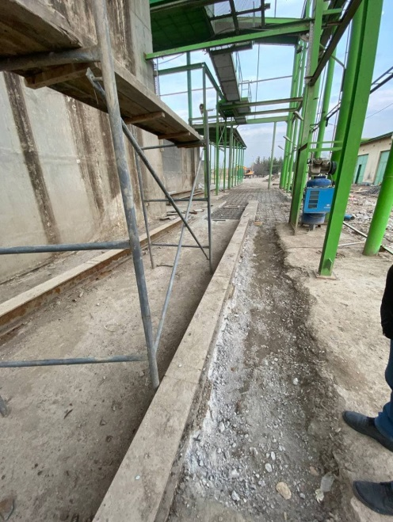 | 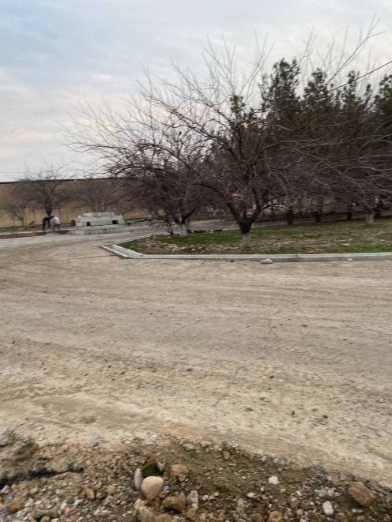

Garage Rehabilitation (Contract CW4)
- PIU Support Consultant’s Environmental Specialist visited Mirabad and Bektemir garages where the works under the contract No. SUE/Maxsustrans/NCB-W4 were continued. Mr. Karandaev conducted visual assessment of impacts related to garage reconstruction in August, October and December 2021. The civil works were completed in both garages of Maxsustrans by the end of December 2021. In the pictures below there are on-going works and completed facilities in both garages. To the moment, the works commissioning is going on. Necessary precautions are taken to ensure effectiveness of environmentally appropriate systems of collecting, transporting and depositing of construction wastes.

Mirabad Garage (the construction phase):
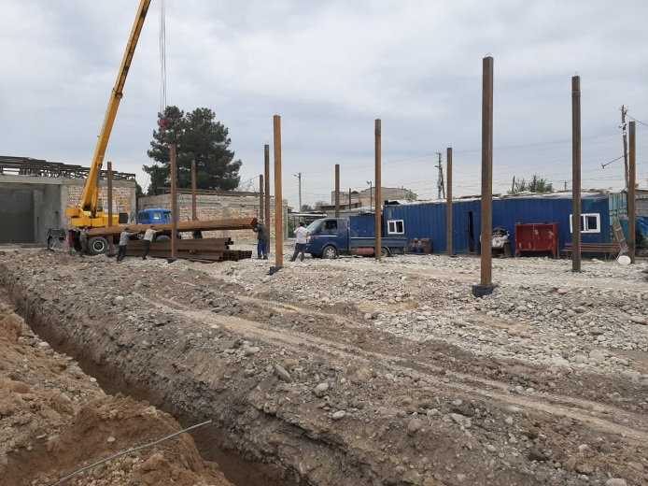 | 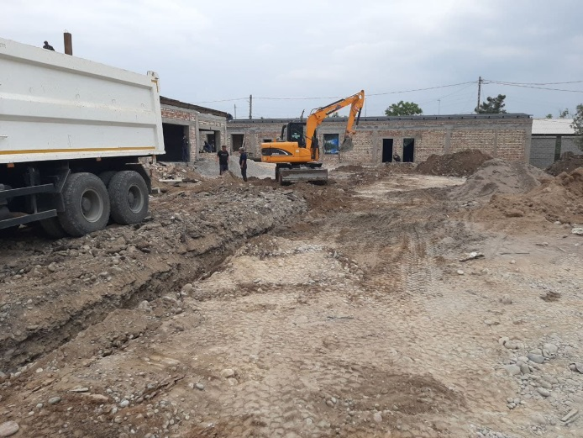
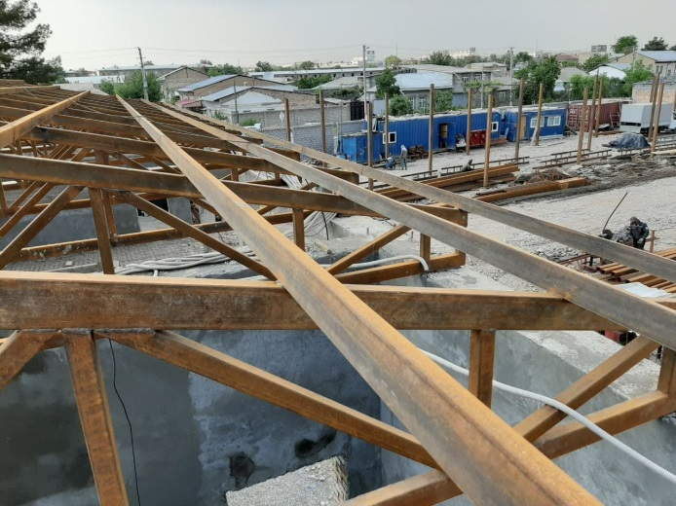 | 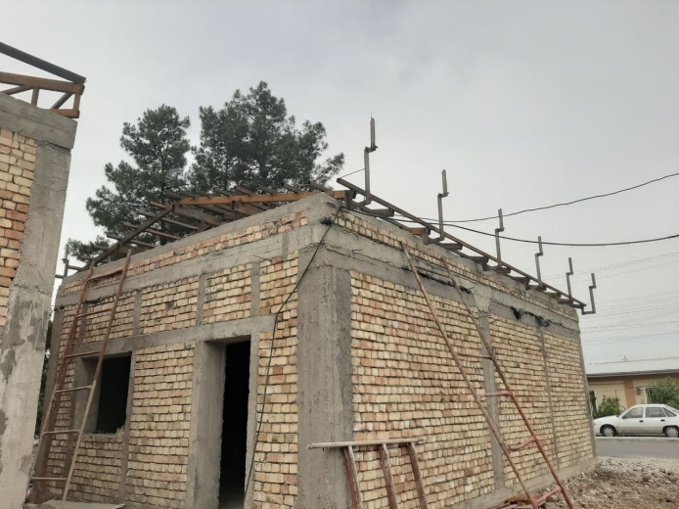
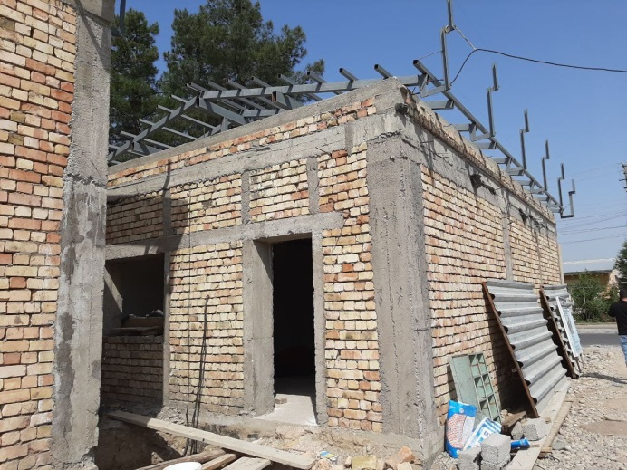 | 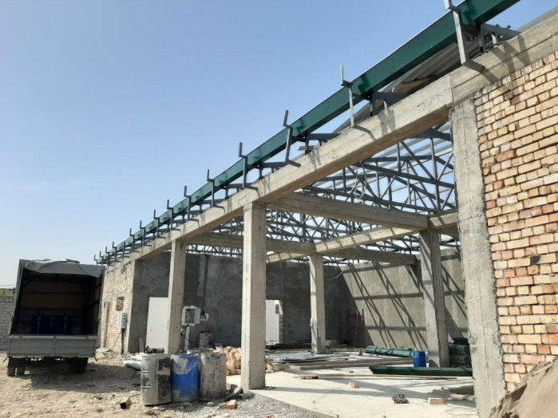
Mirabad Garage (construction completed):
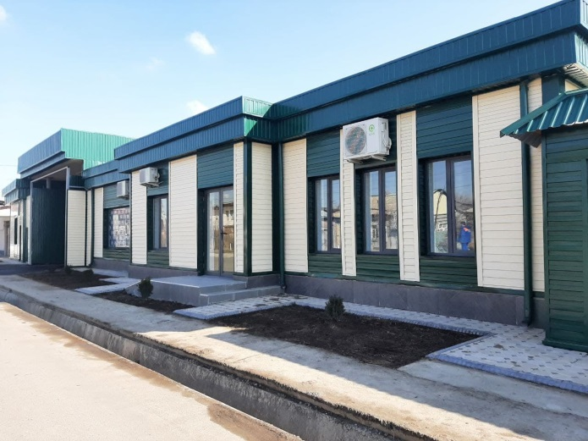 | 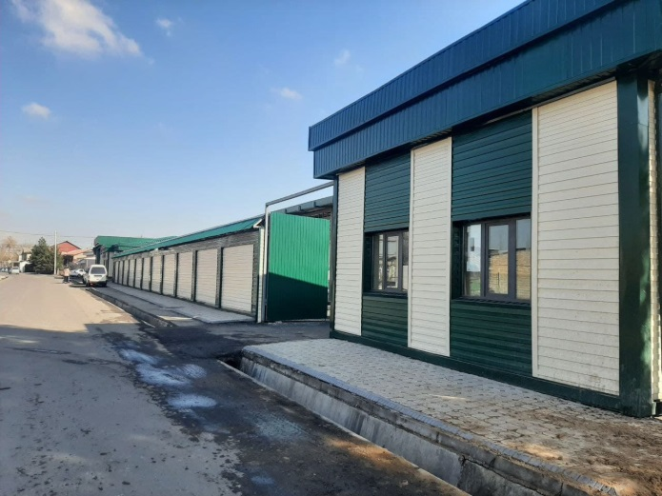
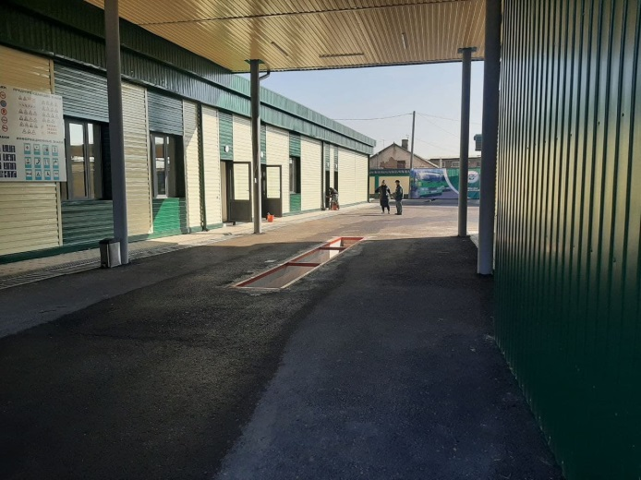 | 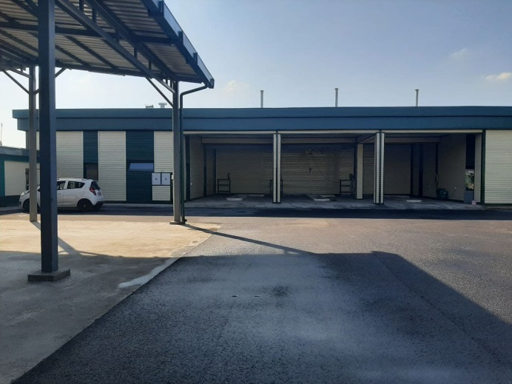
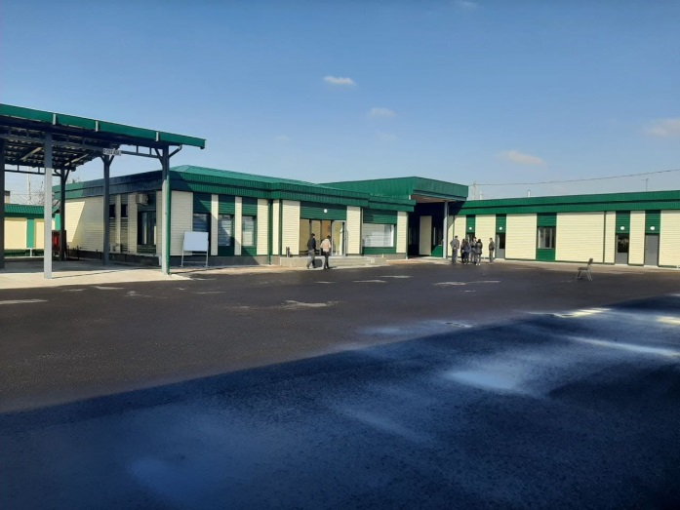 | 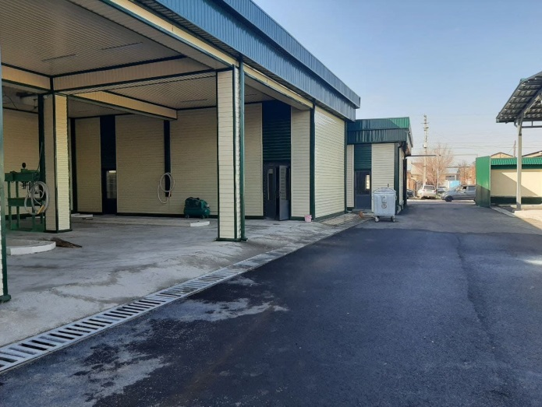
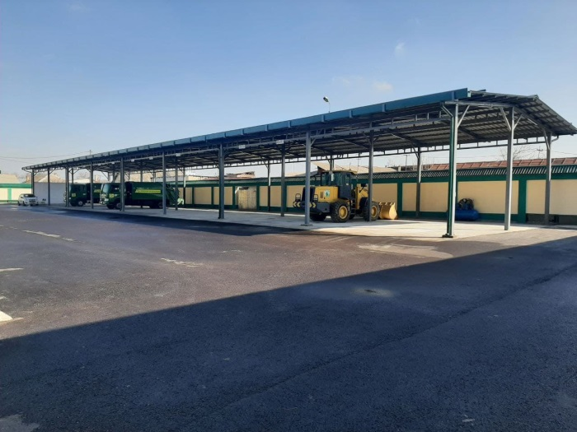 | 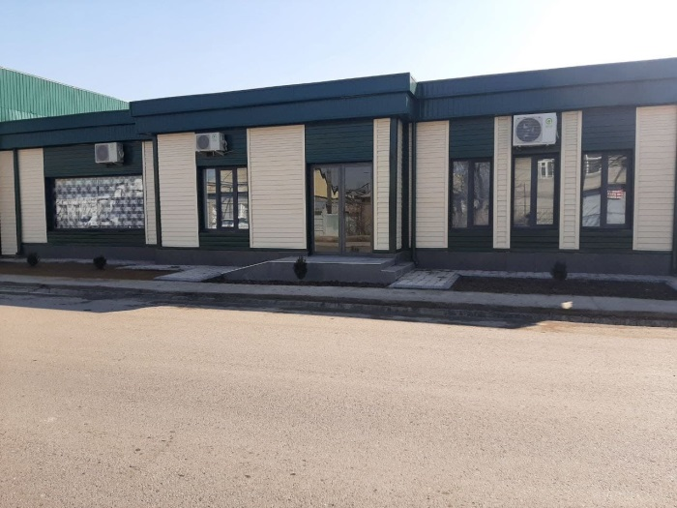
Bektemir Garage: (the construction phase):
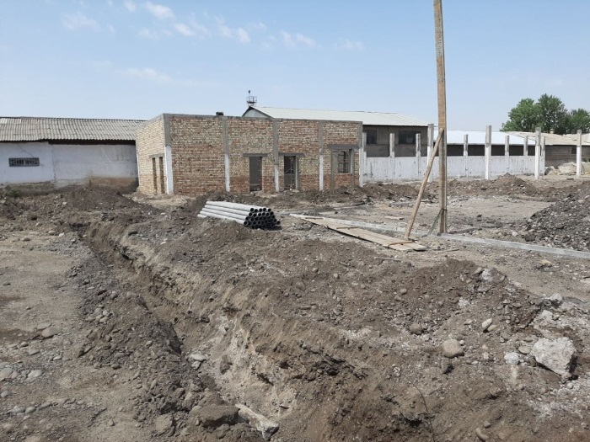 | 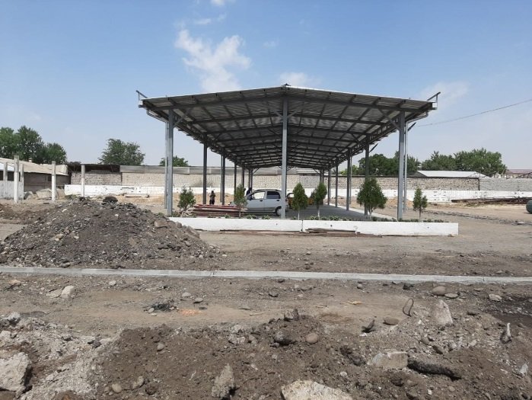
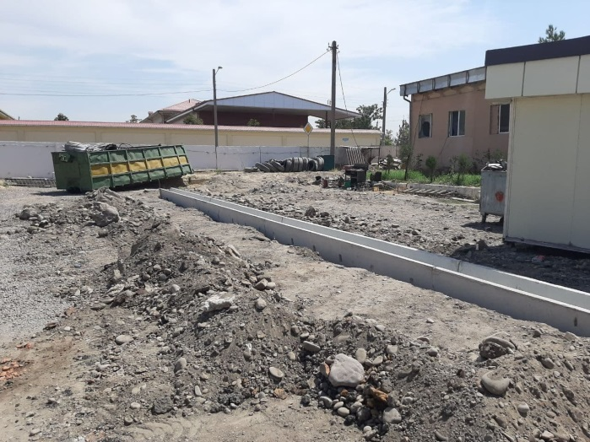 | 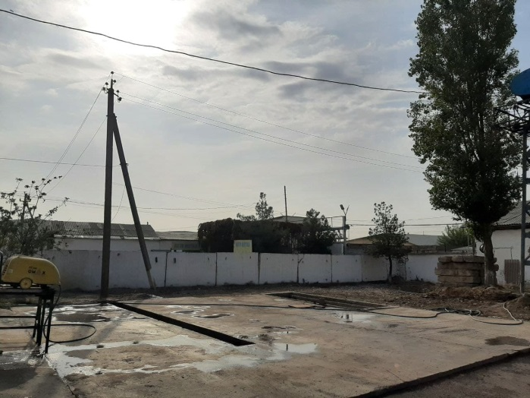
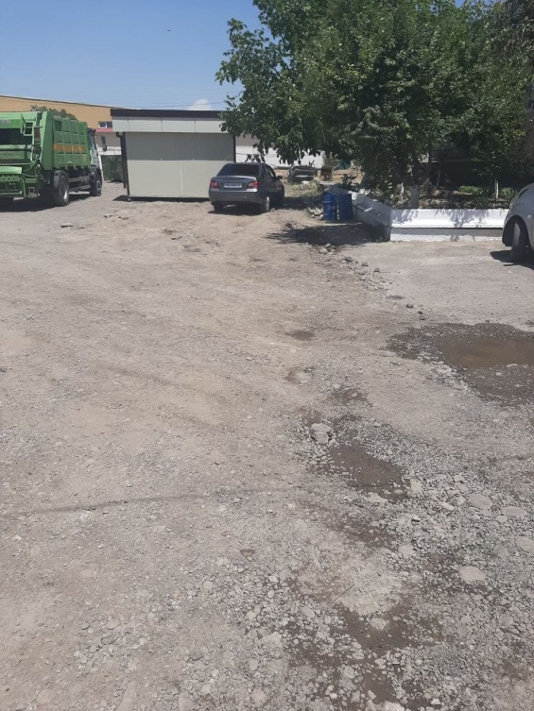 | 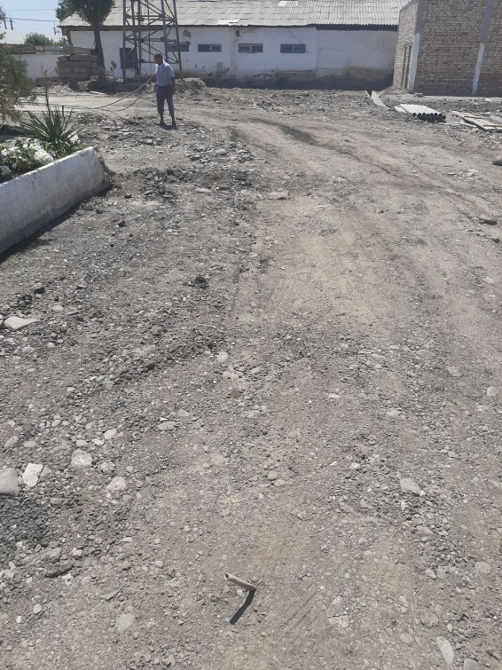
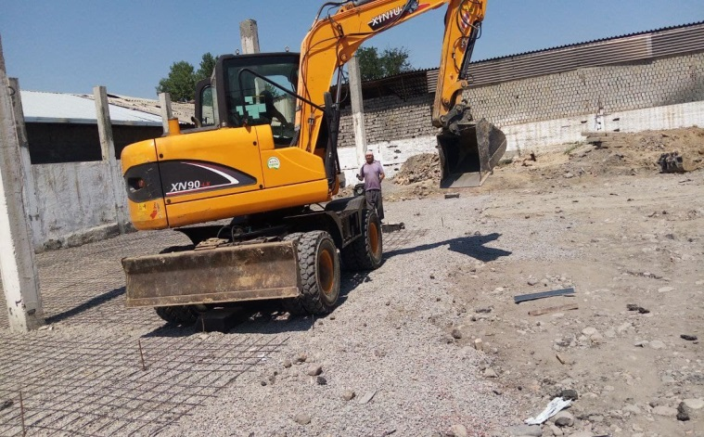

ADB Missions
- There was not any ADB environmental & safeguard related field mission in this reporting period due to COVID -19 pandemic related restrictions.

Issues Tracking (Based on Non-Conformance Notices)
- There was no issue identified during the previous monitoring period (before December 2021).
Table 7. Implementation Status of Corrective Actions proposed in the previous monitoring report(s)
Issue | Required Action | Responsibility | Timing (Target Dates) | Description of Resolution and Timing (Actual) | If not yet resolved, indicate the reason why and specify further required action and timeframe.
The updated EIA of construction of new landfill site required by the national regulation has not been prepared  (raised in the SAEMR for July - December 2020). | An updated EIA of construction of new landfill should be prepared for further approval by the State Committee of Ecology and Environmental Protection (SCEEP) before construction works. | Maxsustrans together with recruited local firm and with support by CUCD Consultant | November 2021 | Partially RESOLVED.  The updated EIA is prepared by the recruited specialized firm in November 2021, however, set of appropriate documents needed for formal submission to SCEEP shall be prepared and submitted to SCEEP in February 2022. | Set of appropriate documents needed for formal submission to SCEEP will be prepared by 20 Feb 2022.
Approval of the updated EIA by SCEEP has not been obtained (raised in the SAEMR for July - December 2020). | Approval of the updated EIA of construction of new landfill should be received from SCEEP. | Maxsustrans (with CUCD Consultant’s support) | December 2021 | NOT RESOLVED:  Scheduled for March 2022, i.e. 28 days after submission of formal application to SCEEP | The reason for delay with state expertise is a long time for agreement procedures with local residents/ communities and district administration, which delayed submission of EIA to SCEEP’s review and expertise. Full set of documents will be submitted to SCEEP by 20 Feb 2022. SCEEP’s approval is expected by 20 Mar 2022.
The PAM (Solid Waste Management Improvement Project: Project Administration Manual | Asian Development Bank (adb.org)) requires “international safeguards specialist” to monitor and report the environmental safeguard activities of the Project  (raised in the SAEMR for July -December 2020). | During the construction works on new landfill site, which is scheduled from January 2022 + 18 months, monitoring and reporting on environmental safeguard activities should be performed by international environmental specialist of Landfill Design and Supervision Consultant (CUCD).  Note: Up to date this task has been performed by national environmental specialist of PIU Support Consultant. In the beginning of the Project (until January 2017) this task was performed by international environmental specialist Mr. Irakli Kaveladze. | CUCD Consultant | January 2022 | NOT RESOLVED:  The civil works on new SLF not started yet. | Contract amendment with SLF Supervision Consultant, for the recruitment of international safeguard specialist, will be signed, and the international specialist will be on board prior to the commencement of CW1R civil works (expected in March 2022).
The borrower is required to disclose IEE (including the EMP) in an accessible place and in a form and language(s) understandable to affected people and other stakeholders. But this has not been done as of 30 June 2021 (see Table 6). | The IEE including EMP shall be translated in Uzbek language which is understandable to affected people and other stakeholders. The IEE including EMP shall be disclosed in the website of Maxsustrans. | Maxsustrans together with PIU and PIU Support Consultants | January 2022 | NOT RESOLVED:  Due to large size of the IEE the Borrower intends to translate in Uzbek language EMP only (Annex 6 of IEE), which is scheduled for disclosing by April 2022. | Due to work load of Maxsustrans, PIU and PIU Consultant related to Uzbek translation of the previous SAEMRs, the Uzbek translation of EMP was not possible during the reporting monitoring period. The Uzbek translation of EMP will be disclosed in April 2022.
Relevant information from environmental monitoring reports has not been disclosed in an accessible place and in a form and language(s) understandable to affected people. | In addition to disclosed English and Russian languages the following reports will be disclosed in the corporate website of Maxsustrans in Uzbek language understandable to affected people:  - Environment Impact Assessment report for New Landfill, 2013 (Russian language only)  - SAEMR for July – December 2020  - SAEMR for January – June 2020  - SAEMR for July - December 2019  - SAEMR for January – June 2019  - SAEMR for July - December 2018 | Maxsustrans together with PIU and PIU Support Consultants | January 2022 | Partially RESOLVED:  The Uzbek translation of the following monitoring reports has been disclosed during the reporting period:  - SAEMR for July – December 2020  - SAEMR for January – June 2020  - SAEMR for July - December 2019  - SAEMR for January – June 2019  - SAEMR for July - December 2018 | The Uzbek translation of the following monitoring reports shall be disclosed within the next reporting period:  - EIA for the new SLF, 2013 (April 2022)  - SAEMR for January – June 2020 (March 2022)

Trends
- During the reporting period, monitoring and audits of construction sites did not reveal any issues and complaints from the public regarding non-compliance with environmental safeguards.

Unanticipated Environmental Impacts or Risks
- COVID-19 pandemic is unanticipated impact. The detailed directions which must be followed as precaution to COVID-19 should be reflected in SEMP to be submitted by the Construction Contractor before commencement of construction activities.
- According to the ADB letter dated 01.09.2020 about the necessity of conducting COVID-19 risk assessment at the project level and updating the respective plans such as Health and Safety Plan (HSP) and Emergency Response Plan (ERP), as well as Environmental Management Plan (EMP), the PIU Support Consultant gave consultation for updating plans above.
- All H&S procedures associated with COVID-19 pandemic and recommended by WHO and Uzbek Government are addressed and followed. HSP has been updated according to the ADB request. Special COVID 19 ERP has been elaborated under contracts CW2: and CW4.
- The health and safety requirements of any construction activity must also not be compromised at this time. If an activity cannot be undertaken safely due to a lack of suitably qualified personnel being available or social distancing being implemented, it should not take place.
- Due to the outbreak of COVID-19 all over the world, the ongoing Contractors were very much conscious and proactive about the pandemic of the COVID-19 and took necessary precautionary and preventive measures. They organized special awareness meeting and training to the workers. They also adjusted work plan according to the situation and carried out appropriate precautionary and safeguard measured against spreading and infection of Coronavirus Pandemic during the reported period.
- The ongoing Contractor has taken additional protective measures against its employees. Thus, all Contractors’ employees were provided with protective/medical masks, medical gloves, and antiseptics. Every day, before the start of the working day, as well as at the end of the working day, the employee's body temperature was measured. Additional wet cleaning was carried out in the office.
- In addition, the EHS management plan should be prepared by Contractor under the contract CW1R before the commencement of works and aligned with relevant government regulations and guidelines on COVID-19 prevention and control, and with international good practice guidelines. The plan should include COVID-19 prevention and control measures, including disinfection/cleaning of offices, construction sites and labor camps, on-site temperature checks, social distancing measures, mandatory use of personal protective equipment such as facemasks, provision of hand washing stations and hand sanitizers etc., and procedures to be adopted in the event any worker is infected with COVID-19.

RESULTS OF ENVIRONMENTAL MONITORING

Overview of Monitoring Conducted during Current Period
- Initial Environmental Examination (IEE) report designed in 2013 for all phases (design, construction and operation) of the SLF and its on-site associated facilities. However, this ‘Environmental Monitoring Report’ covers only the design phase impact monitoring, as there is no construction activity.
- Current situation depend on the COVID-19 Pandemic: No significant environmental issues were flagged and no complaints received from the local residents and no adverse impacts occurred as a result of no construction activities during the reporting period.
- No specific environmental monitoring program was suggested for the closed dumpsite. In the technical specification a groundwater monitoring program (composition and level) is included covering both the closed dumpsite and the new sanitary landfill.
- There are no surface water streams in the valley where the existing dumpsite is located and no traces of surface erosion in the bottom of the valley are visible. As the precipitation in the area is very low an attempt to monitor surface water run-off (and potential leak of leachate through the slopes) from the closed dumpsite is deemed inappropriate.
- Other environmental monitoring such as noise and dust is not relevant as no activities take place on the SLF site.
- Meteorological monitoring should be included in the monitoring program and this should cover both the new landfill and the closed dumpsite.
- Most of the environmental monitoring requirements are for the construction period of project site. At the construction stage, the Contractor’s site engineer is responsible for the preparation and submission of monthly environmental supervision reports. Meanwhile, the PIU is responsible for the monitoring of environmental parameters and preparing environmental results reports. The National Environmental Specialist of PIU Support Consultant is responsible for assistance to PIU in compiling the environmental monitoring reports.
- Monitoring and reporting of the project will be conducted prior to construction, during construction and operation. The PIU shall monitor the performance and implementation of the EMPs. Monitoring reports on the performance and in implementing the EMPs, shall be prepared prior to construction (detailed engineering design and procurement stages), during construction and during project operation, as follows: i) monthly progress reports; and ii) quarterly monitoring reports to be submitted to ADB. The monitoring report/s shall also document the relevant environmental aspect and its respective mitigation measure, as well as grievances received and resolved, if any.
- Prior to commencement of any construction work, contractor has to submit a Site-specific EMP (SEMP) and compliance report to PIU ensuring that all identified impacts detailed in the environmental assessment have been undertaken. The PIU will review reports submitted by CC as soon as construction works commence.
- The PIU supposed to organize an induction training to discuss the submitted SEMP including environmental monitoring requirements and reporting of unexpected adverse impacts or impractical mitigating measures observed during the construction phase.

Trends
- Contractor’s HSE performance is generally satisfactory, relevant trainings are provided to the site staff, required documents and reports submitted, waste segregation and disposal procedure acceptable. The Works will be carried out on periodic monitoring of the construction site for compliance with the SEMP requirements by the PIU Consultant and/or SLF Design and Supervision Consultant. During the monitoring, special attention will be paid to the organization of timely waste removal, dust suppression, dump storage, health safety of workers and the local population.

Summary of Monitoring Outcomes
- Table 8 summarizes the implementation status of EMP during the monitoring period on Package CW2 and CW4.

Table 8. Implementation Status of EMP during the construction period (Packages CW2, CW4)
Impacts | Mitigation/Enhancement Measures | Compliance Attained |  | Comment on Reasons for Partial or Non-Compliance | Required Action and Target Dates to Achieve Compliance
 |  | CW2 | CW4
 | - Ensure that irrigation to affected plot/s aside from the allocated area remains unimpeded. | Yes | Yes
Construction Phase
Noise generation | - Install mufflers and silencers for machines and equipment
 | - Avoid working during rest periods / nighttime | Yes | Yes
 | - Regularly maintain equipment | Yes | Yes
 | - Establish fences around the work area as barrier | Yes | Yes
 | - Impose minimum speed limits within the project site | Yes | Yes
Flora | Re-introduce local occurring vegetative cover in areas within the SLF where it would be most appropriate. Shallow rooted vegetation is recommended | Not applicable | Not applicable
Traffic | - Regulate the entry and exit of vehicles and equipment in the construction site | Yes | Yes
 | - Properly regulate delivery of materials into the project site | Yes | Yes
 | - Impose minimum speed within the project site | Yes | Yes
 | - Do not allow vehicles to stay within the project site for a long period of time | Yes | Yes
 | - Regular monitoring to ensure that traffic flow remains optimal and clean-up of any debris can be undertaken immediately. | Yes | Yes
 | - Regular maintenance of equipment. | Yes | Yes

Material Resources Utilization
- No special licenses/permits are required for Contractors CW2 and CW4.
- Surveying and identification of all utilities were done with the participation of the relevant stakeholder. Information about use of electricity, water and construction materials during the civil works were not provided in the SEMP, because they are not subject of regular monitoring.
- As for December 2021 following materials were mobilized on site by the Contractor CW4:
Table 9. Material Mobilization CW4 Contractor
N | Materials | Unit | Quantity  (since works commencement)
1 | Cement | t | 70
2 | Sand | t | 296
3 | Steel strip details | t | 174
4 | Ferro-concrete reinforcement | t | 1 399

- As for December 2021 following materials were mobilized on site by the Contractor CW2:
Table 10 Material Mobilization CW2 Contractor
N | Materials | Unit | Quantity  (since works commencement)
1 | Soil | m3 | 3 994
2 | Sand | m3 | 75
3 | Asphalt | t | 1 573
4 | Ferro-concrete reinforcement | t | 15
5 | Concrete | m3 | 705
6 | Sandy gravel | m3 | 514
7 | PVC pipes D200 x 3.9 | m | 168
8 | Crushed stone | m3 | 295
9 | Reinforced concrete products | t | 397

- For storing and utilization scrap material the Contractor is using specially equipped site. Periodically, it is sold to the different companies according to the market price of metal.

Waste Management
- According to EMP and SEMP, all wastes from the construction sites should be disposed of in accordance with national environmental regulation. In the course of construction work, waste sometimes accumulates, including both construction and domestic waste. Waste management is organized by Contractors according to the developed Site-specific EMP. Waste segregation and disposal procedure established.

Health and Safety
- During the COVID-19 pandemic, the Contractors will ensure necessary protection to the deployed workforce and minimize the risk of spread of infection.
- These are exceptional circumstances and the contractor must always remain abreast of and comply with the latest Government advice on COVID-19.
- The health and safety requirements of any construction activity must also not be compromised at this time. If an activity cannot be undertaken safely due to a lack of suitably qualified personnel being available or social distancing being implemented, it should not take place.
- It is to be noted that emergency services are also under great pressure and may not be in a position to respond as quickly as usual.
- The Contractor site in charge should remind the workforce at every opportunity of the Worksite Procedures which are aimed at protecting them, their colleagues, their families and the population residing in the vicinity.

Training
- To increase the public safety, the Contractors provided training and awareness rising to its personnel and workers about safety at work sites before the commencement of the civil works.
- Due to the outbreak of COVID-19 all over the world, the Contractors were very much conscious and proactive about the pandemic of the COVID-19 and took necessary precautionary and preventive measures. They organized special awareness meeting and training to the workers. They also adjusted work plan according to the situation and carried out appropriate precautionary and safeguard measured against spreading and infection of Coronavirus Pandemic during the reported period.
- To ensure effective implementation of the EMP, the capacity of the PIU, contractors will be strengthened, and all parties involved in implementing mitigation measures and monitoring of environmental performance must have an understanding of the goals, methods, and the best practices of project environmental management. It will be offered series of trainings to strengthen the capacity of the PMO and IAs concerned for EMP implementation. The main training emphasis will be to ensure that the contractors and PIUs are well versed in environmentally sound practices and are able to undertake all construction and operation with the appropriate environmental safeguards.
- The training program also addresses long-term capacity building and awareness raising needs, i.e. for the operational phase of the sanitary MSW landfills. Training and awareness raising campaigns will be provided by qualified operation and maintenance experts and the consultants.
- An evaluation questionnaire will be used to assess the effectiveness of the training and the training program will be adjusted based on feedbacks. Training will be provided throughout the implementation of the project and the training program is summarized in Table 11.
Table 11: Institutional Strengthening and Training Program
Training topic | Scope of Training
Procurement and contract management | - ADB’s procurement guideline and bidding procedure  - Bidding document preparation, including EMP clauses  - Risk of improper procurement and mitigation measures  - Handling variation orders and contract management
Implementation of EMP and other health and safety requirements | - EMP contents and EMP implementation, including implementation responsibilities, environmental monitoring, supervision, inspection and reporting, consultation and participation, mechanism of EMP review, feedback and adjustment;  - Site EMP preparation and implementation reporting procedures,  - EHS considerations during project construction and operation;  - Monitoring and inspection methods, data collection and processing, interpretation of data, reporting system;  - Communication with the public by different means (innovative community-based advocacy campaigns);
Grievance redress mechanism (GRM) | - GRM structure, responsibilities and timeframe  - Types of grievances, eligibility assessment;  - Use and purpose of GRM;  - Subproject level GRM;  - ADB requirements for GRM;  - GRM procedures;  - Roles and responsibilities;
Municipal solid waste management | - Integrated MSW management system  - Kitchen waste management  - Construction waste management  - MSW reduce, reuse, and recycle  - Policies and regulations for MSW management  - MSW sorting and recycling  - MSW source utilization  - New technologies in MSW treatment and management  - Waste charging to incentivize higher waste minimization, waste reuse, and recyclingrates  - Public awareness program
Emergency preparedness and response planning | - Response mechanism to incidents such as spills  - Response plan development  - Mitigation measures for similar events  - Emergency response team, procedure and actions  - Drills of emergency response plan
Construction safety | - International and national good practice for safety at construction sites  - Policies for improving construction safety  - Safety risk and hazard assessment  - Safety training program development and implementation  - Public awareness program and education
Operation of sanitary landfill and leachate facility | - Good practice of sanitary MSW landfill management;  - O&M of sanitary MSW landfills;  - O&M of leachate facilities  - Effluent monitoring from the leachate facilities
5.8. Grievance Redress Mechanism
- A project-specific grievance redress mechanism (GRM) is established by the SUE Maxsustrans (IA) to provide a transparent mechanism to voice and resolve environmental concerns linked to the project. According to the Decree of President of the Republic of Uzbekistan SUE Maxsustrans established “People’s Reception Room” in its each district branch in Tashkent city, including one in head office of SUE Maxsustrans for PIU related queries. The IA ensures that grievances and complaints are addressed in a timely and satisfactory manner to avoid any potential delays in the establishment of the project.

Figure below gives the details of the grievance redress mechanism.
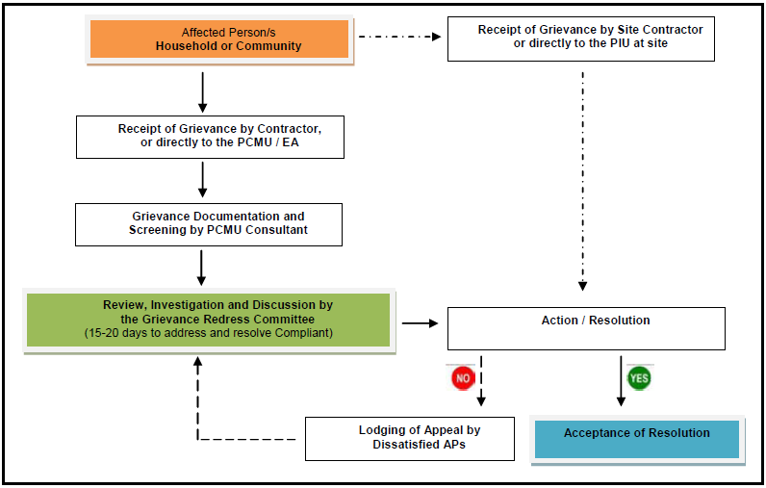
* PIU – responsible person for GRM is the Head of PIU, Mr. Jasur Hamidov, tel: +998 712473816, email: piu3067@gmail.com
PIU Consultant’s Deputy Team Leader, Mr. Dilshod Mavlyan-Kariev, tel: +998 712477923, email: dilshod75@mail.ru
Figure 1 Grievance Redress Mechanism*

- The PIU has established Grievance Redress Committee (GRC). GRC provides any affected person (AP) venue to file complaints and queries on any environmental (or social) aspect related to the project. Grievances can be submitted in writing or orally to the contractor or directly to the PIU / IA contact person. These are properly documented (i.e. indicating the date it was received, details of the complaint and complainant/s) and screened by the designated PIU safeguard consultant for its veracity and validity. The committee has 15 to 20 days to address and come up with a resolution. Under this GRM, unsatisfied grievances may be able to appeal for a final resolution. This mechanism also does not prevent any AP to approach regulatory agencies to assist and resolve complaints at any stage of the process. In occasions wherein grievances are perceived by the AP to be immediate and urgent; the contractor, EHS officer and PIU on-site supervisor will provide the most accessible and practical solution for a quick resolution of grievances. Such grievances and respective resolutions submitted to the PIU for proper documentation. The PIU contact person is responsible for recording the complaint, the step taken to address grievance, minute of the meetings and preparation of a report for each complaint. Records is kept by the PIU of all grievances received including contact details of AP, date the complaint waste received, nature of grievance, agreed remedial / corrective action and the date this was implemented, and the final outcome in Complaints Log Book kept at the PIU office.

- The complaint handling process will be reported to ADB through monitoring reports. The safeguard specialists of PIU Consultant will periodically review and record the efficiency and effectiveness of the GRM highlighting the project’s ability to prevent and address grievances.

- In period of July - December 2021 PIU Consultant’s Environmental Specialist contacted with the representatives of Tashkent Region and Akhangaran District Hokimiyats of the project area to obtain information on complaints. No complaints/addresses are received during the monitoring period. The Consultant will continue monitoring of complains under the Project at further stage of project implementation and construction works to ensure the proper and timely address any complains under the project.

FUNCTIONING OF THE SEMP

6.1. SEMP Review
- Site-Specific Environmental Management Plan (SEMP) for CW2 and CW4 were prepared to ensure compliance with the ADB’s environmental safeguard requirements and all applicable laws, regulations, and standards for environmental protection in Republic of Uzbekistan. The SEMPs contains the measures to mitigate and prevent the unwanted effects that may arise during the Project implementation, as well as the monitoring actions to check the compliance of construction works implementation process to the planned mitigation measures. The Contractor is responsible for implementation of SEMP during construction works.
- At this stage, presented mitigation measures are effective and there is no need for corrections or alternatives. So, no changes needed in the mitigation measures of the EMP at the moment.
Public Awareness Activities:
- No public awareness activities among population who lived along project sites were carried out within the project during the period of July – December 2021.
The impact of the restrictive measures of the Government of Uzbekistan due to COVID-19 pandemic has affected the work of environmental specialist on the sites in terms of ensuring disclosure of information on the EMP activities. The environmental specialist on the site was not able to fully carry out his work according to the developed environmental impact management system of the project. The public awareness activities were not carried out within the monitoring period to population who living along project sites.
Public awareness activities on the SLF site (package CW1-R) will be conducted by the Contractor, in case of commencement of civil works that is scheduled for March 2022. The environmental specialists of PIU Support Consultant and the SLF Design and Supervision Consultant (CUCD) will be responsible for monitoring and reporting on these activities on the SLF site.

GOOD PRACTICE AND OPPORTUNITY FOR IMPROVEMENT

7.1. Good Practice
- Any activity assessed as a good practice was not recorded. The mitigation measures outlined in the SEMP are sufficient, effective and acceptable.

7.2. Opportunities for Improvement
- At the moment, such areas for this construction project have not been identified.

SUMMARY AND RECOMMENDATIONS

8.1. Summary
- The issues identified during this monitoring period is summarized in Table 12.
Table 12. Issues Identified During the Monitoring Period (including the pending issues from the previous report(s))
Issue | Required Action | Responsibility | Timing  (Target Dates)
- Preparation of appropriate documents needed for formal submission of the updated EIA for new SLF to SCEEP (raised in the SAEMR for July - December 2020). | An updated EIA of construction of new landfill should be prepared for further approval by the State Committee of Ecology and Environmental Protection (SCEEP) before construction works under CW1-R. | Maxsustrans together with recruited local firm and with support by CUCD Consultant | Set of appropriate documents needed for formal submission to SCEEP will be prepared by 20 Feb 2022.
- Approval of the updated EIA for new SLF by SCEEP has not been obtained (raised in the SAEMR for January - June 2021). (raised in the SAEMR for July - December 2020). | Approval (a positive State Expertise) of the updated EIA of construction of new landfill should be received from SCEEP. | Maxsustrans with local specialized firm | The reason for delay with state expertise is a long time for agreement procedures with local residents/ communities and district administration, which delayed submission of EIA to SCEEP’s review and expertise. Full set of documents will be submitted to SCEEP by 20 Feb 2022. SCEEP’s approval is expected by 20 Mar 2022.
- The PAM (Solid Waste Management Improvement Project: Project Administration Manual Asian Development Bank (adb.org)) requires “international safeguards specialist” to monitor and report the environmental safeguard activities of the Project (raised in the SAEMR for January - June 2021). (raised in the SAEMR for July -December 2020). | Mr. Irakli Kaviladze.has performed his tasks as individual consultant - international environmental specialist until January 2017. His scope of services was to help to PIU/IA with initial monitoring and reporting on the environmental issues of the Project.  Since August 2017 up to date this task was continued by Mr. Sergey Karandaev, national environmental specialist of PIU Consultants (H.P. Gauff and Infratech Consulting). The environmental monitoring reports relating to all activities of the Project will be prepared by PIU Consultants as before, but based on inputs of international environmental specialist of SLF Design and Supervision Consultants (CUCD).  During the construction works on new SLF, which is scheduled from March 2022 + 18 months, monitoring and reporting on environmental safeguard activities and issues should be performed by international environmental specialist of SLF Design and Supervision Consultant (CUCD). | PIU, PIU Consultants, SLF Design and Supervision Consultant | Contract amendment with SLF Supervision Consultant, for the recruitment of international safeguard specialist, will be signed, and the international specialist will be on board prior to the commencement of CW1R civil works (expected in March 2022).
- The borrower is required to disclose IEE (including the EMP) in an accessible place and in a form and language(s) understandable to affected people and other stakeholders. But this has not been done as of 31 December 2021 (see Table 6). (pending since the previous monitoring period.) | Due to large size of the IEE the Borrower intends to translate in Uzbek language EMP only (Annex 6 of IEE). The EMP shall be translated in Uzbek language which is understandable to affected people and other stakeholders. The EMP shall be disclosed in the website of Maxsustrans. | Maxsustrans together with PIU and PIU Consultants | Due to work load of Maxsustrans, PIU and PIU Consultant related to Uzbek translation of the previous SAEMRs, the Uzbek translation of EMP was not possible during the reporting monitoring period. The Uzbek translation of EMP will be disclosed in April 2022.
- Relevant information from environmental monitoring reports has not been disclosed in an accessible place and in a form and language(s) understandable to affected people. (pending since the previous monitoring period.) | The following reports will be disclosed in the corporate website of Maxsustrans in Uzbek language understandable to affected people:  - EIA for new SLF, 2013  - SAEMR for January-June 2021  - SAEMR for July-December 2021 | Maxsustrans together with PIU and PIU Consultants | The Uzbek translation of the following monitoring reports shall be disclosed within the next reporting period:  - EIA for the new SLF, 2013 (April 2022)  - SAEMR for January – June 2020 (March 2022)
- The project is compiled in accordance with the planning of Tashkent, which can meet the landfill demand of domestic waste within the scope of service. From a technical and economic perspective, the project is feasible.
- The landfill capacity is about 7.66 million m³, which can meet the landfill requirements in about 10-12 years.
- The construction of the landfill has improved the utilization rate of land, prevented the domestic waste from landfilling, and reduced the secondary pollution to the surrounding environment.
- The project has convenient transportation, suitable transportation distance, suitable terrain, convenient water and electricity supply, and good construction conditions.
- The landfill adopts improved anaerobic landfill treatment technology and single-layer horizontal composite seepage control method. Flood control facilities are arranged with flood intercepting trenches. The whole engineering design process is mature and reliable.
- The detail design (DD) for the New Sanitary Landfill has been finalized in August 2019. All documents have been submitted to the state expertise for expert review and opinion. This is necessary prior announcing the project for international tendering and submitting the corresponding bidding documents.
- As soon as construction works commence (estimated Q1 2022), environmental monitoring will be continued.
- Action plan for the reporting period from January – June 2022 and after:
# | Action | Time frame | Responsibility
1. | Semi-annual Safeguard Compliance and Monitoring Reports | July 2022 | PIU Support Consultants’ National Social Safeguards and Development Specialist
2. | Collect and provide the relevant information on environmental indicators to PIU. | Permanent ongoing | PIU Support Consultants’ National Social Safeguards and Development Specialist
3. | Other routine issues like unscheduled site visits, follow up of the detected defects, environmental assessment of designs. | Upon the need | PIU Support Consultants’ National Social Safeguards and Development Specialist
4. | Reporting on environmental safeguards | Quarterly  Semi-annually | PIU Support Consultants’ National Social Safeguards and Development Specialist
5. | Sanitary Landfill Facility Establishment and Dumpsite Closure. Reporting on environmental safeguards, Other routine issues like unscheduled site visits, follow up of the detected defects, environmental assessment etc. |  | SLF Design and Supervision Consultant  Contracted Construction Company
- Site-Specific Environmental Management Plan (SEMP) will be prepared before commencement of construction activities and during mobilization stage by Environmental Officer of the Contractor (CW1R).
- The preparation of the semi-annual environmental reports will be continued but all items / information / paragraphs, which haven’t changed or developed will not repeated as in the Report.
- The Environmental Monitoring Reports upon review and approval by ADB will be disclosed on Maxsustrans Project’s website and on ADB web-site as before.
- The next Semi-annual Environmental Monitoring Report reflecting January – June 2022 reporting period will be submitted in July/August 2022.

Annex 1: Environmental Management Plan (as BEFORE PROVIDED IN IEE)
Sources of Impact | Impacts | Type /  Degree of Effect | Mitigation / Enhancement Measures | Institutional Responsibilities | Cost
I. Pre-Construction Phase
Land Acquisition | Loss of Agricultural Land | Significant and Long Term | - Not necessary  - The landlord gives it back to the No IR impacts;  - No mitigation measures for involuntary land acquisition;  - The required lands for construction allocated from the district reserve land;  - There is no possibility of any impacts in terms of losing incomes and livelihoods.  - No grievance and complaints are received on project activity.  - Ensure clear delineation and fencing of landfill area | PIU for implementation and monitoring | Included in project Cost
Environmental and Social Monitoring and Assessment | Organizational capacity and commitment | Temporary and short term | - Establish and maintain Environmental, Social and Health & Safety Management System (ESHS). Employ EHS management staff with the Company. | CUCD | Own resources, Consultant remuneration
Occupational Health and Safety | PPE provision | Temporary and short term | - Carry out and keep updated OHS risk assessment of work places prepared by authorized consultant  - Provide PPE for the staff of Company and include in tender documents the requirement for all contractors including the municipal waste collection company to provide adequate PPE according to OHS assessment of workplaces and the local regulations. | PIU, CUCD | Own resources, Consultant remuneration
II. Construction Phase
Land clearing | Generation of fugitive dusts | Temporary but long term | - Open only one area for development on a by phase basis as planned.  - Minimize movement of vehicles inside the construction area  - Cover exposed areas with tarps or similar materials / application of slope stabilization materials  - Establish buffer zones and fences | Contractor/ CUCD to monitor for compliance and reporting to IA / SCEEP (State Committee on Ecology and Environmental Protection | Include such measure in the Contractor’s TOR
 | Noise generation | Temporary and short term | - Notify the affected communities, adequately in advance, about the expected nuisance.  - Reduce project traffic routing through community areas wherever possible.  - Install mufflers and silencers for machines and equipment  - Avoid working during rest periods / night time  - Regularly maintain equipment  - Establish fences around the work area as barrier  - Impose minimum speed limits within the project site | Contractor / CUCD  to monitor for compliance and reporting to IA / SCEEP | Include such costs in the Contractor’s contract
 | Possible Soil erosion | Short-term and temporary | - Contain excavation and other similar activities within design boundaries  - Immediately stabilize areas once cut and fill activities are completed  - Introduce vegetative cover in areas that will remain permanently open  - Cover with pebbles or gravel areas that are to remain open for a long period of time  - Peak Ground Acceleration (PGA) values for the site should be determined and incorporated in the design. | Contractor / CUCD  to monitor for compliance and reporting to IA / SCEEP | Include such measure in the Contractor’s TOR
 | Waste | Temporary and short term | - Ensure that all hazardous waste from temporary storage facility located at the landfill is sent to an appropriate final disposal facility | Contractor / PIU | Management time, as per con-tract
 | Flora | Temporary and short term | - Re-introduce local occurring vegetative cover in areas within the SLF where it would be most appropriate. Shallow rooted vegetation is recommended | Contractor / CUCD  to monitor for compliance and reporting to IA / SCEEP | Include such measure in the Contractor’s TOR
 | Traffic | Temporary and short term | - Regulate the entry and exit of vehicles and equipment in the construction site  - Properly regulate delivery of materials into the project site  - Impose minimum speed within the project site  - Do not allow vehicles to stay within the project site for a long period of time  - Regular monitoring to ensure that traffic flow remains optimal and clean- up of any debris can be undertaken immediately.  - Regular maintenance of equipment. | Contractor / CUCD to monitor for compliance and reporting to IA | Include such measure in the Contractor’s TOR
 | Occupational health and safety | Temporary and short term | - Induction and orientation meetings will be undertaken by all workers. Tool box talks are also recommended.  - Only qualified workers will be hired  - Strictly impose and monitor use of PPE by workers. Regular inspections will be conducted.  - Provide HSE manuals and require placement of safety signs and placards  - Restrict movement of personnel in danger zones  - Insurance Policy for Workmen Compensation should be provided.  - Conduct awareness and training programs on safety and health issues to be handled by the designated HSE Officer. | Contractor / CUCD to monitor for compliance and reporting to IA | Include such cost / measure in the Contractor’s contract
Community Impacts | Community health, safety and security | Temporary and short term | - Develop and implement procedures for protecting public health and safety (e.g. traffic management plan, fencing, drivers training program, pedestrian access and trespassing plan, road design, slope stability, clean-up of spills, well visible signage, awareness-raising) | Contractor / CUCD  to monitor | Include such cost  / measure in the Contractor’s contract
 | Loss of income of informal waste pickers |  | - Identify alternative livelihood options for the waste pickers in accordance with the principles of livelihood framework prepared as above and in consultation with the affected people. | Local Hokimiyat | Consultant remuneration
Closure of the existing dumpsite |  | Temporary and long term | - Conduct a detailed site assessment covering the entire 59 ha  - Development of a ‘safe closure plan’  - Adequate and prompt covering and compaction to prevent exposure of wastes  - Induction and orientation meetings with special focus in the use of PPE will be undertaken by all workers.  - Require placement of safety signs and placards  - Conduct of post-closure environmental monitoring Maintenance of installed facilities.  - Precautionary measures should be taken to ensure uncontrolled fires are not started as a consequence of the closure activities. | Contractor / CUCD  to monitor for compliance and reporting to IA  / SCEEP  Post closure management shall be handled by the IA / PIU | Include such cost / measure in the Contractor’s contract
III. Operation Phase
Operation of the SLF | Air Emissions / Air Quality | Permanent and long term | - Gas emission (i.e. generation of objectionable odors) from the landfill is expected to be moderate.  - Provide all employees with appropriate PPE  - Monitor air quality based on a specified in the monitoring program  - Regulate movement of vehicles inside the landfill to minimize emissions | PIU and SCEEP for monitoring | Cost should be included in the operating budget
 | Health & Safety | Significant, permanent and long-term | - Strictly impose and monitor use of PPE by personnel especially those engaged in the handling of wastes  - Provide and require safety signs and manuals  - Restrict movement of personnel in danger zones  - HSE manual and Insurance Policy for Workmen Compensation should be provided.  - Conduct awareness and training programs on safety and health issues  - Make available first aid kits in the landfill area  - Make available a vehicle that can bring victims to hospitals  - Strictly monitor the entry and exit of outsiders inside the landfill  - Precautionary measures should be taken to ensure uncontrolled fires are not started as a consequence of operational activities. | PIU and PIU Consultant for monitoring | Cost should be included in the operating budget
 | Noise | Insignificant, long term and permanent | - Install mufflers and silencers for machines and equipment  - Avoid working during rest periods  - Regularly maintain equipment  - Impose minimum speed limits within the project site | PIU and SCEEP for monitoring | Cost should be included in the operating budget
 | Groundwater quality | Significant, permanent, long term | - Use of HDPE liner and establish leachate collection and treatment system as designed and planned  - Monitor leachate quality, if any  - Ensure that no leachate percolate into the ground by consistently conducting quality checks of liner prior to disposal.  - Ensure that all leachate are collected and treated  - Properly cover the landfill after the cell is filled  - Introduce vegetative cover in areas where it would be applicable to promote evapo-transpiration and re- direct portions of the precipitation. | PIU Consultant, PIU and SCEEP for monitoring | Cost should be included in the operating budget
 | Vermin & other pests | Significant, temporary and short term | - Ensure that all containers are properly enclosed to avoid manifestation  - Covering should be done every end of the day’s operations | PIU / SCEEP for monitoring | Cost should be included in the operating budget
Operation of the SLF | Traffic | Significant, long term and permanent | - Regulate the entry and exit of vehicles and equipment in the SLF  - All dump trucks should carry a waste manifest / legal papers to avoid long stand by times at the gate.  - Impose minimum speed within the project site.  - Do not allow vehicles to stay within the project site for a long period of time  - Proper maintenance of the internal road network.  - Employ a traffic management system at the ingress/egress of the project site. A traffic circulation plan should be developed not to hamper the traffic flow. | Local authorities | Cost should be included in the operating budget
Operation of auxiliary facilities (e.g.  Leachate Treatment Plant) | Air Emissions | Significant, permanent and long term | - Foul odors are expected to be a permanent feature of the plant. It is therefore necessary that most appropriate ventilation system is implemented. This system should also maintain the appropriate air exchange ratio to minimize stagnation within the plant.  - provide all employees with appropriate PPE  - monitor air quality (indoor and outdoor) based on a specified in the monitoring program  - Regular monitoring for any leaks (loss in pressure) and/or for spills | SCEEP for monitoring | Included in the operating budget
 | Health & Safety | significant, permanent and long term | - Training for personnel pertinent to operations and maintenance.  - Provide the necessary PPE and strictly impose and monitor its use by employees  - Provide require safety signs and placards and restrict movement of personnel in danger zones  - Conduct awareness and training programs on safety and health issues  - Make available first aid kits  - Strictly monitor the entry and exit of outsiders inside the facility | Consultant, PIU/ SCEEP for monitoring | Included in the operating budget
Operation of auxiliary facilities (e.g. leachate treatment plant) | Groundwater quality | Moderate, permanent and long term | - Ensure that all containers and tunnels are properly sealed  - Ensure no leakages in the containers  - Whenever applicable, all floors must be properly sealed  - Ensure that leachate and other spills are properly collected and not disposed in sensitive areas  - Water usage shall be monitored. | Consultant, PIU/ SCEEP for monitoring | Cost should be included in the operating budget
 | Noise | Insignificant, negligible and short term | Note: There are no sources of high level noise from the operation of the plant.  Whenever excessive noise is to be generated, this will be short term. | PIU and SCEEP for monitoring | Cost should be included in the operating budget
 | Vermin & other pests | Insignificant, negligible and short term | The presence of vermin and pest will be very minimal since the facility and its equipment are totally closed. To ensure that employees are not exposed to deleterious materials;  - All workers and personnel shall be provided with appropriate PPE  - Use of the PPE must be strictly implemented and monitored. | PIU Consultant, PIU for monitoring | Cost should be included in the operating budget
IA = Implementing Agency
The Environmental Management Plan [especially for the construction phase] does not claim to be complete and can be expanded at any time according to the need and necessity.

Upon decision of the Government of Uzbekistan this Works contract was removed from ADB Project and implemented by other investment project managed by SCEEP/MIFT.
Financed by Maxsustrans own funds and removed from ADB Project
IEE link: https://www.adb.org/sites/default/files/project-document/77774/45366-004-uzb-iee-01.pdf
Contract Amendment No. 3 for increasing of the contract value and prolongation of the service period from 30 June 2021 to 30 September 2023 is under final review and signing is scheduled in February 2022.
Contract Amendment No. 2 for prolongation of the service period from 31 December 2021 to 31 March 2022 to assist in commissioning of the Works to be signed.
Contract Amendment No. 1 for increasing of the contract value up to 10,391,841,557.73 Uzbek Sums (equiv. $962,000.00) and prolongation of the construction period from 15 August 2021 to 31 December 2021 is signed on 24 December 2021.
ADB. Loan Agreement for L3067-UZB: Solid Waste Management Improvement Project (SWMIP): https://www.adb.org/projects/documents/loan-agreement-solid-waste-management-improvement-project
Based on Table 8 of the previous monitoring report: Solid Waste Management Improvement Project: Environmental Monitoring Report (January - June 2021) | Asian Development Bank (adb.org)
The original EIA of construction of new landfill in Akhangaran district of Tashkent province has been prepared and approved by SCEEP in 2013. According to Decree of the Cabinet of Ministers of Uzbekistan from 07.09.2020 No. 541 “About further improvement of environmental impact assessment mechanism” a positive conclusion of the State ecological expertise is not legally valid, when the construction works has been not implemented during the three years since its issuing. In this case, the conclusion of the State ecological expertise shall be reviewed by the specialized expert branch office of the State Committee of Ecology and Environmental Protection of Uzbekistan (SCEEP), which has issued the previous conclusion before. The specialized firm shall examine (update) the environmental impact assessment items and environmental norms based on design outputs and current status on the site to the date of submission of the application to SCEEP.
The Contract (CW1R - Establishment of Sanitary Landfill) is planned to be signed in January 2022. EHS management plan to be prepared during the pre-construction phase.

