Solid Waste Management Improvement Project
ADB Loan No.: 3067-UZB

PROJECT MANAGEMENT, IMPLEMENTATION AND SUPERVISION CONSULTANCY SERVICES

Contract No.: SUE/Maxsustrans/QCBS-Cons_1-2016-01

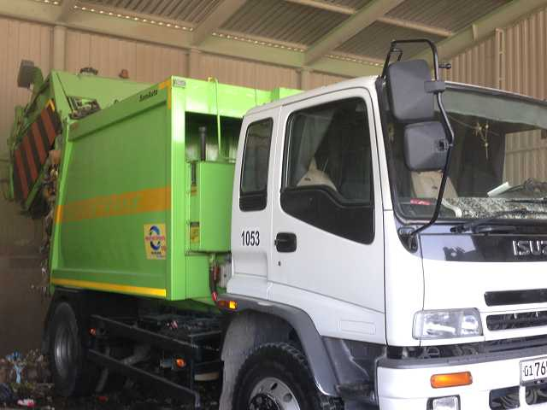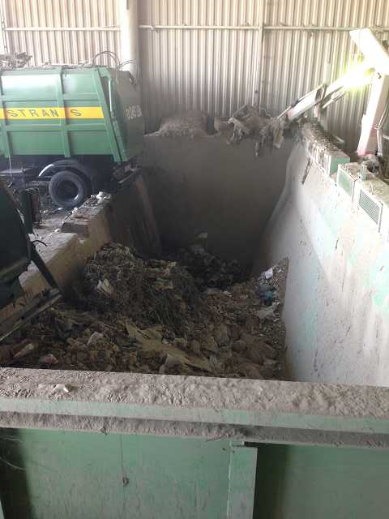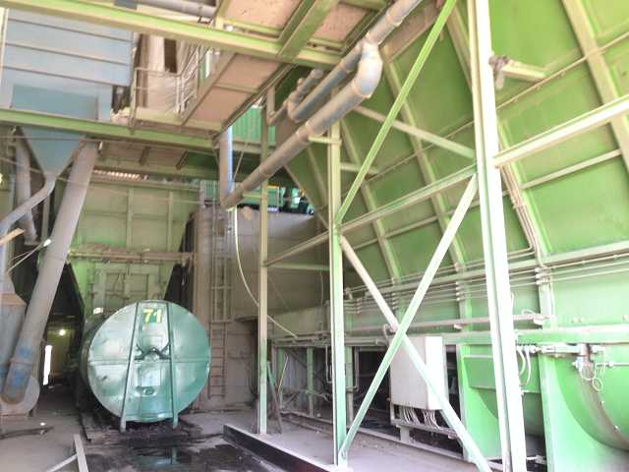

Quality Assurance Plan
[October 2017]

CLIENT – IMPLEMENTING AGENCY
State Unitary Enterprise (SUE) “MAXSUSTRANS” (Tashkent, Uzbekistan)
LEAD CONSULTANT
H.P. Gauff Ingenieure GmbH & Co. KG-JBG (Germany)
in association with
ENG-INVEST Consulting Ltd. (Uzbekistan)
Quality Assurance Plan
______________________________________________________________

Reporting period: August-October 2017 (QR- 2017/1)
Loan Number: 3067-UZB

Republic of Uzbekistan: Solid Waste Management Improvement Project

Financed by: Asian Development Bank

Prepared by H.P. Gauff Ingenieure GmbH & Co. KG – JBG- (Germany) and ENG-INVEST Consulting Ltd. (Uzbekistan) for “State Unitary Enterprise “Maxsustrans” and Tashkent Municipality and the Asian Development Bank.
This “Project Progress Report” is a document of the borrower. The views expressed herein do not necessarily represent those of ADB’s Board of Directors, management, or staff, and may be preliminary in nature.
In preparing any country program or strategy, financing any project, or by making any designation of or reference to a specially territory or geographic area in this document, the Asian Development Bank does not intend to make any judgments as to the legal or other status of any territory or area.

Revision Record
Revision No | Page No | Description of Revision | Date | PM Signature
R0 | All | Initial issue

Contents
Revision Record 2
Contents 3
1. Introduction 5
2. Project Brief 5
3. Validity and Revision of Quality Plan 5
4. Contract Data 5
4.1. Name of the Project 5
4.2. Governing Language 5
4.3. General Information on Project 6
4.4. Project Organization and Technical Interfaces 7
4.5. Scope of Services 7
5. Project Team and Roles & Responsibilities 8
5.1. Senior Personnel 8
5.1.1. SWM Specialist – Team Leader (international) 8
5.1.2. SWM Engineer (international) 8
5.1.3. Procurement Specialist (international) 8
5.1.4. SWM Specialist – Deputy Team Leader (national) 8
5.1.5. Financial Management Specialist (national) 8
5.1.6. Procurement Specialist (national) 9
5.1.7. Social Safeguard and Development Specialist (national) 9
5.1.8. Environmental Specialist (national) 9
5.2. Supporting Staff 9
6. Communications Management 9
6.1. Client Agent 9
6.2. Maxsustrans 10
6.3. Consultant 10
7. Document Management 10
7.1. Filing 10
7.1.1. Electronic filing 10
7.1.2. File structure 11
7.1.3. File names 11
7.2. Revision 11
7.2.1. Document Control 11
7.2.2. Revision code 11
7.2.3. Documents requiring revision code 11
7.2.4. Superseded documents 11
7.3. Checking 11
7.4. Review 14
8. Methodology 14
9. Work Plan 14
9.1. Project Work Plan 14
9.2. Project Schedule 14
9.3. Progress Monitoring 14
10. Resource Schedule 14
11. Risks 14
12. Health & Safety 15
12.1. General 15
12.2. Safety Equipment 15
13. Environment 15
14. Forms 16
14.1. Document Control Form 16
14.2. Design Review Certificate 17

Introduction
This Quality Plan (QP) is based upon the generic Quality Management System (QMS) adopted by H.P. Gauff Ingenieure GmbH & Co. KG –JBG- and ENG-INVEST CONSULTING, with amendments to incorporate the relevant provisions of the Gauff QMS. The (QMS) follows the requirements of to ISO 9001: 2008.
This Quality Plan defines the activities in the process of converting the Client’s requirements into product documents. These activities include:
- Planning;
- Identifying the design inputs;
- Design studies and quality control;
- Review;
- Verification;
- Implementation;
- Standard forms; and
- Management of revision.

Project Brief
The Project is for works under the Task order in the Scope of Works (SOW).
Scope of Works incorporates the Terms of Reference for “PIU Support for Project Management, Implementation and Supervision Consulting Services”.

Validity and Revision of Quality Plan
This Quality Plan and subsequent revisions become valid when the Quality Control Manager (QCM) puts his signature on the Revision Record. The Quality Control Manager keeps the original copy and distributes copies electronically in PDF format to the relevant staff, i.e. authenticated revisions and Quality Control Manager-signed copies are used by the relevant staff.
The initial issue of this Quality Plan is revision R0. Any revisions in later stages of the project will be referred to by incremental revision reference numbers and date of revision. Responsibility for revisions rests with the Quality Control Manager.
In the event of revision, distributed copies of previous versions will be destroyed.

Contractual Data

Name of the Project
Project Implementation Unit (PIU) Support for Project Management, Implementation and Supervision Consulting Services, hereinafter referred to as ‘the Project’.

Project components
- Project Management
- Procurement packages:
- Supply of Goods Packages;
- Civil Works Packages;
- Construction Supervision Monitoring
- Contracts Administration
- Safeguards Implementation, Monitoring and Evaluation
- Media and Public Relations

The Client
The name of the Client is State Unitary Enterprise (SUE) “MAXSUSTRANS”

Governing Language
The language governing the Project is English.

Scope of Services
The key objective of this assignment is to provide project management, implementation and supervision support to the PIU of the SWMIP on behalf of Tashkent Hokimiyat Municipality and State Unitary Enterprise (SUE) “MAXSUSTRANS” and to improve where necessary the project management capability of the SUE “MAXSUSTRANS” and PIU.

Solid Waste Management Improvement Project (SWMIP) is to contribute to the following issues:

- Segregation of Municipal Solid Waste stream;
- Proper collection and dumping to appropriate sites
- Establishment of modern SWM systems
- Remediation of old 'truck and dump' practices in cities and regions

Therefore, the project objective can be defined as follows:

- Technical, economic and financial feasibility;
- Focus on testing least cost technical solutions based on international standards ,
- Operate on the principles of waste minimization and material recycling
- To achieve efficient collection, transfer and disposal of residual waste that meet acceptable standards of environmental protection

Project Management

To prepare necessary project plans, progress reports, payment certificates, provisional and final takeover certificates, claims evaluation reports, project final reports and any other project management documents as required in accordance with good practice, including SUE “MAXSUSTRANS” and ADB requirements.

Procurement

Assistance to PIU in preparing bidding documents and tendering process in accordance with the agreed Procurement Plan updated during implementation and ADB Procurement Guidelines. The Consultant will assist the PIU in carry out the following procurement packages:

- Supply of Goods Packages;

- Package G1 - Landfill Equipment and Machinery;
- Package G2 - Waste Collection Trucks and Transfer Trucks (Trailers and Containers); and
- Package G3 -Waste Collection Bins (750 Liters and 1100 Liters in 2 Lots)
- Package G4- Other Equipment (PIU Support) – completed
- Package G5 -Other Equipment (EA support) – completed

- Civil Works Packages;

- Package CW1 – Sanitary Landfill Establishment;
- Package CW2 - Transfer Station, Garage Rehabilitation;
- Package CW3 - Dumpsite Closure;
- Package CW4 – Garage Rehabilitation; and
- Package CW5 – Collection Points Upgrade and Rehabilitation

Construction Supervision Monitoring

The Consultant will assist the PIU with the oversight of all the construction activities particularly of the civil works packages. These include;
- Review of the designs and works that are performed in conformity to the As Built designs,
- Develop and implement construction quality assurance program,
- Monitor contractors work schedule,
- Monitor supply activities particularly with Uzbekistan Customs Clearances, and
- Address shortcoming in any of these areas.

Contracts Administration

The Consultant will assist the PIU in the administration of the Goods and Civil Works contracts listed above in chapter 4.4.2. of Procurement

Safeguards Implementation, Monitoring and Evaluation

The Consultant will assist the PIU with the implementation of project development, particularly the construction activities in accordance with ADB Safeguard Policy. The Consultant will help the PIU address environmental and social risks associated with the project implementation and provide guidance to minimize, mitigate and if not avoid adverse impacts potentially feasible.

Media and Public Relations

The Consultant will assist PIU in the awareness of the environment and social risks that may potential impacted by the project development activities. The Consultant will guide the PIU to carry out Media and Public Relations activities; carry out public consultations with potential affected people, detailed measurement surveys of lands identified for development, recommend appropriate actions that can be taken.

Project Organization and Technical Interfaces

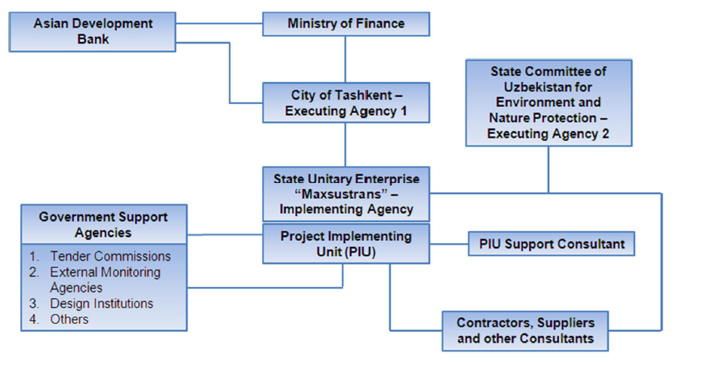

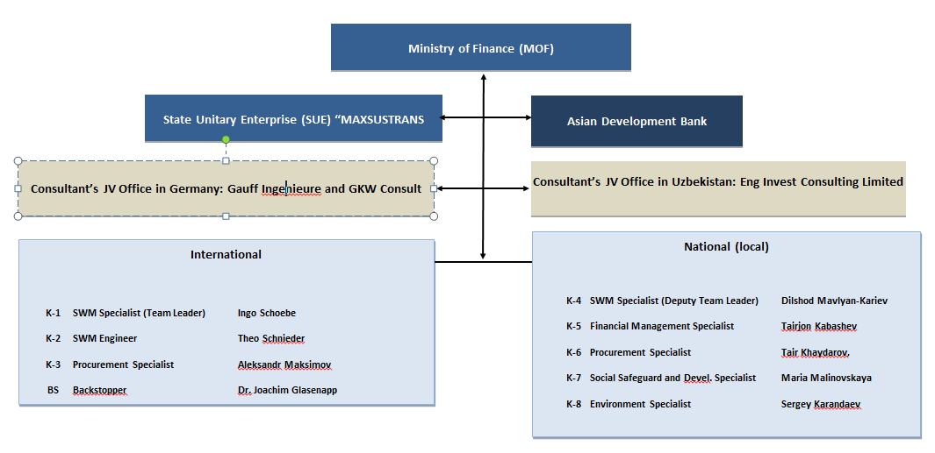

Figure 1 – Overall Project organization and technical interfaces.

Project Team and Roles & Responsibilities
The Project Team has been organized to be cost effective for the mix of skills and experience provided by international and local staff.

Senior Personnel
The following are classified Senior Personnel. Those marked ‘Key Personnel’ are subject to approval by ADB and SUE Maxsustrans.

Project Director ( PD )

For the purposes of this QP the designation PD refers to quality assurance backstopping by Gauff In Frankfurt. Tasks and Responsibilities of the Project Director include:
- Overall administration services,
- Attending the director’s meeting for verification of the work progress in conformity with the contract and the Client’s requirements,
- Acting in financial and contractual matters,
- Ensuring the fulfil of contractual obligations under the project,
- Organizing and following up every contractual tasks,
- Assigning, whenever necessary, part of his powers and responsibilities to another member of the project team,
- Ensuring staff continuity in the project,
- Commenting on work progress and any problems encountered,
- Overall coordination of transportation, accommodation and boarding, and office equipment requirements of the staff,
- Liaison with the SUE Maxsustrans in monitoring and improving the Quality Plan,
- Monitoring the customer’s satisfaction,

SWM Specialist – Team Leader (International- Key Staff)

Tasks and responsibilities will include:
Develop a comprehensive project work program and implementation schedule; Monitor project progress against plan, report on progress, and propose remedial measures as necessary; Coordinate activities of the PIU consulting team, Ensure contractor's designs and works are executed following project requirements; Develop and maintain a project safety plan. Ensure compliance with plan, Develop and maintain a project Quality Assurance plan; Ensure compliance with work plan; Provide capacity building to the national consultant team leader and PIU counterpart personnel. Overall provision and organization of reporting requirements
- Inception Report (start from Commencement Date)
- Quarterly Progress Reports
- Annual Reports
- Completion Report
- Project Work Program and Implementation Schedule
- Safeguard Compliance and Monitoring Report
- Quality Assurance Plan
- Project Coordination Mechanism
- Disbursement Requests (Withdrawal Applications) - As and when required
- Claims Evaluation Report of the Contractors- As and when required

SWM Engineer (International- Key Staff)

Tasks and responsibilities will include:
Review designs and monitor conformity with As Built drawings/designs; Supervise contractor’sworks; Monitor progress against planned works; Certify progress payments of the contractors; Ensure adherence to project safety plan.

Procurement Specialist (International- Key Staff)

Tasks and responsibilities will include:
Help PIU prepare bidding documents and tendering in accordance with ADB Procurement Guidelines; Help PIU manage the contracts; Help PIU prepare variation orders or change order requests from suppliers and contractors; Help PIU prepare overall contract awards for the project; Others tasks as when requested by Client; Provide capacity building to the national consultant and PIU counterpart personnel

SWM Specialist – Deputy Team Leader (National- Key Staff)

Tasks and responsibilities will include:
Help team leader develop a comprehensive project work program and implementation schedule; Help team leader monitor project progress against plan, report on progress, and propose remedial measures as necessary; Help team leader coordinate activities of the PIU consulting team; Help team leader ensure contractor's designs and works are executed following project requirements; Help team leader develop and maintain a project safety plan; Ensure compliance with plan; Help team leader develop and maintain a project Quality Assurance plan; Help team leader ensure compliance with work plan.

Financial Management Specialist (National- Key Staff)

Tasks and responsibilities will include:
Help PIU prepare an overall project disbursement plan, monitor costs, and maintain project accounts following accounting standards acceptable to ADB, Help PIU develop payment certification procedures, Help PIU prepare withdrawal applications and disbursement projections, Help PIU establish a computerized project accounting system.

Procurement Specialist (National- Key Staff)

Tasks and responsibilities will include:
Assist international procurement specialist prepare bidding documents and tendering in accordance with ADB Procurement Guidelines, Assist international procurement specialist manage contracts, Assist international procurement specialist prepare variation orders or change order requests from suppliers and contractors, Assist international procurement specialist prepare overall contract awards for the project, Others tasks as when requested by international procurement specialist

Social Safeguard and Development Specialist (National- Key Staff)

Tasks and responsibilities will include:
Help PIU ensure compliance with existing safeguard plans, Help PIU monitor safeguards, Help PIU ensure safeguards are complied with in accordance with ADB Safeguard Policy, Help PIU carry out media and public awareness programs

Environmental Specialist (National- Key Staff)

Tasks and responsibilities will include:
Help ensure compliance with existing Environmental Management Plan (EMP), Help PIU environmental specialist, Help PIU carry out media and public awareness programs

Supporting Staff
Supporting technical staff are Uzbekistan nationals employed by Eng Invest. For specific and special requirements short term international support staff may also be used, at home office or in country if deemed necessary.

Communications Management and Addresses

Client Agent
The Asian Development Bank (ADB) Contracting Officer will act as agent of the Client for the Project. Only the Contracting Officer has authority to:
- Direct or negotiate any changes in the Statement of Work or specifications;
- Modify or extend the period of performance;
- Change the delivery schedule; or
- Otherwise change any terms and conditions of the Project.
The Asian Development Bank ADB is authorized to make or approve any changes in any of the requirements of the Service Contract for the Project and not withstanding any provisions contained elsewhere in the Service Contract, the said authority remains solely in the ADB. In the event the Gauff/Eng Invest make any changes at the direction of any person other than the ADB, the change will be considered to have been made without authority and no adjustment will be made in the contract price to cover any increase in costs incurred as a result thereof.
The Contracting Officer for this work is Yong Ye, Director Urban Development and Water Division
The Contracting Officer’s Representative (COR) or Design Coordinator (DC) for this work is Lu Shen, lushen@adb.org
Questions regarding the SOW, project schedule and deliverables shall be directed to the KO and COR. Project specific questions will be directed to the Project Manager, Ruoyu Hu, rhu@adb.org

Maxsustrans
Implementing Agency – State Unitary Enterprise “Maxsustrans”
Officer's Name: Kamoliddin Nabiev, Position: Director
Telephone: (+998 71) 239 4853/ 239 2905/ 239 1054
Email address: maxsustrans@inbox.ru
Office Address: Promzona Bekabad, Uchtepinsky District, 100029 Tashkent

Consultant
The consultant’s Home Office Contact is:

H. P. Gauff Ingenieure GmbH & Co. KG - JBG
Berner Str. 45, 60437
Frankfurt/Main, Germany
Director Water Divison:Dr. Joachim Glasenapp,
jglasenapp@gauff.com
Managing Director: Mr. Christian Nunner
cnunner@gauff.com

The Consultant contact in the Uzbekistan is in Tashkent:
Eng Invest Consulting
16a Shahrisabz Street
100015 Tashkent
Uzbekistan
Director: Dilshud Marlyan-Kariev,
dilshod75@mail.ru

Consultan’s office

Dr. Joachim Glasenapp
Director Water Divison
H.P. Gauff Ingenieure GmbH & Co. KG -JBG-
Berner Straße 45, 60437 Frankfurt/Main
Tel. +49 69 5 00 08-234
Fax +49 69 5 00 08-302
Mob +49 151 1955 8006
jglasenapp@gauff.com

Consultant-Site Office

Ingo Schoebe
Project Manager
H. P. Gauff Ingenieure GmbH & Co. KG – JBG
100132 Tashkent
Uchtepa region, Promzona “Bekabad”
Uzbekistan
ischoebe@gauff.com
pbox-swmip.uzb@gauff.com

Document Management

Filing

Electronic filing
Use of ‘hard copy’ paper documents will be limited and generally all documentation will be held as soft copy.
In recognition of that work will be undertaken in multiple locations, by individual specialists and staff it is recognized to be impractical to impose and police a rigid filing regime on individuals. However, all key documentation prepared by each contributing member of the team shall be named and filed according to the project protocol stipulated here.

File structure
For this purpose large capacity ‘hard drives’ will be used for document storage and retrieval. The file structure illustrated by Figure 2 shall be adopted.

File names
Files shall be named according to the following protocol:
YYMMDD_Descriptive_Name_R0
File saved date: year/month/date
Any name suitable to describe content
Revision number (when required) e.g. R0, R1, R2, etc

Revision

Document Control
All documents shall include at the second page the Document Control form at Clause 11.2.

Revision code
Upon significant revision documents shall be assign a ‘revision code’ according to the following protocol:
R0: initial issue, including draft issue;
R1: amendments made to version R0;
R2: amendments mad to version R2;
R3: etc….
The revision code shall be the final two (2) digits of the file name as stipulated at Clause 7.1.3.

Documents requiring revision code
The revision code shall be used for all documents issue outside the Gauff/Schema Project Team. It may be used for intermediate revisions within the Project Team where the changes are significant but generally minor revisions and intermediate version shall be identifiable by the date code the first six (6) digits of the file name.

Superseded documents
Superseded documents shall be moved to a separate sub-folder and identified by the date and/or revision codes.

Checking

Admin
Contract
Accounts
Project
Correspondence
Data
Design
Electronic
Scanned
Photographs
Reference
Mapping
Survey
Geotechnical
SWM Specialist
Safety
SWM Engineer
Procurement
Financial
Solid waste
Supervision
Safeguard
Reports
Staff work files
QA
Quality Plan
Quality Forms
Work Plan
Staffing
Figure 2 – File structure [acc. Necessaty]

Technical checks shall be made at all stages of the work and for correct data entry, numerical calculation errors, compliance with design criteria and codes, presentation, spelling and the like. The purpose of these reviews is to ensure a quality deliverable that is free of errors and deficiencies. Compliance for technical checking shall be the responsibility of all members of the Project Team. The primary check shall be the responsibility of the direct supervisor of the individual preparing the work which requires checking. It is also required that Project line management is alert and shall instigate additional checking if anomalous results are spotted, preferably before submission for design review. Calculations, drawings and sketches shall include boxes for initials of initiator, and checker.

Work Plan

Project Work Plan
The Project Work Plan is a stand alone document produced at produced at the time of the Notice to Proceed (NTP). The Project Work Plan contains the Project Schedule.

Project Schedule
The Project Schedule is a Gantt Chart in MS Project. This is a live document used to monitor and report progress and may be subject to revision if there is a requirement for a significant change.

Progress Monitoring
Progress will be monitoring against the project schedule by percentage completion of sub-tasks.

Resource Schedule
Resource Schedules are generated from the project schedule as a function of MS Project.

Health & Safety

General
Project staff is required to ensure that their supervisor or other appropriate person is aware of the time and location and purpose of visits to the site, including off line sites such as quarries. The notified person shall be informed of the completion of the visit.
Specialist sub-contractors (Surveyor, site investigation, etc) shall provide method statements which include details of Health and Safety provisions.
Similarly a Method Statement detailing Health and Safety provision shall be prepared for any physical activity (e.g. testing) carried out directly by the Gauff/GKW Consult/Eng Invest Consulting team.

Safety Equipment
It is the responsibility of all members of the Project to obtain and use appropriate safety equipment. Adequate supply of equipment shall be held at the project office in Borongan City:
- Reflective jackets/vests for working outside vehicles on any road,
- Suitable footwear, safety shoes or boots for hazardous activities,
- Buoyancy aids/self inflating life vests for work beside or over water, especially bridge inspection.
- Hard hats (quarries, bridge inspection, etc)
- Portable First Aid packs.

Environment
All work shall be undertaken with care for the Environment in compliance with Gauff/GKW Consult GmbH/ Eng Invest Consulting corporate policy.

Forms

[Forms, Templates will be submitted latest with the next QR and acc. necessity updated or extended as necessary]

Supervision forms

The soft copies of the supervision forms will delivered to the contractors to make a booklets.

Check request ( Contractor’s Inspection Request ) form

Contractor’s Submittal Request Form

Daily report Form

Document Control Form
Recipients
Attention |  |  | Copy
Name |  | Organization | Name | Organization
History of Modifications
Submission
Date
Name
Signature
Version | Date | Prepared by | External Control | Modifications
Other information
Author
Date
Reference
Document Title

Design Review Certificate
Part of Job Reviewed:
Documents used in the Review:
Comments:
Items recommended for further review when the technical work is more advanced.
Interim Technical Review
In respect of the design described above, I have carried out a TECHNICAL REVIEW and consider the technical and design concepts are sound, subject to the comments listed above. Please inform me when you have considered the comments above so that I may complete the interim technical review.
Design Reviewer | Name: |  |  | Signature: |  | Date:
Final Technical Review
In respect of the project design described above, I have carried out a TECHNICAL REVIEW and consider the technical and design concepts sound, and that any comments raised under an Interim Technical Review have been satisfactorily addressed.
Technical Reviewer | Name: |  |  | Signature: |  | Date:

