Solid Waste Management Improvement Project
ADB Loan No.: 3067-UZB

PROJECT MANAGEMENT, IMPLEMENTATION AND SUPERVISION CONSULTANCY SERVICES

Contract No.: SUE/Maxsustrans/QCBS-Cons_1-2016-01

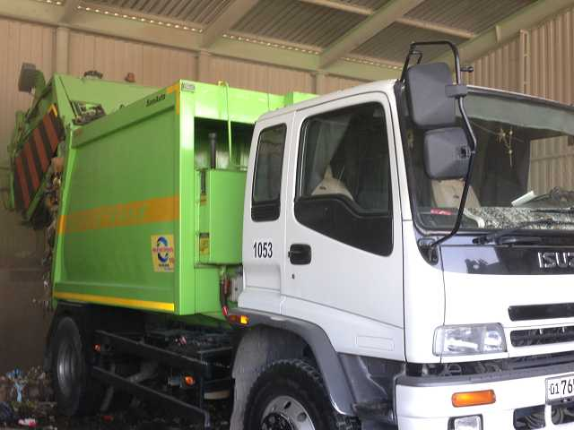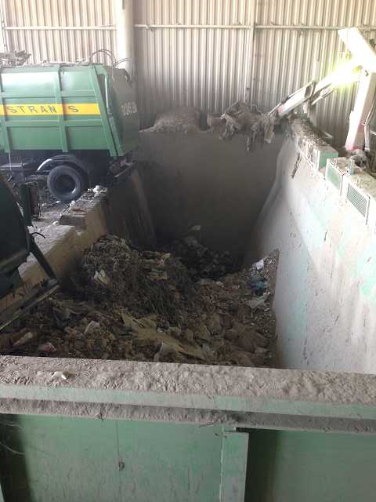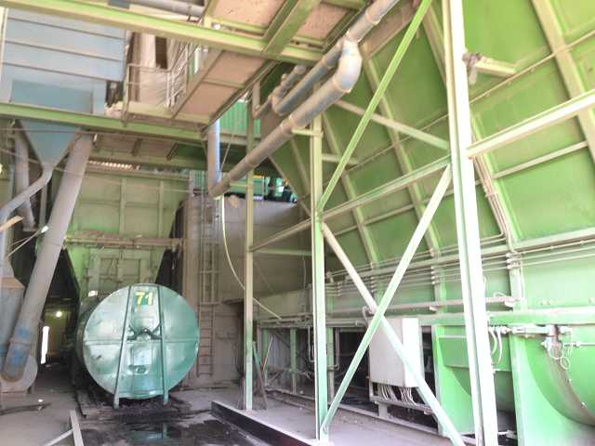

Bi-annual Social Safeguard Monitoring Report
July – December 2017

CLIENT – IMPLEMENTING AGENCY
State Unitary Enterprise (SUE) “MAXSUSTRANS” (Tashkent, Uzbekistan)

LEAD CONSULTANT
H.P. Gauff Ingenieure GmbH & Co. KG-JBG (Germany)

in association with

ENG-INVEST Consulting Ltd. (Uzbekistan)

Social Safeguard Monitoring Report 2

Monitoring of Land acquisition and Resettlement Plan Implementation

Prepared - January 2018 for the period of July-December 2017

UZB: Solid Waste Management Improvement Project (SWMIP)
ADB LOAN 3067-UZB
Consulting Services for Assistance in Project Implementation, Utility Management and Operations

Tashkent 2018

Abbreviations
ADB - Asian Development Bank
AH - affected household
AP - affected person
CAP correction action plan
EA - executing agency
GFP - grievance focal point
GOU - Government of Uzbekistan
GRM - grievance redress mechanism
Ha - hectare
IA - implementing agency
IR - involuntary resettlement
IWP - informal waste picker
LARP land acquisition and resettlement plan
MOF - Ministry of Finance
MSW - municipal solid waste
O&M - operation and maintenance
PIU - project implementation unit
PPTA project preparatory technical assistance
SLF - sanitary landfill
SWM - solid waste management

CURRENCY EQUIVALENTS
(as of October 19, 2017)
Currency Unit - sum (UZS) UZS 1.00 = $0.000124
$1.00 = UZS 8058.77

NOTE
In this report, “$” refers to United State dollars (USD) and UZS refers to Uzbekistan sum.

This social safeguard monitoring report is a document of the borrower. The views expressed herein do not necessarily represent those of ADB's Board of Directors, Management, or staff, and may be preliminary in nature.

In preparing any country program or strategy, financing any project, or by making any designation of or reference to a particular territory or geographic area in this document, the Asian Development Bank does not intend to make any judgments as to the legal or other status of any territory or area.

As per ADB Safeguard Policy Statement (2009) and the Operations Manual section on safeguard policy (OM F1), borrowers/clients are required to establish and maintain procedures to monitor the status of implementation of social safeguards management and ensure progress is made towards the desired outcomes.

Glossary

Compensation | Payment in cash or kind for an asset to be acquired or affected by a project at replacement cost.
Affected Persons | Affected persons (APs) are those who experience full or partial, permanent or temporary physical displacement (relocation, loss of residential land, or loss of shelter) and economic displacement (loss of land, assets, access to assets, income sources, or means of livelihoods) resulting from (i) involuntary acquisition of land, or (ii) involuntary restrictions on land use or on access to legally designated parks and protected areas. APs could be of three types: (i) persons with formal legal rights to land lost in its entirety or in part; (ii) persons who lost the land they occupy in its entirety or in part who have no formal legal rights to such land, but who have claims to such lands that are recognized or recognizable under national laws; and (iii) persons who lost the land they occupy in its entirety or in part who have neither formal legal rights nor recognized or recognizable claims to such land.
Entitlement | The range of measures comprising cash or kind compensation, relocation cost, income rehabilitation assistance, transfer assistance, income substitution, and relocation which are due to /business restoration which are due to AH, depending on the type and degree nature of their losses, to restore their social and economic base. All entitlements will be given to all affected households as per the entitlement matrix.
Hokimiyat | Local government authority that interfaces between local communities and the government at the regional and national level. It has ultimate administrative and legal authority over local populations residing within its jurisdiction.
Land  acquisition | The process whereby a person is compelled by a public agency to alienate all or part of the land s/he owns or possesses, to the ownership and possession of that agency, for public purposes, in return for fair compensation.
Mahalla | Is a local level community-based organization recognized official by the GoU that serves as the interface between state and community and is responsible for facilitating a range of social support facilities and ensuring the internal social and cultural cohesiveness of its members. Mahalla leaders are elected by their local communities.
Meaningful  Consultation | A process that (i) begins early in the project preparation stage and is carried out on an ongoing basis throughout the project cycle; (ii) provides timely disclosure of relevant and adequate information that is understandable and readily accessible to affected people; (iii) is undertaken in an atmosphere free of intimidation or coercion; (iv) is gender inclusive and responsive, and tailored to the needs of disadvantaged and vulnerable groups; and (v) enables the incorporation of all relevant views of affected people and other stakeholders into decision making, such as project design, mitigation measures, the sharing of development benefits and opportunities, and implementation issues.
Illegal | HHs that are not registered their business, agriculture, residential and orchard and those who have no recognizable rights or claims to the land that they are occupying and includes people using private or state land without permission, permit or grant i.e. those people without legal lease to land and/or structures occupied or used by them. ADB’s policy explicitly states that such people are entitled to compensation for their non-land assets.
Replacement  cost | Replacement cost is the principle to be complied with in compensating for lost assets. Calculation of which should include: (i) fair market value; (ii) transaction costs; (iii) interest accrued, (iv) transitional and restoration costs; and (v) other applicable payments, if any. Where market conditions are absent or in a formative stage, APs and host populations will be consulted to obtain adequate information about recent land transactions, land value by types, land titles, land use, cropping patterns and crop production, availability of land in the project area and region, and other related information. Baseline data on housing, house types, and construction materials will also be collected. Qualified and experienced experts will undertake the valuation of acquired assets. In applying this method of valuation, depreciation of structures and assets should not be taken into account.
Significant  impact | 200 people or more will experience major impacts, which are defined as; (i) being physically displaced from housing, or (ii) losing 10% or more of their productive assets (income generating).
Vulnerable  Households | Low-income households, female-headed households with fewer than 2 adult income- earners, the elderly headed with unemployed family members, and disabled.
Leaseholder | Legal entity (registered farm) running agricultural production with the use of land plots granted to him on a long-term lease. Lease term is limited up to fifty years but not less than for ten years. Leaseholder cannot sell - buy, mortgage, sublease, present, exchange the land.

Table of contents

Abbreviations 3
Glossary 4
Executive Summary 7
1. Introduction 9
A. Project description 9
a) Project background 9
b) Project Site Description 10
c) Project Implementation Arrangement 12
B. Objective of Social safeguard monitoring report 15
a) Objective of the report 15
b) Scope of social safeguard monitoring 15
c) Project impact 16
d) Project implementation status 17
e) Social safeguard monitoring parameters 18
C. Legislation 18
2. Methodology 21
3. Compliance to safeguards provisions in agreements under the project 23
4. Assessment of progress on implementation of Land Acquisition and Resettlement Plan 32
4.1 Progress on implementation of LARP 32
5. Gender and poverty assessment 38
6. Redress Grievances 40
6.1 Assessment of efficiency of GRM 40
6.2 Monitoring of grievances for the period of August – December 2017 41
7. Public Awareness 41
8. Conclusion 42
Annex 1 Copy of registration book on the complaints, Akhangaran district, Tashkent region, August – December 2017 43
Annex 2 Inquires to regional and district authorities 44

Executive Summary
- This report is the Semi-annual Report on Social Safeguards Monitoring and Evaluation of the Solid Waste Management Improvement Project. It covers the period of August 2017-January 2018.
- The Key stakeholders involved in social safeguard component are the following: (a) Implementing Agency (IA) of the project is the State Unitary Enterprise (SUE) “MAXSUSTRANS”, providing project management and implementation of guarantees of observance of all requirements for the project safeguard measures developed within the project (b) regional and district municipalities (c) self-governmental bodies (makhalla committees and RCC)
- Status of project implementation: The social safeguard monitoring and valuation under the project is being implemented in compliance with the loan covenants, project agreement and contractor and complying with the proposed mitigation measures described in the Land acquisition and resettlement plan; Project Administration Manual and the contract specifications.
- At this stage of the project implementation, during the period January 16-18, 2018, Consultant, with the direct support of the PIU, requested data from the local authorities (Tashkent Regional Khokimiyat and Khokimiyat of the Akhangaran District) on the current status of resolving the issue of land acquisition and providing compensation to the affected person. Data from these authorities are currently not available. According to the results of the appeal to these organizations, Consultant was informed that the requests are still under consideration.
- Project impact: (a) acquisition of 30 ha of agricultural lands is to be acquired. 34 ha would have negative impact due to acquisition the land under the irrigation canal. (b) one affected households (leasehold farm) and 4 permanent agricultural workers as well as 1 NGO - "Yangi Hayot” Water Consumers Association (destruction of agricultural infrastructure such as irrigation channel); (c) associated impacts on 100 Informal Waste Pickers (at present there is no impact on these groups).
- Progress of the Project: The procedures for applying to local authorities for obtaining information on the current status of the decision on the issue of land acquisition and providing compensation are described in detail in this report. Besides that this report includes the corrective actions to complete the implementation of LARP. Implementation of LARP will be completed prior the commencement of construction and procurement tenders. Compensation will be fully paid to the commencement of civil works and ensure full compliance with the requirements of the Entitlement matrix of LARP.
- Gender and poverty assessment: Consultant studied the reports developed under the period of project implementation. The required land acquisition does not have gender and poverty impacts. At present there are no other required activities on gender and social indicators.
- Redress grievances: The Consultant received the information on complaints, addresses and proposals within the project from the local authorities in the project area. Studying of the copies of register books for complaints and addresses of citizens, received from the administration of Akhangaran district (khokimiyat) for the period August-December 2017 showed that there were no complaints and addresses concerning implementation of the project from the population and the affected persons.
- For the entire period of the project implementation since 2012, the developed GRM was directly used by the affected person – leasehold farm. The main issue of the address – discontent with the provided mitigation measures of the project impact (land acquisition and the amount of compensation). The address of the farmer was directly to the court. For the entire period, there were 2 appeals to the court (the statement of claim and the appeal). The judgment was in favour of the farmer.
- Public Awareness: At this stage of project implementation Consultant started studying the innovative approaches including sorting and recycling waste that can be applied to our national and regional features. Consultant will also study the measures of promotion social benefits for success improvement of waste management.
- Conclusion and recommendations: The implementation of LARP and developed mitigation measures in this project face some difficulties. The key issue to be solved at this stage of project implementation is completing the implementation of LARP prior the commencement of construction works. It has been observed that adequate corrective measures will be taken to coordinate with local and regional municipalities, social, health and environmental institutions and affected household to complete the resettlement activity.

- Introduction
- This report is the semi-annual Report on Social Safeguard Monitoring under Solid Waste Management Improvement Project. The report describes the implementation and evaluation of social safeguards activities for August 2017 – January 2018. The social safeguard monitoring report covers, in particular, the progress and current status of the implementation of LARP.
- Project description
- Project background
- The Government of Uzbekistan (GoU) has applied for a loan from the Asian Development Bank (ADB) for the development and improvement of Solid Waste Management (SWM) system of the capital city (Tashkent). The loan reference number is L3067-UZB: Solid Waste Management Improvement Project (SWMIP). The loan was signed between the Republic of Uzbekistan and Asian Development Bank (ADB) dated 27 February 2014 and Project Agreement dated 12 March 2014 signed between ADB, Tashkent City Municipality and the State Unitary Enterprise “MAXSUSTRANS”.
- The GoU through it Implementing Agency (IA), the State Unitary Enterprise (SUE) “MAXSUSTRANS” intends to utilize part of this loan proceeds towards the cost of the contract for consulting services related to project management, implementation and construction supervision of civil works, supporting the project implementation unit (PIU).
- The project was prepared to impact an improved urban environment and quality of life for the residents of Tashkent. The project will develop a sanitary landfill that meets international standards, rehabilitate transfer stations, and modernize the waste collection and transfer fleet. It will build capacity in waste management and help formulate a national strategy on solid waste management.
- The outcome will be improved SWM services and management in Tashkent with the following key outputs:
- Output 1 - Rehabilitated and expanded solid waste management (SWM) system in Tashkent. By the project completion it is expected that (i) rehabilitation of transfer stations and possible closure of an existing transfer station,2 (ii) 3 million tons of disposal capacity established with international environmental standards, and (iii) 1,950 tons per day of disposal and operational capacity established;
- Output 2 - Strengthened operational capacity. By the project completion it is expected that (i) at least 90% of households actively segregating waste at source, (ii) campaign to raise awareness will reach 90% of households on waste segregation with women households members’ participation, (iii) improved management and operations of Maxsustrans, including a 20% improvement (reduction) in cost per ton of waste disposal, and (iv) an IT-supported MSW collection system based on a geographic information system (GIS) database is implemented and 80% of trips monitored by the system is achieved.; and
- Output 3 - National SWM strategy. By 2016, a draft national SWM strategy prepared and submitted to the Government and ADB.

- The Government of Uzbekistan (GOU) seriously recognizes the need to develop and implement a national Solid Waste Management (SWM) strategy. Therefore the GOU has requested support from ADB to address the SWM challenges. The proposed Project will contribute to sustainable urban development in Uzbekistan by: (i) modernizing SWM to provide continuous and reliable municipal services; (ii) promoting financial sustainability of municipal services through tariff rationalization and prudent financial management; (iii) supporting policy and institutional reforms for improved sanitation and environmental management; (iv) mitigating climate change through a major reduction of GHG emissions, and through compliance with international standards on waste minimization and material recycling; and through all these measures; (v) improving livability of cities.
- The volume of the existing dumpsite is exhausted and the original plan of the city was to extend its dumpsite operations to an adjacent lot of additional 30 hectares of area. Being fully aware of the inevitable environmental impacts through the extension of this practice, the city asked the national government for assistance in this matter. Based on these activities, the Cabinet of Ministers approved in summer 2012 the location of new dumpsite on 30 hectares of agricultural area for the utilization for waste management activities.
- GOU has already decided to start processing land allocation of a 30-hectare land plot immediately to the south of the existing Akhangaran dumpsite, on which to develop an interim dumpsite extension. This facility is designed to accommodate Tashkent’s municipal waste for the next - 7 years, and until the longer-term solution is operational. However, following discussions, the city is now planning to reposition this 30-hectare facility to 25-hectare to the east of the existing dumpsite, and also to upgrade this facility to a sanitary landfill facility, designed to internationally accepted standards of environmental protection.
- Last option of expansion of landfill to the east, it has the potential for progressive expansion to become a 250-hectare long-term regional landfill, which can serve Tashkent’s disposal needs for at least 50-years. In other words, this initial landfill actually is the first development phase of the much larger regional landfill, should this option be later selected by the city as the long-term disposal solution. Should the alternative long-term option be selected instead however, then this interim facility could be closed, or possibly could switch to serve the disposal needs of nearby communities. A conceptual design has been completed for the interim 25-hectare facility, which is naturally included as a component of the Project.
- Project Site Description
- The Akhangaran landfill is located approximately 35 km south of the center of Tashkent City in the Akhangaran district of Tashkent Province. The facility has been in use since 1967 and is currently handling the wastes collected from Tashkent city and partial from Chirchik. The proposed site for a modern Sanitary Landfill is located at the eastern side of the existing Akhangaran Landfill. The total area for Landfill will cover approximately 25 hectares of agricultural land.
- Visibly, the adjacent areas are irrigated agricultural areas predominantly characterized by undulating valleys. There are no residential areas or industrial facilities within a 3-4 kilometer radius. Farmers come primarily from villages located about 5 kilometers from the site. At the landfill area, there are established basic facilities such as a weighbridge, administrative building, a maintenance shed, security gate, and record-keeping shed. The area is connected to the main road, Highway P2 via an asphalt access road that leads directly to the landfill. The distance from the highway to the landfill area is about a kilometer. Aside from the typical agricultural vegetation being grown, the area is characterized by reeds often found along the boundaries of each plot. Common farm livestock is common in the area.
Figure 1 Location map of Akhangaran landfill
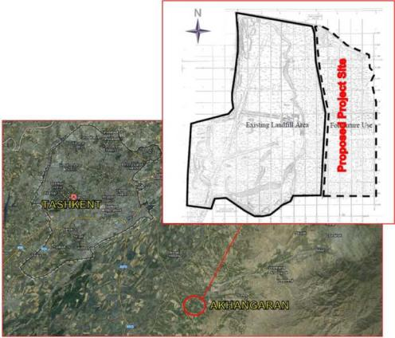

- Access to the site: Land acquisition for the expansion of existing landfill will not require construction of any additional access road to the site. This is visualized below on given image (Figure below). Access to land will be through already functioning road. Buffer zone for the SLF will be within the acquired land plots.

Figure 2 proposed Akhangaran landfill expansion
* Yellow line is border of existing landfill; blue line is border of expansion

Figure 3 Map of acquired land plot and irrigation canal
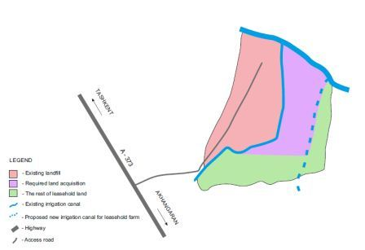

- Project Implementation Arrangement
- Institutional arrangements of the project: SUE “MAXSUSTRANS”, the Implementing Agency (IA), via the Project Implementation Unit. There are two Executing Agencies (EA) for this project: Khokimiyat of Tashkent city for the general supervision and control of the Outputs 1 and 2, as well as the State Committee of the Republic of Uzbekistan on ecology and environmental protection (Goskompriroda) for achievement of the Output 3 - the National strategy for SWM. Outputs 1 and 2 will be implemented by the SUE "MAXSUSTRANS". PIU was established at SUE "MAXSUSTRANS" to support the project implementation. Support will include project management, finance management, purchases, management of contracts, performance of guarantees, construction and technical supervision, as well as monitoring and evaluation.
The following institutions participate in implementation of the Investment program:
Program Implementation Unit (PIU): Investment Programs Implementation Unit (PIU) is established at SUE “MAXSUSTRANS” for realization of functions related to the Investment Program. PIU coordinates construction of subprojects and provides coherence of approach and productivity.
Executing Agency (EA)
- State Committee of the Republic of Uzbekistan on ecology and environmental protection (Goskompriroda): Goskompriroda is responsible for implementation and preparation of National solid waste management strategy for Tashkent city;
- Khokimiyat of Tashkent city (municipality): Khokimiyat of Tashkent city is responsible for management, coordination and performance of all types of activity financed under the loan and bears common responsibility for observance of loan agreements.
Implementation Agency (IA): State Unitary Enterprise (SUE) “MAXSUSTRANS” is responsible for administration, implementation (design, construction and operation) and daily activities.

Figure 4 Project stakeholders
Government of Uzbekistan
Asian Development Bank
Ministry of Finance of Uzbekistan
Goskompriroda (EA)
Tashkent city Hokimiyat (EA)
SUE MAXSUSTRANS (IA)
PIU «Solid Waste Management Improvement»
Consultant
- Institutional Arrangement for social safeguard issues: Stakeholders to be directly involved in implementation, monitoring and evaluation of safeguard measures within Solid Waste Management Project includes:
- SUE "MAHSUSTRANS", implementing agency (IA), providing project management and implementation of guarantees of observance of all requirements for the project safeguard measures developed within the project. These measures should be observed prior to construction works, at the stage of construction and technical supervision.
- City Municipality: Khokimiyat of Tashkent city responsible for management and coordination of observance of social safeguard measures at the administrative level of the project implementation.
- Regional and district municipality: Khokimiyat of Tashkent region and khokimiyat of Akhangaran district bear responsibility for direct observance of the developed safeguard measures for all persons affected by the project, implementation (if required) of remedial measures for mitigation and minimization of adverse impact of the project. In addition, khokimiyats will render direct assistance in carrying out public consultations for all stakeholders and persons affected by the project, as well as receiving and redressing of complaints and addresses within the project.
- Makhalla committees and RCC to be involved in the process of interaction with the project affected persons, and consideration of the complaints and addresses received from the persons affected by the project and other stakeholders.
- Project beneficiaries
Project beneficiaries are residents of Tashkent city and Tashkent region.
- Objective of Social safeguard monitoring report
- Objective of the report
- In accordance with ADB SPS 2009, Solid Waste Management Improvement Project was classified as category B. A project with site-specific impacts, few if any of which are irreversible and where in most cases mitigation measures can be designed more readily compared to projects classified as category A. The Land acquisition and resettlement plan under the project was prepared in December 2012 and disclosed in 2013. So, social safeguard monitoring is a part of project implementation process to be complied by both ADB and PIU.
- The purpose of this report is to ensure that the project is implemented in compliance with social safeguards according to the ADB’s Safeguard Policy Statement 2009, specifically to ensure that these issues are adequately addressed to the requirements of ADB: (i) compensation for land and other affected assets; (ii) compensation for loss of income; (iii) continuing acquisition of land by the original users; (iii) gender issues; (iv) indigenous people (if there is any); (v) grievance redress mechanism; (vi) income and livelihood restoration of the affected people (if required).
- Scope of social safeguard monitoring
- The social safeguard monitoring will allow ADB and the PIU gather information to: i) evaluate the implementation progress of the land acquisition and resettlement by establishing social safeguard compliance status, ii) evaluate the implementation of social safeguard measures for all persons affected by the project taking into account the available and potential social risks resulting from implementation of the project, iii) identify non-conformances / unanticipated impacts and implement necessary mitigation / remedial measures (in case of adverse impacts), and iv) monitoring and evaluation of implementation of safeguard measures.
- The scope of this monitoring report is assessment of progress on implementation of LARP, including compensation payment, grievance redress procedure, evaluation of income restoration program of affected households, indigenous people and vulnerable people ( if there is any).
- LARP was prepared in December 2012 and disclosed in 2013. There was no data on LARP implementation in 2013. The collection of information for updating of the LARP was carried out in 2015. The appropriative assessment of impacts on lands, assets, households as well as socio-economic survey and public consultations were carried out in 2015. The updated LARP was not approved at that period.

- Project impact
- The project impact includes the impacts on agricultural lands, crops and incomes. The information on project impact is presented in table below:
Table 1 Project impact
Indicator | LARP, December 2012 | Data for updating of LARP, February 2015
Land acquisition | 49.9 ha of agricultural lands (44.7 ha of them are irrigating lands) are to be acquired. | 30 ha of agricultural lands are to be acquired.  34 ha would have negative impact due to acquisition the land under the irrigation canal.
Physical Relocation | Not required | Not required
Affected households | (i) 1 farm ("Shahboz Nuri Ziyo" leasehold farm) which belong to 1 affected household (AH) and 9 agricultural workers which would be adversely affected.  (ii) 1 NGO - "Yangi Hayot” Water Consumers Association. There would be destruction of agricultural infrastructure such as irrigation channel, which belong to NGO. | (i) 1 farm ("Shahboz Nuri Ziyo" leasehold farm) which belong to 1 affected household (AH) and 4 permanent agricultural workers which would be adversely affected.  (ii) 1 NGO - "Yangi Hayot” Water Consumers Association. There would be destruction of agricultural infrastructure such as irrigation channel, which belong to NGO.
Associated impacts | 80-100 Informal Waste Pickers.  Due diligence revealed on that existing dumpsite ongoing activity of informal waste pickers (IWPs). Due to fact that this activity is illegal surveyors were unable to confirm exact number of IWPs. With assistance of local community leaders surveyors were able to estimate about 80-100 IWPs on that existing dumpsite. | 100 Informal Waste Pickers.  It was recommended to Mahsustrans to develop action program to address this impact from closure of the existing facility.
Income restoration | Identified AH will lose more than 30% of its cropped land, which is defined as main income generating asset of the farmer. | Identified AH will lose more than 30% of its cropped land, which is defined as main income generating asset of the farmer.
- At present the project requires the land acquisition of farmer lands, 30 ha. The negative impact on 34 ha of farmer lands caused by the removal of the irrigation canal is also expected. Process of LARP implementation was stopped. The reason is dissatisfaction of the farm owner with the provided conditions of the compensation held by independent evaluation company. Owner of the farm claims for higher amount of compensation which, at the same time, he cannot justify with documents. There for the LARP was not implemented up to present.
- Indigenous and Vulnerable Affected People: In the proposed project affected area, no group of people maintains a separate cultural and social identity from the mainstream Uzbekistan society that would classify them as ethnic group, ethnic minority or indigenous people as described in ADB SPS, 2009. Therefore, the proposed project has been categorized as a “C” project with regard to indigenous peoples.
- Project implementation status
- The ADB safeguard policy also requires that project implementation will subject to the LARP related conditions. The most important conditions are: (i) land acquisition including demolishing of any structure and housing is allowed only after all compensations are fully paid, and (ii) commencement of Civil Works is conditional to the satisfactory implementation of the final LARP to be checked and verified by independent monitoring party and reported in the LARP compliance report.
- Based on the Cabinet of Ministers Resolution # 146 (25.05.2011) of GOU any land acquisition and demolition of the structures only can be carried out after the value of compensation has agreed by the land leaseholder and owner of structures. The GOU’s law and regulations on land acquisition require also that civil works can be commenced only after compensation for land acquisition is fully paid.
- At this stage of the project implementation, during the period January 16-18, 2018, Consultant, with the direct support of the PIU, requested data from the local authorities (Tashkent Regional Khokimiyat and Khokimiyat of the Akhangaran District) on the current status of resolving the issue of land acquisition and providing compensation to the affected person. Data from these authorities are currently not available. According to the results of the appeal to these organizations, Consultant was informed that the requests are still under consideration.
- At this stage of project implementation the official information on physical progress of the land acquisition and compensation payments is not provided by the local authorities. The question is now under consideration.
- During the first stage of monitoring there were no progress on LARP implementation and payments of compensation. The project affected household was discontented by the provided conditions of the compensation held by independent evaluation company for the affected land plot. He used the designed Grievance redress mechanism and applied to the court. Owner of the leasehold farm claims for higher amount of compensation which, at the same time, he cannot justify with documents. The process of land acquisition and compensation was considered by the local Khokimiyat and Mahsustrans.
Table 2 Status of LARP implementation, January 2018
Indicator | Status | Remarks
Land acquisition | Under consideration | Consultant in close cooperation with PIU has prepared in an official request for detailed information on the status of the decision on the issue of land acquisition and compensation for the affected person. The request was submitted for consideration to the regional khokimiyat of Tashkent region and the regional khokimiyat of Akhangaran district, Tashkent region.  Despite the fact that the official period for handling appeals is 15 days, the complexity of this issue increased the time for consideration of the request up to 30 days.  Currently, official data from the khokimiyat on the status of land acquisition and compensation is not available.
Compensation “land for land” | Under consideration
Compensation for losses (profit) | Under consideration
Compensation for lost income (workers at the farm) | Under consideration
Income restoration | Under consideration
- Social safeguard monitoring parameters
- The following parameters have been applied during social safeguard monitoring:
    - Monitoring of implementation of Land acquisition and resettlement plan;
    - Progress on compensation payment;
    - Grievances by type and resolution status;
    - Public consultation (if required);
    - Status of vulnerable and Indigenous APs after project intervention (it there is any);
    - Status of income restoration program;
    - APs satisfaction and perception regarding compensation amount;
    - Implementation of social awareness program (social and gender issues);
    - Compliance status of social and resettlement issues with ADB SPS.
- Legislation
- During the preparation this report, Consultant is guided by the following operational documents developed for provision of ADB safeguard policy:
- ADB's 2009 Safeguard policy statement (SPS)
- “Guidelines for Social Analysis” - ADB, 2007
- “Guidelines for Poverty and Social Analysis ” - ADB- 2012
- “Special evaluation of project management in ADB and its projects in developing countries” – ADB – 2003.
- ADB SPS on resettlement address both: (i) social and economic impacts, permanent or temporary, caused by acquisition of land and other fixed assets; and (ii) changes in the use of land or restrictions imposed on land as a result of a Bank operation. An affected or displaced person (AP/DP) is one who experiences such impacts.
The objectives of the policy are: (i) to avoid involuntary resettlement impacts wherever feasible; (ii) to minimize resettlement impacts by choosing alternative viable project options; and (iii) to ensure that affected people receive compensation, assistance for relocation (including provision of relocation sites with appropriate facilities and services) and assistance for rehabilitation, so that they will be at least as well off as they would have been in the absence of the project.
- ADB Safeguard Policies have the following policy principles:
- Screen projects early on to identify past, present, and future involuntary resettlement impacts and risks.
- Carry out meaningful consultations with affected persons, host communities, and concerned non-governmental organizations. Inform all displaced persons of their entitlements and resettlement options. Ensure their participation in planning, implementation, and monitoring and evaluation of resettlement programs. Pay particular attention to the needs of vulnerable groups, especially those below the poverty line, the landless, elderly, women and children, and Indigenous Peoples, and those without legal title to land, and ensure their participation in consultations. Establish a grievance redress mechanism to receive and facilitate resolution of the affected persons’ concerns.
- Improve or at least restore, the livelihoods of all displaced persons through (a) land- based resettlement strategies when affected livelihoods are land-based where possible or cash compensation at replacement value for land when the loss of land does not undermine livelihoods; (b) prompt replacement of assets with access to assets of equal or higher value; (c) prompt compensation at full replacement cost for assets that cannot be restored; and, (d) additional revenues and services through benefit sharing schemes where possible.
- Provide physically displaced persons with needed assistance, including the following: (a) secure land tenure on land identified for new sites and (b) if necessary transitional support and development assistance such as land development, credit facilities, training, or employment opportunities.
- Improve the standards of living of the displaced poor and other vulnerable groups, including women, to at least national minimum standards and provide access to land and other resources that is both legal and affordable.
- Develop procedures in a transparent, consistent, and equitable manner if land acquisition is through negotiated settlement to ensure that those people who enter into negotiated settlements will maintain the same or better income and livelihood status.
- Ensure that displaced persons without titles to land or any recognizable legal rights to land are eligible for resettlement assistance and compensation of loss of non-land assets.
- Prepare a draft resettlement plan and disclose a resettlement plan elaborating on displaced persons’ entitlements, the income and livelihood restoration strategy, institutional arrangements, monitoring and reporting framework, budget, and time-bound implementation schedule. Implement resettlement as part of the project.
- Pay compensation and provide other resettlement entitlements before physical or economic displacement and implement the resettlement plan under close supervision throughout project implementation.
- Monitor and assess resettlement outcomes, their impacts on the standards of living of displaced persons, and whether the objectives of the resettlement plan have been achieved by considering the baseline conditions and the results of resettlement monitoring and disclose these monitoring results.
- Legislative acts of the Republic of Uzbekistan applied for provision of social safeguards and rights of the population:
- Constitution of the Republic of Uzbekistan, 1992;
- Land Code of the Republic of Uzbekistan, 1998;
- Civil Code of the Republic of Uzbekistan, 1995;
- Law of the Republic of Uzbekistan "On evaluation activity" dated 19.08.1999. No. 811-I;
- Decree of the Cabinet of Ministers of the Republic of Uzbekistan No. 146 "On the measures for improvement of the order of allocation of the land plots for town-planning and other non-agricultural needs", 2011;
- Decree of the Cabinet of Ministers of the Republic of Uzbekistan No. 97 "On the order of compensation payments to citizens and legal entities in view of land acquisition for state and public needs", 2006;
- Decree of the President of the Republic of Uzbekistan "On further improvement of activity of the evaluation companies and raise of their responsibility for the quality of rendered services" (No. PP-843 dated 24.04.2008) and other legislative acts.

- Methodology
- This section presents information on general and special methods which is used to prepare the Social safeguard monitoring report, including progress of LARP implementation and CAP (if required).
- The methodology applied for this report includes reviewing records and document, field visits and consultation with relevant stakeholders and affected person in order to (a) verify compliance issues pertaining in all safeguards matters related to contracts, social conditions, land acquisition and resettlement, consistent with Government of the Republic of Uzbekistan and ADB requirements; (b) gather the required documents and materials upon the project (c) carry out random performance checks on the work.
  - General approach
- Methodology of preparation monitoring report consists of the following general approach:
- Field / site visits, where land acquisition process is taken place or taking place to assess the social safeguard issues, the progress on LARP implementation, including progress of land acquisition, compensation payments, current situation with IWP, persons living in temporary constructions in the suburbs of agricultural fields for the period of seasonal works and operation of waste collection points. It will be done using participatory observation during the safeguard compliance monitoring.
- Review of the documents, including reports prepared during the period of project implementation since project start, payment forms of compensation to ascertain that compensation has been fully paid prior to the commencement of civil works and ensure full compliance with the requirements of the Entitlement matrix of LARP etc.
- Analytical study to validate whether the unit costs used in compensating fixed assets are at current market prices or replacement costs. If required, design recommendations and correction actions to improve the situation of providing compensation.
For the evaluation study, the methodology will be based mainly on comparison of the socio-economic status of APs following land acquisition and income losses and their socio-economic prior to pre-project level. For this purpose, a follow-up socio-economic survey will be conducted by the Consultant to find out the living standards of APs for the period of six months to one year following completion of LARP implementation. This activity will cover at least 30% of all the APs in the project.
- Primary data gathering will be carried out through a combination, as appropriate, of the following techniques:
  - questionnaires;
  - personal interviews of APs;
  - public meetings / consultations; and
  - meetings with project staff.
- Some methods have been spoken about above will be carried out during monitoring of progress of LARP implementation, the other will be applied during safeguard compliance monitoring, and some continuously carried out during the whole monitoring and evaluation period.
  - Methods of monitoring
- During preparation of this Social safeguard monitoring report Consultant analyzes the issues related to social, land acquisition and resettlement aspects of project implementation. Besides, the following methods were adopted during preparation of this document.
  - Review of secondary sources available in connection with the project such as monthly and other periodic reports.
  - Analysis of information of LARP, land acquisition laws and practices, methods of compensation determination, previous report, documents of the project and other available secondary sources which would be taken into account during preparation of the report.
  - Assessment of effectiveness of the grievances redress mechanism introduced in LARP on the social & resettlement issues by analyzing the complaints received upon the project. An effective mechanism for receiving the complaints from the aggrieved persons from the local community has been introduced in this report. Period of analysis of complaints is January – July 2017.
  - Gathering the information taken from different institutions and stakeholders considered in preparation of this document.
  - During construction period, checking and verification of the compliance of social issues with the stated requirements of ADB SPS. Information so far collected by Consultant will be incorporated in the quarterly reports.
- Indicators for initial monitoring are the following:
- Ensure that the standard of living of affected persons are restored or improved;
- Ascertain whether activities are LARP implementation as per schedule and the timelines are being met;
- Assess if compensation, rehabilitation measures are completed;
- Identify problems or potential issues;
- Identify methods to rapidly mitigate problems;
- Special care for the affected vulnerable and poor persons in terms of compensation and rehabilitations (if such persons are appeared during the project implementation).

- Compliance to safeguards provisions in agreements under the project
  - Compliance to Project Administration Manual
- The Project Administration Manual (PAM, November 2016), describes the essential administrative and management requirements to implement the project on time, within budget, and in accordance with Government and Asian Development Bank (ADB) policies and procedures. The PAM is mandatory and serves as the main document describing implementation details. The status of implementing the safeguards requirements set out in PAM are provided in Table below.
Table 3 Compliance to PAM
Details | Compliance Status | Remarks
Section VII - Safeguards b) Social – Involuntary resettlement. Municipality and Maxsustrans ensure that land acquisition would be carried out in accordance with ADB Safeguard Policy Statement (2009), and applicable laws and regulations of Uzbekistan that has been formulated and developed in the LARP. | Completed | At the stage of preliminary design it was identified that there were land requirements and involuntary resettlement impacts within the project implementation.  In compliance with the ADB’s SPS LARP was prepared in 2012 and disclosed in 2013.
Municipality and Maxsustrans ensure that LARP would be implemented, and monitored to ensure that no affected people would suffer by unattended impacts associated with land acquisition. | Under consideration | Information on physical progress of the land acquisition and payments of compensation is under consideration of regional and local authorities. Consultant inquired the detailed information on the progress of work. However the information is not provided yet.
Municipality and Maxsustrans ensure that:  (i) The PIU recruit a social development specialist to implement the LARP and address other social concerns of the project, if any. | Completed | Consultant on social safeguard monitoring issues addresses the social and resettlement concerns of the project.  Consultant carries out detailed monitoring of the process of LARP implementation.
(ii) The LARP would be updated upon completion of the detail design. The updated LARP report will be carried out with adequate consultation with affected people. The report should at least indicate any change to land acquisition from the detailed designed, change to affected people, or change to budget for LARP implementation. The updated LARP must be submitted to ADB for concurrence prior to implementation. | Completed | As there were changes in land requirements and land acquisition under detailed design the LARP was preliminary updated in 2015. It was not approved and disclosed.
(iv) The LARP would be disclosed to affected people. | Completed | LARP report was disclosed on ADB and Maxsustrans websites. The link to JMRC site is https://www.adb.org/projects/45366-004/main.
(vi) The awarding of civil works any contract would be done only after affected people (including other parties to receive compensation for developing new agricultural land) receive full payment of compensation, and report on full payment of compensation is submitted to ADB. The advance payment to the contractor only can be released by ADB after the report on full payment is received. | Under consideration. | The construction works will not start before the LAPR is implemented. The awarding of civil works will be done after full payments on compensation and other mitigation measures are completed.  The issue on land acquisition and payment of compensation is under consideration at regional and local authorities.
(vii) Report on monitoring the implementation of LARP will be submitted to ADB on a quarterly basis until the payment of compensation to affected parties are fully paid. | On-going | Consultant carries out quarterly monitoring of LARP implementation of LARP. The proper section of the report (LARP implementation) is prepared to assess the progress on payments of compensation to the affected persons and providing other mitigation measures described in LARP.
(viii) The Social development specialist of PIU will develop the implementation plan in close consultation with local government for livelihood improvement program to address impacts to waste pickers and waste collection points due to closure of existing dumpsite. | Completed | Informal waste pickers: The survey conducted for the informal waste pickers during preparation of LARP, it was obtained that all the IWP had their main income source. Picking of waste was alternative additional source of income. The share of this additional income is 10-12% of their total income.  If negative impact on these affected groups is identified during the future actions on project implementation, Consultant will design the recommendations to Mahsustrans (ЕА) to develop action program to address this impact from closure of the existing facility.  Consultant will check up the source and type of income of informal waste pickers and identify the need of preparation of livelihood improvement program for them (if required).  Waste collection points (waste paper, plastic, polyethylene and other): At this stage of project implementation there are no impacts on waste collection points.
Section VII - Safeguards c) Social – Indigenous people  In the proposed project area and affected area, no group of people maintain a separate cultural and social identity from the mainstream Uzbekistan society that would classify them as ethnic group, ethnic minority or indigenous people as described in ADB SPS, 2009. Therefore, the proposed project has been categorized as a “C” project in relation to indigenous peoples. | Not applicable. | N/A
Section VIII - Gender and Social Dimensions a) Gender participation: Women, who are mainly responsible for household waste management, will benefit from cleaner collection points and more regularized waste pick-up services. The project will include specific actions to strengthen women’s roles and capacities as waste minimizers and recycling facilitators, encouraging others within the household to assist in sustainable environmental practices and also to ensure job equity and equal opportunity for those employed by SWM system operators. The project will:  (i) Improve female consumer awareness of SWM issues through citywide public awareness campaigns in coordination with Women’s Committee and municipality (mahalla representatives) at the local level. | Will be implemented. | There is no gender participation at this stage of project implementation.  Now no activities on gender issues are required.  At further stage of project implementation Consultant will conduct the public consultations for the project affected persons, relevant stakeholders and other interesting people (residents of communities, including women) to inform them about the project, LARP implementation progress, ADB’s SPS requirements, local legislation and grievance redress mechanism with detailed data on responsible persons.  The periodically public consultations or workshops will be conducted for female residents of communities (households in Tashkent city) to aware them on SWM system. This activity will be carried out in close cooperation with the Environmental specialist during the project implementation as well as local municipality and other stakeholders. The results of consultations will be given in quarterly Social safeguard monitoring reports.  The proper program / information bulletin will be published on the website of Mahsustrans (EA) and submitted to the local municipality.
(ii) Empower women to establish and maintain acceptable household waste handling and storage practices and optimize recyclable material segregation increased awareness and the development of households waste management guidelines and handbooks. | Will be implemented. | There is no gender participation at this stage of project implementation.  This component will be carried out in close cooperation with the Environmental specialist, other specialists of the project team and in assistance with the project stakeholders.
(iii) Improve overall conditions for women operators of collection points throughout the city through ensuring equal pay, equal access to recyclables and providing protective equipment such as gloves and masks. | Will be implemented | There is no gender participation at this stage of project implementation.  Now no activities on gender issues are required.  This component will be carried out in close cooperation with the Environmental specialist, other specialists of the project team and in assistance with the project stakeholders.
(iv) Provide targeted education program for representatives of local communities in the management of proper community based SWM practices. | Will be implemented | There is no gender participation at this stage of project implementation.  Now no activities on gender issues are required.  This component will be carried out in close cooperation with the Environmental specialist, other specialists of the project team and in assistance with the project stakeholders.  Consultant will take part in development the education program for the representatives of local community and conduct the public consultations to increase the awareness of the residents of local communities based on proper SWM practice.
(v) Provide school-based educational programs to educate primary and secondary level students in SWM and recycling practice. | Will be implemented | This component will be carried out in close cooperation with the Environmental specialist, other specialists of the project team and in assistance with the project stakeholders.  The proper program / information bulletin will be published on the website of Mahsustrans and submitted to the local municipality.
(v) Abandon unsanitary waste picking practices at the existing dumpsite and transition these illegal waste pickers to alternative sources of livelihood and income. | Will be implemented | If it is required at further stage of project implementation Consultant will design the recommendations to Mahsustrans (ЕА) to develop action program to address this impact from closure of the existing facility.
Section VIII - Gender and Social Dimensions b) Contractors of civil works:  Maxsustrans would also include a specific provision in the bidding documents to ensure that civil works contractors (i) comply with core labor standards, applicable laws and regulations in the Uzbekistan and incorporate applicable workplace occupational safety norms, (ii) do not differentiate payment between men and women for work of equal value, (iii) do not employ child labor in the construction and maintenance activities, (iv) eliminate forced or compulsory labor, (v) eliminate employment discrimination, (vi) to the extent possible, maximize employment of local poor and disadvantaged persons for project construction purposes, provided that the requirements for job and efficiency are adequately met, and (vii) disseminate information on the risks of sexually transmitted diseases, including human immunodeficiency virus/acquired immunodeficiency syndrome, to the employees of the contractors under the project and to members of the local communities near the project. | Will be implemented | During the construction period Consultant will visit the construction site to monitor the following social safeguard indicators:  - Labor standards and guaranties;  - Health conditions, risks of sexually transmitted diseases, including human immunodeficiency virus/acquired immunodeficiency syndrome;  - Social and living conditions;  - Safety rules and safeguards etc.  The results of monitoring will be included in the quarterly Social safeguard monitoring reports.
Section VIII - Gender and Social Dimensions c) Gender consultation: The social development specialist of PIU would assist Maxsustrans to implement gender related activities in close consultation with Women’s Committee and mahallas and report the progress and achievements or any issues in routine basis to ADB as part of the quarterly project report. | Will be implemented | at further stage of project implementation the public consultations or workshops will be conducted for female residents of communities (households in Tashkent city) to aware them on SWM system. This activity will be carried out in close cooperation with the Environmental specialist, other specialists of the project team and in assistance with the project stakeholders.  The results of consultations will be given in quarterly Social safeguard monitoring reports.  The proper program / information bulletin will be published on the website of Mahsustrans and submitted to the local municipality.
Section IX - Performance Monitoring, Evaluation, Reporting and Communication B. Monitoring. Project performance monitoring. Monitoring and evaluation will be based on socio-economic and gender-disaggregated data for social and poverty impact indicators. These indicators will be monitored and evaluated on a quarterly basis to determine the efficiency and effectiveness of the project. Disaggregated baseline data for output and outcome indicators gathered during project processing will be updated in the quarterly reports. | On-going | Consultant carries out quarterly monitoring of social safeguard indicators of project area. Beneficiaries will be involved in project monitoring and evaluation as well.
Section IX - Performance Monitoring, Evaluation, Reporting and Communication B. Monitoring. Safeguards monitoring – Resettlement: Land acquisition completion report would be submitted to ADB before award of civil works contracts which involves land acquisition and resettlement concerns. Monitor the progress on implementation and performance in regards to the safeguards requirements would be carried out before the civil works start. | On-going. | Consultant carries out monitoring of mitigation measures / correction actions on resettlement and relocation issues under the project.
Section IX - Performance Monitoring, Evaluation, Reporting and Communication B. Monitoring. Gender and social dimensions monitoring: Action plans pertaining to social and poverty will be prepared if required. | Being complied. | Consultant will provide guidance to the IA and PIU in developing and establishing effective monitoring and reporting systems and processes on social and gender issues. Baseline surveys will be undertaken at the start of project implementation and all indicators will be monitored and reported. These will be included in quarterly social safeguard monitoring reports.
Section IX - Performance Monitoring, Evaluation, Reporting and Communication B. Monitoring. Disclosure of Monitoring Reports  All the reports prepared within the project must be disclosed at ADB’ website and website of PIU or Mahsustrans. | Being complied.  . | Quarterly social safeguard monitoring reports will disclosed on ADB and PIU or Mahsustrans websites. The link to JMRC site will be given in the reports and public materials.

  - Compliance with Social Safeguard Covenants of Loan Agreement
- The status of Compliance with social Safeguard Covenants of Loan Agreement is presented in below:

Table 4 Compliance to social safeguard covenants
Indicators | Status | Remarks
Resettlement: The Borrower shall ensure that all land and all rights-of-way required for the project are made available to the Works contractor in accordance with schedule agreed under the related Work contract and all land acquisition and resettlement activities are implemented in compliance with (a) all applicable laws and regulation of the Borrower relating to land acquisition and involuntary resettlement, (b) the involuntary Resettlement Safeguards; and (c) all measures and requirements set forth in the LARP, and corrective of preventative action set forth in the Social Safeguards Monitoring Reports. Without limiting the application of the Involuntary Resettlement Safeguards or the LARP, the Borrower shall ensure that no physical or economic displacement takes in connection with the Project until; compensation and other entitlements have been provided to affected people in accordance with LARP; and a comprehensive income and livelihood restoration program has been established in accordance with LARP. | Complied | The project has complied with the ADB Safeguard Policy Statement 2009, Land Code of the Republic of Uzbekistan, Resolution of Cabinet of Ministers of RUz # 97 (29 May 2006), Resolution of Cabinet of Ministers of RUz # 146 (25 May 2011) and other relevant laws and guidelines of the Republic of Uzbekistan.  The compensation payment and other resettlement and rehabilitation activities are under consideration of regional and local authorities.  Consultant applied to the regional and local authorities to obtain the information on progress of land acquisition and payments of compensation. Currently there is no official reply from the authorities. The question is under consideration.
Indigenous Peoples: The Borrower shall ensure that the preparation, design, construction, implementation and operation of the Project and all project facilities comply with (a) all applicable laws and regulation of the Borrower relating to indigenous people; (b) the Indigenous people Safeguards; and (c) all measure and requirements set forth in the IPP, and any corrective or preventative actions set forth in as Safeguards monitoring Report. | Not applicable. | In the proposed project area and affected area, no group of people maintain a separate cultural and social identity from the mainstream Uzbekistan society that would classify them as ethnic group, ethnic minority or indigenous people as described in ADB SPS, 2009.
Grievance Redress Mechanism: Within 12 months after the Effective Date, Borrower shall prepare a grievance redress mechanism acceptable to ADB and establish a special committee to receive and resolve complaints/grievance or act upon reports from stakeholders on misuse of funds and other irregularities, Including grievance due to resettlement. The special committee shall (i) make public of the existence of this grievance redress mechanism, (ii) review and address grievance of stakeholders of the Project, in relation to either Project, any of the service providers, or any person responsible for carrying out any aspect of the project; and (iii) proactively and constructively responding them. | Complied | The Grievance redress mechanism was designed within the preparation of LARP in 2012.  The effectiveness of the functioning of the designed GRM and analysis of complaints received and solved upon the project is being assessed during the quarterly Social safeguard monitoring reports.  This report includes the analysis of complaints received for August – December 2017.
Safeguards Monitoring and Reporting: The Borrower shall do the following: (a) submit quarterly Safeguards monitoring reports to ADB and disclose relevant information from such reports to affected person promptly upon submission; (b) if any unanticipated social risks and impacts arise during construction, implementation or operation of the Project that were not considered in the LARP, promptly inform ADB or the occurrence of such risks or impacts, with detailed description of the event and the proposed corrective action plan; (c) report any actual or potential breach of compliance with the measures and requirements set forth in the LARP promptly after becoming aware of the breach. | Complied | Social safeguard monitoring reports will be prepared on quarterly basis. Any actual or potential breach of compliance with the social safeguard measures and requirements will be reported.  Quarterly reports on social safeguard monitoring will be submitted to ADB and disclosed.
Gender: The Borrower shall ensure that the assessment of gender impacts is in a timely manner during the entire Project period, and that adequate resources are allocated for this purpose. In particular the Borrower shall ensure that gender impacts are closely monitored, and the progress shall be reported to ADB. | Complied | Social safeguard monitoring reports will be prepared on quarterly basis. Gender impacts will be monitored and assessed in quarterly reports. Any actual or potential breach of compliance with the social safeguard measures and requirements on gender issues will be reported.

- Assessment of progress on implementation of Land Acquisition and Resettlement Plan
  - Progress on implementation of LARP
- The main objective of this section is to determine if the established goals of LARP were achieved, and if not, what actions should be taken. The table below reflects current situation with land acquisition and related issues.
- The LARP was prepared during project preparatory phase which includes landfill designing process and negotiation with GOU. LARP was prepared in December 2012 and disclosed in 2013. The LARP was preliminary updated in February 2015 and based on the field survey conducted to confirm or identify additional AHs and APs, systematic consultation with AHs and APs; disseminated entitlement matrix and grievance redress mechanisms. However the preliminary updated LARP was not approved and disclosed. Consequently, compliance to the LARP is carried out basing on the principles of LARP 2012.
- The table below provides the status of compliance to LARP.

Table 5 Status of compliance to LARP implementation
Indicator | Status | Remarks
Involuntary resettlement | Not applicable | No physical relocation of the household is required under the project.
Land acquisition | Under consideration | 30 ha of agricultural lands are to be acquired. 34 ha would have negative impact due to acquisition the land under the irrigation canal. The owner of the land plot is leasehold farm "Shahboz Nuri Ziyo".  Progress on land acquisition in implementation а LARP:  - 2014 year: Municipality (khokimiyat) of Akhangaran district, Tashkent region issued the decree on land acquisition and providing compensation in compliance with the calculated amount of compensation. The owner of the affected leasehold farm was unsatisfied with the estimated amount of losses and compensation held by independent evaluation company. He applied to the court in compliance with the developed grievance redress mechanism. Owner of the farm claims for higher amount of compensation which, at the same time, he cannot justify with documents.  - 2015 year: Municipality of Tashkent Region issued the decree on land acquisition and compensation. The right of ownership of the 30 ha land transferred to SUE "Mahsustrans".  - 2016 year: The owner of the affected leasehold farm was unsatisfied with provided conditions of the compensation. He applied to the court in compliance with the developed grievance redress mechanism. The right of ownership was transferred to the leasehold farm.  The issue on land acquisition is under consideration at local and regional municipalities.  As part of the monitoring of social safeguard issues at this stage of the project implementation, during the period January 16-18, 2018, Consultant, with the direct support of the PIU, requested data from the local authorities (Tashkent Regional Khokimiyat and Khokimiyat of Akhangaran District) on the current status of the issue on land acquisition and compensation to the affected person. Data from these authorities are currently not available. According to the results of the appeal to these organizations, Consultant was informed that the requests are still under consideration.  The established period for processing applications is 15 days. Due to the fact that the issue of land acquisition and providing compensation is a complex and multi-faceted issue requiring the involvement of other interested organizations, the processing period of the appeal may be about 30 days.  The monitoring process included the following actions:  Akhangaran district, Tashkent region  - On January 11, Consultant contacted the district khokimiyat of Akhangran district to obtain general information on progress on the issue of land acquistion and provide compensation for the project. At the time of the appeal, Consultant did not receive a result. The responsible person, who is dealing with the matter, is the deputy hokim in the district khokimiyat for economic and business issues.  - On 16 January 2018, with the direct support of the PIU, Consultant sent a request for information on the status of implementation of the mitigation measures of LARP and assistance in resolving this issues to the district khokimiyat of Akhangaran district of Tashkent region. The request was received by the office at the general reception department of the khokimiyat.  - On January 19, after the resolution of the khokim of Akhangaran district was received, the request was submitted to the deputy khokim for economic and business issues, Miryunusov M. The registration number of incoming letter No. 23-77 / 16.  - On January 30, the request was submitted for consideration to the cadastral department of the district khokimiyat. The head of the department is Aliev A.  - Currently, the request is under consideration in the cadastre department.  Tashkent region  - On January 18, 2018, Consultant sent a request for information and assistance to resolve the issue of land acquisition and compensation to the regional khokimiat of Tashkent region.  - On January 22, 2018, the request was pending with the regional khokim.  - On January 23, after receiving the khokim resolution, the request was forwarded to the first deputy of the khokim of the Tashkent region on industrial development, regional economy and entrepreneurship, Rustamov O. Registration No. 4-2 / 227.  - On January 25, the request was submitted to the cadastre department of the khokimiyat. Registration number is 2-6 / 160. Responsible specialist is specialist on land allocation, Khodzhimurodov H.  - On 26 January, the request was also submitted to the consolidated financial department of the khokimiyat. Responsible specialists are F. Kupaikhinov and D. Rizaev.  - Currently, the request is under consideration in the cadastre department..  On January 25, 2018, Consultant also, with the direct support of the PIU, sent requests for confirmation of the consideration and resolution of the issue of land acquisition and compensation to the regional khokimiyat of Akhangaran district, Tashkent region and regional khokimiat of Tashkent region. Within the framework of this request, Consultant requested copies of confirming documents on the issue of land acquistion and resettlement:  1. Decisions of the khokim to land acquisition and provide compensation;  2 Documents confirming the agreement of the farm with the amount of compensation provided;  3. Cadastral documents confirming the transfer of ownership rights to the land plot to SUE "Mahsustrans";  4. Other relevant documents reflecting the status of solving the issue of land and compensation within the project.  Requests are under consideration by the khokim. The resolution of the district and regional khokims have not been received yet. The inquiries are given in the Annex.
Compensation ( including severe impact allowance) | Under consideration | The issue on payment of compensation is under consideration at local and regional municipalities. See the details above.
Associated impacts (informal waste pickers) | Completed | The survey conducted for the informal waste pickers during preparation of LARP, it was obtained that all the IWP had their main income source. Picking of waste was alternative additional source of income. The share of this additional income is 10-12% of their total income.  At this stage of project implementation no actions is required on this indicator.
Associated impacts (Waste Collection Points (waste paper, plastic, polyethylene and other) | Not applicable | At this stage of project implementation there is no impacts on waste collection points.  If negative impact on these points will be identified during the future project actions, Consultant will design the recommendations to Maxsustrans (ЕА) to develop action program to address the impacts from closure of existing facility.
Indigenous Peoples: | Not Applicable. | In the proposed project area and affected area, no group of people maintain a separate cultural and social identity from the mainstream Uzbekistan society that would classify them as ethnic group, ethnic minority or indigenous people as described in ADB SPS, 2009.
Grievance Redress Mechanism | On-going | The Grievance redress mechanism designed under LARP 2012 in in force during the period of project implementation.
  - Correction actions for LARP implementation
- Consultant identified two main indicators of LARP to be completed prior the commencement of construction and procurement tenders. Land acquisition and compensation should be fully completed to the commencement of civil works and ensure full compliance with the requirements of the Entitlement matrix of LARP. Consultant developed the correction actions to complete implementation of mentioned indicator.
Table 6 Correction of actions for LARP implementation
Impact, social and resettlement indicator | Correction actions | Success criteria | Responsibility / resources | Deadlines
Land acquisition:  Lawful use of necessary land holdings must be in place prior to commencement of construction and procurement tenders and contracts and the release of loan in order to deliver the new systems.  Existing collection points and existing landfill are on public land | This issue in under the consideration at regional and local authorities. Consultant will continue monitoring of the LARP implementation.  Acquisition of land for development of sanitary landfill will be completed before start of the construction works under the project.  The Consultant monitors the situation and conditions of location of the affected leasehold farm.  The Consultant recommends the EA and local authorities:  - to provide the affected leasehold farm with the designed mitigation measures and compensation for losses. | Proper and timely compensation as defined in the LARP. | Municipality of Akhangaran district (khokimiyat), Municipality of Tashkent region (khokimiyat), SUE "Mahsustrans", PIU and relevant departments of Health Ministry, Ministry on ecology and natural protection, Ministry of water and agricultural resources, epidemiological departments | Prior to commencement of construction and procurement tenders
Compensation ( including severe impact allowance) | Provide the compensation for the losses defined in LARP. In particularly:  - land for land compensation;  - compensation for lost crops and profit;  - compensation to 4 workers of the affected leasehold farm (Loss of Income/Livelihood of workers).  Taking into account that the LARP was prepared in 2012, calculation of the losses and amount of compensation has to be reassessed at present replacement cost of the losses.  The Consultant recommends the EA and local authorities:  - to provide the affected leasehold farmer with the compensation according to the market value of losses restoration. Evaluation of the affected land plot and losses of the farmer should be carried out by the independent evaluation company. | Proper and timely compensation as defined in the LARP. | Municipality of Akhangaran district (khokimiyat), Municipality of Tashkent region (khokimiyat), SUE "Mahsustrans" | Prior to commencement of construction works.

- Gender and poverty assessment
- Consultant studied the reports developed under the period of project implementation, especially:
- Gender and social assessment report, 2012;
- Section on gender and social dimensions in PAM, 2016,
- Based on these documents Consultant identified the tasks on gender and social assessment for the social safeguard monitoring and evaluation. At further stags of project implementation Consultant will carry out the following:
- Improve female consumer awareness of SWM issues through citywide public awareness campaigns in coordination with Women’s Committee and municipality (mahalla representatives) at the local level;
- Empower women to establish and maintain acceptable household waste handling and storage practices and optimize recyclable material segregation increased awareness and the development of household waste management guidelines and handbooks;
- Improve overall conditions for women operators of collection points throughout the city through ensuring equal pay, equal access to recyclables and providing protective equipment such as gloves and masks;
- Provide targeted education program for representatives of local communities in the management of proper community based SWM practices;
- Provide school-based educational programs to educate primary and secondary level students in SWM and recycling practice.

- During the construction period Consultant will visit the construction site to ensure that the civil contractor provides the following social safeguard indicators:
- Labor standards and guaranties, applicable laws and regulations in the Uzbekistan and incorporate applicable workplace occupational safety norms;
- Employment discrimination: providing equity of male and female employees, payment between men and women for work of equal value;
- Do not employ child labor in the construction and maintenance activities, forced or compulsory labor;
- Health conditions, risks of sexually transmitted diseases, including human immunodeficiency virus/acquired immunodeficiency syndrome to the employees of the contractors under the project and to members of the local communities near the project;
- If possible, employment of local poor and disadvantaged persons for project construction purposes, provided that the requirements for job and efficiency are adequately met;
- Social and living conditions;
- Safety rules and safeguards etc.
The results of monitoring will be included in the quarterly Social safeguard monitoring reports
- At present there are no other required activities on gender and social indicators.
- Ethnicity Minorities and Indigenous People: There is no minority in the project area. Therefore, the ADB’s policy, as described in ADB’s SPS, 2009 in the Indigenous Peoples is not triggered. No special action is required for this indicator.

- Redress Grievances
  - Assessment of efficiency of GRM
- GRM objective and scope: The GRM under the project was designed in 2012. Implementation of resettlement activity under the project was a complex process that had been followed by the complaints of the project affected persons. The main objective of the GRM functioning under the Project is to ensure timely and convenient resolution of grievances received from the citizens/beneficiaries/ APs.
- The designed grievance redress mechanism under the project is available for project stakeholders and project affected households who can submit their questions, comments, suggestions and/or complaints resulted by the project implementation. Project stakeholders provide the proper feedback on all project-funded activities.
- The functioning GRM gives the right to any interested party to address a complaint on resettlement activity or a suggestion about the implementation of the project. The functioning GRM allow beneficiaries/citizens to use the GRM to make complaints/comments about all project issues during the whole period of project implementation.
- The project grievance mechanism does not hinder affected households from addressing to national / state legal system with their complaints at any stage of the GRM process. PAPs make complaints to the courts at any stage of the grievance examination (if it is required), and not only after using the designed GRM.
- GRM use: The designed GRM is used by project beneficiaries and project affected people, as well as the stakeholders for the purposes of providing complaints.
- Managing of the GRM: The GRM for the project is managed by PIU. Complaints are expressed anytime throughout the project implementation and after project completing.
- Examination of grievance and redress procedures: During the analysis Consultant studied the following indicators to assess the general functionality of designed GRM upon the project.
Table 7 Examination of general indicators of GRM
Indicator | Assessment
GRM is clear, formal, and transparent | GRM is clear, formal, and transparent.  All the APs are informed the process of GRM in details during the LARP preparing period.  The relevant information and brochures designed upon the project were distributed to the APs. These brochures included detailed information on focal complaints points, contact information, responsible persons and specialists as well as level of GRM.
Grievance redress unit / Grievance redress committees / Grievance redress officers. | Works efficiently. All the redress units, officers as well as point accepted all the complaints from the affected persons or project beneficiaries, registered them and tried to solve or resolve.
Responsibility for grievance redress | Local authorities are responsible for the effectiveness of GRM. There is no need to design the remedial actions to improve the GRM.  Local authorities, resettlement specialists as well as PIU are obliged to take actions on all grievances. They take all the actions according to their obligations to designed GRM.  The responsibility, obligations as well as terms of consideration are limited by the designed procedure of GRM upon the Project. All of these procedures are effective.
Awareness of GRM procedures | All project beneficiaries are aware of their right to file a grievance and of the grievance redress process. The GRM procedures were presented in details during the conducted public consultations upon LARP.
Records and registration of complaints | There were well-organized internal processes in place to record, track, and monitor the grievances and the action taken on them.
  - Monitoring of grievances for the period of August – December 2017
- The Consultant received the copies of the registration books on complaints, addresses and proposals within the project submitted to the local authorities in the project area. The Consultant revealed that all complaints coming to the involved organizations at upper levels are sent down to subordinate level during consideration. In this case, all complaints are sent to Khokimiyat level / makhalla committee under direct supervision of the higher organization of the complaint consideration.
- Studying of the copies of register books for complaints and addresses of citizens, received from the administration of Akhangaran district (khokimiyat) for the period August - December 2017 showed that there were no complaints and addresses concerning implementation of the project from the population and the affected persons. Copies of books are in the Annex.
- In general, for the entire period of the project implementation since 2012, the developed GRM was directly used by the affected person – leasehold farm. The main issue of the address – discontent with the provided mitigation measures of the project impact (land acquisition and the amount of compensation). The address of the farmer was directly to the court. For the entire period, there were 2 appeals to the court (the statement of claim and the appeal). The judgment was in favor of the farmer. The issue of land acquisition and provision of compensation was considered in 2015 and 2016.
- Public Awareness
- At this stage of project implementation Consultant started studying the innovative approaches including g sorting and recycling waste that can be applied to our national and regional features. Consultant will design the required materials and measures to increase public awareness (especially, households, students, schoolchildren etc.) and carry out the public consultations or workshops to inform on the realization of urban waste sorting and disposal improvements.
- Consultant will also study the measures of promotion social benefits for success improvement of waste management.
- Conclusion
- The implementation of LARP and developed mitigation measures is under consideration of regional and local authorities. Consultant applied to the regional and local authorities to provide the information on progress on land acquisition and compensation. At present no information is provided by regional and local authorities. The overall progress of implementing LARP and social safeguard measures show a satisfactory level.
Table 8 Overall progress
Indicator | Progress
LARP Implementation | Under consideration
Land acquisition | Under consideration
Compensation payment | Under consideration
Associated impacts | Not applicable at this stage
Grievance redress mechanism | On-going (functioning efficiently)
Gender and poverty assessment | Not applicable at this stage
Social safeguard monitoring at stage of construction work | Not applicable at this stage

- The key issue to be solved at this stage of project implementation is completing the implementation of LARP prior the commencement of construction works. The civil works can be commenced only after compensation for land acquisition is fully paid.
- As a result, during the current monitoring period, it has been observed that adequate corrective measures should been taken to coordinate with local and regional municipalities, social, health and environmental institutions and affected household to complete the resettlement activity. Table below presents the actions that are proposed in the this report to address this problem:
Table 9 Actions suggested addressing the problem of LARP Implementation
Actions recommended | Responsible institutes
(i) Land acquisition and compensation to the project affected household | Municipality of district, Municipality of region, SUE Maxsustrans, PIU
- Carry out the updated evaluation of the project affected leasehold farm to assess losses in current market replacement cost. The evaluation must be carried out by independent evaluating company. | Municipality of district, Municipality of region, SUE Maxsustrans, PIU

- Recommendation for third Social safeguard monitoring and evaluation report:
- Assess the progress on land acquisition and compensation process;
- Monitoring and assessment of complaints received upon the project;
- Monitoring social, gender and poverty issues; Develop required actions and measures to mitigate any impacts;
- Regular coordination with the EA / IA.

Annex 1 Copy of registration book on the complaints, Akhangaran district, Tashkent region, August – December 2017
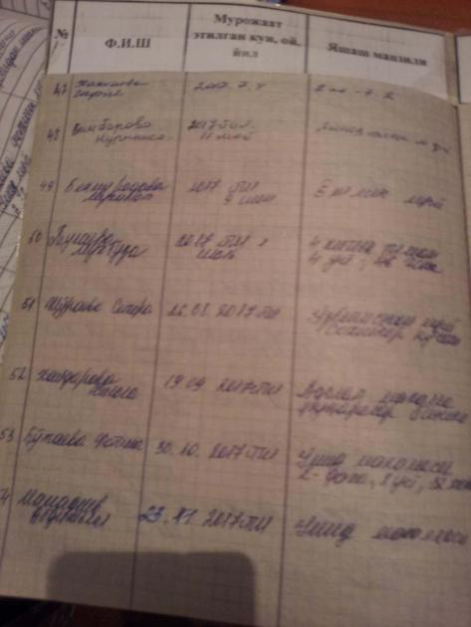 | 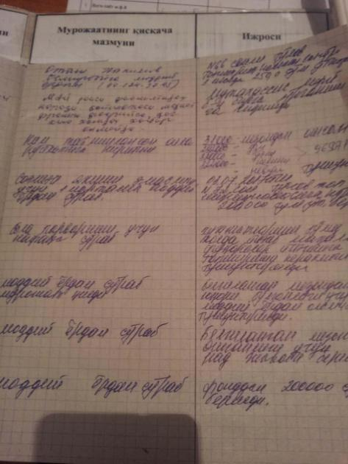

Annex 2 Inquires to regional and district authorities

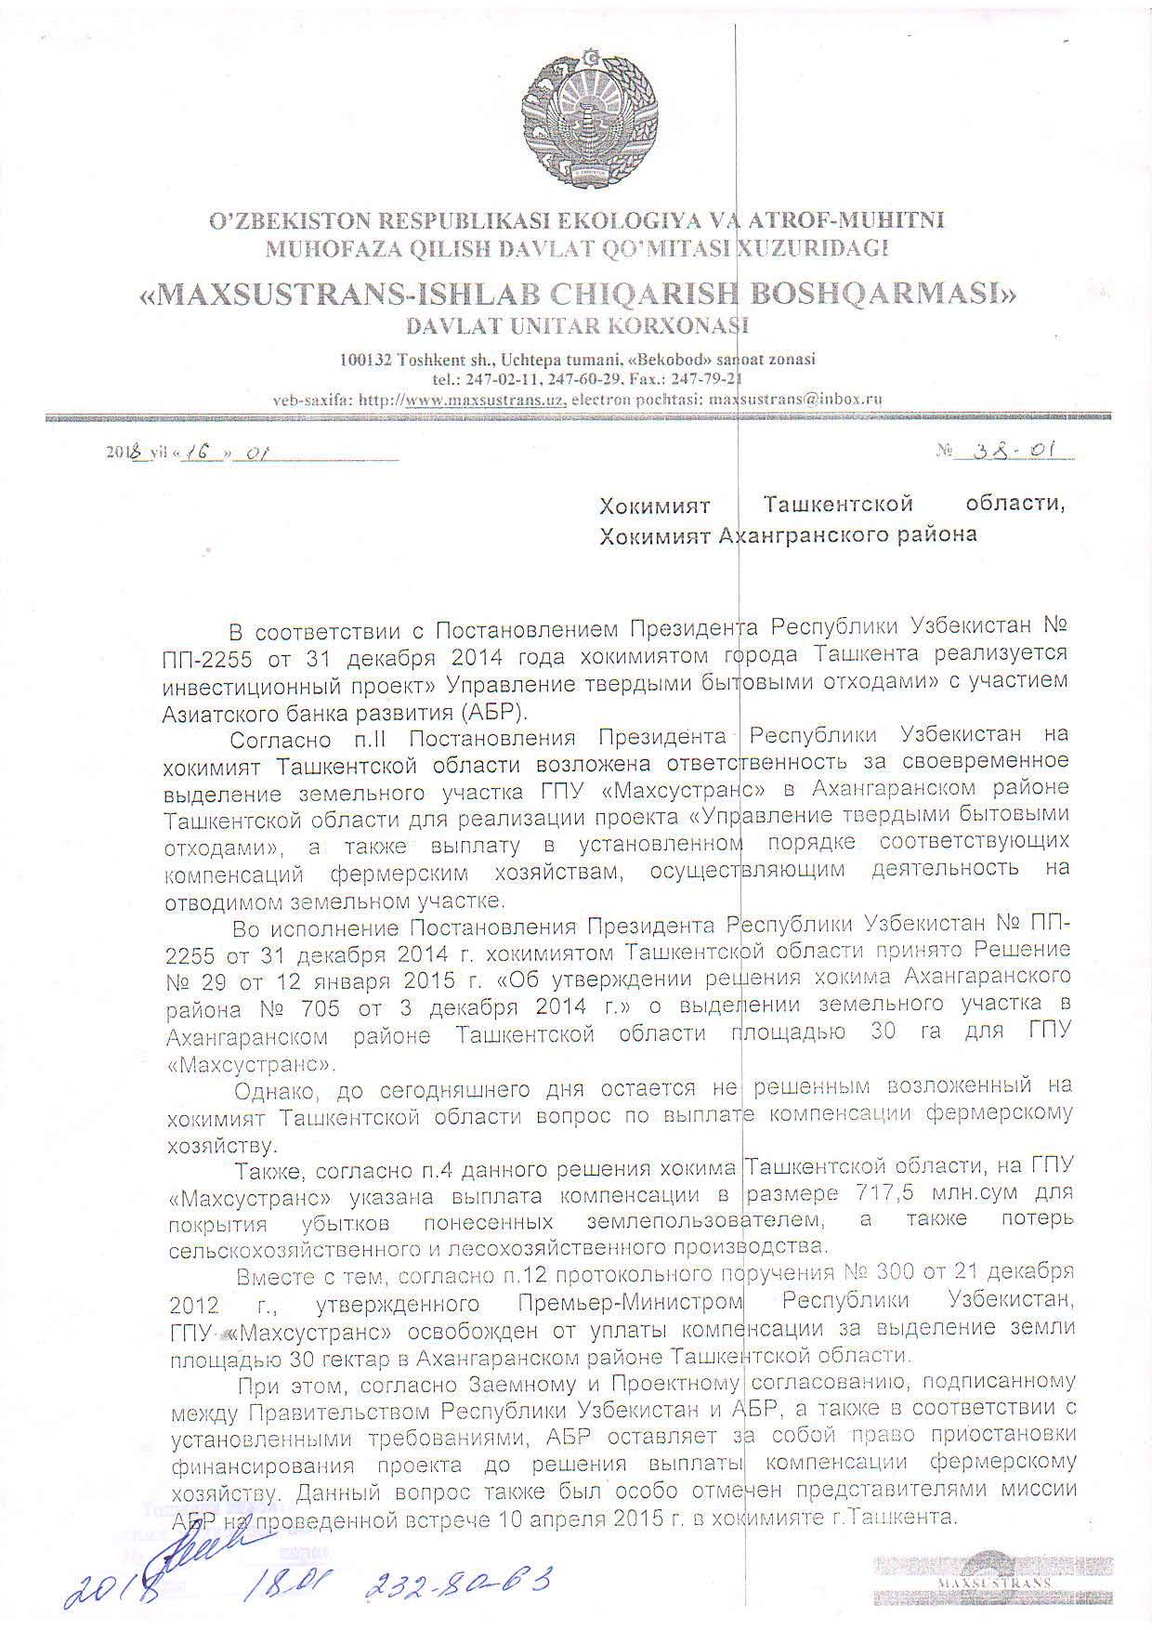
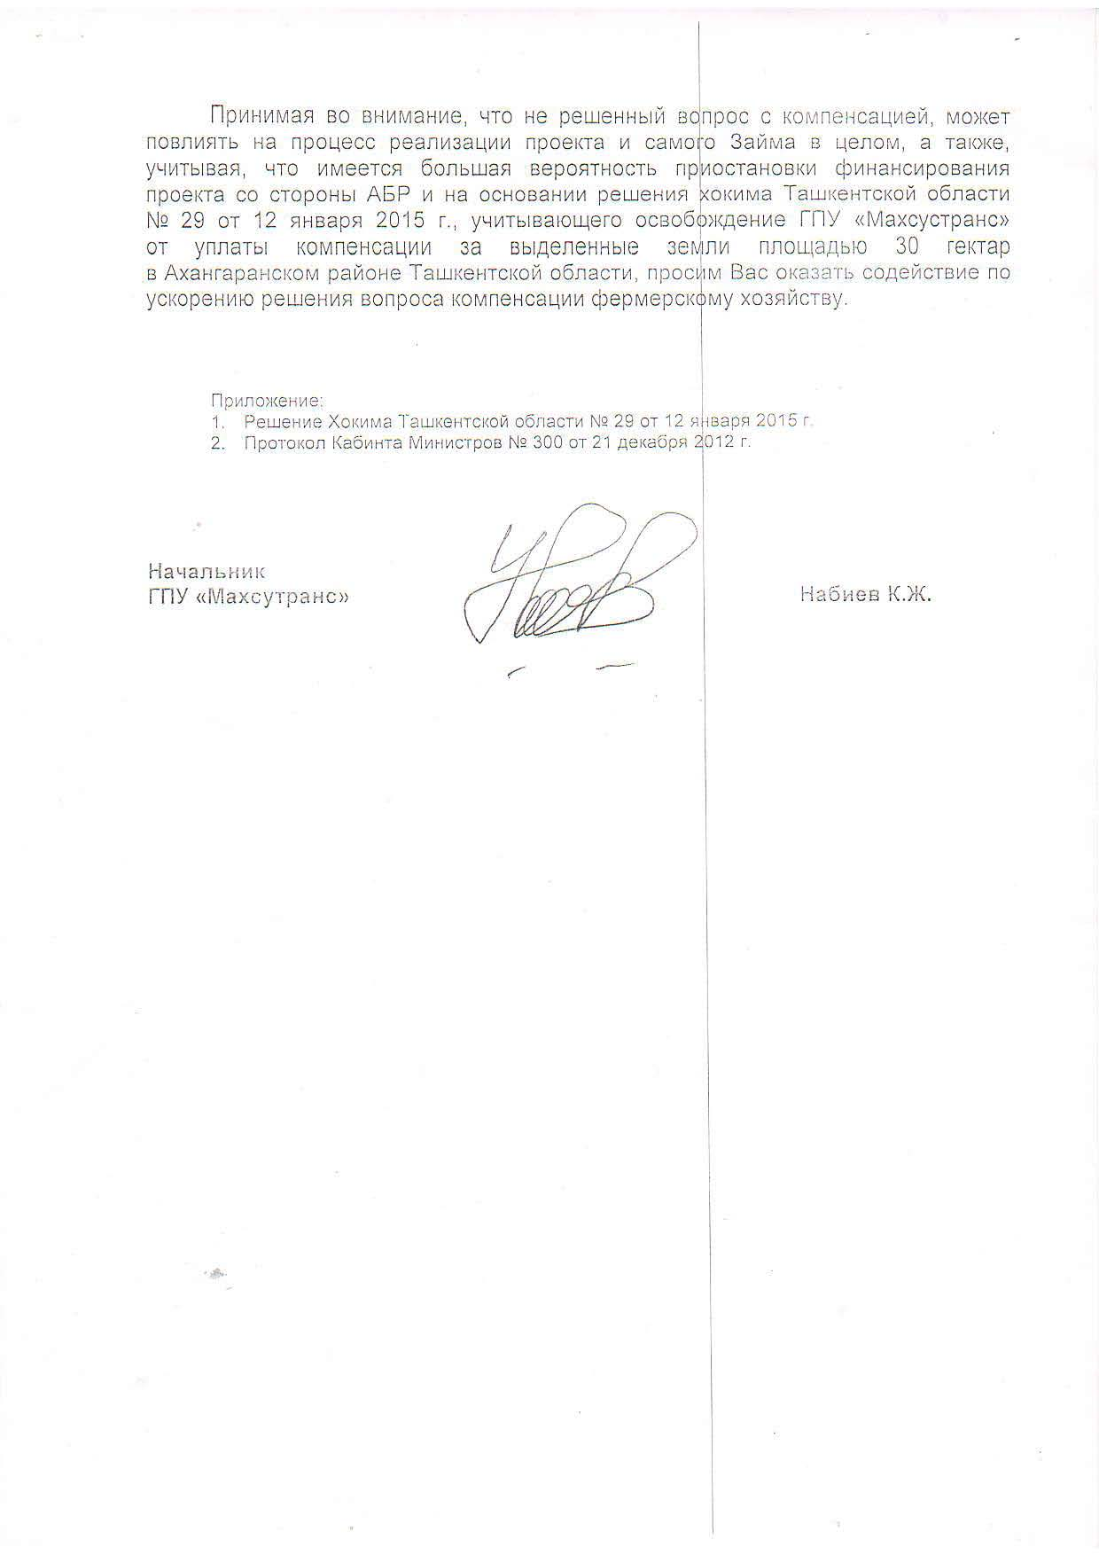
The original document is in Russian, the translation in English is unofficial
To khokimiyat of Tashkent region
To khokimiyat of Akhangaran district
In accordance with the Decree of the President of the Republic of Uzbekistan No. PP-2255 of December 31, 2014, the Tashkent city administration has implemented the investment project "Solid Household Waste Management" with the participation of the Asian Development Bank (ADB).
According to paragraph 2 of the Decree of the President of the Republic of Uzbekistan, the Tashkent region hokimiyat is responsible for the timely allocation of the land plot of the State unitary enterprise "Mahsustrans" in the Akhangaran district of the Tashkent region for the implementation of the project "Management of solid domestic wastes", as well as the payment in due course of appropriate compensation to farms, carrying out activities on the allotted land.
In pursuance of the Resolution of the President of the Republic of Uzbekistan No. PP-2255 of December 31, 2014, the hokimiyat of the Tashkent region adopted Decision No. 29 of January 12, 2015 "On approval of the decision of the hokim of Akhangaran district No. 705 of December 3, 2014" on allocation of a land plot in the Akhangaran district of Tashkent an area of ​​30 hectares for the State Unitary Enterprise "Mahsustrans".
However, until today, the issue of paying compensation to the farming sector, which was assigned to the hokimiyat of the Tashkent region, remains unresolved.
Also, according to paragraph 4 of this decision of the hokim of the Tashkent region, the state unitary enterprise "Mahsustrans" indicated payment of compensation in the amount of 717.5 million soums to cover losses incurred by the land user, as well as losses of agricultural and forestry production.
At the same time, according to point 12 of the protocol commission No.300 dated December 21, 2012, approved by the Prime Minister of the Republic of Uzbekistan, the State Unitary Enterprise "Mahsustrans" is exempted from compensation for allocation of land with an area of ​​30 hectares in the Akhangaran district of the Tashkent region.
At the same time, according to the Loan and Project Agreement signed between the Government of the Republic of Uzbekistan and the ADB, and in accordance with the established requirements, the ADB reserves the right to suspend the financing of the project before the payment of compensation to the farmer. This issue was also specially noted by the representatives of the ADB mission at the meeting held on April 10, 2015 in the Tashkent city administration.
Taking into account that the unresolved issue of compensation may affect the implementation of the project and the Loan itself as a whole, and given that there is a high probability of the project financing suspension by ADB and based on the decision of the hokim of Tashkent region No. 29 of January 2015 year, taking into account the exemption of the state unitary enterprise "Mahsustrans" from payment of compensation for allocated land of 30 hectares in Akhangaran district of Tashkent region, we ask you to assist in speeding up the solution of the issue of farming compensation.
Аpplications:
1. Khokim's Decision of the Tashkent Region No. 29 of January 12, 2015
2. Minutes of the Cabinet of Ministers No. 300 of 21 December 2012.
Head of State Unitary
enterprise "Mahsustrans" Nabiyev K.J
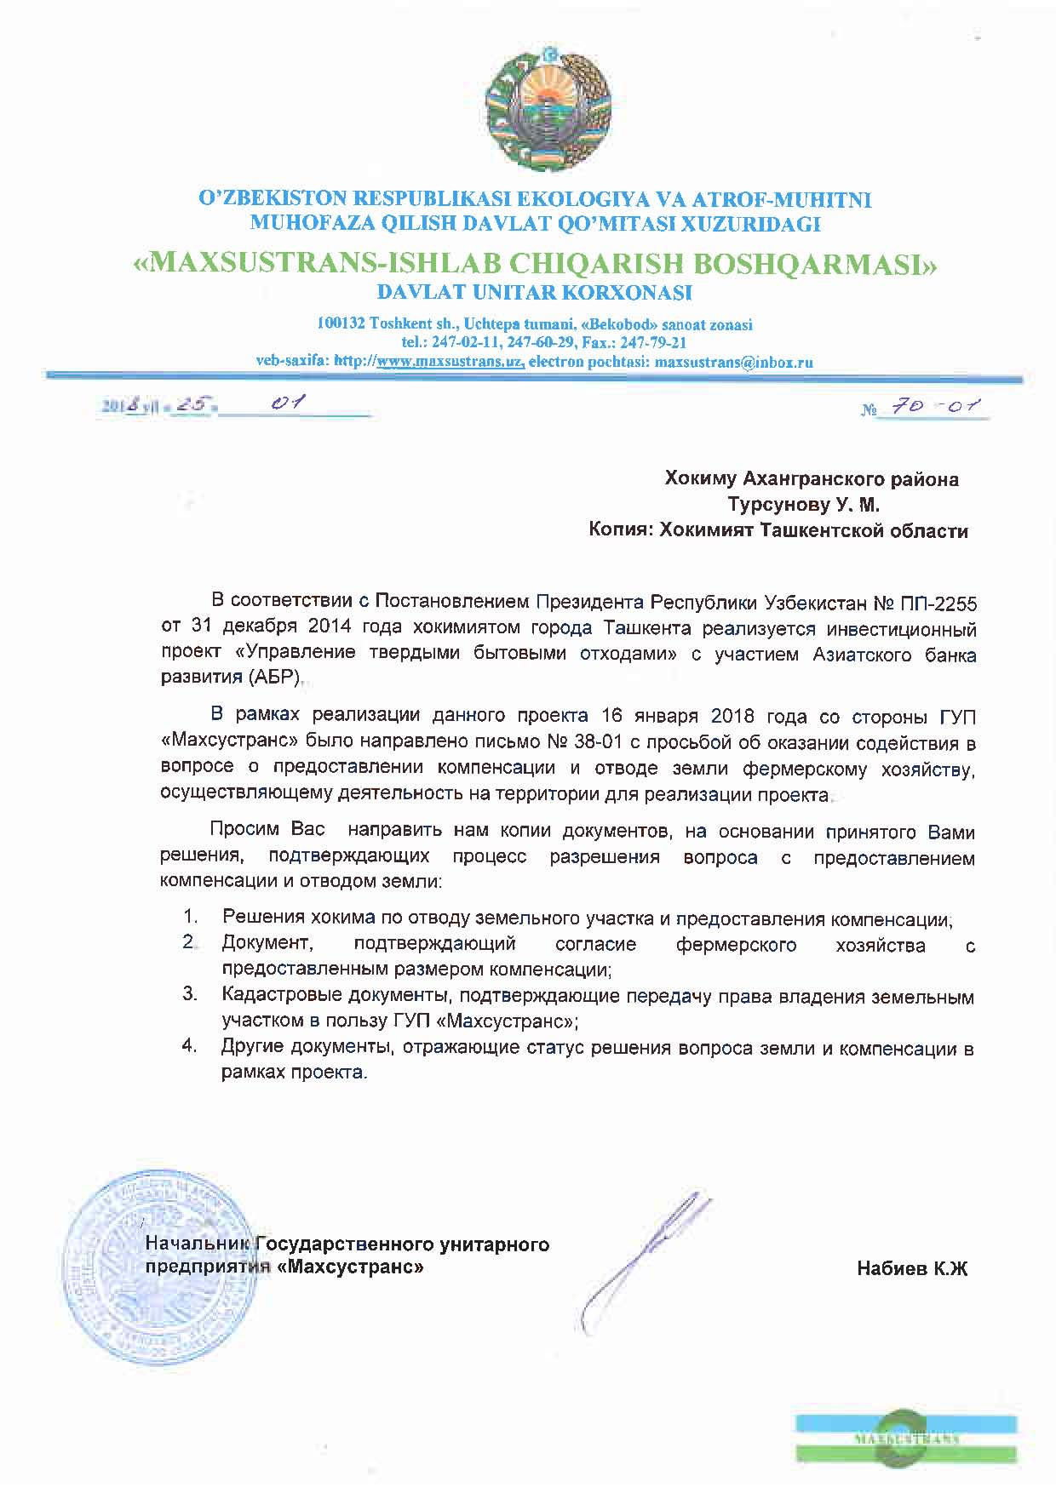
The original document is in Russian, the translation in English is unofficial
То Khokim of Akhangaran district, Tursunov U.M.
Khokimiyat of the Tashkent region

In accordance with the Decree of the President of the Republic of Uzbekistan No. PD-2255 of December 31, 2014, the Tashkent city administration has implemented the investment project "Solid Waste Management" with participation of the Asian Development Bank (ADB).
As part of the project, on January 16, 2018, the letter from the the state unitary enterprise "Mahsustrans" was sent to the Ministry of Justice to provide assistance in resolving the outstanding issue with the provision of compensation and the withdrawal of farm land plot that carry out activities in the area required for the project.
We ask you to send us copies of the documents on the basis of your decision confirming the process of resolving the issue with compensation and land allocation:

1. Decisions of the hokim to allocate land plot and provide compensation;
2. A document confirming the agreement of the leasehold farming with the amount of compensation provided;
3. Cadastral documents confirming the transfer of ownership rights to the land plot in favor of the state unitary enterprise "Mahsustrans"";
4. Other documents reflecting the status of solving the issue of land plot and compensation within the project.

Head of State Unitary
enterprise "Mahsustrans" Nabiyev K.J

То Hokim of Akhangaran district
Tursunov U.M.
Cоpy: Hokimiat of the Tashkent region

In accordance with the Decree of the President of the Republic of Uzbekistan No. PD-2255 of December 31, 2014, the Tashkent city administration has implemented the investment project "Solid Waste Management" with participation of the Asian Development Bank (ADB).
As part of the project, on January 16, 2018, the letter from the the state unitary enterprise "Mahsustrans" was sent to the Ministry of Justice to provide assistance in resolving the outstanding issue with the provision of compensation and the withdrawal of farm land plot that carry out activities in the area required for the project.
We ask you to send us copies of the documents on the basis of your decision confirming the process of resolving the issue with compensation and land allocation:

1. Decisions of the hokim to allocate land plot and provide compensation;
2. A document confirming the agreement of the leaseholding farmings with the amount of compensation provided;
3. Cadastral documents confirming the transfer of ownership rights to the land plot in favor of the state unitary enterprise "Mahsustrans"";
4. Other documents reflecting the status of solving the issue of land plot and compensation within the project.

Head of State Unitary
enterprise "Mahsustrans" Nabiyev K.J

