Environmental Monitoring Report
_________________________________________________________________
#18 Semestral Report
Reporting period: July – December 2024
Project Number: 45366-004

UZB: Solid Waste Management Improvement Project (SWMIP)

Loan No. 3067-UZB
(Financed by the Asian Development Bank)
Prepared by the State Unitary Enterprise “Maxsustrans” for Tashkent Municipality, State Committee of the Republic of Uzbekistan of Ecology and Environment Protection (SCEEP), and the Asian Development Bank (ADB)




Solid Waste Management Improvement Project
ADB Loan No.: 3067-UZB

PROJECT MANAGEMENT, IMPLEMENTATION AND SUPERVISION CONSULTANCY SERVICES

Contract No.: SUE/Maxsustrans/QCBS-Cons_1-2016-01

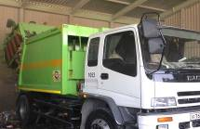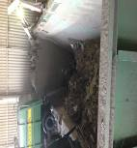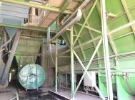

Semi-Annual Environmental
Monitoring Report

Reporting Period: July – December 2024

CLIENT – IMPLEMENTING AGENCY
State Unitary Enterprise (SUE) “MAXSUSTRANS” (Uzbekistan)

PIU SUPPORT CONSULTANT
Infratech Consulting SDN Ltd. (Uzbekistan)

CURRENCY EQUIVALENTS
(As of 30 December 2024)
Currency unit | – | Sum (SUM)
SUM1.00 | = | $0,0000774
$1.00 | = | SUM 12,920.48

ABBREVIATIONS

ADB  AP | Asian Development Bank  Affected people
BER | Bid Evaluation Report
CDP | Corporate Development Program
CSC | Construction Supervision Consultant
EHS | Environmental Health & Safety
EIA | Environmental Impact Assessment
EIP | Environmental Impact Permit
EMP | Environmental Management Plan
GoU | Government of Uzbekistan
GRM | Grievance Redress Mechanism
IEE | Initial Environmental Examination
LARP | Land Acquisition and Resettlement Plan
Maxsustrans  Ministry | State Unitary Enterprise “Maxsustrans”  Ministry of Ecology, Environmental Protection and Climate Change of the Republic of Uzbekistan
MSW | Municipal Solid Waste
PIU | Project Implementation Unit
SCEEP | State Committee of Ecology and Environment Protection of the Republic of Uzbekistan
SLF | Sanitary Landfill Facility
SPS | Safeguard Policy Statement
SEMP | Site-specific Environmental Management Plan
SWM | Solid Waste Management
SWMIP | Solid Waste Management Improvement Project
NOTE{S}
This Environmental Safeguard Monitoring Report is a document of the Borrower. The views expressed herein do not necessarily represent those of ADB's Board of Directors, Management, or staff, and may be preliminary in nature.
In preparing any country program or strategy, financing any project, or by making any designation of or reference to a particular territory or geographic area in this document, the Asian Development Bank does not intend to make any judgments as to the legal or other status of any territory or area.
TABLE OF CONTENTS

1 INTRODUCTION 6
1.1 Preamble 6
1.2 Headline Information 6
2 PROJECT DESCRIPTION AND CURRENT ACTIVITIES 7
2.1 Project Description 7
2.2 Project Contracts and Management 8
2.3 Project Activities During the Reporting Period 12
2.4 Description of Any Changes to Project Design 15
2.5 Description of Any Changes to Agreed Construction Methods 15
3 ENVIRONMENTAL SAFEGUARD ACTIVITIES 16
3.1 General Description of Environmental Safeguard Activities 16
3.2 Site Audits 17
3.3 ADB Missions 19
3.4 Unanticipated Environmental Impacts or Risks 20
4 STATUS OF COMPLIANCE WITH COVENANTS 21
5 RESULTS OF ENVIRONMENTAL MONITORING 27
5.1 Overview of Monitoring Conducted during Current Period 27
5.2 Air and Ground Water Quality 27
5.3 Noise and Vibration 27
5.4 Waste Management 27
5.5 Health and Safety 28
5.6 Use of Material Resources 28
5.7 Summary of Monitoring Outcomes 28
5.8 Training 32
5.9 Complaints 32
6 SUMMARY AND RECOMMENDATIONS 34
6.1 Summary 34
6.2 Recommendations 34
7 APPENDIXES 35
Appendix 1: Environmental Management Plan (Annex 6 of IEE) 35
Appendix 2: Environmental Monitoring Plan (Annex 7 of IEE) 40
Appendix 3: Groundwater Monitoring Analyses 41
Appendix 4: Air Quality Monitoring Analyses 43
Appendix 5: Waste Management on Site 47

LIST OF FIGURES

Figure 1: Task Distribution Scheme 17
Figure 2: Grievance Redress Mechanism 33

LIST OF TABLES

Table 1: Summary of the Work contracts and physical progress as of 30 June 2024 9
Table 2: Environmental Safeguards Personnel 11
Table 3: Role of Agencies towards EMP Implementation 11
Table 4: Ongoing Contracts of the Project No. L3067-UZB 15
Table 5: Site inspections 18
Table 6: Status of Compliance with Covenants 22
Table 7: Mobilization of materials of the Contractor CW1-R 28
Table 8: Status of corrective actions proposed in the previous EMRs (not applicable) 29
Table 9: Status of EMP implementation during the construction period (Contract CW1-R) 30
Table 10: Summary of complaints received during the monitoring period 34
Table 11: Summary of Action Plan for the Next Reporting Period 35

INTRODUCTION

Preamble
- As per the Loan and Project Agreements for the L3067-UZB: Solid Waste Management Improvement Project (SWMIP), State Unitary Enterprise (SUE) “Maxsustrans” and Project Implementation Unit (PIU) are bound to ensure that: (i) the project is constructed and operated in accordance with the national and local environmental regulations and guidelines, ADB's Safeguard Policy Statement (2009) and the Initial Environmental Examination (IEE) report; (ii) any adverse environmental impacts arising from the construction and operation of the project facilities are minimized by implementing the mitigation measures as per the environmental monitoring program and other recommendations presented in the IEE report; and (iii) the implementation of the Environmental Management Plan (EMP) and violations of safety or environmental standards, if any, be regularly reported to Asian Development Bank (ADB).
- This is the 18th Semi–Annual Environmental Monitoring Report (SAEMR) for the SWMIP covering the reporting period of July – December 2024. This SAEMR describes the implementation of the environmental monitoring and mitigation measures recommended in the IEE, analyzes environmental data collected from the ongoing projects during the reporting period and provides recommendations for resolving identified issues.
- To be more specific, this SAEMR covers the following areas: (i) documentation review and compliance assessment with the applicable environmental regulations; (ii) environmental management institutional structure and responsibilities; (iii) mitigation measures undertaken to minimize adverse environmental impacts arising from the construction; (iv) environmental monitoring results and analyses; and (v) conclusions and recommendations.
- The Government of Uzbekistan (GoU) took tough measures against COVID-19 and all necessary preventive measures to prevent the spread of coronavirus infection during March – August 2020. In particular, all transport communication and public activities have been limited or prohibited. Tashkent city and other regions went into quarantine mode, and most companies, organizations, and institutions were transferred to remote work. In the reporting period, the restriction measures due to COVID-19 have been cancelled in Uzbekistan, however, it is recommended to use masks in public places.

Headline Information
- The civil works on sanitary landfill were completed under the Works Contract CW1 by the end of the reporting period. The civil works began on April 8, 2022 and should be originally completed by September 30, 2023. Due to justified reasons of construction delay (weather conditions, design changes because of groundwater level in Cell 3, etc.), the construction completion was extended until July 2024. De-facto, the construction was ended by end of September 2024 as confirmed by the official letter of the Contractor CW1.
- As reported in the previous SAEMRs the civil works for rehabilitation of two garages and waste transfer stations in Tashkent city have been completed and commissioned in the previous years of the Project. Currently, these facilities are being operated by SUE “Maxsustrans”.

PROJECT DESCRIPTION AND CURRENT ACTIVITIES

Project Description
- The GoU has applied for a loan from the ADB for the development and improvement of the Solid Waste Management (SWM) system of the capital city Tashkent. ADB approved the project on 27 November 2013 with a loan amount of $69.0 million from its ordinary capital resources. The loan reference number is L3067-UZB: Solid Waste Management Improvement Project (SWMIP). The Loan Agreement was signed between the Republic of Uzbekistan and ADB on 27 February 2014, and the Project Agreement was signed between ADB, Tashkent City Municipality and the SUE “Maxsustrans” on 12 March 2014. The Loan Agreement became effective on 29 December 2014 and comprises Part A – National Municipal Solid Waste Strategy and Part B – Solid Waste Management in Tashkent city.
- The overall objective of SWMIP is to provide an improved SWM system in Tashkent, the capital city, to upgrade urban infrastructure and services. The project’s impact is improved urban environment and quality of life for the residents of Tashkent. The expected outcome is improved SWM services and management in Tashkent. The project has three outputs: output 1 - rehabilitated and expanded SWM system in Tashkent; output 2 - strengthened operational capacity; and output 3 - national SWM strategy. Tashkent City Municipality is the Executing Agency for the outputs 1 and 2, with the State Committee of Uzbekistan of Ecology and Environment Protection (SCEEP) being the Executing Agency for output 3. Maxsustrans is the Implementing Agency responsible for the daily project implementation.
- The total project cost is $76.3 million equivalent (of which ADB loan amount is $69.0 million and GoU contribution - $7.30 million), inclusive of tax and customs duty exemptions, and financial charges during implementation covered by the GoU. The project finances:
- supply of waste collection trucks and transportation of municipal solid waste;
- supply of equipment and machinery for the sanitary landfill;
- supply of waste bins for waste collection points and containers for transportation of waste;
- construction and rehabilitation of waste collection points;
- rehabilitation of two transfer stations in the city of Tashkent;
- rehabilitation of two garages of Maxsustrans;
- closure of an existing landfill solid waste dumpsite;
- construction of a new sanitary landfill;
- preparation of a draft national strategy for the management of solid waste, including a draft sector investment program;
- capacity development support for Maxsustrans, including in the areas of operation and management and Project implementation; and
- development and implementation of a waste minimization and recycling program and a parallel media and public awareness campaign about waste minimization and recycling.
- To be noted the construction and rehabilitation of waste collection points was financed by Maxsustrans own funds and the closure of existing dumpsite is financed by the Korean company “Sejin G&E Co. Ltd.” under the Waste to Energy project, for details please refer to the next chapter below. Therefore, these components are no longer part of the Project.
- Originally, the project was designed for five years of implementation with a loan closing date of 30 June 2019. On 17 December 2018, ADB approved a 24-months loan extension with the revised Loan Closing Date of 30 June 2021 to complete all ongoing contracts and planned civil works, delayed due to start-up delays (including ten months’ delay in effectiveness) and procurement delays (the first contract was awarded in 2016 only) because of the Executing Agency’s insufficient capacity and GoU’s prolonged contract registration process.
- Based on the letters of the Ministry of Finance of Uzbekistan (MoF) dated 26 March 2021 and 17 July 2021, on 23 July 2021, ADB approved a 30-months loan extension with the revised Loan Closing Date from 30 June 2021 to 31 December 2023 to ensure successful and timely completion of the project. This approval was provided by ADB on a post-facto-basis considering the GoU’s commitment to strictly adhering to the time-bound action plan and mitigation measures submitted to ADB, which shall be implemented by Tashkent City Municipality, Maxsustrans, and PIU.
- Further, in line with the letter of Ministry of Economy and Finance of Uzbekistan dated 18 September 2023 regarding the third extension of the Loan Closing Date, the ADB approved the requested extension of the Loan Closing Date from 31 December 2023 to 31 December 2024. So, the cumulative extension months are 66 months (or 5,5 years).
- The project includes a new Sanitary Landfill Facility (SLF) development concept approach. This utilizes the planned SLF as an immediate and effective solution for Tashkent’s waste disposal challenges, with the potential to progressively expand the facility to become a disposal solution that can serve a part of the Tashkent region over the long term. The proposed SLF concept is based on the Best Environmental Practices (BEP) resulting to a state-of–the-art design consistent with internationally acceptable standards.
- The volume of the existing dumpsite is exhausted, and the original plan of the Tashkent City Municipality was to extend its dumpsite operations to an adjacent lot of additional 30 hectares (ha) of area. Being fully aware of the inevitable environmental impacts through the extension of this practice, the city asked the national government for assistance in this matter. Based on these activities, the Cabinet of Ministers of Uzbekistan approved in summer 2012 the location of a new landfill on 30 ha of agricultural area for waste disposal (Akhangaran district of Tashkent region).
- The GoU has allocated a 30-ha land plot immediately to the south of the existing Akhangaran dumpsite of which ca. 25 ha for new sanitary landfill and ca. 5 ha for auxiliary facilities. The new landfill has been designed in accordance with the internationally recognized environmental standards and considering the national construction and environmental norms and requirements. In the second half of 2019 the engineering design of the sanitary landfill and auxiliary facilities has been completed and a positive expert conclusion on the design documentation has been received from the local authority. According to local regulation any design for construction or reconstruction of a facility shall first be reviewed and confirmed by the responsive authority and after the Employer is entitled to conclude the works contract with the Contractor.
- The GoU, through its Implementing Agency, the SUE “Maxsustrans” utilizes part of this loan proceeds towards the cost of the contract for Consulting Services related to Project Management, Implementation and Supervision, supporting the PIU.

Project Contracts and Management
- Summary information on the work contracts and physical progress is presented in Table 1. All work contracts awarded under the SWMIP included EMP approved by ADB. For the awarded contracts environmental assessment was not required in accordance with national regulations of Uzbekistan. Since the works targeted to rehabilitation of existing structures to be carried out on the same area without any expansion of the territory and negative impact on environment, and as the original use of the rehabilitated structures has been not changed, preparation of a local EIA was not required. The CW1 contract (Sanitary Landfill Establishment) includes a PIC approved by ADB and the conditions for national approval of the EIA (paragraph 30).

Table 1: Summary of the Work contracts and physical progress as of 30 December 2024
Contractor | Scope | Signed  Date | Approval Date |  |  | Name of personnel |  | Civil Works |  | Progress as of |  | DLP
Contractor | Scope | Signed  Date | SSEMP | COVID-19 HSMP | ERP | Environmental Officer | Health and Safety Officer | Start  Date | End  Date | 30 Jun 2024 | 26 Sep 2024 | Start  Date | End  Date
CW1: JV «STECOL-POWERCHINA GUIYANG» (China) | Sanitary landfill establishment | 31 Jan 2022 | 7 Jul 2022 | 7 Jul 2022 | 7 Jul 2022 | Ms. Yuliya Gnedina | Ms. Aytbike Yusupova | 8 Apr  2022 | 30 Sep  2024 | 96.0% | 100.0% | (1 Nov 2024) | (30 Oct 2025)
CW2: JV of Future Growth Ltd., VBN Engineering Ltd and Eastern construction Ltd. (Uzbekistan) | Transfer station rehabilitation | 12 Apr 2021 | Apr 2021 | Apr 2021 | Apr 2021 | Mr. Nozimhon Saydullayev | Mr. Xasan Bashirov | 1 May  2021 | 31 Aug  2022 | 100% | 100% | 1 Sept 2022 | 31 Aug 2023
CW3: Cancelled | Dumpsite closure
CW4: Indigo Baraka Servis LLC (Uzbekistan) | Garage rehabilitation | 7 Dec  2020 | 21 Dec 2020 | 21 Dec 2020 | Jan 2021 | Mr. Khabibulla Mukhtarov | Mr. Rakhmatilla Normatov | 16 Dec  2020 | 31 Dec  2021 | 100% | 100% | 1 Jan  2022 | 30 Jun 2023
CW5: Various local contractors | Construction and rehabilitation of waste collection points | Various contracts |  |  |  | n/a | n/a | Various dates | Various dates | 100% | 100% | N/A | N/A

Notes:
The Month/Years in brackets are planned schedule.
COVID-19 HSMP = COVID-19 Health and Safety Management Plan, ERP = Emergency Response Plan, SSEMP = Site-Specific Environmental Management Plan, DLP=Defect Liability Period as per work contracts

- The daily administration of the project is being conducted by PIU established at Maxsustrans, which is currently represented by the acting Head of PIU Mr. Jamol Irbutayev appointed from 01.12.2023.
- PIU has received аn official letter from H.P. Gauff Ingenieure GmbH & Co. KG. on 24 July 2020 about оrdеr of the local court of Nurеmbеrg оn opening of insolvency proceedings according to Gегmаn Law regarding H.P. Gauff Ingenieure GmbH & Co. KG. PIU has also received аn official letter from H.P. Gauff Ingenieure GmbH & Co. KG. on 17 September 2020 about declaration of non-entry of the соmраnу in the Cоntгасt No. SUE/Maxsustrans/QCBS-Cons1-2016-01.
- Considering the necessity to соntinue the PIU support sеrviсеs for еnsuring an uninterrupted implementation of the Project, the obligations under the Соntrасt No. SUE/Maxsustrans/QCBS-Cons 1-2016-01 were assigned to the local partner of JV - Infratech Consulting SDN Ltd. (Uzbekistan). Maxsustrans has signed Amendment No. 5 to the Contract Cons_1 on 9 December 2020 with extension of the Consultant’s service until 30 June 2021.
- After the Loan Closing Date was extended until 31 December 2023, by Amendment No. 6 dated 9 December 2021, the PIU Consultant services have been prolonged from 30 June 2021 until 31 December 2023. To strengthen the financial management and contract administration capacities of the Project, the Consultant’s team was extended by two additional non-key national experts: Financial Management Specialist/Accountant and Contract Administration Specialist.
- A full rеsроnsibility of the Consultant to регfоrm this cоntrасt against the Client is handed over to lnfratech Consulting SDN Ltd. Mr. Dilshod Mavlyan-Kariev, national SWM Specialist/Deputy Team Leader is in charge in the overall project administration and reporting for the Project.
- PIU Support Consultant has mobilized the national environmental specialist Mr. Sergey Karandayev with input 18.93 per/mon since 01.07.2018 and to support him with site monitoring missions assistant Mr. Akmal Begimkulov with input 3.88 per/mon, who was mobilized on 18.04.2022. They both are in charge of environmental monitoring and reporting, supervision over mitigation measures are implemented and reported properly.
- On 31.01.2023 Mr. Begimkulov has resigned PIU Consultant team and since 01.03.2023 he working as the national environmental specialist of PIU for continuing the Project’s environmental monitoring and reporting. His contract with PIU until the end of July 2024 – end of construction of sanitary landfill. As per 30.06.2024, the remaining input of Mr. Karandaev is 0.74 per/mon.
- Maxsustrans has recruited the China Urban Construction Design & Research Institute Co., Ltd. (CUCD) as the Consultant for SLF Design and Construction Supervision Services (contract Cons_2). The design services of CUCD commenced in December 2018 and completed in October 2019 by state expertise of the engineering design documentation. Based on the approved design prepared by CUCD, Maxsustrans has launched the international bid under the contract CW1 – Sanitary Landfill Establishment and Dump Site Closure in October 2019. The package was rebid in October 2021 due to cancellation of the dumpsite closure based on decision of the GoU.
- The civil works under the contract CW1-R: Sanitary Landfill Establishment commenced on 8 April 2022 and the supervision services of CUCD under the contract Cons_2 commenced on 5 May 2022 and continued until 3 June 2024. On 25 April 2022, Maxsustrans signed with CUCD the Amendment No. 3 to the contract extending the supervision service until 31 October 2023. CUCD acting as the Engineer under the contract CW1-R and monitors the safeguard compliance. Mr. Mingtao Nie - international environmental specialist of CUCD with input of 3.0 per/mon for the supervision phase, who has worked from May 2022 to May 2023.
- CUCD environmental specialist monitored the implementation of Site-Specific Environmental Management Plan (SSEMP) prepared by the Contractor according to the requirements of the national Environmental Impact Assessment (EIA = the Russian abbreviation “ZVOS”) and the Environmental Management Plan (EMP) cleared by ADB as part of the Project’s Initial Environmental Examination (IEE) dated May 2013 https://maxsustrans.uz/project/dokumenty-po-proektu.
- After finishing the SLF design by CUCD, a national EIA has been ordered by Maxsustrans and a positive conclusion of the State Ecological Expertise to the updated national EIA has been obtained on 9 March 2022. The national EIA is available on the website of Maxsustrans https://maxsustrans.uz/uz/project/regulyarnye-otchety.
- The main stakeholders of the Project related to environmental safeguards are presented in Table 2.
Table 2: Environmental Safeguards Personnel
Stakeholder | Organization / Firm | Title | Name | Email address
Executing Agency | Tashkent City Municipality (EA-TCM) | First Deputy Mayor | Mr. Bakhtiyor Rakhmanov | b.raxmonov@tashkent.uz
Implementing Agency | State Unitary Enterprise “Maxsustrans” (IA-Maxsustrans) | Director | Mr. Komoliddin Nabiev | maxsustrans@inbox.ru
Implementing Agency | State Unitary Enterprise “Maxsustrans” (IA-Maxsustrans) | Deputy Director | Mr. Mirjamol Soatov | maxsustrans@inbox.ru
IA’s PIU | State Enterprise “Solid Waste Management Improvement Project Implementing Unit” (PIU) | Acting Head | Mr. Jamoliddin Irbutaev | piu3067@gmail.com
PIU Support Consultant | Infratech Consulting SDN Ltd. (ITC) | Deputy Team Leader | Mr. Dilshod Mavlyan-Kariev, | dilshod75@mail.ru  infratech_consulting@asia.com
PIU Support Consultant | Infratech Consulting SDN Ltd. (ITC) | Environmental Specialist | Mr. Sergey Karandaev | infratech_consulting@asia.com
Landfill Design and Supervision Consultant | China Urban Construction Design & Research Institute Co. Ltd. (CUCD) with sub-consultants Uzagrosanoatloyiha Ltd. and Mailc Engineering Ltd. | Project Director | Mrs. Yuwei Xue | icc@cucd.cn  cucdconsulting@163.com
Landfill Design and Supervision Consultant |  | Environmental Specialist | Mr. Mingtao Nie | hjpmo@163.com
- The role of each agency in the project is presented in Table 3.
Table 3: Role of Agencies towards EMP Implementation
Agency | Role
Project Implementation Unit (PIU) | - Holds overall responsibility with regards to EMP Implementation  - Report to various stakeholders (ADB, Regulatory bodies) on status of EMP Implementation  - Coordinate with Environmental Experts (PIU Consultant, Contractors and External Monitors)  - Responsible for obtaining Regulatory Clearances  - Review of the progress made by Contractors  - Ensure the BoQ items mentioned in EMP are executed as per contract provisions
PIU Support Consultant | - Assist PIU in monitoring of overall implementation of EMP  - Review of periodic reports on EMP implementation and advising PIU in taking corrective measures  - Conduct periodic field inspection of EMP implementation  - Assist PIU and reporting to various stakeholders (ADB, Regulatory bodies) on status of EMP implementation  - Conduct environmental training for field officers and engineers of contractor
Design and Supervision Consultant – Engineer of the Works contract | - Supervise the implementation of the environmental protection and impact mitigating measures by the contractors  - Supervise construction activities to ensure minimum impact on the natural and socioeconomic environment  - Regularly monitor and report on performance of the Contractor(s) environment staff, verifying monitoring methodologies and results  - Review of the construction design to ensure compliance with project engineering design and the EMP with regards to environmental protection and impact mitigation  - Prepare the necessary remedial actions for any unforeseen impacts  - Instruct the Contractor(s) to take corrective actions within timeframe as determined by the Environmental Specialist  - Address complaints related with environmental aspect of the project through GRM  - Provide trainings to the Contractor regarding the implementation of the safeguard activities and plans on the construction site  - Contribute to the final report on safeguard aspects upon completion of construction
Contractor | - Responsible for development of Site-specific Environmental Management Plan (SSEMP)  - Responsible for ensuring the implementation of SSEMP as per provisions in the document  - Discuss various environmental / social issues and environmental / social mitigation, enhancement and monitoring actions with all concerned directly or indirectly  - Ensure environmentally sound and safe construction practices  - Conduct periodic environmental and safety training for contractor’s engineer, supervisors and workers  - Sensitize on social issues that may be arising during the construction stage of the project  - Conduct environmental monitoring and control activities including pollution monitoring, safety  - Prepare and submit monthly reports on status of implementation of safeguard measures  - During the COVID-19 pandemic, ensure necessary protection to the deployed workforce and minimize the risk of spread of infection.
- During the civil works under CW1-R, the Design and Supervision Consultant is responsible for approval and monitoring of implementation of SSEMP by the Contractor and regularly report to PIU/Employer on compliance with the safeguard requirements of the Project. The PIU Support Consultant is responsible for overall monitoring of supervision consultants and contractors involved under the Project at performing their safeguard compliance tasks and progress reporting based on monitoring results.

Project Activities During the Reporting Period
- The status of the Works contracts of the Project is as follows:
- Contract CW1-R – Sanitary Landfill Establishment signed on 31 January 2022: The Contractor – JV «STECOL-POWERCHINA GUIYANG» (China). The amended contract’s value is $17.19 million excl. local VAT. The contract experienced significant delay compared to the original implementation schedule due to delayed selection of the Contractor during 2019 and 2020. The works commenced on 8 April 2022 and had to be completed by 31 July 2024 – after extension by 10 additional months. The actual completion date is 30 September 2024 (30 months in total):
- Number of workers and drivers of earthmoving equipment and trucks involved in the reporting period was at least 8 people and no more than 20 people. This number of workers and drivers will be increased depending on the progress of physical work in the next period.
- Implementation of safeguard plans (SSEMP, SAP/GAP and SSHSMP [SSHSMP – Occupational Health and Safety Management Plan for specific facilities; HS-C19 Plan – COVID-19 Health and Safety Plan], including HS-C19 plan);
- Before the civil works, provide working personnel with a workroom, etc.;
- Installation of the Project scoreboard, protective fencing and warning signs on the site;
- Brickwork of the walls of the administrative building;
- Purchase of construction materials and fuel;
- Construction of access road;
- Construction of operational ring road and operating road to the bottom of the landfill;
- Installation of a mesh fence around the landfill area.

Below are photographs on construction activities of the Contractor CW1 within the reporting period:

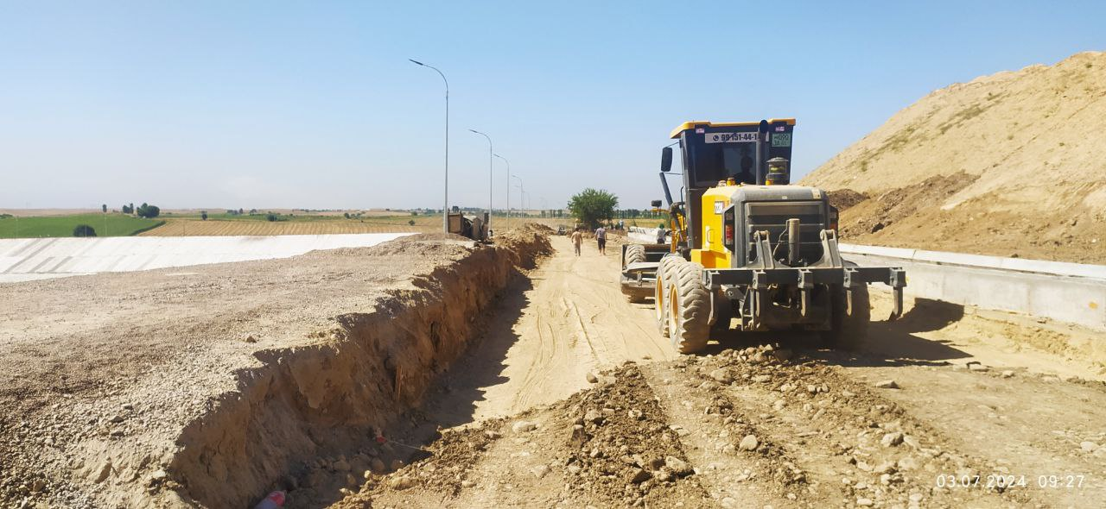 | 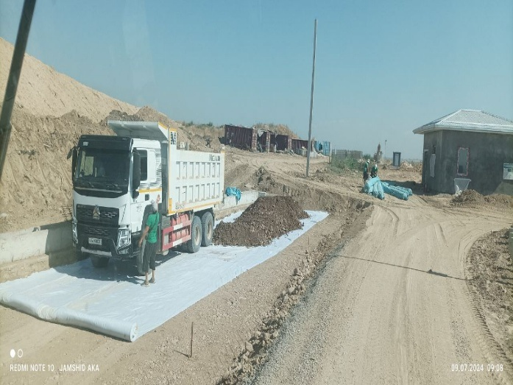
Pic. 1 Background preparation of access road (03.07.2024) | Pic. 2 Installation of liner of access road (09.07.2024)
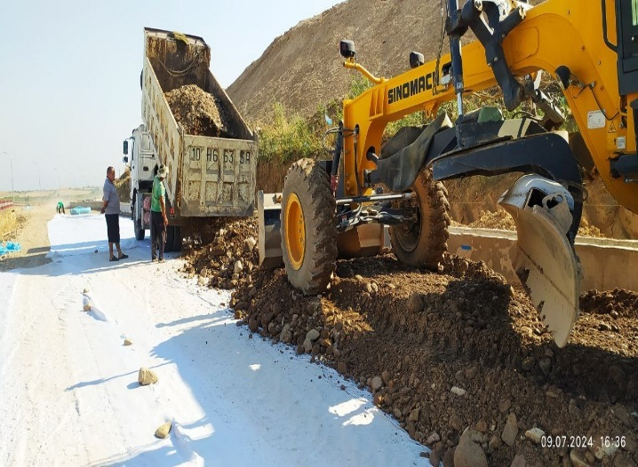 | 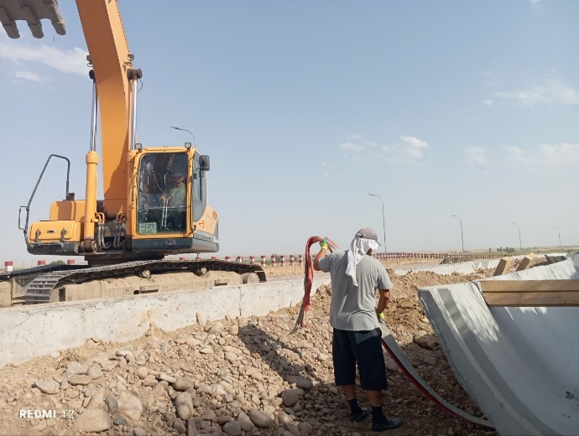
Pic. 3 Laying the gravel basement of access road (09.07.2024) | Pic. 4 Installation of irrigation channel for local farmer use (15.07.2024)
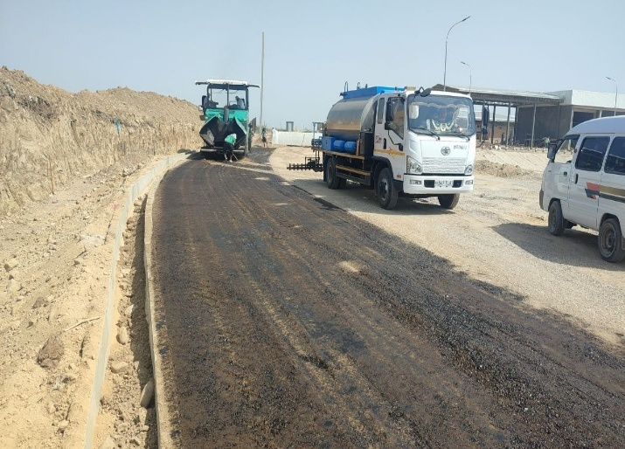 | 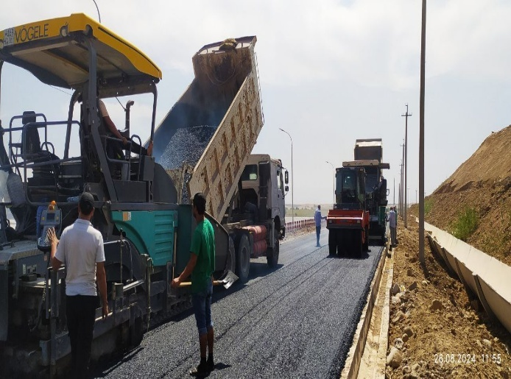
Pic. 5 Background preparation for asphalt coverage (01.08.2024) | Pic. 6 Laying asphalt coverage  (26.08.2024)
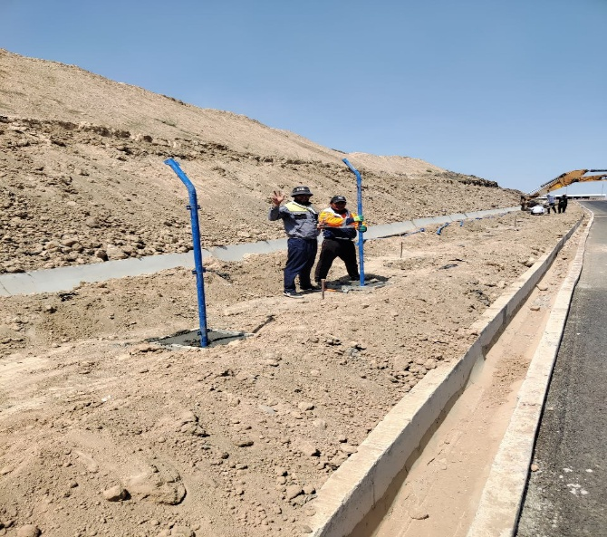 | 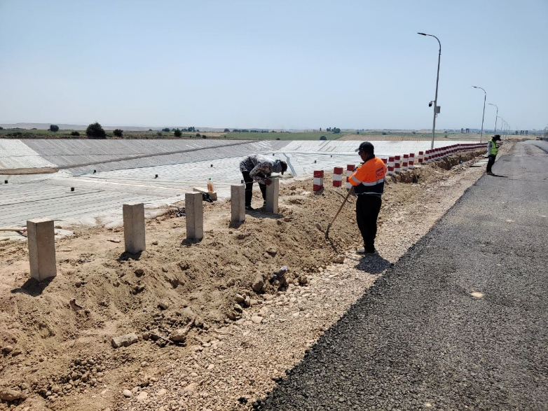
Pic. 7 Installation of fence of landfill (01.08.2024) | Pic. 8 Installation of signal posts (15.08.2024)
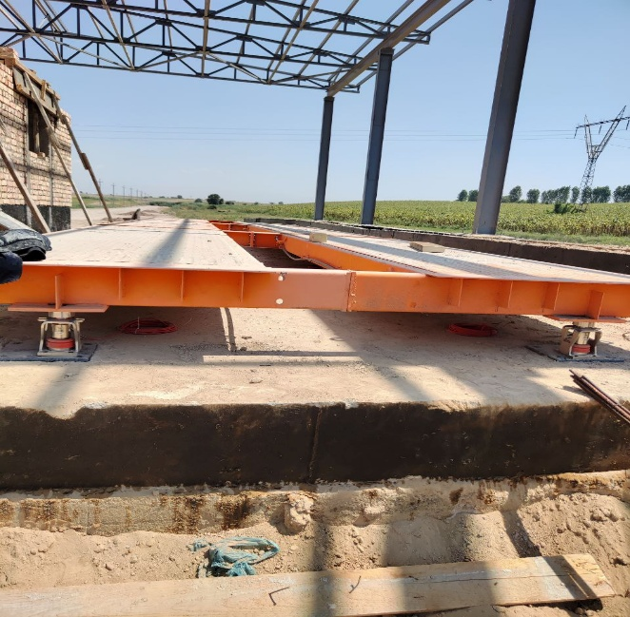 | 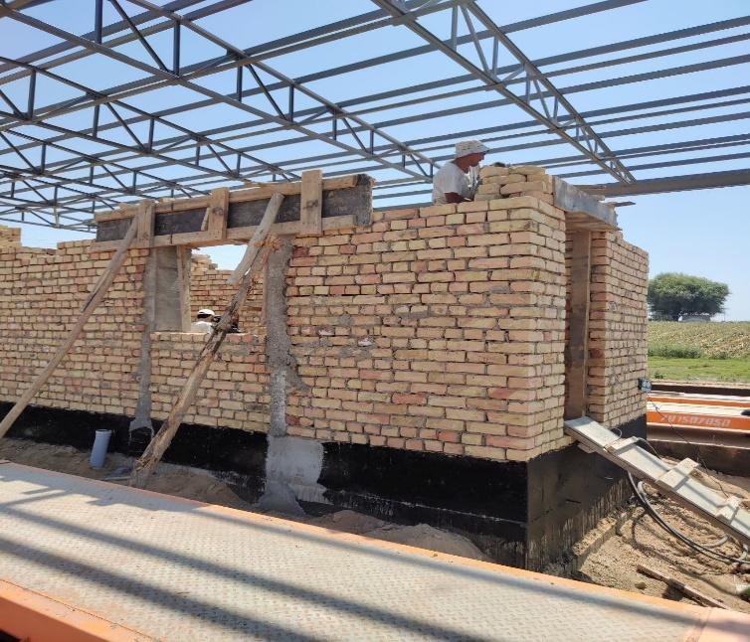
Pic. 9 Installation of weight bridge at entrance (15.08.2024) | Pic. 10 Construction of check point building – weigh bridge operator and security rooms (15.08.2024)
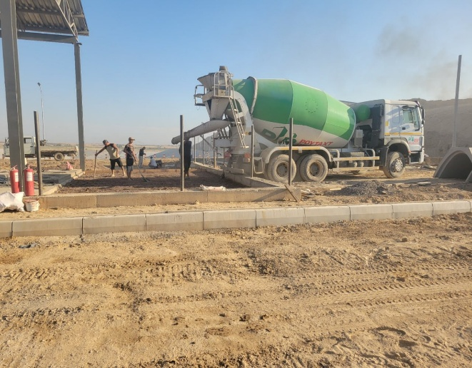 | 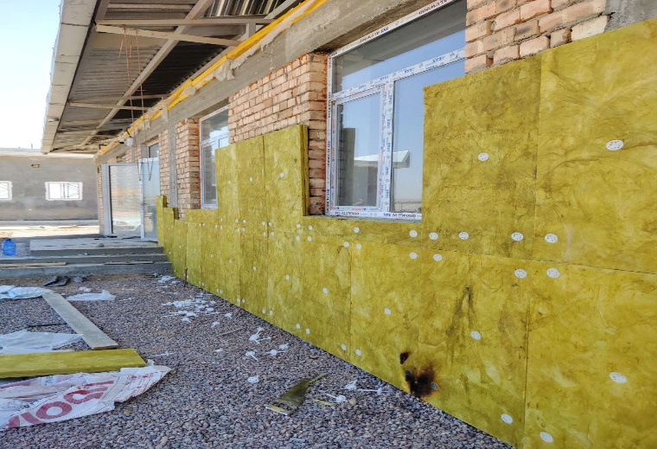
Pic. 11 Concrete works at workshop area (28.08.2024) | Pic. 12 Isolation works in administrative building (04.09.2024)

Table 4: Ongoing Contracts of the Project No. L3067-UZB
No. and Name of Contract | Category (works, goods or services) | Contract amount  (US$) | Contract completion
C1: PIU Support Consultant | Services | 2,410,000.00 | 31-Dec-24
C2: Sanitary Landfill Design & Supervision Consultant | Services | 2,698,650.00 | 31-Oct-23
CW1-R: Sanitary Landfill Establishment | Works | 17,196,268.86 | 31-Jul-24

Description of Any Changes to Project Design
- No changes to the agreed project design took place during the reporting period.

Description of Any Changes to Agreed Construction Methods
- No changes to agreed construction methods took place within the reporting period.
- The construction and rehabilitation of solid waste collection points, originally foreseen by the ADB loan funds of the Project, have been financed by Maxsustrans own funds and all works are completed within 2015-2019.

ENVIRONMENTAL SAFEGUARD ACTIVITIES

General Description of Environmental Safeguard Activities
- During the reporting period, no changes in organizational structure of the Project’s environmental safeguard activities made. With support of PIU’s environmental specialist PIU Consultant has monitored the overall project implementation and environmental safeguard measures on SLF site (contract CW1-R). PIU Consultant used data of the monthly safeguard monitoring reports of the SLF Contractor.
- Most of the environmental monitoring requirements are for the construction period of project site. At the construction stage, the Contractor’s specialist is responsible for preparation and submission of monthly environmental safeguard reports. Meanwhile, the PIU is responsible for the monitoring and summarization of compliance with the environmental safeguard requirements. The national environmental specialist of PIU Consultant is responsible for assistance to PIU in compiling the semi-annual environmental monitoring reports.
- Monitoring and reporting of the project is conducted prior to construction, during construction and operation. PIU monitors the performance and implementation of Environmental Management Plans (EMP). The environmental monitoring reports (EMR) on implementing the EMP are prepared prior to construction (detailed design and procurement stages), during construction and during operation, as follows: (i) monthly EMRs to the IA; and (ii) quarterly or semi-annual EMRs to ADB. The EMRs shall also document the relevant environmental aspects and its respective mitigation measures, as well as grievances received and resolved, if any.
- Prior to commencement of construction works, Contractor(s) have to submit Site-specific EMPs and compliance report to PIU ensuring that all identified impacts detailed in the environmental assessment have been undertaken. The PIU will review and approve the SSEMPs submitted by Contractor(s).
- During the reporting period, the activities undertaken by the Project’s environmental personnel include:
- National Environmental Specialist of PIU Consultants (Mr. Sergey Karandaev):
- monitor and report on environmental safeguard issues since August 2017 up to date,
- liaise with the Client (Maxsustrans), the Contractor (CW1-R) and the Supervision Consultant (CUCD),
- cooperate with PIU environmental specialist Mr. Akmal Begimkulov,
- conduct the site inspections on project sites where construction works are ongoing (new sanitary landfill in Akhangaran district of Tashkent region),
- propose mitigation measures when issues identified on the site.
- International Environmental Specialist of SLF Supervision Consultant (Mr. Mingtao Nie), demobilized since 1 May 2024:
- Update the EMP for the construction of the sanitary landfill,
- Review the Contractor’s site-specific environmental management plan (SSEMP) and propose suggestions for improvement;
- Monitor the implementation of SSEMP by the Contractor CW1-R and report to Maxsustrans/PIU,
- Review the Contractor’s monthly EMRs,
- Prepare quarterly EMPs based on the Contractors’ monthly EMRs and submit to Maxsustrans / PIU,
- Coordinate with other environmental specialists working in the project.

The following scheme presents the current task distribution agreed by the environmental specialists of the PIU Consultant, the Supervision Consultant and the Contractor after the training for environmental safeguard issues on 10 June 2022:

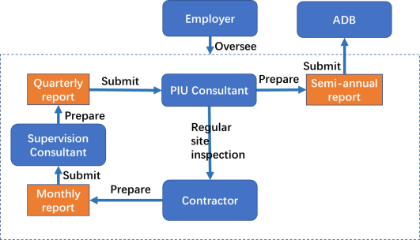
Figure 1: Task Distribution Scheme
- During the reporting period, the activities undertaken by the Contractors’ environmental personnel included:
- Compliance with the SSEMP and Site Specific Health and Safety Management Plan (SSHSMP) including the Health and Safety COVID-19 Plan (HS-C19 Plan),
- Prepare monthly EMRs,
- Keep the records and maintain the statistics on environmental safeguard issues,
- Weekly visits to the construction site for monitoring the compliance with the requirements of the SSEMP,
- Conduct trainings for staff on environmental safeguard issues,
- Propose corrective measures when problems identified on the site, removal of identified comments issues by the environmental specialists of the Project, construction and design supervision engineers,
- Liaise with the Employer (Maxsustrans) and the Supervision Consultant (CUCD).

Site Audits
- During the monitoring period, Mr. Dilmurad Mavlyan-Kariev – Deputy head of PIU acting as National environmental specialist has performed the following site audit visits to monitor of environmental, health and safety (EHS) aspects on the SLF:

Table 5: Site inspections
Date of visit | Purpose of the site visits | Contractor | Reference to the inspection report
25.10.2024  09.11.2024  21.12.2024 | Compliance review on occupational health, safety and environmental protection | CW1R, Joint venture "STECOL- POWERCHINA GUIYANG" (China) | Site visit report with inconsistencies and recommendations

Contract CW1(R) – Sanitary Landfill Establishment (construction ongoing):
- The construction works in the management area were the main activities of the Contractor CW1-R during the reporting period, so the Contractor continued to implement the EHS measures according to SSEMP and employed the EHS officers.
The following photos made during the site audits for the reporting period:
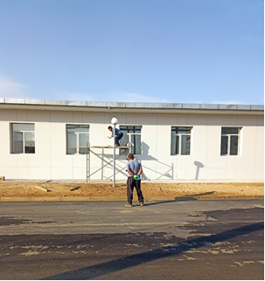 | 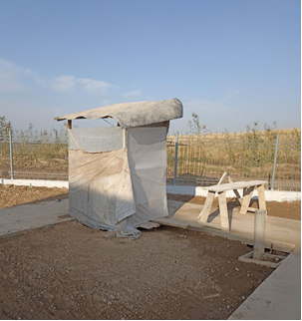
Pic. 13 Workers are not provided with protective  clothing (25.10.2024)  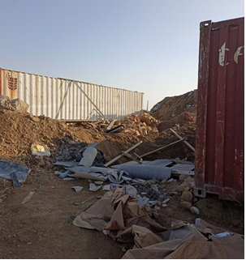 | Pic. 14 Sanitary facilities are not well organized  (25.10.2024)  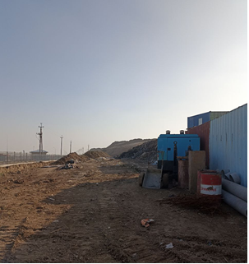
Pic. 15 Construction waste not removed (09.11.2024) | Pic. 16 Construction waste not removed (09.11.2024)

ADB Missions
- The issues identified during the site visit of ADB safeguard specialists (27 May 2024) were resolved by the Contractor as shown in the following table:
No | Issue | Action to be Taken | Responsibility | Timing  (Target Dates) | Description of Resolution and Timing (Actual) | If not yet resolved, indicate the reason why and specify further required action and timeframe
1 | Workers are not provided with protective clothing) | Workers should be provided with protective clothing | Contractor, PIU | 25 April 2024 | The rectification has been carried out as required, and helmets and work clothes have been provided to the workers. Please refer to photos 3 and 4 for details | Resolved see photo below
2 | Violation of the rules of bitumen storage and use | Put protective hard type barricades around the  holes and put warning signs. | Contractor, PIU | 25 April 2024 | The asphalt has been cleaned up | Resolved see photo below
3 | No fencing tape, no warning signs | In order to provide safe resting area for the  workers, the door needs to be fixed immediately. | Contractor, PIU | 23 April 2024 | The contractor has pulled the caution tape | Resolved see photo below
4 | Construction debris scattered around the construction site | Collect construction debris, clean up construction sites | Contractor, PIU | 25 April  2024 | Trash has been removed. | Resolved see photo below

- Completed inconsistencies that identified in May 2024 during the ADB mission:
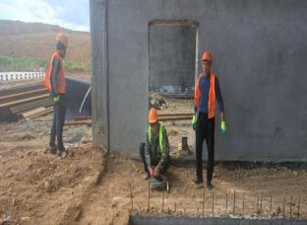 | 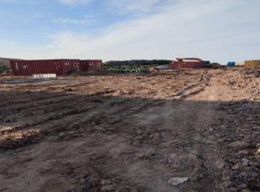
Pic. 17 Rectification carried out as required, and helmets and work clothes have been provided to the workers | Pic. 18 Violation of the rules of bitumen storage and use
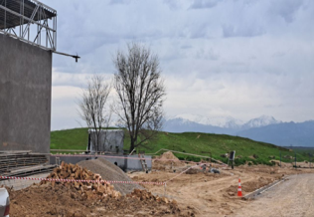 | 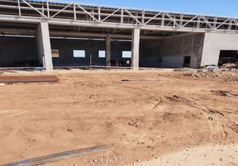
Pic. 19 Contractor has pulled the caution tape | Pic. 20 Trash has been removed

Unanticipated Environmental Impacts or Risks
- The COVID-19 pandemic is an unforeseen impact. The detailed instructions to be followed as a precautionary measure against COVID-19 should be reflected in the SPUOS, which should be submitted by construction contractors prior to the start of construction work.
- According to the ADB letter dated 01.09.2020 on the need to conduct a COVID-19 risk assessment at the project level and update relevant plans, such as the Health and Safety Plan (HSP) and the Emergency Response Plan (ERP), as well as the Environmental Management Plan (EMP), the PIU Support Consultant gave advice on updating the plans, specified above.
- All health and safety procedures related to the COVID-19 pandemic and recommended by WHO and the Government of Uzbekistan are taken into account and followed. The health and safety plan has been updated as requested by ADB. The CW1 Contractor prepared a Site-specific Occupational Health and Safety Management Plan (SSHSMP), including a COVID-19 Occupational Health and Safety Plan (HS-C19 Plan), which was submitted to the Employer in accordance with the Contract. The plan includes measures for the prevention and control of COVID-19, including disinfection/cleaning of offices, construction sites and labor camps, temperature checks at facilities, social distancing measures, mandatory use of personal protective equipment such as face masks, provision of places for hand washing and hand sanitizers, etc. as well as procedures that should be taken in case any employee is infected with COVID-19. The Contractor reported on the status of the implementation of the SSHSMP and the HS-C19 plan in monthly EMR and monthly construction progress reports.

STATUS OF COMPLIANCE WITH COVENANTS
- The environmental covenants under SWMIP require that the design, construction, operation and implementation of all sub-project facilities are carried out in accordance with the requirements set forth in the IEE for core sub-components agreed upon between the GoU and ADB, and the national environmental laws and regulations and ADB’s Safeguard Policy Statement (2009). Any adverse environmental impacts arising from the construction, operation and implementation of sub-component facilities will be minimized by implementing the environmental mitigation and management measures, and other recommendations specified in environmental assessment reports (e.g. IEE). The Government ensures environmental requirements are incorporated in bidding documents and civil works contracts. Issuance of bid documents is made after review and clearance of IEE/EIA by ADB and the SCEEP. PIU prepares and submits SAEMRs to ADB that describe progress in implementation of the EMP and issues encountered and measures adopted; and compliance with the relevant assurances and loan covenants.
- Table 6 shows the status of compliance with ADB’s loan covenants relating to environment, health and safety during the monitoring period (July – December 2024).

Table 6: Status of Compliance with Covenants
Covenants | Reference to  Loan and Project Agreement | Status of Compliance (as of 30 December 2024)
Conditions for Award of Contract
- The Borrower shall ensure that Maxsustrans shall not award any Works contract which involves environmental impacts until:  (a) SCNP has issued a statement of ecological expertise; and  (b) the Borrower has incorporated the relevant provisions from the EMP into the Works contract. | LA Schedule 4, paragraph 6 | Complied.  a) In November 2021, an updated EIA of the construction of a new landfill was prepared according to the national standards and legislation. On March 9, 2022, a positive conclusion of the State Environmental Expertise of the State Committee for Ecology was obtained.  b) All work contracts (CW1, CW2 and CW4) are procured on the basis of bidding documents, including the relevant provisions of the Project's EMP.
Consulting services
- The Borrower shall recruit the individual consultants for capacity development in the areas of project management, procurement, safeguards, financial management and monitoring and evaluation in accordance with procedures acceptable to ADB for recruiting individual consultants. | LA Schedule 4, paragraph 10 | Complied.  The Borrower has hired four individual consultants in accordance with the ADB procurement guidelines, in particular: an international project management/procurement specialist, an international environmental specialist, a national financial management specialist and a national monitoring and evaluation specialist. These specialists provided services for the development of the STVA and PIU capacities in the field of project management, procurement, guarantees, financial management, as well as monitoring and evaluation in accordance with ADB procedures. Contracts for the provision of services with all specialists were completed in early 2017, when a PIU Support Consultant was selected, and in January 2017 a Cons_1 Contract was signed.
Implementation Arrangements
- No later than 6 months after the Effective Date (December 29, 2014), the Borrower shall cause Maxsustrans to establish a website for the Project where key information about the Project will be available. The Project website will be accessible to the public and will contain the following information about the Project:  (a) Project scope, structure, responsible institutions, impact, outcomes, results;  (b) Status of project objectives;  (c) Information on procurement and advisory services, including the announcement of the bidding, bidding procedures, list of participating bidders, names of the winners of the bidding, the amount of contracts awarded and a description of the goods or services purchased; and  (d) All key documentation related to security measures, including EMP and RP.  The project's website will be updated regularly, and its content will be presented in English, Russian and Uzbek. | LA Schedule 5, paragraph 2 | Complied. Ongoing.  Project website is www.maxsustrans.uz. Project information is available in the Uzbek, Russian languages and some key information on in English language as well. The following updates have been done:  a. Done.  b. The following project status related information has been disclosed:  • Annual Progress Report of PIU Consultants for January-December 2023  • Quarterly Progress Report of PIU Consultant for January-March 2024  c. Bid announcement:  • Procurement Plan, update No. 12  • Invitation for Bids – additional package No. SUE/Maxsustrans/ICB-G7R: Supply of Waste Collection and Transfer Trucks (cancelled referring to decision of Tender Commission of TCM)  • Invitation for Bids – additional package No. SUE/Maxsustrans /ICB-G8R: Supply of Waste Collection Bins and Containers (cancelled referring to decision of Tender Commission of TCM)  d. The following safeguards related documentation has been uploaded:  • Social Safeguard Monitoring Report for January-June 2024  • Environmental Monitoring Report for January-June 2024  • Gender Action Plan updated as of 30 June 2023
- The Borrower shall cause Tashkent Municipality and Maxsustrans to:  (i) use their best endeavors to ensure that critical Project staff remain in their position on a full-time basis for a reasonable duration to ensure continuity in the implementation of the Project; and  (ii) ensure that all Project Executing and Implementing Agencies are adequately staffed and provided with the necessary financial, technical, and other resources to perform their functions under the Project. | LA Schedule 5, paragraph 3 | Complied.  Mr. Komoliddin Nabiev was appointed by the Tashkent City Municipality on 14 February 2023 as Director of the State Unitary Enterprise (SUE) Maxsustrans.  Mr. Jamoliddin Irbutaev was appointed by SUE Maxsustrans as acting Head of Solid Waste Management Improvement Project Implementation Unit was appointed on 1 December 2023.
Environment
- The Borrower shall cause Maxsustrans to ensure that the preparation, design, construction, implementation, operation and decommissioning of the Project and the Project Facilities comply with (a) applicable laws and regulations of the Borrower relating to environment, health, and safety; (b) the Environment Safeguards; and (c) all measures, and requirements set forth in the IEE, the EMP, and any corrective or preventative actions set forth in a Safeguards Monitoring Report. | LA Schedule 5, paragraph 5 | Complied.  Currently three consultants are engaged by Maxsustrans, in particular:  - PIU Support Consultant (Infratech Consulting SDN Ltd., Uzbekistan)  - Sanitary Landfill Design and Supervision Consultant (China Urban Construction Design & Research Institute Co., Ltd., China)  - Transfer Station Rehabilitation Design and Supervision Consultant (Quality Planning Ltd., Uzbekistan)  The design and supervision consultants have prepared the design documentation in compliance with applicable laws and regulations of Uzbekistan relating to environment, health, and safety and also the Environment Safeguards of ADB and measures/requirements set forth in the IEE. The corrective or preventative actions, if any, are provided in regular Safeguard Monitoring Reports submitted by PIU Support Consultant to PIU and Maxsustrans.  However, the Contractors CW1-R and CW-4 (excl. CW2) started the civil works before the SSEMP was prepared referring to the Table 1.
Human and Financial Resources to Implement Safeguards Requirements
- The Borrower shall make available or cause Maxsustrans to make available necessary budgetary and human resources to fully implement the EMP and the RP. | LA Schedule 5, paragraph 9 | Complied. Ongoing.  To implement the EMP and the RP Maxsustrans has recruited:  - Mr. Irakli Kaviladze (Georgia) as International Safeguard Specialist (contract signing date: 19-Aug-2015; contract completion date: 23-Jan-2017)  - Infratech Consulting SDN Ltd (Uzbekistan) as PIU Support Consultant (contract signing date: 11-Jan-2017; contract completion date: 31-Dec-2023 (ongoing). Due to the extension of the project, the contract extended by 12 months - until 31 December 2024). The Consultant’s team includes the National Environmental Specialist Mr. Sergey Karandaev and National Social Safeguard and Development Specialist Ms. Maria Malinovskaya.  - China Urban Construction Design & Research Institute Co., Ltd. as Sanitary Landfill Design and Supervision Consultant (contract signing date: 16-Nov-2018; contract completion date: ongoing). The Consultant employed the international key specialists: Mr. Mingtao Nie, Environmental Specialist and Ms. Dajiang Sun, Social Safeguard Specialist. According to ToR of the Consultant, the Consultant’s safeguard specialists have to ensure that the construction works on SLF are carried out by the Contractor in accordance with environmental and social norms and regulations of Uzbekistan and ADB.
Safeguards–Related Provisions in Bidding Documents and Works Contracts
- The Borrower shall ensure or cause Maxsustrans to ensure that all bidding documents and contracts for Works contain provisions that require contractors to:  - comply with the measures relevant to the contractor set forth in the IEE, the EMP and the RP (to the extent they concern impacts on affected people during construction), and any corrective or preventative actions set forth in a Safeguards Monitoring Report;  - make available a budget for all such environmental and social measures;  - provide Maxsustrans and the Borrower with a written notice of any unanticipated environmental, resettlement or indigenous peoples risks or impacts that arise during construction, implementation or operation of the Project that were not considered in the IEE, the EMP and the RP;  - adequately record the condition of roads, agricultural land and other infrastructure prior to starting to transport materials and construction; and  - reinstate pathways, other local infrastructure, and agricultural land to at least their pre-project condition upon the completion of construction. | LA Schedule 5, paragraph 10 | Complied. Ongoing.  The provisions listed in this covenant have been considered and included in the Bidding Documents and Contracts for Works, which are currently in implementation stage:  - CW1-R: Sanitary Landfill Establishment (to be completed in August 2024)
Safeguards Monitoring and Reporting
- The Borrower shall do the following or cause Maxsustrans to do the following:  - submit semi-annual Safeguards Monitoring Reports to ADB and disclose relevant information from such reports to effected persons promptly upon submission;  - if any unanticipated environmental and/or social risks and impacts arise during construction, implementation or operation of the Project that were not considered in the IEE, the EMP and the RP, promptly inform ADB of the occurrence of such risks or impacts, with detailed description of the event and proposed corrective action plan; and  - report any actual or potential breach of compliance with the measures and requirements set forth in the EMP or the RP promptly after becoming aware of the breach. | LA Schedule 5, paragraph 11 | Complied. Ongoing.  - During the reporting period the following safeguard monitoring reports have been submitted and disclosed on English, Uzbek or Russian languages:  - Semi-annual Safeguards Monitoring Reports for January-June 2024 has been submitted and disclosed on August 2024 (social) and October2024 (environmental) respectively  - The EIA related to the access road design of the new sanitary landfill, for which the Government has provided additional land area 1,2ha, has been prepared by the licensed company Eco Standard Proekt LLC. A positive conclusion from the state environmental expertise has been obtained for this EIA on 16 February 2024 with validity period until 16 February 2027.  - Not available.
Prohibited List of Investments
- The Borrower shall ensure that no proceeds of the Loan are used to finance any activity included in the list of prohibited investment activities provided in Appendix 5 of the SPS. | LA Schedule 5, paragraph 12 | Complied.
Health and Labor Standards
- The Borrower shall cause Maxsustrans to ensure that contractors engaged under contracts for Works:  - comply with all applicable labor laws;  - use their best efforts to employ women and local people, including disadvantaged people, living in the vicinity of the Works;  - provide equal pay to men and women for work of equal type;  - provide and adequately equip first-aid, health and sanitation, and personal hygiene facilities for male and female workers at the Works sites;  - maximize female training and employment;  - conduct an information and education campaign on sexually transmitted diseases and HIV/AIDS for construction workers as part of the health and safety program at campsites and adjacent communities during Works implementation; and  - abstain from child labor.  Relevant Works contracts must include specific clauses on these undertakings. | LA Schedule 5, paragraph 13 | Complied. Ongoing  - The ongoing Works Contract No. SUE/Maxsustrans/ICB-W1R “Sanitary Landfill Establishment” dated 31.01.2022 include the specific clauses (GCC 4.8, 6.7, 6.25)

RESULTS OF ENVIRONMENTAL MONITORING

Overview of Monitoring Conducted during Current Period
- The IEE was prepared in 2013 for all phases (design, construction, and operation) of the SLF and its on-site associated facilities. The Contractor CW1-R JV Stecol-PowerchinaGuiyang has submitted the first draft SSEMP related to construction of the SLF in April 2022 and the SSEMP was approved in July 2022.
- During the reporting period, the construction works continued under the contract CW1-R only. The environmental specialist of PIU and PIU Consultant conducted site audits (refer to item 3.2) to ensure the environmental safeguard compliance of the construction works.
- During the current reporting period, the following indicators were monitored on the new landfill site:
- Air quality (measured)
- Water contamination (measured)
- Noise and vibration (measured)
- Waste management (monitored)
- Health and safety incl. activities against COVID-19 (monitored)

Air and Ground Water Quality
- The Contractor CW1-R in order to monitor the air quality signed a contract with the certified Environmental Quality Monitoring Department of state company “Uzhydromet”. The Contractor and its subcontractors take measures to suppress dust by regularly watering the sites and access roads. The air quality analysis was carried out last time on 16 June 2024 by the certified laboratory for monitoring of air pollution of the Uzhydromet’s department. The air samples made during the previous reporting period show that the level of dust around the construction sites of laying networks complies with the national norms (please refer to Appendix 4). During the reporting period no air and water quality measurements have been done by the Contractor.
- The Contractor CW1-R in order to monitor the ground water quality signed a contract with the Central Laboratory of JSC “Uzbekgeologorazvedka” of Tashkent region. The ground water quality analysis was carried out in 4 locations of the landfill area last time on 19 June 2024 by the certified laboratory for monitoring of water contamination of JSC “Uzbekgeologorazvedka”. The ground water samples made during the previous reporting period show that the ground water quality complies with the national norms (please refer to Appendix 3). During the reporting period no air and water quality measurements have been done by the Contractor.

Noise and Vibration
- The landfill site is located at a distance of about 1000-1700 m from residential and commercial buildings. On the access road to the landfill, the Contractor set a speed limit. The Contractor imposed restrictions on the time of work from 8:00 to 19:00. During the reporting period, there were no complaints from residents or commerce of nearby houses.
- To noted that during the construction phase the Contractor used SanPiN No. 0325-16 (Requirements for noise level in workplaces). SanPiN No. 0267-09 (Noise level standards for the adjacent territory of residential buildings) will be also used in the following tests.

Waste Management
- The Contractor has concluded a waste collection contract with the SUE "Maxsustrans". The Contractor placed several garbage containers for various types of waste on the site, equipped special places on the site for several types of construction waste in order to separate the waste using special signs. The Contractor also placed garbage containers with lids all over the site in places where work is actively underway, near the kitchen and work settlements. The Contractor keeps a log of the generated and collected waste, which summary data is provided in Appendix 6 of the report.

Health and Safety
- The health and safety requirements on the construction site have been implemented by the Contractor and its sub-contractors, which are arranged and monitored by the qualified personnel responsible for compliance with the health and safety requirements.
- The Contractor’s SSEMP includes the Health and Safety COVID-19 Plan (HS-C19 Plan), which is implemented on site. The workforce is aware about these plans and clarification works took place on site.
- The Contractor’s health and safety performance is generally satisfactory. Relevant trainings are provided to staff onsite, required documents and reports submitted, and waste segregation and disposal procedure are established.

Use of Material Resources
- Water. The Contractor arranged on site a clean water reservoir filled regularly by the water tanks, the delivered water used for domestic and drinking purposes. The water volume is not recorded.
- Electricity. There is no connection to local electricity supply grids on site.
- Gas. Natural gas is not used.
- As of September 2024, the Contractor CW1-R has mobilized the following materials at the site:
Table 7: Mobilization of materials of the Contractor CW1-R
N | Materials | Quantity (t)  (aggregated)
1 | Concrete | 550
2 | Sand | 1350
3 | Details of the steel strip | 416
4 | Reinforced concrete | 8,500

Summary of Monitoring Outcomes
- There are no outstanding corrective actions proposed in the previous EMRs, which were not resolved in the previous monitoring periods (see Table 8).
- Table 9 summarizes the status of the EMP implementation at the construction phase during the monitoring period under the CW1-R contract, as required in Annex 6 of IEE - the Environmental Management Plan (please refer to Appendix 1). Through letter of the Ministry of Finance of Uzbekistan (Borrower) dated March 26, 2021, all works related to the Akhangaran dumpsite closure in the amount of $5.7 million have been excluded from the SWMIP. The ADB consent letter for this proposal was provided on July 23, 2021. The reason is that the Government of Uzbekistan decided to close the old dumpsite in Akhangaran district of Tashkent region with investment funds of the Korean company Sejin G&E Co. Ltd.

Table 8: Status of corrective actions proposed in the previous EMRs (not applicable)
Issue | Required Action | Responsibility | Timing (Target Dates) | Description of Resolution and Timing (Actual) | If not yet resolved, indicate the reason why and specify further required action and timeframe.
- N/A

Table 9: Status of EMP implementation during the construction period (Contract CW1-R)
Impacts | Type /  Degree of Effect | Mitigation / Enhancement Measures | Compliance Attained | Comment on Reasons for Partial or Non-Compliance | Required Action and Target Dates to Achieve Compliance
Formation of flying dust | Temporarily, but for a long time | - Open only one area for development on a phased basis, as planned. | Yes
Formation of flying dust | Temporarily, but for a long time | - Minimize the movement of vehicles inside the construction site | Yes
Formation of flying dust | Temporarily, but for a long time | - Cover the exposed areas with tarpaulin or similar materials / apply materials to stabilize the slope. | Yes
Formation of flying dust | Temporarily, but for a long time | - Install buffer zones and fences | Yes
Noise generation | Temporary and short-term | - Notify the affected communities in advance of the expected troubles. | Yes
Noise generation | Temporary and short-term | - If possible, reduce the routing of project traffic through community zones. | Yes
Noise generation | Temporary and short-term | - Installation of silencers and silencers on machinery and equipment | Yes
Noise generation | Temporary and short-term | - Avoid working during rest periods/at night | Yes
Noise generation | Temporary and short-term | - Regularly service the equipment | Yes
Noise generation | Temporary and short-term | - Install fences around the work area as a barrier | Yes
Noise generation | Temporary and short-term | - Introduce minimum speed limits on the project territory | Yes
Soil erosion is possible | Short-term and temporary | - Include excavation and other similar work within the project boundaries. | Yes
Soil erosion is possible | Short-term and temporary | - Immediately stabilize the areas after completion of excavation and backfilling. | Yes
Soil erosion is possible | Short-term and temporary | - Introduce vegetation cover in areas that will remain permanently open. | Yes
Soil erosion is possible | Short-term and temporary | - Cover areas with pebbles or gravel that should remain open for a long period of time. | Yes
Soil erosion is possible | Short-term and temporary | - The values of peak ground acceleration (PGA) for the site should be determined and included in the project. | Yes
Wastes | Temporary and short-term | - Ensure that all hazardous waste from the temporary storage located at the landfill is sent to the appropriate final disposal point. | Yes
Flora | Temporary and short-term | - Restore local vegetation cover in those areas within the SLF where it would be most appropriate. Finely rooted vegetation is recommended | Yes
Traffic | Temporary and short-term | - Regulate the entry and exit of vehicles and equipment to the construction site. | Yes
Traffic | Temporary and short-term | - Competently regulate the delivery of materials to the project site. | Yes
Traffic | Temporary and short-term | - Set the minimum speed within the project site. | Yes
Traffic | Temporary and short-term | - Do not allow the vehicle to remain on the project site for an extended period of time. | Yes
Traffic | Temporary and short-term | - Regular monitoring to make sure that the traffic flow remains optimal and any garbage collection can be undertaken immediately. | Yes
Traffic | Temporary and short-term | - Regular maintenance of the equipment. | Yes
Occupational health and safety | Temporary and short-term | - Introductory and installation meetings will be held by all employees. It is also recommended to talk about a set of tools. | Yes
Occupational health and safety | Temporary and short-term | - Only qualified workers will be hired. | Yes
Occupational health and safety | Temporary and short-term | - Strictly impose and control the use of PPE by employees. Regular inspections will be carried out. | Yes
Occupational health and safety | Temporary and short-term | - Provide a guide to the HSE and require the placement of safety signs and signs. | Yes
Occupational health and safety | Temporary and short-term | - Restrict the movement of personnel in hazardous areas. | Yes
Occupational health and safety | Temporary and short-term | - An insurance policy must be provided for workers' compensation. | Yes
Occupational health and safety | Temporary and short-term | - Conduct awareness-raising and training programs on occupational safety and health issues, which will be handled by a designated HSE officer. | Yes
Public health and safety | Temporary and short-term | - Develop and implement procedures to protect public health and safety (e.g. traffic management plan, fencing, driver training program, pedestrian access and intrusion plan, road design, slope stability, spill cleanup, well-visible signs, awareness raising) | Yes
Loss of income by informal garbage collectors | Temporary and short-term | - Identify alternative livelihood options for garbage collectors in accordance with the principles of the livelihood system prepared as above and in consultation with affected people. | Yes

Training
- No trainings to increase occupational safety awareness were conducted by the Contractor CW1-R within the reporting period.

Complaints
- SUE "Maxsustrans" has created a complaint mechanism (a Grievance Redress Mechanism) for the Project to provide a transparent scheme for voicing and solving the environmental issues and inquires related to the Project. According to the Decree of the President of Uzbekistan SUE "Maxsustrans" in its district branches in Tashkent city, including the head office of SUE "Maxsustrans", a "People's reception room" has been created. The people's reception room ensures timely and satisfactory handling of complaints and claims in order to avoid any potential delays in the project implementation.
- Figure 2 below gives the details of the grievance redress mechanism of the Project.
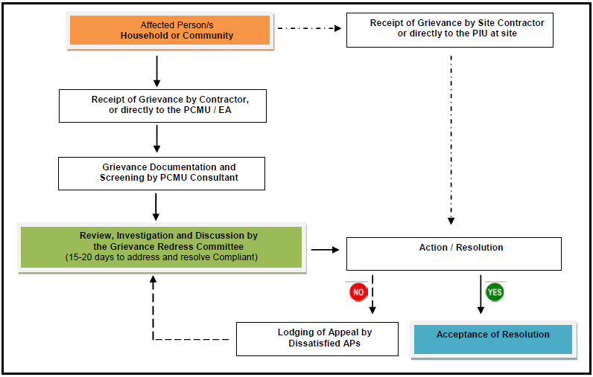
PIU’s acting Head responsible for GRM, Mr. Jamoliddin Irbutaev, Tel: +998 712473816, email: piu3067@gmail.com
PIU Consultant’s Deputy Team Leader, Mr. Dilshod Mavlyan-Kariev, Tel: +998 712477923, email: dilshod75@mail.ru

Figure 2: Grievance Redress Mechanism
- The PIU has established Grievance Redress Committee (GRC). GRC provides any affected person (AP) a venue to file complaints and queries on any environmental (or social) aspect related to the project. Grievances can be submitted in writing or orally to the contractor or directly to the PIU / IA contact person. These are properly documented (i.e., indicating the date it was received, details of the complaint and complainant/s) and screened by the designated PIU safeguard consultant for its veracity and validity. The committee has 15 to 20 days to address and come up with a resolution. Under this GRM, unsatisfied grievances may be able to appeal for a final resolution. This mechanism also does not prevent any AP to approach regulatory agencies to assist and resolve complaints at any stage of the process. In occasions wherein grievances are perceived by the AP to be immediate and urgent; the contractor, EHS officer and PIU onsite supervisor will provide the most accessible and practical solution for a quick resolution of grievances. Such grievances and respective resolutions submitted to the PIU for proper documentation. The PIU contact person is responsible for recording the complaint, the step taken to address grievance, minute of the meetings and preparation of a report for each complaint. Records is kept by the PIU of all grievances received including contact details of AP, date the complaint received, nature of grievance, agreed remedial / corrective action and the date this was implemented, and the final outcome in Complaints logbook kept at the PIU office.
- The complaint handling process will be reported to ADB through monitoring reports. The safeguard specialists of PIU Consultant will periodically review and record the efficiency and effectiveness of the GRM highlighting the project’s ability to prevent and address grievances.
- During the reporting period, the national environmental specialist of PIU contacted representatives of the Administration of the Tashkent region and Akhangaran district to receive information about complaints related to the construction site. No complaints were received during the reporting monitoring period (Table 10). Monitoring of complaints about the Project will be continued at the further stage of the construction works to ensure proper and timely management of complaints under the Project.

Table 10: Summary of complaints received during the monitoring period
Details of Complaint | Complainant* | Received |  |  | Actions (to be) taken with the target date | Resolution Status***
Details of Complaint | Complainant* | Through* | by whom** | date
No | No | No | No | No | No | No
* Resident, NGO (non-governmental organization), etc.
** Verbally, letter, complaint box, email, etc.
*** Contractor, supervision consultant or implementing/executing agency
**** Open or closed (if closed include date)
- The stakeholder consultations with the concerned stakeholders during the construction activities to inform about the project progress and safeguard measures were not planned for the reporting period.

SUMMARY AND RECOMMENDATIONS

Summary
- During reporting period no significant environmental issues were flagged, no complaints received from the local residents and no adverse impacts occurred as a result of the construction activities of the Project. The works under the contract CW1-R commenced on 8 April 2022 and according to the amended Contract they should be completed by 31 July 2024, but actually they were completed by end of September 2024.
The Action plan for the reporting period July – December 2024 is presented in the table below:

Table 11: Summary of Action Plan for the Next Reporting Period
# | Action | Time interval | Responsibility
1. | Final Environmental Monitoring Report (FEMR) incl. Post construction environmental audit report about decommissioning works detail with photo-documentation | December 2024 | National Environmental Specialist of PIU with assistance of PIU Support Consultant
2. | Collect and provide the relevant information on environmental indicators to PIU | Permanent ongoing | National Environmental Specialist of PIU with assistance of PIU Support Consultant
3. | Other routine issues like unscheduled site visits, follow up of the detected defects, environmental assessment of designs | Upon demand | National Environmental Specialist of PIU with assistance of PIU Support Consultant
4. | Monitoring for air quality, noise, odour, groundwater/leachate contamination and residual wastes as per the EMoP | Quarterly | Environmental Officer of the Contractor CW1-R with supervision of the environmental specialists of PIU or PIU Support Consultant
- This SAEMR upon review and approval by ADB specialists will be disclosed on the websites of Maxsustrans and ADB as before. The first draft FEMR including the Post-construction environmental audit report (PCAER) with description of the decommissioning works with detailed photo-documentation will be submitted by 15 December 2024.

Recommendations
- The Project is going to completion by end of 2024. After successful completion of all works under the Contract CW1-R the PIU and PIU Consultant approx. starting from November 2024 will be engaged in preparation of the Project Completion Report according to template of ADB. This report will include a separate part for environmental safeguard issues raised during the implementation of SWMIP.

APPENDIXES

Appendix 1: Environmental Management Plan (Annex 6 of IEE)
Sources of Impact | Impacts | Type /  Degree of Effect | Mitigation / Enhancement Measures | Institutional Responsibilities | Cost
I. Pre-Construction Phase
Land acquisition | Loss of agricultural land | Significant and long-term | - Not required  - The landlord returns it without IR exposure.  - Lack of measures to mitigate the forced withdrawal of land.  - Necessary land for construction allocated from the reserve lands of the district.  - There is no possibility of any impact in terms of loss of income and livelihood.  - There were no complaints or complaints about the project activity.  - Ensure a clear delineation and fencing of the landfill territory. | PIU for Implementation and Monitoring | Included in the cost of the project
Environmental and social monitoring and assessment | Organizational capacity and commitment | Temporary and short-term | - Create and maintain an Environmental, Social, Occupational Safety and Industrial Safety (ESHS) Management System. Hire EHS management staff in the Company. | CUCD | Own resources, Consultant's Remuneration
Occupational health and safety | Provision of PPE | Temporary and short-term | - Conduct and update the workplace health and safety risk assessment prepared by an authorized consultant.  - Provide PPE for the Company's personnel and include in the tender documentation a requirement for all contractors, including the household waste disposal company, to provide appropriate PPE in accordance with the assessment of occupational safety workplaces and local regulations. | PIU, CUCD | Own resources, Consultant's Remuneration
II. Construction Phase
Land clearing | Formation of flying dust | Образование летучей пыли | - Open only one area for development on a phased basis, as planned.  - Minimize the movement of vehicles inside the construction site  - Cover the exposed areas with a tarpaulin or similar materials / apply materials to stabilize the slope.  - Install buffer zones and fences | Contractor/CUCD for compliance monitoring and reporting to IA/SCEEP (Ministry) | Include such a measure in the Contractor's TOR
 | Noise generation | Temporary and short-term | - Notify affected communities in advance of expected inconveniences.  - If possible, reduce the routing of project traffic through community areas.  - Installation of silencers and silencers on machinery and equipment  - Avoid working during rest periods/at night.  - Regular maintenance of equipment  - Install fences around the work area as a barrier  - Introduce minimum speed limits on the project territory | Contractor/CUCD  monitor compliance and report to IA/ SCEEP (Ministry) | Include such expenses in the Contractor's contract
 | Soil erosion is possible | Short-term and temporary | - Include excavation and other similar work within the project boundaries.  - Immediately stabilize the sites after completion of excavation and backfilling.  - Introduce vegetation cover in areas that will remain permanently open.  - Cover with pebbles or gravel areas that should remain open for a long period of time.  - The values of peak ground acceleration (PGA) for the site should be determined and included in the project. | Contractor/CUCD  monitor compliance and report to IA/ SCEEP (Ministry) | Include such a measure in the Contractor's TOR
 | Waste | Temporary and short-term | - Ensure that all hazardous waste from the temporary storage located at the landfill is sent to the appropriate final disposal point. | Contractor / PIU | Management time according to the contract
 | Flora | Temporary and short-term | - Restore local vegetation cover in those areas within the SLF where it would be most appropriate. Finely rooted vegetation is recommended | Contractor/CUCD  monitor compliance and report to IA/ SCEEP (Ministry) | Include such a measure in the Contractor's TOR
 | Traffic | Temporary and short-term | - Regulation of entry and exit of vehicles and equipment to the construction site.  - Properly regulate the delivery of materials to the project site  - Enter the minimum speed on the project website  - Do not allow vehicles to remain on the project site for an extended period of time.  - Regular monitoring to ensure optimal traffic flow and immediate cleaning of debris.  - Regular maintenance of the equipment. | Contractor/CUCD must monitor compliance and report to IA | Include such a measure in the Contractor's TOR
 | Occupational health and safety | Temporary and short-term | - Introductory and installation meetings will be held by all employees. It is also recommended to talk about a set of tools.  - Only qualified workers will be hired  - Strictly impose and control the use of PPE by employees. Regular inspections will be carried out.  - Provide guidance on the HSE and require the placement of safety signs and posters  - Restrict the movement of personnel in hazardous areas  - An insurance policy for workers' compensation must be provided.  - Conduct awareness-raising and training programs on occupational safety and health issues, which will be handled by a designated HSE officer. | The contractor/CUCD must monitor compliance and report to IA | Include such costs/measures in the Contractor's contract
Community impact | Public health and safety | Temporary and short-term | - Develop and implement procedures to protect public health and safety (e.g. traffic management plan, fencing, driver training program, pedestrian access and intrusion plan, road design, slope stability, spill cleanup, well-visible signs, awareness raising) | Contractor / CUCD  Control | Include such costs/measures in the Contractor's contract
Community impact | Loss of income by informal garbage collectors |  | - Identify alternative livelihood options for garbage collectors in accordance with the principles of the livelihood system prepared as above and in consultation with affected people. | Local administration | Consultant's remuneration
Closure of existing dumpsite  (this component has been cancelled in this project) |  | Temporary and long-term | - Conduct a detailed assessment of the site covering all 59 hectares  - Development of a "safe closure plan"  - Adequate and timely coating and sealing to prevent exposure to waste  - All workers will hold introductory and installation meetings with a special emphasis on the use of PPE.  - Require the placement of safety signs and signs  - Conducting environmental monitoring after closing. Maintenance of installed facilities.  - Precautions should be taken to prevent the occurrence of uncontrolled fires as a result of closure measures. | IA shall implement the mitigation and strengthening measures after closure the existing dumpsite | Include such costs/measures in the IA's annual budget for 2024
III. Operation Phase
Land clearing | Formation of flying dust | Temporary and short-term | - Open only one area for development on a phased basis, as planned.  - Minimize the movement of vehicles inside the construction site  - Cover the exposed areas with a tarpaulin or similar materials / apply materials to stabilize the slope.  - Install buffer zones and fences | Contractor/CUCD for compliance monitoring and reporting to IA/SCEEP (Ministry) | Include such a measure in the Contractor's TOR
 | Noise generation | Temporary and short-term | - Notify affected communities in advance of expected inconveniences.  - If possible, reduce the routing of project traffic through community areas.  - Installation of silencers and silencers on machinery and equipment  - Avoid working during rest periods/at night.  - Regular maintenance of equipment  - Install fences around the work area as a barrier  - Introduce minimum speed limits on the project territory | Contractor/CUCD  monitor compliance and report to IA/ SCEEP (Ministry) | Include such expenses in the Contractor's contract
 | Soil erosion is possible | Temporary and short-term | - Include excavation and other similar work within the project boundaries.  - Immediately stabilize the sites after completion of excavation and backfilling.  - Introduce vegetation cover in areas that will remain permanently open.  - Cover with pebbles or gravel areas that should remain open for a long period of time.  - The values of peak ground acceleration (PGA) for the site should be determined and included in the project. | Contractor/CUCD  monitor compliance and report to IA/ SCEEP (Ministry) | Include such a measure in the Contractor's TOR
 | Waste | Temporary and short-term | - Ensure that all hazardous waste from the temporary storage located at the landfill is sent to the appropriate final disposal point. | Contractor / PIU | Management time according to the contract
 | Flora | Temporary and short-term | - Restore local vegetation cover in those areas within the SLF where it would be most appropriate. Finely rooted vegetation is recommended | Contractor/CUCD  monitor compliance and report to IA/ SCEEP (Ministry) | Include such a measure in the Contractor's TOR
 | Traffic | Temporary and short-term | - Regulation of entry and exit of vehicles and equipment to the construction site.  - Properly regulate the delivery of materials to the project site  - Enter the minimum speed on the project website  - Do not allow vehicles to remain on the project site for an extended period of time.  - Regular monitoring to ensure optimal traffic flow and immediate cleaning of debris.  - Regular maintenance of the equipment. | The contractor/CUCD must monitor compliance and report to IA | Include such a measure in the Contractor's TOR
 | Occupational health and safety | Temporary and short-term | - Introductory and installation meetings will be held by all employees. It is also recommended to talk about a set of tools.  - Only qualified workers will be hired  - Strictly impose and control the use of PPE by employees. Regular inspections will be carried out.  - Provide guidance on the HSE and require the placement of safety signs and posters  - Restrict the movement of personnel in hazardous areas  - An insurance policy for workers' compensation must be provided.  - Conduct awareness-raising and training programs on occupational safety and health issues, which will be handled by a designated HSE officer. | The contractor/CUCD must monitor compliance and report to IA | Include such costs/measures in the Contractor's contract
Community impact | Public health and safety | Temporary and short-term | - Develop and implement procedures to protect public health and safety (e.g. traffic management plan, fencing, driver training program, pedestrian access and intrusion plan, road design, slope stability, spill cleanup, well-visible signs, awareness raising) | Contractor / CUCD  Control | Include such costs/measures in the Contractor's contract
Community impact | Loss of income by informal garbage collectors |  | - Identify alternative livelihood options for garbage collectors in accordance with the principles of the livelihood system prepared as above and in consultation with affected people. | Local administration | Consultant's remuneration
Closure of existing dumpsite  (this component has been cancelled in this project) |  | Temporary and long-term | - Conduct a detailed assessment of the site covering all 59 hectares  - Development of a "safe closure plan"  - Adequate and timely coating and sealing to prevent exposure to waste  - All workers will hold introductory and installation meetings with a special emphasis on the use of PPE.  - Require the placement of safety signs and signs  - Conducting environmental monitoring after closing. Maintenance of installed facilities.  - Precautions should be taken to prevent the occurrence of uncontrolled fires as a result of closure measures. | IA shall implement the mitigation and strengthening measures after closure the existing dumpsite | Include such costs/measures in the IA's annual budget for 2024
IA = Implementing Agency (SUE Maxsustrans)
EMP = Environmental Management Plan [especially for the construction phase] does not claim to be complete and can be expanded at any time according to the need and necessity

Appendix 2: Environmental Monitoring Plan (Annex 7 of IEE)
Environmental Components | Parameters | Frequency | Responsible Party | Station/ Location
Air Quality | - Nitrogen Dioxide (NO2), VOCs  - Particulates - PM10 and PM2. Nitrogen Dioxide (NO2), Sulfur Oxides (SOx),  - Noise / Objectionable Odour | - Quarterly  - Bi –annually  - Quarterly / Monthly | PIU Environmental Specialist | - On the identified point sources within the premises of the SLF and the old dumpsite  - Within the project site including areas at old dumpsite  - Within and outside the SLF (1-2 Km North-west and West-North-West end)
Occupational Health and Safety | - No of accidents per day/month/ year  - Top Ten causes of illness  - Worker’s housing and sanitation facilities | - Bi- Annually | EHS Officer | - Within the premises
Groundwater / Leachate Contamination | - pH  - Conductivity  - DO  - BOD5  - TDS  - Salinity  - Total Hardness  - Alkalinity  - Carbonates  - Oil and Grease  - Trace Metals  - Coli form | - Quarterly | PIU Environmental Specialist | - Ground Water Monitoring Wells (whenever installed – see discussion)  - Leachate Collection and Pump shafts
Residual Wastes | - Volume / quality  - Characterization of wastes / Type  - Efficiency of storage facilities | - Annually  - Quarterly  - Quarterly | PIU Environmental Specialist / EHS Officer | - Within the SLF

Appendix 3: Groundwater Monitoring Analyses
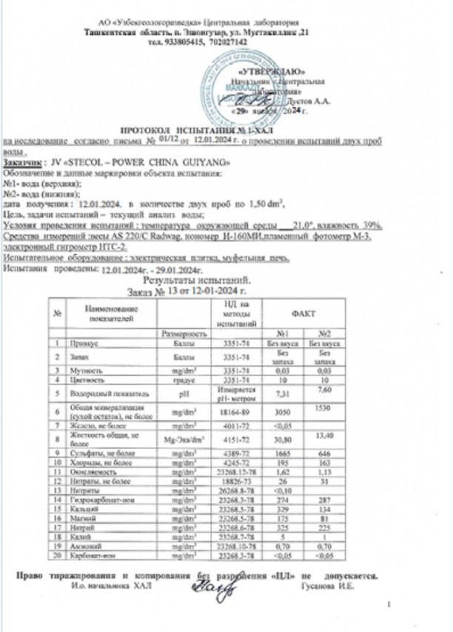
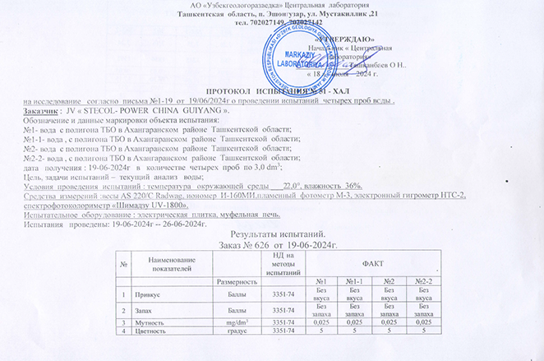

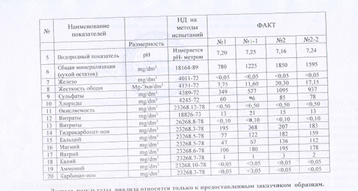

Appendix 4: Air Quality Monitoring Analyses

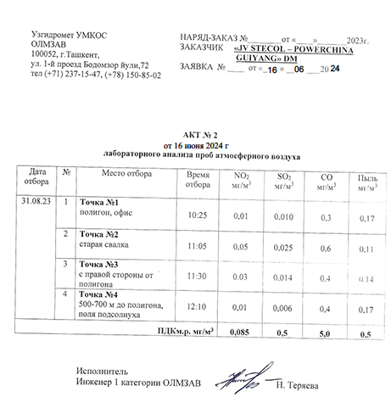

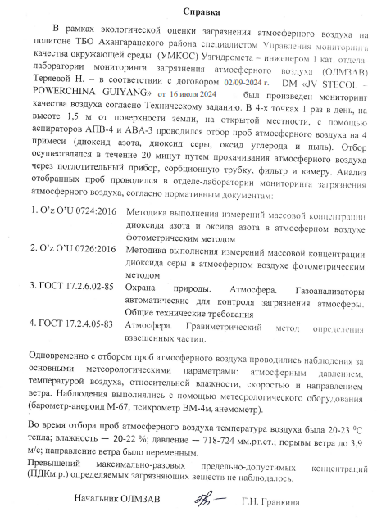
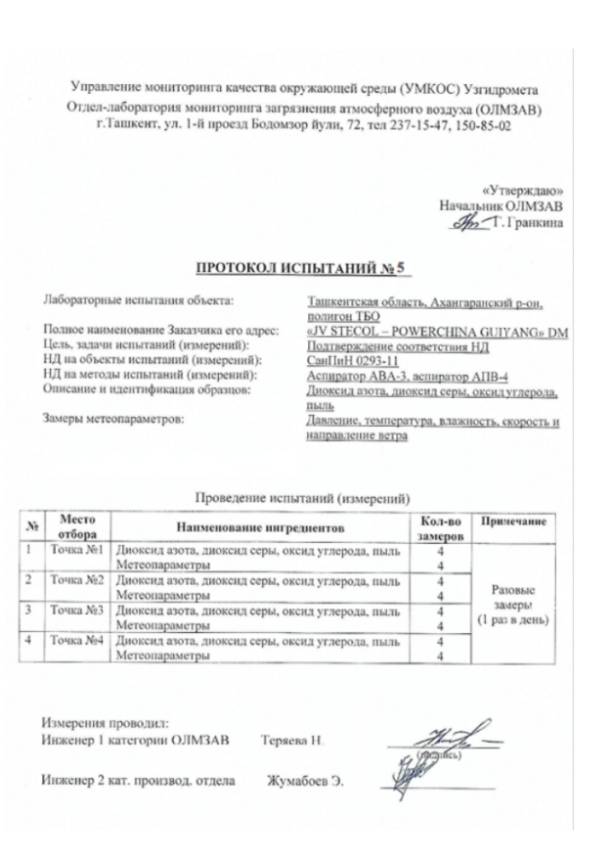
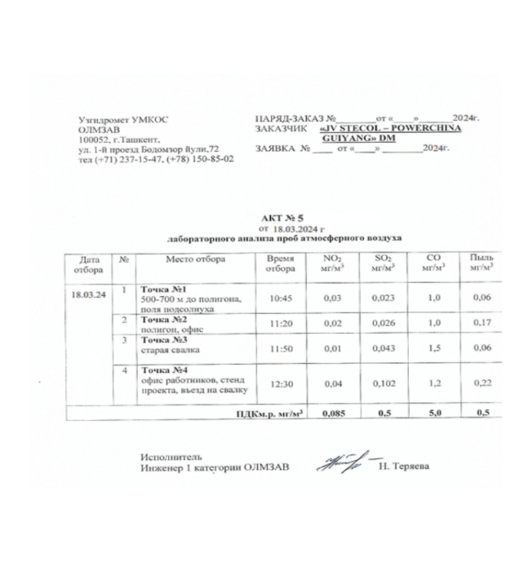

Appendix 5: Waste Management on Site

Type of waste | Description  of waste | Quantity |  | Conditioning method | Disposal method | Final disposal | Waste transportation
Type of waste | Description  of waste | 4Q  2023 | 1Q and 2Q  2024
Non-hazardous waste | Leftovers of homemade food | 22+22+20+15+18+90=187kg | 15+20+22+  25+30+40=  152kg | Storage in a closed container on an isolated site in a closed area | Delete it once a week | Export by local residents for pet food
Non-hazardous waste | Paper | 10+10+1+10=31 kg | 5+2+1+5+10=23 kg | Storage in a closed container on an isolated site in a closed area | Delete it once a week | Removal to landfill
Non-hazardous waste | Fabric and workwear | 5+5+8+3+5+10=36 kg | 20+15+10+8+5+3=61 kg | Storage in a closed container on an isolated site in a closed area | Delete it once a week | Removal to landfill
Non-hazardous waste | Concrete
Non-hazardous waste | Wood
Non-hazardous waste | Iron |  |  | Storage in a closed container on an isolated site in a closed area | Delete it once a week | Export to places of processing
Non-hazardous waste | Municipal solid waste | 40+40+15+11+83+150=339 kg | 10+10+15+  40+80+80  =235 kg | Storage in a closed container on an isolated site in a closed area | Delete it once a week | Removal to a local waste disposal site
Non-hazardous waste | Glass and light bulbs
Non-hazardous waste | Empty barrels/plastic
Non-hazardous waste | Electrodes and grinding wheels
Non-hazardous waste | All kinds of packing boxes
Non-hazardous waste | Thermal insulation materials (mineral wool, foam, etc.)
Non-hazardous waste | Waste water | 1,5+1,5+1,5+1,5+1,5+3=10,5 m3 | 1,5+1,5+1,5 +3+3+3 =13,5 m3 | Storage in a closed container on an isolated site in a closed area | Delete it once a week | Removal to the sewage treatment plants of the district
Non-hazardous waste | Drains from the toilet
Hazardous waste | Clinical/medical waste
Hazardous waste | Used/used oils and lubricants
Hazardous waste | Polluted soil
Hazardous waste | Dangerous chemicals
Hazardous waste | Used tires
Hazardous waste | Acid batteries
Hazardous waste | Oil filters

According to Decree of the President of Uzbekistan No. UP-81 from 31.05.2023 SCEEP was reorganized into the Ministry of Ecology, Environmental Protection and Climate Change of the Republic of Uzbekistan (the Ministry), https://lex.uz/ru/docs/6479185
Foreign Exchange (www.cbu.uz)
According to Decree of the President of Uzbekistan No. UP-81 from 31.05.2023 SCEEP was reorganized into the Ministry of Ecology, Environmental Protection and Climate Change of the Republic of Uzbekistan (the Ministry).
Post Construction Environmental Audit Report (PCAER) after the works completion has been not submitted, because the scope of works was rehabilitation of existing facilities. However, a summarized PCEAR is scheduled for preparation and submission after completion of all works of the Project (approx. in Q4 2024)
Post Construction Environmental Audit Report (PCAER) after the works completion has been note submitted, because the scope of works was rehabilitation of existing facilities. However, a summarized PCEAR is scheduled for preparation and submission after completion of all works of the Project (approx. in Q4 2024)
Environmental monitoring and the required PCAERs after the completion of civil works to be continued by national environmental experts of PIU & PIU Consultant, in order to avoid overlapping the tasks among environmental experts of the Project.
IEE link: https://maxsustrans.uz/project/dokumenty-po-proektu
Signing Amendment No. 4 to the contract for extension of the service period of the Supervision Consultant for additional 13 months (i.e. until 30 November 2024) is pending due to comments of local authority.
The actual completion of construction was performed by 30 September 2024.
ADB. Loan Agreement for L3067-UZB: Solid Waste Management Improvement Project (SWMIP): https://www.adb.org/projects/documents/loan-agreement-solid-waste-management-improvement-project
Contract CW1-R: A draft SSEMP has been submitted by the Contractor in April 2022. The time period from April till July 2022 was needed for review and revision of SSEMP. As construction of SLF is a critical last and most important component of the Project and the remaining time for the construction is quite tight due to Loan Closing Date on 31.12.2023 (now extended until 31.12.2024), it was decided to give the site access without having approved the SSEMP on exceptional basis. Contract CW4: From 16 to 21 December 2020 the Contractor CW4 carried out mobilization activities and site preparation, the civil works have been actually started in January 2021, i.e. after approval of SSEMP.

