

Solid Waste Management Improvement
Project
ADB Loan No.: 3067-UZB

PROJECT MANAGEMENT, IMPLEMENTATION AND SUPERVISION CONSULTANCY SERVICES

Contract No.: SUE/Maxsustrans/QCBS-Cons_1-2016-01

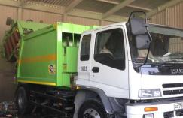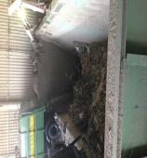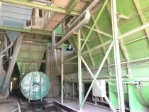

Due Diligence Report
Land acquisition and Resettlement
July 2019
Revision 3 – April 2020

CLIENT – IMPLEMENTING AGENCY
State Unitary Enterprise (SUE) “MAXSUSTRANS” (Uzbekistan)

LEAD CONSULTANT
H.P. Gauff Ingenieure GmbH & Co. KG-JBG (Germany)

in association with

Infratech Consulting SDN Ltd. (Uzbekistan)
April 2020

Due Diligence report for land acquisition and resettlement

Project No: 45366
ADB Loan 3067-UZB
April 2020

UZB: Solid Waste Management Improvement Project (SWMIP)
Financed by the ADB

This document is prepared by JV «H.P. Gauff Ingenieure GmbH & Co. KG – JBG- (Germany) and Infratech Consulting SDN Ltd. (Uzbekistan)» for State Unitary Enterprise «Maxsustrans», Hokimiyat of Tashkent city and ADB. This report is a document of the Borrower.
This document was prepared in July 2019. The revision 2 was made in October 2019 as agreed with the responsible expert of ADB. This document is revision 3 made in April 2020.

Abbreviations
ADB - Asian Development Bank
AH - Affected Household
AP - Affected Person
CAP Correction Action Plan
EA - Executing Agency
GFP - Grievance Focal Point
GOU - Government of Uzbekistan
GRM - Grievance Redress Mechanism
Ha - Hectare
IA - Implementing Agency
IR - Involuntary Resettlement
IWP - Informal Waste Picker
LARP Land Acquisition and Resettlement Plan
MOF - Ministry of Finance
MSW - Municipal Solid Waste
O&M - Operation and Maintenance
PIU - Project Implementation Unit
PPTA - Project Preparatory Technical Assistance
SLF - Sanitary Landfill
SSEMP Social safeguard and Environmental Monitoring plan
SWM - Solid Waste Management

NOTE
In this report, “$” refers to United State dollars (USD) and UZS refers to Uzbekistan sum.

CURRENCY EQUIVALENTS
(as on the day of June 30th, 2019)

Currency Unit - sum (UZS) UZS 1,000.00 = $0.1199
$1.00 = UZS 8562.34

This Due Diligence report is a document of the borrower. The views expressed herein do not necessarily represent those of ADB's Board of Directors, Management, or staff, and may be preliminary in nature.

In preparing any country program or strategy, financing any project, or by making any designation of or reference to a particular territory or geographic area in this document, the Asian Development Bank does not intend to make any judgments as to the legal or other status of any territory or area.

As per ADB Safeguard Policy Statement (2009) and the Operations Manual section on safeguard policy (OM F1), borrowers/clients are required to establish and maintain procedures to monitor the status of implementation of social safeguards management and ensure progress is made towards the desired outcomes.

Glossary
Compensation | Payment in cash or kind for an asset to be acquired or affected by a project at replacement cost.
Affected Persons | Affected persons (APs) are those who experience full or partial, permanent or temporary physical displacement (relocation, loss of residential land, or loss of shelter) and economic displacement (loss of land, assets, access to assets, income sources, or means of livelihoods) resulting from (i) involuntary acquisition of land, or (ii) involuntary restrictions on land use or on access to legally designated parks and protected areas. APs could be of three types: (i) persons with formal legal rights to land lost in its entirety or in part; (ii) persons who lost the land they occupy in its entirety or in part who have no formal legal rights to such land, but who have claims to such lands that are recognized or recognizable under national laws; and (iii) persons who lost the land they occupy in its entirety or in part who have neither formal legal rights nor recognized or recognizable claims to such land.
Entitlement | The range of measures comprising cash or kind compensation, relocation cost, income rehabilitation assistance, transfer assistance, income substitution, and relocation which are due to /business restoration which are due to AH, depending on the type and degree nature of their losses, to restore their social and economic base. All entitlements will be given to all affected households as per the entitlement matrix.
Hokimiyat | Local government authority that interfaces between local communities and the government at the regional and national level. It has ultimate administrative and legal authority over local populations residing within its jurisdiction.
Land  acquisition | The process whereby a person is compelled by a public agency to alienate all or part of the land s/he owns or possesses, to the ownership and possession of that agency, for public purposes, in return for fair compensation.
Mahalla | Is a local level community-based organization recognized official by the GoU that serves as the interface between state and community and is responsible for facilitating a range of social support facilities and ensuring the internal social and cultural cohesiveness of its members. Mahalla leaders are elected by their local communities.
Meaningful  Consultation | A process that (i) begins early in the project preparation stage and is carried out on an ongoing basis throughout the project cycle; (ii) provides timely disclosure of relevant and adequate information that is understandable and readily accessible to affected people; (iii) is undertaken in an atmosphere free of intimidation or coercion; (iv) is gender inclusive and responsive, and tailored to the needs of disadvantaged and vulnerable groups; and (v) enables the incorporation of all relevant views of affected people and other stakeholders into decision making, such as project design, mitigation measures, the sharing of development benefits and opportunities, and implementation issues.
Replacement  cost | Replacement cost is the principle to be complied with in compensating for lost assets. Calculation of which should include: (i) fair market value; (ii) transaction costs; (iii) interest accrued, (iv) transitional and restoration costs; and (v) other applicable payments, if any. Where market conditions are absent or in a formative stage, APs and host populations will be consulted to obtain adequate information about recent land transactions, land value by types, land titles, land use, cropping patterns and crop production, availability of land in the project area and region, and other related information. Baseline data on housing, house types, and construction materials will also be collected. Qualified and experienced experts will undertake the valuation of acquired assets. In applying this method of valuation, depreciation of structures and assets should not be taken into account.
Leaseholder | Legal entity (registered farm) running agricultural production with the use of land plots granted to him on a long-term lease. Lease term is limited up to fifty years but not less than for ten years. Leaseholder cannot sell - buy, mortgage, sublease present, exchange the land.

Table of contents

Abbreviations 3
Glossary 4
1. Introduction 7
2. Project background 9
2.1 Project Description 9
2.2 Project Objectives and Outputs 9
2.3 Project Site 10
3 Due Diligence activities 13
3.1 Objectives of Due Diligence Report and Methodology 13
3.2 Scope of Due Diligence Report (DDR) 13
3.3 Due Diligence Findings: Impact assessment 13
3.3.1 Site visit 14
3.3.2 Right of Way 17
3.3.3 Involuntary Resettlement and land allocation 18
3.3.4 Access Road 22
3.3.5 Waste pickers 23
3.3.6 Irrigation Infrastructure 24
3.4 Institutional Arrangements 25
3.5 Grievances and complaints 26
3.6 Indigenous People 26
3.7 DD Outcomes 27
4 Public consultations 28
4.1 Public consultations within Social safeguard monitoring 28
4.2 Public consultations within Due Diligence 28
4.3 Future consultations and disclosure 29
5 Grievance Redress Mechanism 31
6 Mitigation of social concerns 32
7 Implementation Schedule 33
8 Conclusions and Recommendations 34
Annex I Sanitary-epidemiological standards and norms 36
Annex II Decision of khokim of Akhangaran Districts of Tashkent region on allocation the land plots for project needs 37
Annex III Land optimization program 43
Annex IV Data on lands, sowing crops and area of the leasehold farmer 49
Annex V Information on waste pickers employed at existing Akhangaran landfill 52
Annex VI Public consultation 58
Annex VII Confirmation letter on land acquisition and Involuntary Resettlement avoidance 67
Annex VII Minutes of the Meeting №300 dated October 12, 2012 68
68

- Introduction
- The Government of Uzbekistan (GoU) has applied for a loan from the Asian Development Bank (ADB) for the development and improvement of Solid Waste Management (SWM) system of the capital city (Tashkent). The loan reference number is L3067-UZB: Solid Waste Management Improvement Project (SWMIP). The loan was signed between the Republic of Uzbekistan and Asian Development Bank (ADB) dated 27 February 2014 and Project Agreement dated 12 March 2014 signed between ADB, Tashkent City Municipality and the State Unitary Enterprise “MAXSUSTRANS”.

- The project was prepared to impact an improved urban environment and quality of life for the residents of Tashkent. The project will develop a sanitary landfill that meets international standards, rehabilitate transfer stations, and modernize the waste collection and transfer fleet. It will build capacity in waste management and help formulate a national strategy on solid waste management. Current stage of project implementation is detailed design of the construction a new landfill.

- The ADB safeguard policy requires that project implementation will subject to the assessment the following LARP related conditions: (i) land acquisition including demolishing of any structure and housing is allowed only after all compensations are fully paid, and (ii) commencement of civil works is conditional to the satisfactory implementation of the final LARP to be checked and verified by independent monitoring party and reported in the LARP compliance report.

- Draft LARP for the project impacts was prepared at the stage of developed feasibility study in 2012. The project category was specified as Category B for IR. During the preparation stage of the project the impact of the project included the land acquisition of one leasehold farm.

- Safeguard monitoring under the project selected through the tender in December 2016 is carried out by PIU Consultants (H.P. Gauff Ingenieure GmbH & Co. KG – JBG- (Germany) and GKW Consult GmbH (Germany) and ENG-INVEST Consulting Ltd (Uzbekistan). Regular quarterly social safeguard monitoring for LAR activities carried out since 2017 year. According to the monitoring results leasehold farmer assessed as affected person in LARP 2012 had 188.5 ha for growing of agricultural crops. In 2018 in compliance with optimization program, the size of the land plots used by the leasehold farmer was decreased. The mentioned optimization program requires the rational and efficient use of agriculture land, including increasing financial and labor resources for improving the productivity of lands. However, the farmer does not have sufficient resources to improve land productivity. Farmer returned his allocated land plot sized at 30 ha to the reserve lands fund of the district. Further the land transferred to the reserve land fund of the district may be used for state needs.

- The detailed design of the project started in December 2018. The contractor for detailed design of new landfill and closure the existing landfill according package C2 for Sanitary Landfill Design and Supervision Consultant – is China Urban Construction Design & Research Institute Co., Ltd." The contractor applied avoidance policy to avoid any LAR impacts from the project. The works on detailed design were completed in August 2019. Currently the document is under assessment by state expertise committee. The final approval is expected by the end of October 2019. The construction period will be 18 months. International Construction Contractor has not been hired yet. No civil works started under the project.
- Before the start of the construction works it is required to prepare assessment an assessment on the likelihood for land acquisition, resettlement and social issue (if any) as well as to suggest a social mitigation plan for unanticipated social issues that may arise during implementation of construction works. No land acquisition and resettlement impacts were identified during social safeguard monitoring. Due to this the Due Diligence report for land acquisition and resettlement has been prepared as a part of Social safeguard monitoring assignment under Project to confirm whether there are no involuntary land acquisition and resettlement, outstanding grievances or issues for lands allocated for the construction under the project. The report is based on the results of desk review of the documentations, site visit, public consultations and grievances under the project.
- Project background

Project Description
- The Government of Uzbekistan (GOU) seriously recognizes the need to develop and implement a national Solid Waste Management (SWM) strategy. Solid Waste Management Improvement Project (L3067-UZB) is implemented for the development and improvement of Solid Waste Management (SWM) system of the capital city (Tashkent). Therefore, the GOU has requested support from ADB to address the SWM challenges. The proposed Project will contribute to sustainable urban development in Uzbekistan by:
- modernizing SWM to provide continuous and reliable municipal services;
- promoting financial sustainability of municipal services through tariff rationalization and prudent financial management;
- supporting policy and institutional reforms for improved sanitation and environmental management;
- mitigating climate change through a major reduction of GHG emissions, and through compliance with international standards on waste minimization and material recycling; and through all these measures;
- improving livability of cities.
- The volume of the existing dumpsite is exhausted and the original plan of the city was to extend its dumpsite operations to an adjacent lot of additional 30 hectares of area. The Cabinet of Ministers approved in summer 2012 the location of new dumpsite on 30 hectares of agricultural area for the utilization for waste management activities.

Project Objectives and Outputs
- The project’s overall objective is to provide an improved solid waste management (SWM) system in Tashkent, the capital city, to upgrade urban infrastructure and services. The project will develop a sanitary landfill that meets international standards, rehabilitate transfer stations, and modernize the waste collection and transfer fleet. It will build capacity in waste management and help formulate a national strategy on solid waste management.

- Given the current SWM practices, the option converting and allocating an area adjacent to the existing dumpsite to an engineered Sanitary Landfill was decided. The proposed sanitary landfill facility (SLF) concept will be based on the Best Environmental Practices (BEP) resulting to a state-of–the-art design consistent with international acceptable standards. This “stand alone” facility will drastically improve the SWM system (i.e. the handling and final disposal of MSW) with a possible integration capability for a long-solution to cover the entire Tashkent region. The inclusion into the design of a multi-barrier system, leachate and gas collection systems will result in a significant reduction of anticipated impacts.

- There are two executing agencies (EAs) for the project – the Tashkent Municipality (Hokimiyat of Tashkent city) for the overall oversight and monitoring of Outputs 1 and 2 and State Committee of the Republic of Uzbekistan of Ecology and Environment Protection (SCEEP) for execution of Output 3–the national SWM strategy. Outputs 1 and 2 will be implemented by State Unitary Enterprise “MAXSUSTRANS”. A PIU was established within MAXSUSTRANS to support project implementation. This support will include project management, financial management, procurement, contract administration, safeguards implementation, construction and technical supervision, and monitoring and evaluation.

- GoU through it Implementing Agency (IA), the State Unitary Enterprise (SUE) “MAXSUSTRANS” utilizes part of project loan proceeds towards the cost of the contract for Consulting Services related to Project Management, Implementation and Supervision, supporting the Project Implementation Unit (PIU).

Project Site
- The Akhangaran landfill is located approximately 30-35 km south of the center of Tashkent City in the Akhangaran district of Tashkent Province. The facility has been in use since 1967 and is currently handling the wastes collected from Tashkent city and partial from Chirchik.

Figure 1 Location map of Akhangaran landfill
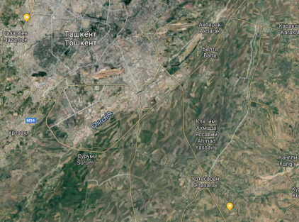
30 -35 km
Existing landfill

- According to the detailed design of the project 30.91 hectare land plot located directly to the south of the existing Akhangaran dumpsite are required for the project:
- The landfill area is about 26.51 hectares (including roads), the landfill area is about 24.62 hectares (actual landfill area);
- Regulation point - 0.7 ha;
- Control point - 0.76 ha;
- Other facilities (including water sump) 2.94 ha.
- The content of the construction is the territory of the reservoir, the road, the leaching pool, the control zone and other structures.
- The landfill capacity is 7.66 million cubic meters.
- The expected service life is 12.1 years.
Figure 2 Designed new landfill site
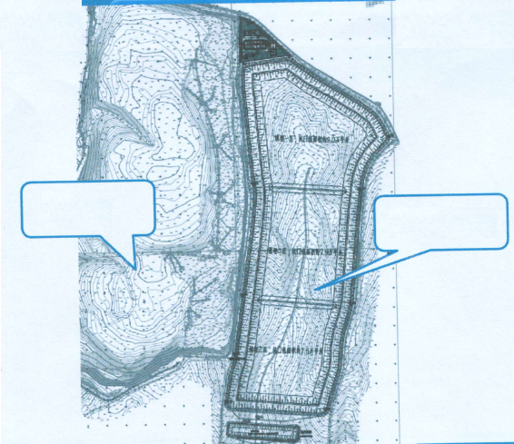
New landfill (project)
Existing landfill

- Access to the site: The detailed design developed for the project showed that the new landfill will use the existing access road and require the construction of additional access road to the new site. This is visualized below on given image (Figure below).

Figure 3 Access road to new landfill site
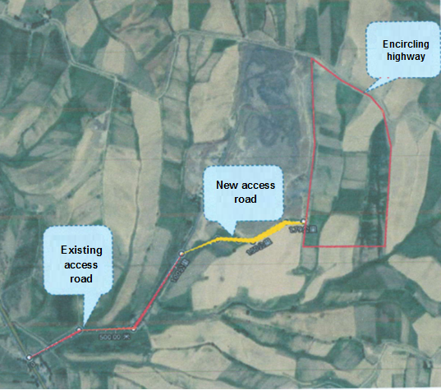

- Due Diligence activities
  - Objectives of Due Diligence Report and Methodology
- Objective of DDR: The objective of the Due Diligence Report (DDR) is to make assessment and confirm that the project the project will not require land acquisition and involuntary resettlement for the construction. Specifically, the DDR confirm that (i) the lands allocated for the development of project is free of any involuntary resettlement impacts, e.g., land acquisition, displacement, and (ii) ascertain if there would be any adverse impacts on income and livelihood on any of people specified in LARP 2012.

- Methodology used for Assessing Land Acquisition and Resettlement: Data collection. Necessary data regarding social, resettlement information has been collected primarily through desk review, check list for involuntary resettlement, field visits to the proposed projects item and public consultations with stakeholders.
  - Scope of Due Diligence Report (DDR)
- This DDR relates to lands allocated for the construction of new landfill at the existing Akhangaran landfill. This survey was to verify the initial survey findings and to confirmed that no LAR impacts. The DDR has been prepared by Social safeguard consultant as a part of Bi-annual social safeguard monitoring in July 2019. The detailed survey was carried out on the project site in September 2019. This survey was to verify the initial survey findings and to confirm that there is no LAR impact from the construction of a new landfill site.

- Scope of the DDR is conducted necessary activities, desk reviews and on-site studies, conducted due diligence of land acquisition and resettlement issues. As per the requirements of ADB, it is mandatory that the project under stage of detailed design comply with ADB environmental and social safeguards. This report is prepared to serve the purpose of due diligence with ADB’s social safeguards under Safeguards Policy Statement (SPS), 2009.

- DDR includes the LAR review and implementation process on land allocation for project needs to assess and confirm that the land required for the new landfill construction has been allocated without any involuntary land acquisition and resettlement. As per detail design and verified due diligence conducted the project will not have an impact full or partial, permanent, physical and economic displacements to people. No safeguard mitigation measures are required under the project (LAR activities) before the start of construction works.

  - Due Diligence Findings: Impact assessment
- To assess the situation with the planned construction and the allocation of land for the construction of a new landfill, Consultant examined all the documents available within the project and made a site visit to the project territory.
    - Site visit
- Consultant visited the project area to conduct visual assessment of the lands allocated for the project needs in May 2019. A new land plot for the landfill was allocated in the south of the existing landfill Akhangaran. The total size of the land is visually approx. 30 hectares. The main access to the new landfill will be through the existing road already exist to the existing landfill and a new access road as junction from the existing road parallel south side of the existing landfill (planned to be constructed) .

- Site visit also visually confirmed that there are no users / holders on the land where the construction of new landfill and additional access road will be developed. There is currently no agricultural activity or any improvements that have been made in this site. The project area does not have any households occupied the lands allocated for the project. According to the current sanitary-epidemiological standards and norms (“SanPiN”) No. 0350-17 “Sanitary standards and norms of the atmospheric air protection of human settlements of the Republic of Uzbekistan” residential and farming are not allowed at the sanitary protection zone of the landfill.

Figure 4 Photo of the project site – lands allocated for the construction of new landfill
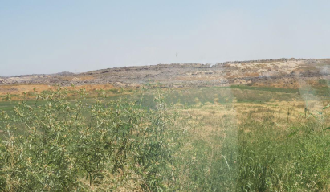
Land plot for new landfill
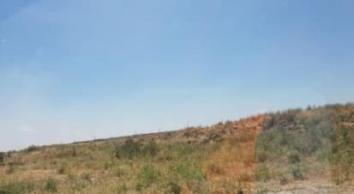
Land plot for additional access road
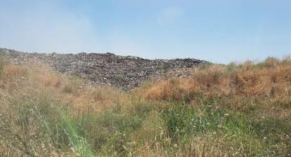
View of existing landfill
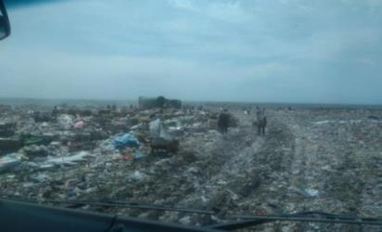
View of existing landfill
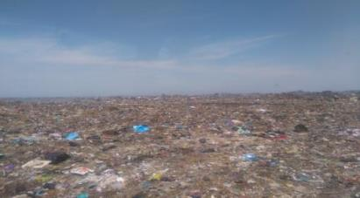
View of existing landfill
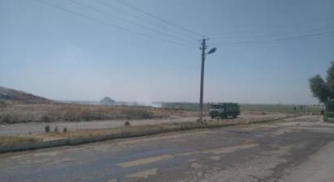
Existing access road

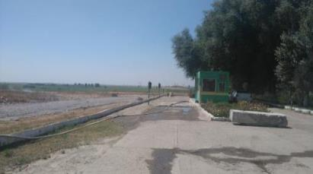
Existing access road

- The completed screening checklist explaining the project’s IR impacts is presented as Table below.
Figure 5: Resettlement Screening Checklist
Probable Involuntary Resettlement Effects | Yes | No | Not Known | Remarks
Involuntary Acquisition of Land
1. Will there be land acquisition? |  | No |  | Subproject will use state reserved land allocated for the landfill site.
2. Is the site for land acquisition known? |  |  |  | N/A
3. Is the ownership status and current usage of land to be acquired known? |  |  |  | N/A
4. Will easement be utilized within an existing Right of Way (ROW)? |  | No
5. Will there be loss of shelter and residential land due to land acquisition? |  | No
6. Will there be loss of agricultural and other productive assets due to land acquisition? |  | No
7. Will there be losses of crops, trees, and fixed assets due to land acquisition? |  | No
8. Will there be loss of businesses or enterprises due to land acquisition? |  | No
9. Will there be loss of income sources and means of livelihoods due to land acquisition? |  | No
Involuntary restrictions on land use or on access to legally designated parks and protected areas
10. Will people lose access to natural resources, communal facilities and services? |  | No
11. If land use is changed, will it have an adverse impact on social and economic activities? |  | No
12. Will access to land and resources owned communally or by the state be restricted? |  | No
Information on Displaced Persons:
Any estimate of the likely number of persons that will be displaced by the Project?  If yes, approximately how many? _____ |  |  |  | N/A
Are any of them poor, female-heads of households, or vulnerable to poverty risks? |  |  |  | N/A
Are any displaced persons from indigenous or ethnic minority groups? |  |  |  | N/A
    - Right of Way
- Sanitary protection zone for the landfills is 1000 meters in compliance with the sanitary-epidemiological standards and norms (“SanPiN”) No. 0350-17 “Sanitary standards and norms of the atmospheric air protection of human settlements of the Republic of Uzbekistan”. The sanitary protection zone is not allocated for landfill construction. The project will not affect the protection zone of 1000 m. That is why the protection zone 1000 meters for the landfill is not included in the allocated land. As described above in the project design information the construction of the landfill will be limited by the allocated 31.2 ha. The allocated land 31.2 ha only will be used for the construction of a new landfill (30 ha) and access road (1.2 ha) according to the detailed design project.

Figure 6: Google map of existing and new sanitary protection zone
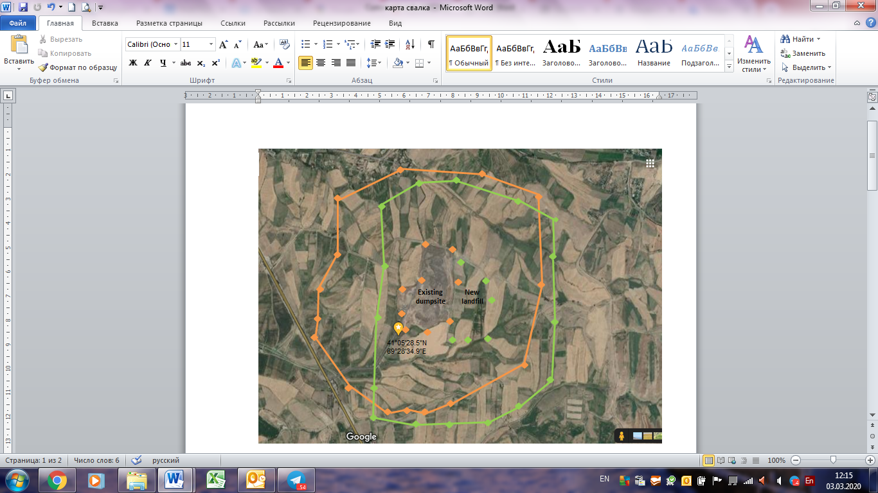
The protection zone for the existing dumpsite is highlighted in orange (1000 meters existing sanitary protection zone), the protection zone for new landfill is highlighted in green

- The lands in existing protection zone are used for the growing crops. There are no living houses in the existing protection zone. Despite on the legal requirements for 1000 meters of environmental protection from the dumpsite's impacts, local authorities allow using these lands for growing agricultural crops.

- The lands included into the new/adjusted protection zone due to the new landfill site will continue used for the agricultural growing as well. The local authorities will not acquire the lands within the protection zone. So the lands that are currently used for agricultural crops growing will continue using for agriculture after construction a new landfill. Consequently there would be no any limitation on the current land use of the land plots inside the protection zone.
    - Involuntary Resettlement and land allocation
- According to the LARP 2012 the Project construction would entail land acquisition on 49.9 ha of agricultural land, 44.7 ha of them are irrigating lands. The census of LARP 2012 identified 1 farm which belong to 1 affected household (AH) and 9 agricultural workers which will be adversely affected as a result of the Project. The table below provides information on land impact on 1 affected farm (2012).
- LARP was not implemented because there was no detailed design for the project. Draft LARP prepared in 2012 was not updated. Draft LARP was prepared based on Feasibility study and based on the assumption that the land is allocated to the farmer and is being used/productive as per the requirement for land allocation by the government.

Table 1 Information on land impact on 1 affected farm, LARP 2012
Type of lands | LARP 2012 | Impact on lands
Irrigated lands | 108,3 | 44,7
Pasture | 29,6 | 1,9
Orchard | 30,2
Aryk and drains | 10,6 | 1,8
Roads | 3,3 | 1
Other lands | 6,4 | 0,5
TOTAL, ha | 188,5 | 49.9

- Development of detailed design requires to assess any the project impacts on lands required for the project implementation before the start of the consturction work. Taking into aacount the project impacts on lands mentioned in LARP 2012, Consultant started due diligence of the land plots allocated for the construction.

- Within the Due Diligence Consultant studied the situation with lands leased by the affected farmer mentioned in LARP in details. According to the detailed design the project requires in total 30.91 ha of lands for construction of new landfill and additional access road to the site. The required lands for the construction of new landfill are allocated by Akhangaran hokimiyat from the district reserve lands. Allocation of lands for project needs was carried out by the issued decrees of hokimiyat in 2018-2019 (See Annex II). The owner of lands was hokimiyat of Akhangaran district. The lands were allocated in two stages. First step of allocation of land was in August 2018. In accordance with the decree of hokimiyat of Akhangaran district #1536 30 ha for construction of new landfill were allocated.

- 30 ha of lands (previously leased by the farmer) allocated by the hokimiyat decision on allocation of land included the following types of lands, such as 26.8 ha of agricultural land, 1.1 hectares of meadows and pastures, 1.9 ha of irrigation ditches and 0.2 hectares of roads. The additional 1.2 ha of reserved for new access road to the landfill included 1.2 ha of pastures. Consultant analyzed the documents on type of lands allocated for the project needs. There is no data on type of lands before 2014. Hokimiyat provided data for the type of lands in 2013- 2014. According to available documents, a land plot of 30 ha in 2014 has the same breakdown by land type as in 2018. No improvements of the land types for the 2013-2018 were made by the farmer on the studied lands. The costs and investments of the farmer included preparing the soil for sowing crops. Wheat and vegetables were grown on this land plot. Taking into account the practice of growing wheat under state orders, finance for the cultivation is allocated from the state.

- Decrees on allocation the lands for project implementation confirms that allocation of lands in 2018-2019 was carried out from the reserved agricultural lands of the district. Reserving of the agricultural lands at district land fund was based on the state optimization program. Land optimization program has affected this farmer in view of inefficient use of land or lack of financial and labor resources to cultivate it (2015-2018).

- During the social safeguard monitoring 2018 -2019 it was confirmed that allocation of lands was carried out from the reserved agricultural lands of the district. Reserving of the agricultural lands at district land fund was based on the state optimization program Land optimization program has affected this farmer in view of inefficient use of land or lack of financial and labor resources to cultivate it (2015-2018).

- Consultant analyzed the documents on process on state optimization program in details. Optimization of the size of the land plot of the farm is process on changing the size of the land in order to more rationally use of land and water resources and ensure the financial sustainability of the farm.

- As the results of optimization program a number of farmers and their land plots in all regions of Uzbekistan have been reconsidered. The allocation of the land plots have been revised in compliance the level of provision of territories with labor resources, population density, economic and financial indicators of the farmers, the availability of appropriate professionally trained personnel potential and farming machinery.

- The optimization procedure was carried out in several stages and initiated by the Government of Uzbekistan - Decree of the President of the Republic of Uzbekistan dated October 22, 2012 No. UP-4478 "On measures to further improve the organization of activities and the development of farming in Uzbekistan." That is, the process of reducing the size of the land plot of farms is carried out directly by the state, since all land in Uzbekistan is state owned.

- Land optimization is based on the need to increase the efficiency of agricultural land / sown area use. The process of optimizing the size of land is initiated by Decree of the President (mentioned above) and implemented by the relevant resolutions of the Cabinet of Ministers:
- Resolution of the Cabinet of Ministers No. 22 dated January 31, 2013 “On the procedure for optimizing the size of the land plot of a farm and its liquidation”
- Decree of the Cabinet of Ministers No. 362 dated December 15, 2015 “On measures to optimize the size of lands provided for farming”
- Resolution of the Cabinet of Ministers No. 14 dated January 9, 2019 "On additional measures to optimize land plots of farms and other agricultural enterprises, as well as the efficient use of sown areas of agriculture".

- The implementation of the optimization program is carried out by the Republican Commission for Deepening Economic Reforms in Agriculture, the Ministry of Agriculture and Water Resources of the Republic of Uzbekistan, the Council of Ministers of the Republic of Karakalpakstan, khokimiyats of regions and districts with the participation of territorial councils of farmers, heads of farms and wide public involvement. Methodology for the implementation of the optimization program described in the optimization program (Annex III).

- The Republican Commission summarizes the results of assessment of the use of land by farmers and develops measures to further optimize the size of land provided for farming, in the main areas of the farm specialization. Optimization measures are aimed at providing farmers with medium-sized land plots, taking into account the areas of the farm specialization (cotton, wheat, vegetables etc.).

- The above mentioned methodology of assessment of land use efficiency in compliance with the Decree of the Cabinet of Ministers No. 362 dated December 15, 2015 on optimization was applied to this farmer including the average land size of wheat growing farmers in the district, farm specialization etc.

- State optimization program identifies the average size of land plot for Akhangaran district for the grain growing farmers at 54.4 ha per one leasehold farmer. According to the data on lands of the studied farmer, the table below shows the land size during 2013-2018. The size of the land plot of the farmer in 2013 LARP preparation period) was 188.5 ha allocated to the farmer for lease. Resulted by the optimization program, the land plot of the farmer up to 2018 the size of the total land plot of the farmer was 83.61 ha. In 2018 the size of land plot was decreased to 53.61 ha. That is the average size of the land plot for the farmers in the district, requested by the Resolution of the Cabinet of Ministers on optimization. (See Annex III). Thus, as a part of implementation of optimization program the land plot of this farm for the period 2013-2018 decreased by 134.89 ha in total.

Table 2 Information on land size of 1 affected farm, LARP 2012, for the period of 2013-2018
Type of lands | 2013 | 2014 | 2015 | 2016 | 2017 | 2018 | Lands 30 ha, allocated for construction (reserve fund)
Irrigated lands | 108,3 | 108,3 | 108,3 | 75 | 45,06 | 18,26 | 26,8
Pasture | 29,6 | 29,6 | 29,6 | 3,9 | 3,9 | 2,8 | 1,1
Orchard | 30,2 | 30,2 | 30,2 | 30,2 | 24,4 | 24,4
Aryk and drains | 10,6 | 10,6 | 10,6 | 6,52 | 6,52 | 4,62 | 1,9
Roads | 3,3 | 3,3 | 3,3 | 1,37 | 1,37 | 1,17 | 0,2
Other lands | 6,4 | 6,4 | 6,4 | 2,36 | 2,36 | 2,36
TOTAL, ha | 188,5 | 188,5 | 188,5 | 119,35 | 83,61 | 53,61 | 30

- The financial and economic indicators of the farmer were evaluated in compliance with the internal evaluation procedure designed for local authorities. The assessment of farm productivity indicators under the optimization program was made by the district Commission on Deepening Economic Reforms in Agriculture.
- Consultant applied to the hokimiyat to get information on evaluation on the farmer. However details of evaluation procedures and results on evaluation are available only for farmer himself ( leaseholder of the farm) or his legal representatives. It is caused by the fact of confidentiality of financial information on the farm. In case in farmer is not agreed with the conducted evaluation, he can apply to the court.

- The optimization program was applied to the farmer via consultations with the farmer on his willingness to invest resources, availability of agricultural techniques and machinery for land improving before the measures of optimization was applied to his land plot.

- Resulted by the detailed analysis of the situation with the allocation of the land plot, Consultant confirms that allocation of lands from the reserve lands of the district for the construction of new landfill does not imply the involuntary land acquisition and resettlement. All lands required for th project are part of the land reserve fund of the district.
    - Access Road
- During the preparation of detailed design for the project, it was assessed the need of additional lands for the access road for the new landfill. The access to the new landfill will be carried out through the existing road which will connect to new additional road. Based on this option of detailed design additionally 1.2 ha was allocated from the district reserve lands in June 2019. (See Annex II Decree of khokimiyat of Akhangaran district, Tashkent region #3860 dated June 15, 2019). The land allocated for additional assess roads is non-irrigated agricultural land. Allocation of lands for access road from the reserve lands of the district does not imply the involuntary land acquisition and resettlement.

Figure 7: Existing and new access road
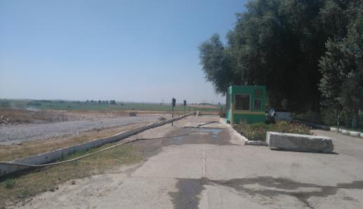
New access road
Existing access road
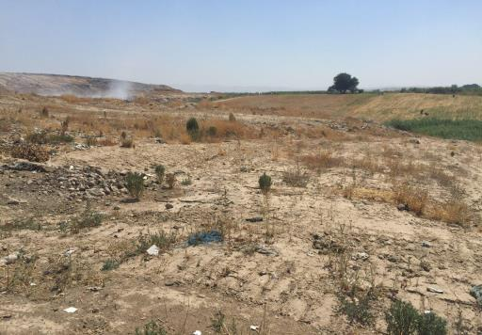
New access road

    - Waste pickers
- The construction will be confined to the district project site. There will be no temporary disruption of livelihood of any household or group of community in this area during construction period.

- At the existing dumpsite sorting of the solid wastes is carried out by the waste pickers. According to the LARP 2012 on existing dumpsite the activity of informal waste pickers (IWPs) was revealed during consultation date at the dumpsite. Due to fact that this activity was illegal, surveyors were unable to confirm exact number of IWPs. With assistance of local community leaders surveyors were able to estimate about 80-100 IWPs on that existing dumpsite. However, according to the dumpsite administration, these “people” could be people from the neighboring communities who seek additional source of income. Since there is no list of these “people” with their names identified for these people, at the stage of project it is not possible to identify these people.

- Since no civil works was started within 2013-2018, according to the landfill administration informal waste pickers continued their activity at the landfill and there were no impact on their livelihood.

- Social safeguard consultant as a part of monitoring studied the status of the waste pickers livelihood. Consultant held public consultations with the employees of this company who are engaged in sorting wastes at the dumpsite of Akhangaran within social safeguard monitoring in September 2018. In September 2018 number of employees at the landfill was 31 people. These waste pickers confirmed that all of them work on the basis of a labor contract with mentioned organization Mehr Sahovat (copy of the documents are given in Annex V).

- Within Due diligence in 2019 Consultant studied the situation with these waste pickers in details. Based on the results on survey, Consultant notes that there are no any informal waste pickers working at the dumpsite. In compliance with the requested information on number of workers and working conditions provided to waste pickers by the employer, Consultant obtained the following information: All waste pickers who work there are workers of “Mehr Sahovat” Ltd under State rehabilitation center for social vulnerable people. These people are officially employed at this organization and ensured with proper social and labor guarantees of their incomes / salaries by the employer. In July 2019 there are 7 permanent working and 30-35 temporary waste pickers with hourly rate wage.

- These people are provided with different paid public works like cleaning of streets, parks and other public places, including work at a special facility in Akhangaran (dumpsite). They sort the wastes. Each of them receives a daily salary. According to data from Mehr Sahovat, people who work on waste sorting can change daily, as they can choose other types of paid public work. This means that each employee at this center has the right to choose a place of public work offered by the company. Mehr Sahovat company receives the requests for workers on different public works from the local government and different organizations and offers work to its workers.

- The company provides these people with the work and guarantees for salary in compliance with governmental social protection measures. These people are provided with the social support of their livelihood though providing them with cloth, shelters, and medicines, paid work at public facilities. Work at a landfill - is paid public work offered by the khokimiyat to the company as well.

- The work of waster pickers is not a permanent place of work and not main sources of income for these people. Social safeguard consultant of PIU in close consolation with Mehr Sahovat discussed social support of these people to address livelihood improvement program to maintain the livelihood of these people. As the company provides these people with different paid public works, when the existing landfill is closed these people will be re-employed at the other infrastructural facilities like transfer stations, sorting stations, land and road improvement enterprises etc. Mehr Sahovat is providing employment opportunities and respectively to landfill closure these workers will be employed by the different paid public works based on their choice. There is a discussion that these workers as interested may continue working at the new landfill if required. According to the detailed design for construction of new landfill, the closure of the existing dumpsite will be carried out by parts. Otherwise Mehr Sahovat will provide them with other paid public works.

    - Irrigation Infrastructure
- An irrigation canal flows along the edge of an existing landfill. The canal is maintained by a local irrigation organization - Non-Governmental Organization Yangi Hayot Water Users Association. According to the LARP 2012 expansion of landfill required destruction part of existing irrigation network.
- Data of the detailed design confirms that the land plot under the irrigation canal is not affected by the construction of the new landfill. There is no disruption of the irrigation canal. The water users of this irrigation canal will continue using it for irrigation their land plots. The lands mentioned in the LARP as to be affected by partial dismantling of the irrigation infrastructure, namely, plot numbers 335,336,337 will not be affected.
- The map below shows the location of irrigation canal:

Figure 8: Map of location of irrigation canal (irrigation canal is showed by the red pointers)

  - Institutional Arrangements
- Institutional Arrangements and Role and Responsibilities: The following agencies are involved in project implementation
- State Committee on Ecology and Environmental Protection (SCEEP) and Tashkent Hokimiyat (Municipality) are the Executing Agencies (EA). Tashkent Hokimiyat responsible for management, coordination and execution of all activities funded under the loan and has overall responsibility for compliance with loan covenants.
- State Unitary Enterprise “Maxsustrans” (Maxsustrans) is the implementing agency (IA), which is responsible for administration, implementation (design, construction and operation) and all day-to-day activities under the loan. The PIU coordinates construction of subprojects, and ensures consistency of approach and performance.
- PIU was established within MAXSUSTRANS to support project implementation. This support will include project management, financial management, procurement, contract administration, safeguards implementation, construction and technical supervision, and monitoring and evaluation.
- PIU Support Consultant - International Project Management and Supervision Consultant (H.P. Gauff Ingenieure GmbH & Co. KG and his JV-Partner Infratech Consulting SDN Ltd (Tashkent) supporting the PIU on social safeguard measures that may occur during the implementation. The selection of a consultant began in December 2017. The contract was awarded on November 16, 2018. The main reasons for the delay are the following: 1) Changes in the legislation of the Republic of Uzbekistan on procurement procedures, including for IFC funds. 2) Process of institutional reforms among the government bodies and executive agencies initiated by the government in 2017; 3) Composition of Tender Commission of Tashkent Khokimiyat responsible for holding a large-scale tenders changes 3 times due to the amendments in order and regulations of tender commissions. This all delayed the process of evaluation, approval of the results of the evaluation and award of the contract.
- Contractor (Construction Supervision Company) - Sanitary Landfill Design and Supervision Consultant "China Urban Construction Design & Research Institute Co., Ltd." has been hired on December 14, 2018. This consulting company carries out design works of closing old landfill and establishing of new sanitary landfill. During the construction work they will supervise all construction works related to Landfill establishment.
  - Grievances and complaints
- The existing GRM developed for the project functions for the whole period of project implementation. For the period of 2018-2019 no complaints or addresses on project are received form the population or any stakeholders. Monitoring of complaints and addresses is carried out by the Social safeguard consultant within the quarterly periods of monitoring.
  - Indigenous People
- There is no identified indigenous people/ethnic minority communities on the proposed project site, thus no ethnic people will be affected by the project activities. The project has no IP impact and classified as Category C for IP.
  - DD Outcomes
- The detailed information on project LAR activities is given in table below:

Table 3 Due Diligence for LAR activities
Project activity | Type of losses | Name of APs | Possible social impacts | Involuntary resettlement | Indigenous people
Construction of new landfill site | No losses applicable | No losses applicable | - No IR impacts;  - No requirements for involuntary land acquisition;  - The required lands for construction allocated from the district reserve land;  - There is no possibility of any impacts in terms of losing incomes and livelihoods.  - No grievance and complaints are received on project activity. | Not required | Not found
Construction of additional access road

- As per results of the data gathering, detailed survey of the sites and review of land documents, the project is considered as Category C for IR, i.e., the project does not require temporary or permanent involuntary land acquisition and resettlement and there are no impacts involving the allocation of land, structures, crops and trees, businesses or income.

- All project facilities at the new landfill will be constructed using the land allocated from the reserve lands of the district and owned by SUE "Maxsustrans". There is sufficient land within the allocated lands required for proposed construction of new landfill and additional access road. SUE "Maxsustrans" with PIU confirmed ownership of the land with the proper cadastral documents in detailed design project.

- Public consultations
  - Public consultations within Social safeguard monitoring
- Public consultations with the farmer and his workers were first conducted during the preparation of the draft LARP 2013. The next public consultation with the farmer and his workers was conducted in 2015. Meaningful public consultations (2018, 2019) were held in the project area as a part of social safeguard monitoring since 2017 (photos, list of participants are given in Social safeguard monitoring reports).

- Farmer was informed and invited to participate in the meaningful public consultations (2018, 2019). The farmer did not participate in these consultations. That is why Consultant conducted individual consultation with the farmer in September 2018. Farmer confirmed that his lands were optimized by the government. He had no financial resources to improve the lands. Farmer returned the mentioned land plot to the district reserve fund of land himself. Consultant informed him about the GRM and his rights to apply to the court if he was not agreed with the results of optimization.

- Farmer also participated in the individual consultation conducted during the ADB Mission within 22-28 August 2017. As a part of the Mission ADB experts and local environmental and social consultants visited the existing dumpsite. The leaseholder of the farm was involved in the discussion of social impacts of project implementation. In that period farmer confirmed that he used his land plot for growing crops as usual.

  - Public consultations within Due Diligence
- Stakeholders and public consultation was conducted with officials, community people living near by the proposed project site, public representatives and other stakeholders to identify different issues, problems/ constraints and prospects and feedback from the participants in connection to construction of new landfill under the project. The consultation covers mainly information dissemination about the current stage of the project and its scope, possible impacts, involvement of local people in different activities of the Project etc. The public participation process included (i) identifying interested parties (stakeholders); (ii) information and providing the stakeholders with sufficient background and technical information regarding the proposed project development; (iii) describing opportunities and mechanisms whereby they can participate and raise their views (issues, comments and concerns) with regard to the proposed development; (iv) giving the stakeholders feedback on process findings and recommendations; and (v) ensuring compliance to process requirements with regards to the social and related legislations.

- The safeguard team visited the district administration and had meeting with representatives of hokimiyat, community local public representatives and different stakeholders and local people, community leaders and local government representatives on October 4, 2019. The participants were also informed of the date of the public meeting via the advertisement at local administration and informing the leaders of communities.

- Farmer was informed and invited to participate in this consultation. However the farmer did not participate in these consultations. The consultation was attended by interested persons of local authorities, representatives of the makhalla Yangi hayot where this farm is located.

Figure 9 Photo of the public consultation

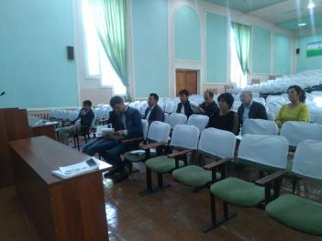

- A public meeting was arranged by the district administration. The meeting site was at the building of Akhangaran district hokimiyat. 10 participants were present in the consultation meeting. The following issues were discussed during the meeting:

- Period of construction. Expected start: First quarter of 2020;
- Order of selection of contractor for construction works after evaluation, expected December 2019;
- Order of closure of existing landfill; after evaluation, expected December 2019;
- Power supply of the construction works; local power network and generators;
- Impact from construction work of agricultural lands and roads. It is expected that all the construction works will be carried out inside the allocated lands for project needs.
  - Future consultations and disclosure
- This due diligence report and other relevant documents will be made available on the websites of SUE "Maxsustrans" and ADB. The same information will be provided to local administration for relevant stakeholders and local people.

- Future consultation activities will be coordinated by the PIU / SUE Maxsustrans and consultant teams to ensure that the communities are fully aware of the activities at all stages of the Project implementation. During construction phase, engineering team with assistance of social and environmental consultant teams will conduct (i) public meetings with local communities to discuss and plan work programs and allow issues to be raised and addressed once construction has started; and (ii) smaller-scale meetings to discuss and plan construction work with individual communities to reduce disturbance and other impacts, and to provide a mechanism through which stakeholders can participate in Project monitoring and evaluation. The PIU will coordinate the schedule with the contractors and will ensure proper public consultations are held prior to start of civil works and during implementation. Documentation should be included in the social safeguard monitoring report.

- The relevant information in this due diligence report together with following information on GRM will be translated to local language and disclosed to people in the project area. Documentation will be included during social safeguard monitoring report. The social safeguard specialist will disclose information within public consultations.

- Grievance Redress Mechanism
- Grievance Redress Mechanism. Grievance Redress Mechanism. A Project-specific grievance redress mechanism (GRM) has been established in LARP 2012 to receive, evaluate, and facilitate the resolution of AP’s concerns, complaints, and grievances about the social and environmental performance at the level of the Project. The GRM aims to provide a time-bound and transparent mechanism to voice and resolve social and environmental concerns linked to the Project. Figure below gives the details of the grievance redress mechanism:

Figure 10 Grievance Redress Mechanism*
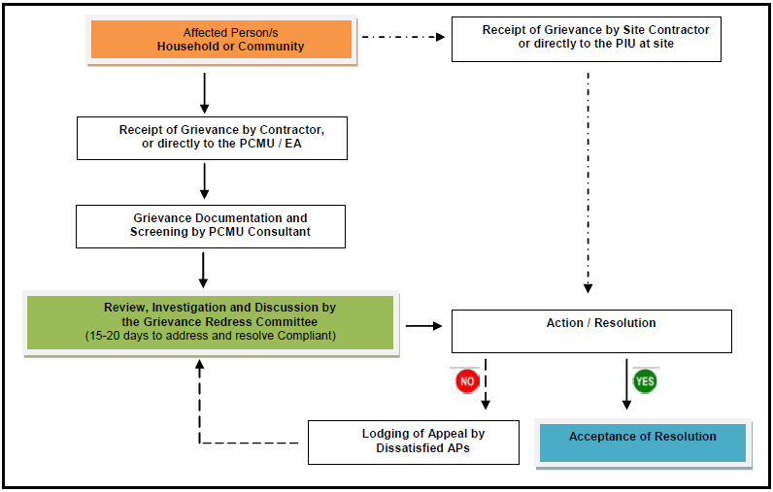
* PIU – responsible person for GRM is the director of PIU, Mr. Rustam Shukurov, tel: +99871 2477923
EA is SUE Maxsustrans. The responsible person for GRM is Mr. Shukhrat Inogamov, tel: +99871 2473599, email: maxsustrans@inbox.ru
PCMU Consultant is social and resettlement specialist, Mrs. Maria Malinovskaya, tel: +99871 1508887, email: malinovskaya@almarconsulting.org

- Mitigation of social concerns
- The Social Safeguard Specialist of PIU will continue to conduct quarterly monitoring to verify that there are no impacts during implementation and that information disclosure and meaningful consultation are continued throughout construction period. The result will be compiled as part of the Quarterly Safeguard Monitoring Report prepared by the PIU Consultant. The PIU will review the report and submit to ADB for review and disclosure.

- Although the design and construction are not expecting any land acquisition and involuntary resettlement, physical or economic displacement, or temporary restrictions to land use. However, some assumptions were made that during civil works that the following measures should be suggested to eliminate any impacts:
- Informing all the residents, local households and traders about the nature and duration of works in advance, so that they can make necessary preparation to face the situation;
- Increasing the workforce and using the appropriate equipment to complete the work in a minimum timeframe.
- Increasing the workforce attracted from local residents.
- Other social concern, if any, shall be properly solved by the Grievance Redress Committee (GRC) under the Grievance Redress Mechanism (GRM) of the Project to be formed by the PIU.
- Any other preventive measures to be adopted as required considering the situation during construction.

- The above mitigation measures during construction activities will ease the temporary disturbances in connection to movement and operation activities of the local residents.

- Implementation Schedule
- Implementation Schedule. The detailed design of the project in completed and under assessment of state expertise committee. The preliminary period of start of construction works is first quarter of 2020. The planned period of construction is 20 months.

- A tentative time-schedule for implementation (only as an indication) is shown Figure below:

Figure 11 Implementation schedule
Item of works | YEAR
Item of works | 2019 |  |  |  |  |  | 2020 |  |  |  |  |  |  |  |  |  |  |  |  |  | 2021
Item of works | 7 | 8 | 9 | 10 | 11 | 12 |  | 1 | 2 | 3 | 4 | 5 | 6 | 7 | 8 | 9 | 10 | 11 | 12 | 1 |  | 2 | 3 | 4 | 5 | 6
Preparation of bid documents
Approval of detailed design
Tendering and evaluation of contractor for the construction works
Executing of physical works

- Conclusions and Recommendations
- A due diligence for involuntary resettlement impacts for the project was undertaken to ensure that the project will not cause any LAR impacts. Both permanent and temporary impacts were considered and analyzed during this assessment. The due diligence process was conducted for the project to examine the LAR impacts with respect to the requirements of the SPS-2009 of ADB. The results of this Due Diligence study conclude that, as per ADB Safeguard Policy Statement, the project is considered as "no involuntary land acquisition and resettlement". Important findings of the study in connection to social safeguard issues are (i) construction of new landfill will be carried on reserve lands of the district and will not require land acquisition thus no IR will be occurred due to construction works; (ii) no landfill site or access road need resettlement, dislocation or relocation; (iii) there are no structures, houses, shops, trees or any other establishments on the ROWs of the proposed landfill site and access road; (iv) the required land for construction work is owned by SUE Maxsustrans (v) there is no possibility of any adverse impact in terms of losing income or livelihood; (vi) as a result no dislocation, demolition of houses or structures will be required due to the construction activities.

- As the results of the study suggest that the impact of this project does not incur any land acquisition, resettlement or economic displacement. This project can be categorized as “C” for Involuntary Resettlement (IR) impact as per the ADB’s Safeguard Policy Statement, 2009 (SPS). In case any claims or complaints are submitted during the project implementation period, an effective and efficient Grievance Redress Mechanism will enhance provision of timely and sensible hearings and facilitate solutions.

- Social Safeguard Specialist of PIU will continue to conduct quarterly monitoring to verify that there are no project impacts caused by the project implementation.

- The Contractor engaged in sanitary landfill civil works will also consider implementation and monitoring of the following social and gender issues during the construction period specified at their assignments.

- Recommendations: Although no LAR impacts are expected under the project, the following recommendations are made to ensure steadiness execution of work and adopting mitigation measure to avoid or minimize potential LAR impacts if any and to minimize illegal occupancy in future.

- Public consultation with local communities and nearby households / mahalla residents will be held on regular basis at all stages of project implementation for information dissemination, record any concerns / complaints and prompt resolution of the concerns / complaints within GRM established for the project.
- During the construction SUE "Maxsustrans" with support of Construction Supervision Consultant will monitor temporary land use and ensure that in case the additional land plots are required for temporary use during construction activities, the Construction Contractor obtains relevant agreements allowing use of such lands. Moreover, after completion of civil works the lands taken for temporary use (if any) will be restored to their pre project conditions by Construction Contractor and rent fees shall be fully paid to the users of those land plots.
- If unanticipated IR impacts emerge during implementation of project works are due to restriction of access to the land due to contractor activities, it will be immediately reported to the supervision consultant and contract will stop the civil work activities in the affected areas until the corrective action plan is prepared in consultation with ADB safeguards team. Nonetheless in such sections the project works will be kept on hold till ADB cleared CAP is implemented and confirmed as such.
- Social and environmental safeguard monitoring will be conducted on quarterly basis during the construction period and after the civil works are completed in order to make assessment of project impacts and develop mitigation measures for any other negative impacts on lands or local communities and nearby households / mahalla residents ( if any).
Page 23

Annex I Sanitary-epidemiological standards and norms


The Ministry of Public Health
Of the Republic of Uzbekistan
The State Sanitary-Epidemiological
Supervision Center of Tashkent region

No. 10/792
26 April 2019
Deputy Director of SUE “MAXSUSTRANS”
Under the State Committee
On Ecology and Environmental Protection
Kattakhodjaev Sh.I.

In response to your letter No. 358-02 dated 26 March, 2019, the State Sanitary-Epidemiological Supervision Center of Tashkent region reports as follows:
In order to construct a controlled not-improved landfill for different sorts of household waste for SUE "MAXSUSTRANS", it is planned to allocate 30 hectares of land plot from the contours 337-, 338-, 340-, 342-, 343-, 344- and 345- of the neighborhood "Yangi Hayot" of Akhangaran district of Tashkent region. As a result of examining of the provided topographic map (scale 1: 500), as well as the inspection conducted by specialists of the State sanitary-epidemiological supervision center of Tashkent region, it was determined that the sanitary protection zone of the projected sanitary landfill from settlements will be 1,500 meters.
In accordance with the paragraph 6.4. of current sanitary-epidemiological standards and norms (“SanPiN”) No. 0350-17 “Sanitary standards and norms of the atmospheric air protection of human settlements of the Republic of Uzbekistan” and taking into account that the above-mentioned landfill will include area of composting structures for both solid and liquid waste, sanitary protection zone should be 1000 meters.
In addition, we note that in the design stage of the landfill, it is necessary to carefully follow the requirements set out in Decree No. 73 dated June 15, 2016 "On approval of the guidelines for the design and operation of landfills" of the Chief Director of “Uzkommunkhizmat”

Chief Doctor (signed) Baltabaev B.A.

Annex II Decision of khokim of Akhangaran Districts of Tashkent region on allocation the land plots for project needs

Translation in English is unofficial

REPUBLIC OF UZBEKISTAN
KHOKIM
OF AKHANGARAN DISTRICT
OF TASHKENT REGION

DECISION

August «25», 2018 № 1536 Akhangaran town

On the allocation of land plot for improvement the solid waste management system for SUE “Maxsustrans”of Hokimiyat of Tashkent city out of the land plots in the possession of the regional public stock in the territory of the collection of citizens of “Yangi Hayot” mahalla of Akhangaran district of Tashkent region

On the basis of paragraph 4 of Annex 2 of the Resolution of the President of the Republic of Uzbekistan №3874 as of July 19, 2018 “On additional measures to accelerate the implementation of investment and infrastructure projects in 2018-2019”, having considered the submitted documents on the land management related to the allocation of land plot for the organization of production electricity from gas obtained received from solid waste for SUE “Maxsustrans” of Hokimiyat of Tashkent city out of the land plots in the possession of the regional public stock in the territory of the collection of citizens of “Yangi Hayot” mahalla of Akhangaran district, on the basis of Article 6 of the Law of the Republic of Uzbekistan “On Local State Administration”
I AM DECIDING:
1. To approve the Act of the commission on allocating land for non-agricultural needs in the district Hokimiyat as of August 16, 2018 about allocating a land plot in the area of 30,0 hectares, including 26,8 hectares of irrigated land, 1,1 hectares of meadows and pastures, 1,9 hectares irrigation ditches and drainage ditches and 0,2 hectares of roads for the organization of electricity production from gas obtained from solid waste for SUE “Maxsustrans” of Hokimiyat of Tashkent city out of the land plots in the possession of the regional public stock in the territory of the collection of citizens of “Yangi Hayot” mahalla of Akhangaran district.

2. To allocate a land plot in the area of 30,0 hectares, including 26,8 hectares of irrigated land, 1,1 hectares of meadows and pastures, 1,9 hectares irrigation ditches and drainage ditches and 0,2 hectares of roads located on the contours of 337k, 338, 340, 342, 343, 344 and 345 of the agricultural map for the organization of electricity production from gas obtained from solid waste SUE “Maxsustrans” of Hokimiyat of Tashkent city out of the land plots in the possession of the regional public stock in the territory of the collection of citizens of “Yangi Hayot” mahalla of Akhangaran district.
3. SUE “Maxsustrans” of Hokimiyat of Tashkent city shall:
А) Note, that to design the construction project for the organization of electricity production from gas obtained from solid waste, first of all, it is necessary to order for assignments (ART-1-2 parts) for architectural planning in the Main Department of Architecture and Civil Engineering of Tashkent region,
B) Approve, that the loss of agricultural production (cash indemnification for losses) from the land plot allocated for permanent use for the organization of electricity production from gas obtained from solid waste for SUE “Maxsustrans” of Hokimiyat of Tashkent city out of the land plots in the possession of the regional public stock in the territory of the collection of citizens of “Yangi Hayot” mahalla of Akhangaran district will be paid for by SUE “Maxsustrans”.
C) Remind SUE “Maxsustrans” of Hokimiyat of Tashkent city that, with the condition of transferring used land plots at the disposal of the district public stocks where the electricity manufacturing has been organized from gas from solid waste, with preliminary remediation, and keeping in working condition functioning irrigation and melioration networks, engineering communications in gradually additionally allocated land plots and border areas in the construction period used by farms and agricultural enterprises.
4. On the basis of this decision the head of the district department of Land Resources and the State Cadastre (B. Sotiboldiyev) is assigned to introduce appropriate changes in the district land fund.
5. To make official warning to SUE “Maxsustrans” that on the basis of Article 10 of the Law of the Republic of Uzbekistan “On Local State Administration”, if the allocated land plot is not developed within three years, this decision loses its validity.
6. To introduce the discussion of this decision into the agenda of the regular session of the Council of People’s Deputies of Akhangaran district.
7. To ask khokim of Tashkent region to approve this decision.
8. Control over the execution of this decision shall be assigned to the first deputy of khokim of district M. Miryunusov.

Khokim of the district U. Tursunov
Allo

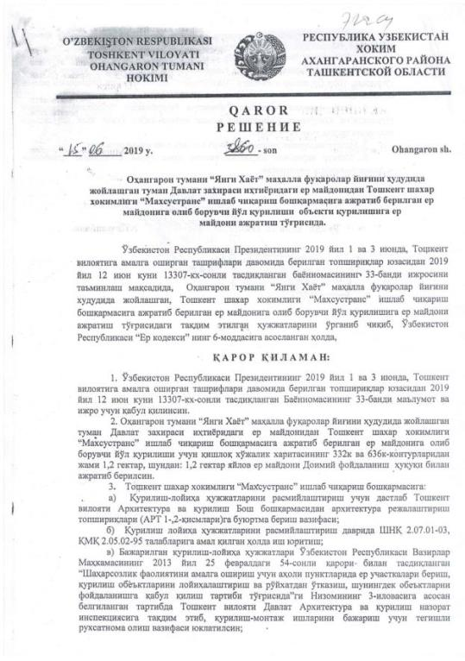
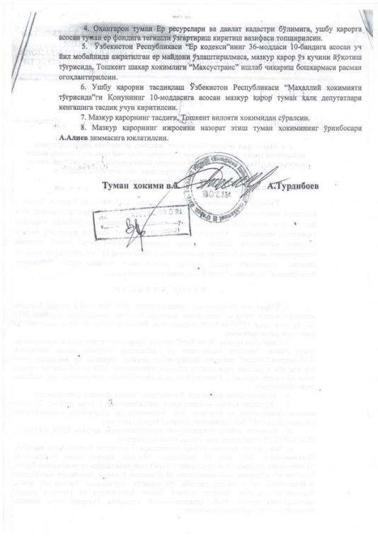

Translation in English is unofficial

REPUBLIC OF UZBEKISTAN
KHOKIM OF AKHANGARAN DISTRICT OF TASHKENT REGION

DECISION

June«15», 2019 № 3860 Akhangaran town

On the allocation of land plot for construction of road for SUE “Maxsustrans”of Hokimiyat of Tashkent city out of the land plots in the possession of the regional public stock in the territory of community of “Yangi Hayot” mahalla of Akhangaran district of Tashkent region

On the basis of paragraph 33 of the Resolution of the President of the Republic of Uzbekistan № 13307 as of June 12, 2019, hokimiyat of Akhangaran district considered the submitted documents on the land management related to the allocation of land plot for SUE “Maxsustrans” from the land plots in the possession of the regional public stock in the territory of the collection of citizens of “Yangi Hayot” mahalla of Akhangaran district, on the basis of Article 6 of the Land Code of the Republic of Uzbekistan, decided the following:

1. To adopt and implement the paragraph 33 of the Resolution of the President of the Republic of Uzbekistan № 13307 as of June 12, 2019 and implement tasks approved on June 1 and 3, 2019.

2. To allocate a land plot in the area of 1.2 hectares of pastures for the construction of road for SUE “Maxsustrans” under Hokimiyat of Tashkent city out of the land plots in the possession of the regional public stock in the territory of the community of “Yangi Hayot” mahalla of Akhangaran district pointed on the map by numbers 332 and 636. .
3. Production Directorate of “Maxsustrans” of Hokimiyat of Tashkent city shall:
a) Note, that to design the construction project for the organization of electricity production from gas obtained from solid waste, first of all, it is necessary to order for assignments (ART-1-2 parts) for architectural planning in the Main Department of Architecture and Civil Engineering of Tashkent region,
b) Consider the design documents for construction within construction norms SHNK 2.07.01-03. KMK 2.05.02-95.
c) Consider and approve the construction documents and permission for the construction works based on Regulation No 54 “Order of the allocation, using lands and construction works of the facilities in communities and settlements” dated February 25, 2013, Inspection on construction at Tashkent regional Architecture and construction department.
4. On the basis of this decision the head of the district department of Land Resources and the State Cadastre is assigned to introduce appropriate changes in the district land fund.
5. To make official warning to SUE “Maxsustrans” that on the basis of Article 10 of the Law of the Republic of Uzbekistan “On Local State Administration”, if the allocated land plot is not developed within three years, this decision loses its validity.
6. To introduce the discussion of this decision into the agenda of the regular session of the Council of People’s Deputies of Akhangaran district.
7. To ask khokim of Tashkent region to approve this decision.
8. Control over the execution of this decision shall be assigned to the deputy khokim of district Aliev A.

Khokim of the district U. Turdiboev

Annex III Land optimization program

Resolution of the Cabinet of Ministers of the Republic of Uzbekistan about measures to optimize the sizes of land plots provided for farming
In order to further improve the efficiency of farming, as well as to ensure the rational use of land and water resources, to strengthen the financial and economic condition of farms, the Cabinet of Ministers decides:
1. To take into account that in accordance with the decision of the Republican Commission for Deepening Economic Reforms in Agriculture, the Ministry of Agriculture and Water Resources of the Republic of Uzbekistan, the Council of Ministers of the Republic of Karakalpakstan, khokimiyats of regions and districts with the participation of territorial councils of farmers, heads of farms and wide involvement of the public it was carried out work on:
an inventory of the size of land provided for farming, a critical analysis of their effective and rational use;
the study of the financial and economic condition of farms, the availability of material and technical base, labor resources and working capital, for the implementation of their effective activities, the fulfillment of the terms of land lease agreements and contract agreements concluded between farms and purchasing organizations, primarily for the sale of agricultural products for state needs;
further optimization of the size of land provided for agriculture, taking into account the level of provision of territories with labor resources, population density, the efficiency of farms, taking into account their economic and financial indicators, the availability of appropriate professionally trained personnel potential.
2. To approve the khokimiyats of regions and districts, developed and approved by the Republican Commission for Deepening Economic Reforms in Agriculture together with the Council of Ministers of the Republic of Karakalpakstan, reviewed and approved by the district and regional councils of people's deputies:
summarizes the results of further optimization of the size of land provided for agriculture, in the main areas of their specialization in the context of the Republic of Karakalpakstan and regions in accordance with Annexes No. 1, 1-1 - 1-5;
according to the results of optimization, the number of farms and averaged land plots provided to them, taking into account their areas of specialization in the context of the Republic of Karakalpakstan, regions and districts in accordance with Annexes No. 2, 2 -1 - 2-13.
3. The Council of Ministers of the Republic of Karakalpakstan, the khokimiyats of the regions together with:
The State Committee of the Republic of Uzbekistan for Land Resources, Geodesy, Cartography and State Cadastre within a week take measures to conclude long-term lease agreements for land plots with the heads of newly created farms, as well as heads of farms whose land plots are optimized;
Uzdonmahsulot JSC, within ten days, take measures to renegotiate contracts for the supply of grain crops of the 2016 harvest for state needs;
Uznefteprodukt JSC, Uzkimyosanoat JSC and other organizations serving agriculture, within ten days, take measures to renegotiate contracts with farms for the acquisition of material and technical resources and the provision of services;
The State Tax Committee of the Republic of Uzbekistan and the State Committee of the Republic of Uzbekistan on Statistics to take measures to exclude liquidated farms from the state register of legal entities in the established manner.
Report the results of the work done before December 25, 2015 to the Cabinet of Ministers.
4. To establish the procedure in accordance with which, starting January 1, 2016 the representation of land plots for farming and their seizure will be carried out on the basis of the decision of the district councils of people's deputies on the conclusion of the territorial councils of farmers, dekhkan farms and owners of private land and a commission for the consideration of granting (implementation) land plots.
The Ministry of Justice, the Ministry of Agriculture of the Republic of Uzbekistan, the Council of Farmers, Dekhkan Farms and the owners of household lands of Uzbekistan to ensure effective legal protection of the legitimate interests of farms, strict adherence to the established procedure for the liquidation and creation of farms.
5. The Council of farms, dekhkan farms and owners of household lands of Uzbekistan, the Ministry of Agriculture, together with the Ministry of Development of Information Technologies and Communications of the Republic of Uzbekistan, other interested ministries and departments, as well as the Council of Ministers of the Republic of Karakalpakstan, the khokimiyats of regions and districts, within a month, to create a single base of farm farms, including information on the basic production and economic indicators of the farm.
6. The Ministry of Agriculture and Water Resources, the Council of Farmers of Uzbekistan, the State Committee of the Republic of Uzbekistan on Land Resources, Geodesy, Cartography and the State Cadastre together with the Ministry of Justice within one month to submit proposals to the Cabinet of Ministers on amendments of the legislation arising from this resolution.
7. The control over the implementation of this resolution is assigned to the Prime Minister of the Republic of Uzbekistan Sh. Mirziyoyev.
President of the Republic of Uzbekistan, I. Karimov
Tashkent city,

As of December 15, 2015,
# 362

ANNEX No. 1
to the Resolution of the Cabinet of Ministers as of December 15, 2015 No. 362
SUMMARY RESULTS
On optimizing the size of land provided for farming in the Republic of Karakalpakstan and regions

 | October 1, 2015  before optimization |  | On December 1, 2015  according to optimization results |  | Difference
 | total farms, units | the average size of the land per 1 farm, ha | всего total farms, units | the average size of the land per 1 farm, ha | number of farmers |  | the average size of the land per 1 farm, ha
 |  |  |  |  | ед.  (+;–) | % | ha  (+;–) | %
Republic of Karakalpakstan | 3 691 | 80,6 | 4 802 | 58,7 | 1 111 | 30,1 | –21,9 | –27,2
regions:
Andijan | 7 251 | 29,8 | 8 538 | 25,6 | 1 287 | 17,7 | –4,2 | –14,2
Bukhara | 4 632 | 44,4 | 5 273 | 39,0 | 641 | 13,8 | –5,4 | –12,1
Jizzakh | 7 784 | 55,7 | 10 073 | 43,2 | 2 289 | 29,4 | –12,6 | –22,6
Kashkadarya | 10 756 | 51,2 | 12 373 | 44,8 | 1 617 | 15,0 | –6,4 | –12,4
Navoi | 1 814 | 48,3 | 2 519 | 35,6 | 705 | 38,9 | –12,7 | –26,2
Namangan | 5 523 | 35,7 | 7 397 | 26,9 | 1 874 | 33,9 | –8,9 | –24,8
Samarkand | 10 952 | 36,9 | 12 641 | 32,1 | 1 689 | 15,4 | –4,8 | –13,1
Surkhandarya | 5 447 | 45,5 | 6 108 | 41,2 | 661 | 12,1 | –4,4 | –9,6
Syrdarya | 5 097 | 48,6 | 5 459 | 46,1 | 362 | 7,1 | –2,5 | –5,2
Tashkent region | 6 272 | 53,3 | 9 418 | 29,6 | 3 146 | 50,2 | –23,7 | –44,4
Ferghana | 8 805 | 31,3 | 10 420 | 26,1 | 1 615 | 18,3 | –5,2 | –16,6
Khorezm | 5 490 | 36,9 | 6 049 | 33,8 | 559 | 10,2 | –3,1 | –8,4
Republic of Karakalpakstan | 83 514 | 43,9 | 101 070 | 36,1 | 17 556 | 21,0 | –7,8 | –17,8

ANNEX No. 1-1
to the resolution of the Cabinet of Ministers as of December 15, 2015 No. 362
OPTIMIZATION RESULTS
the size of land provided for farming specialized in cotton and grain growing
 | October 1, 2015  before optimization |  | On December 1, 2015  according to optimization results |  | Difference
 | total farms, units | the average size of the land per 1 farm, ha | всего total farms, units | the average size of the land per 1 farm, ha | number of farmers |  | the average size of the land per 1 farm, ha
 |  |  |  |  | ед.  (+;–) | % | га  (+;–) | %
Republic of Karakalpakstan | 2 710 | 100,8 | 3 732 | 69,3 | 1 022 | 37,7 | –31,5 | –31,2
regions:
Andijan | 3 119 | 56,4 | 3 868 | 45,7 | 749 | 24,0 | –10,8 | –19,1
Bukhara | 3 190 | 57,7 | 3 707 | 50,8 | 517 | 16,2 | –6,9 | –11,9
Jizzakh | 5 330 | 72,0 | 7 216 | 55,8 | 1 886 | 35,4 | –16,1 | –22,4
Kashkadarya | 7 431 | 65,0 | 8 656 | 56,9 | 1 225 | 16,5 | –8,2 | –12,5
Navoi | 1 129 | 70,3 | 1 393 | 57,3 | 264 | 23,4 | –13,0 | –18,5
Namangan | 2 648 | 62,9 | 3 451 | 49,1 | 803 | 30,3 | –13,8 | –21,9
Samarkand | 7 355 | 47,8 | 8 556 | 41,3 | 1 201 | 16,3 | –6,5 | –13,6
Surkhandarya | 2 784 | 75,7 | 3 297 | 65,3 | 513 | 18,4 | –10,4 | –13,8
Syrdarya | 3 438 | 63,2 | 4 255 | 56,1 | 817 | 23,8 | –7,2 | –11,3
Tashkent region | 3 435 | 75,2 | 4 788 | 47,2 | 1 353 | 39,4 | –28,0 | –37,2
Ferghana | 3 040 | 72,4 | 4 180 | 52,7 | 1 140 | 37,5 | –19,8 | –27,3
Khorezm | 2 655 | 63,3 | 3 596 | 49,9 | 941 | 35,4 | –13,4 | –21,1
Total | 48 264 | 65,1 | 60 695 | 52,7 | 12 431 | 25,8 | –12,4 | –19,0

ANNEX No. 2
to the resolution of the Cabinet of Ministers as of December 15, 2015 No. 362
QUANTITY AND AVERAGE SIZES
land plots provided for farming, based on the optimization of the size of their land plots in the Republic of Uzbekistan
 | Total farms |  | including:
 |  |  | cotton-growing and grain-growing |  | vegetable-growing and melon-growing |  | gardening and viticulture |  | livestock breeding |  | Other directions
 | number,units | Average size of land plot for 1 farm, ha | number,units | Average size of land plot for 1 farm, ha | number,units | Average size of land plot for 1 farm, ha | number,units | Average size of land plot for 1 farm, ha | number,units | Average size of land plot for 1 farm, ha | number,units | Average size of land plot for 1 farm, ha
Republic of Karakalpakstan | 4 802 | 58,7 | 3 732 | 69,3 | 223 | 9,8 | 250 | 8,5 | 388 | 43,0 | 209 | 9,7
regions:
Andijan | 8 538 | 25,6 | 3 868 | 45,7 | 509 | 6,3 | 2 443 | 8,0 | 460 | 20,6 | 1 258 | 7,5
Bukhara | 5 273 | 39,0 | 3 707 | 50,8 | 87 | 7,2 | 777 | 7,5 | 630 | 16,2 | 72 | 10,7
Jizzakh | 10 073 | 43,2 | 7 216 | 55,8 | 419 | 9,1 | 1 490 | 5,7 | 714 | 24,3 | 234 | 8,7
Kashkadarya | 12 373 | 44,8 | 8 656 | 56,9 | 726 | 8,9 | 1 985 | 5,8 | 797 | 54,3 | 209 | 6,3
Navoi | 2 519 | 35,6 | 1 393 | 57,3 | 17 | 6,9 | 684 | 8,1 | 297 | 12,3 | 128 | 5,5
Namangan | 7 397 | 26,9 | 3 451 | 49,1 | 120 | 7,2 | 3 049 | 5,8 | 227 | 25,7 | 550 | 8,9
Samarkand | 12 641 | 32,1 | 8 556 | 41,3 | 428 | 6,7 | 2 522 | 9,3 | 563 | 36,9 | 572 | 9,6
Surkhandarya | 6 108 | 41,2 | 3 297 | 65,3 |  |  | 1 777 | 7,8 | 814 | 25,0 | 220 | 9,5
Syrdarya | 5 459 | 46,1 | 4 255 | 56,1 | 17 | 6,8 | 544 | 7,9 | 300 | 21,5 | 343 | 6,4
Tashkent region | 9 418 | 29,6 | 4 788 | 47,2 | 339 | 9,0 | 3 437 | 5,5 | 587 | 48,8 | 267 | 9,0
Ferghana | 10 420 | 26,1 | 4 180 | 52,7 | 672 | 8,3 | 4 667 | 6,6 | 331 | 33,4 | 570 | 7,6
Khorezm | 6 049 | 33,8 | 3 596 | 49,9 | 98 | 8,7 | 1 105 | 5,5 | 464 | 24,0 | 786 | 9,0
By the republic: | 101 070 | 36,1 | 60 695 | 52,7 | 3 655 | 8,1 | 24 730 | 6,8 | 6 572 | 31,2 | 5 418 | 8,3

ANNEX No. 2-11
to the resolution of the Cabinet of Ministers as of December 15, 2015 No. 362
QUANTITY AND AVERAGE SIZES
land plots provided for farming, based on the optimization of the size of their land plots in Tashkent region
Districts | Total farms |  | including:
Districts |  |  | cotton-growing and grain-growing |  | vegetable-growing and melon-growing |  | gardening and viticulture |  | livestock breeding |  | Other directions
Districts | number,units | Average size of land plot for 1 farm, ha | number,units | Average size of land plot for 1 farm, ha | number,units | Average size of land plot for 1 farm, ha | number,units | Average size of land plot for 1 farm, ha | number,units | Average size of land plot for 1 farm, ha | number,units | Average size of land plot for 1 farm, ha
Akkurgan | 556 | 41,3 | 400 | 52,5 | 1 | 9,0 | 88 | 5,3 | 22 | 57,5 | 45 | 5,6
Akhangaran | 620 | 41,1 | 344 | 54,4 | 4 | 8,5 | 207 | 6,1 | 63 | 87,3 | 2 | 10,5
Bekabad | 718 | 48,3 | 600 | 55,5 | 5 | 10,4 | 68 | 5,5 | 20 | 36,6 | 25 | 7,4
Buka | 807 | 34,4 | 655 | 39,4 | 29 | 8,4 | 65 | 6,5 | 35 | 31,3 | 23 | 8,5
Bostanlik | 477 | 22,9 | 82 | 57,2 | 7 | 9,9 | 297 | 6,4 | 86 | 49,2 | 5 | 5,8
Zangiota | 628 | 17,2 | 247 | 28,0 | 39 | 8,4 | 303 | 6,5 | 37 | 42,8 | 2 | 6,0
Kibray | 585 | 16,0 | 127 | 41,5 | 178 | 9,2 | 241 | 5,3 | 31 | 36,6 | 8 | 7,3
Kuyichirchik | 797 | 35,9 | 514 | 49,7 | 15 | 8,3 | 148 | 5,2 | 24 | 38,3 | 96 | 12,9
Parkent | 1 249 | 11,1 | 162 | 24,2 |  |  | 995 | 5,0 | 88 | 56,3 | 4 | 6,3
Pskent | 493 | 37,9 | 294 | 55,7 | 42 | 9,2 | 81 | 6,0 | 56 | 22,4 | 20 | 7,5
Urtachirchik | 627 | 39,7 | 477 | 47,8 | 2 | 9,5 | 103 | 6,0 | 32 | 41,9 | 13 | 7,5
Chinaz | 440 | 37,5 | 309 | 48,2 | 3 | 9,7 | 110 | 5,2 | 16 | 62,7 | 2 | 5,0
Yukorichirchik | 469 | 38,4 | 288 | 51,8 | 1 | 10,0 | 119 | 7,6 | 48 | 44,0 | 13 | 5,2
Yangiyul | 952 | 17,4 | 289 | 41,0 | 13 | 7,3 | 612 | 5,0 | 29 | 51,7 | 9 | 5,7
Total: | 9 418 | 29,6 | 4 788 | 47,2 | 339 | 9,0 | 3 437 | 5,5 | 587 | 48,8 | 267 | 9,0

Annex IV Data on lands, sowing crops and area of the leasehold farmer
Cadastral information on lands leased by the farmer
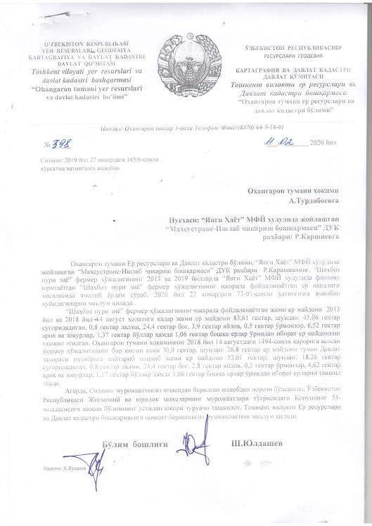

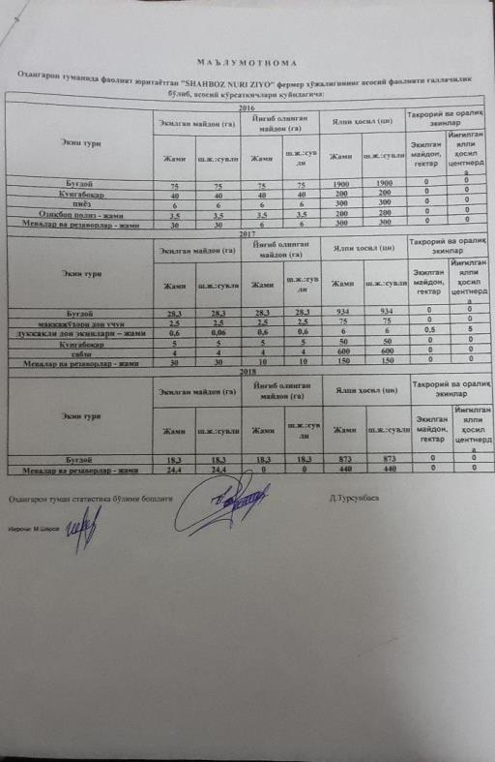

Translation in English is unofficial

Department of Akhangaran cadaster department
No. 398 dated February 11, 2020

Copy to Hokimiyat of Akhangaran district
Yangy Hayot makhalla
SUE Maxsustrans
***
The size of the land plot leased by Shahboz Nuri Ziyo, since 2013 to August 14, 2018 amounted at 83.61 ha, including 45.06 ha of irrigated lands, 0.8 ha of non irrigated lands, 24.4 ha of orchard, 3.9 ha of pastures, 0.5 ha are forests, 6.52 ha of aryk and drains, 1.37 ha of roads, 1.06 ha of other lands. In compliance with the decree of hokimiyat No. 1494, dated August 14, 2018 the leasehold farmer returnued the land plot of 30 ha, including 26.8 ha of irrigated land, 1.1 hectares of pastures, 1.9 ha of aryk and drains and 0.2 hectares of roads. The size of land of the leasehold farmer became 53.61 ha, including 18.26 ha of irrigated lands, 0.8 ha of non irrigated lands, 24.4 ha of orchard, 2.8 ha of pastures, 0.5 ha are forests, 4.62 ha of aryk and drains, 1.17 ha of roads, 1.06 ha of other lands.
***

Head of the department Sh. Yuldashev

Reference on main imdicators of crops growing by the grain farming Shahboz Nuri Ziyo:

Crop | Sowing area, ha |  | Harvested area, ha |  | Harvest |  | Secondary crops
Crop | Total, ha | Irrigated area | Total, ha | Irrigated area | Total | Irrigated area | Total, ha | Irrigated area
2016
Wheat | 75 | 75 | 75 | 75 | 1900 | 1900 | 0 | 0
Sunflower | 40 | 40 | 40 | 40 | 200 | 200 | 0 | 0
Onion | 6 | 6 | 6 | 6 | 300 | 300 | 0 | 0
Melons and vegetab les | 3.5 | 3.5 | 3.5 | 3.5 | 200 | 200 | 0 | 0
Fruints and berries | 30 | 30 | 30 | 30 | 300 | 300 | 0 | 0
2017
Wheat | 28.3 | 28.3 | 28.3 | 28.3 | 934 | 934 | 0 | 0
Maize | 2.5 | 2.5 | 2.5 | 2.5 | 75 | 75 | 0 | 0
Beans | 0.6 | 0.6 | 0.6 | 0.6 | 6 | 6 | 0 | 0
Sunflower | 5 | 5 | 5 | 5 | 50 | 50 | 0 | 0
Carrot | 4 | 4 | 4 | 4 | 600 | 600 | 0 | 0
Fruints and berries | 30 | 30 | 30 | 30 | 150 | 150 | 0 | 0
2018
Wheat | 18.3 | 18.3 | 18.3 | 18.3 | 873 | 873 | 0 | 0
Fruints and berries | 24.4 | 24.4 | 24.4 | 24.4 | 440 | 440 | 0 | 0

Annex V Information on waste pickers employed at existing Akhangaran landfill
Request on number of people engaged in waste collection and sorting
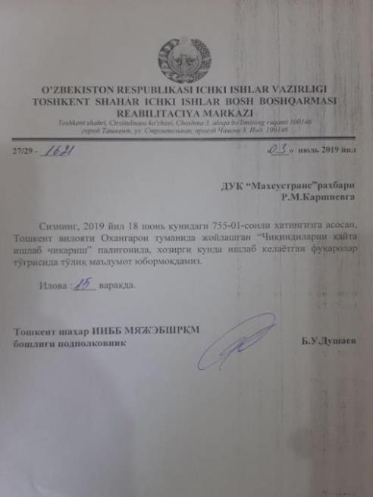
Translation in English is unofficial

Department of internal affairs of the Republic of Uzbekistan, Tashkent city
Rehabilitation Center
#27/29 -1621
Date: July 3, 2019
To head of SUE “Maxsustrans”, Mr. Karshiev R.

In order to reply on your request #755-01 dated June 18, 2019 we give you the information on citizents working at the landfill at Akhangaran district, Tashkent region.

Department of internal affairs of the Republic of Uzbekistan, Tashkent city
Head of Rehabilitation center, lieutenant colonel Dushaev B.

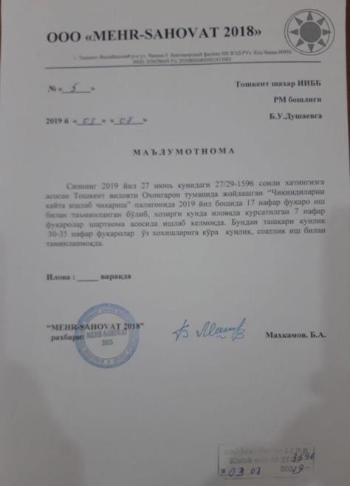
Translation in English is unofficial
Mehr Sahovat LTD
#5
Date: July 3, 2019

TO Department of internal affairs of the Republic of Uzbekistan, Tashkent city
Head of Rehabilitation center, lieutenant colonel Dushaev B.

In order to reply on your request #27/29-1596 dated June 27, 2019 we give you the information on citizents working at the landfill at Akhangaran district, Tashkent region: there are 17 waste pickers were emplyed at the landfill at the beginning of 2019 year by labor contract; Now there are 7 workers who are work there by the labor contarct. 30-35 citizents work at the landfill at their own wishes every day or several hours per day.
Head of Rehabilitation center,
lieutenant colonel Dushaev B.

Copy of the labor contract
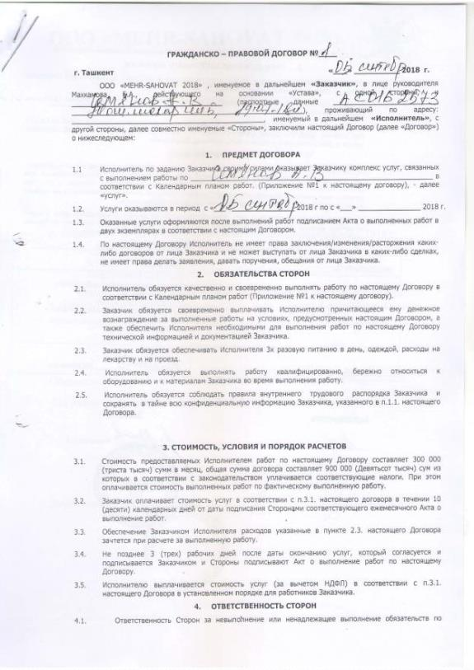
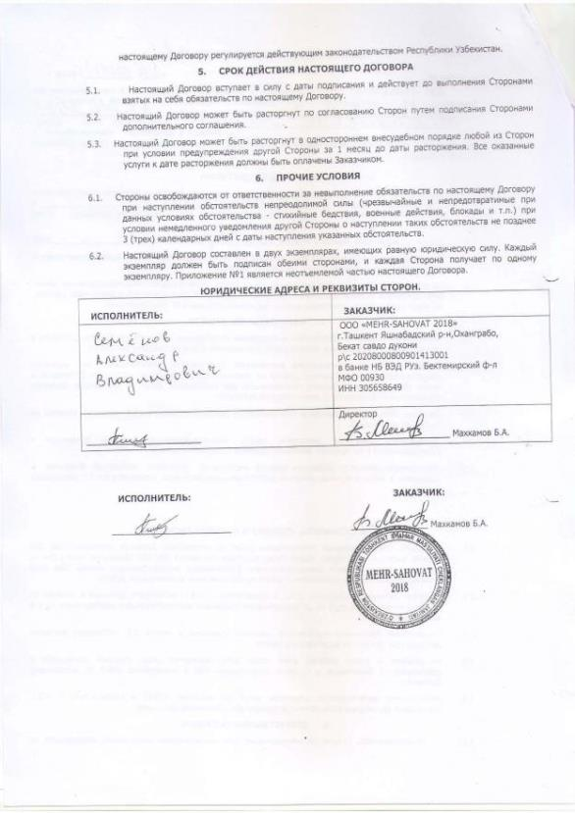

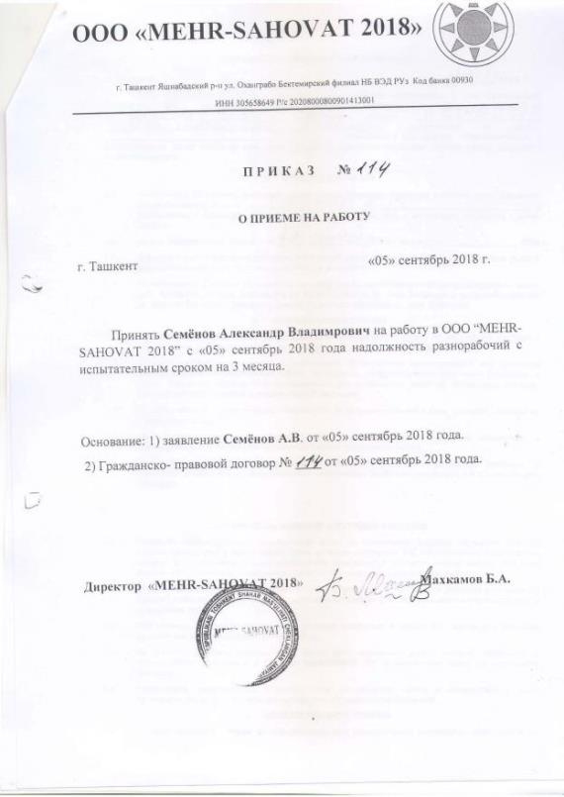

Translation in English is unofficial

The labor contract includes the legal articles on contract parts, subject of the contract, obligations and rights of the contract parts, payments, terms of the contract and other conditions.

Accroding to the article on subject of the contract, the employee do the work for the mentioned period of work. The calendar schedule of the work is an Annex of the contract. The work carried out is confirmed by the act of executed services.

Obligations and rights of the contract parts, terms of the contract and other conditions: Employee must carry out the work in compliance with the schedule.
Employer must provide the employee with 3 times meal, clothes, medicine, and payments for fare.

Articles on payments: the amount of the contract is 900.000 UZS. The taxes are paid from this amount. The payments to the employee is 300 000 UZS. The Employer must pay the salary to the employee within 10 working days after finishing the works.

Terms of the contract: The contract is valid for the concluded period.

Other conditions, inlduing force majeure, cases of cancellation of the contract.

Stamps, requisite elements.

Annex VI Public consultation

Notification on public consultations for local government

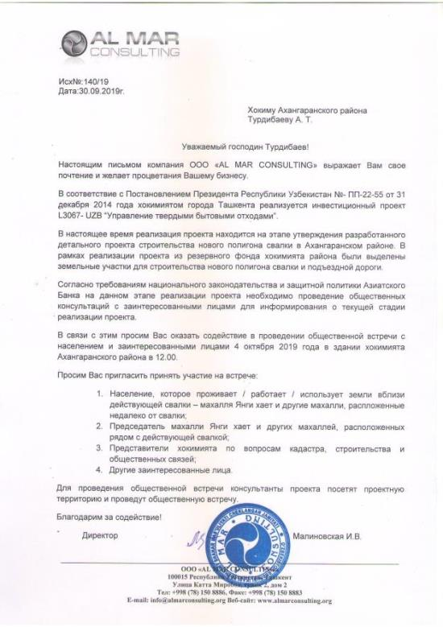

Out coming number: 140/19
Date: 30.09.2019

To khokim of Akhangaran district,
Mr. Turdibaev A.

Dear Mr. Turdibaev!
Al Mar Consulting LLC expresses you respect and wishes prosperity to your business
In accordance with the Decree of the President of the Republic of Uzbekistan No. PP-22-55 dated December 31, 2014, “Solid Waste Management Improvement” Investment Project L3067-UZB is being implemented in Tashkent city.
Currently, the implementation of the project is at the stage of approving the developed detailed project for the construction of a new landfill in Akhangaran district. As part of the project, land plots were allocated from the state land fund for the construction of a new landfill and access roads.
In accordance with the requirements of national legislation and the ADB’s safeguard policy, the public consultations / meetings should be conducted to inform the stakeholders and other interested people about the current stage of project implementation.
In this regard, we ask you to assist in holding a public meeting with the population and stakeholders on October 4, 2019 at the building of Akhangaran district khokimiyat at 12.00.
We ask you to invite to participate in the meeting the following people:
- The population that live / work / use the land near the existing landfill – mahalla Yangi hait and other mahallas located near the landfill;
- The chairman of the mahalla Yangi hayat and other mahallas located next to the existing landfill;
- Representatives of the hokimiyat on cadastre, construction and public relations;
- Other stakeholders.
To conduct a public meeting, project consultants will visit the project site and hold a public meeting.
Thank you for cooperation!
Director Malinovskaya I.

Minutes of the public consultation
Solid Waste Management Improvement Project
Date: October 4, 2019
Time: 12.00 a.m.
Venue: Hokimiyat of Akhangaran district, Tashkent region
Participants:
- Specialties of cadaster department of hokimiyat of Akhangaran district, Mr. Gulomov N.;
- Specialties of architecture department of hokimiyat of Akhangaran district, Mr. Isroilov S.;
- Specialties of investment department of hokimiyat of Akhangaran district, Mr. Hudoykulov U.;
- Specialties of economic department of hokimiyat of Akhangaran district, Mr. Akramov;
- Specialties of ecological department of hokimiyat of Akhangaran district, Mr. Holmatov A.;
- Specialties of communal service department of hokimiyat of Akhangaran district, Mr. Gafurov F.;
- Specialties of agricultural department of hokimiyat of Akhangaran district, Ms.Yuldasheva M.;
- Specialist of SUE “Toza Hudud” of Akhangaran district; Ms. Usmanova J.
- Chairmen of “Yangi hayot ” makhalla, Mr. Uralov I.
- Assistant of the Chairmen of “Yangi hayot ” makhalla, Ms. Urazkulova M.
Purpose of the meeting: informing stakeholders and population persons about the current stage of the project implementation and the main social and environmental issues within the project.
The meeting was held with stakeholders and representatives of local government bodies involved in the project implementation process, especially cadaster, architecture, investment, economic departments. Representatives of makhalla committee located near the existing and planned for construction landfill also took part at the meeting.
During the meeting, information was provided on the current stage of project implementation (detailed design), activities planned for further project stages of construction as well as issues on environmental and social monitoring and mitigation measures for activities related to future construction period. Grievance redress mechanism also presented to the meeting’s participants.
Brochures with the information presented during the public meeting were distributed to the participants.
During the meeting, information was presented on the planned project for the construction of a new landfill, the use of allocated land, the timing of the planned start of construction and the length of the construction period.
At the public meeting, the main indicators of social and environmental monitoring were presented, which were necessary for analysis and assessment of the impact of the project on the environment and the population.
The table below presents questions from the participants:
Question | Answer
When will the construction works start? | Current stage of the project is approving the developed detailed design. Once the detailed design is approved, tender for selection of contractor for construction works will start. The construction works will start in first quarter of 2020.
What company is the contractor for construction works? | The contractor for construction will be selected through the tender. It is expected that the tender will be conducted in future next months.
Will the existing landfill be closed? When will it be closed? | Existing landfill will be closed once new one is completed. It will be closed in compliance with the international standards of waste disposal. The existing landfill is also used for biogas production.
There is biogas production at the existing landfill. The burning of wastes in a biogas plant has a very unpleasant odor. This smells are spread by wind into residential villages. In particular, residents of the mahalla Yangi hayot suffer very much from such odors. What can we do with this? | In this case, it is necessary to use the project complaints mechanism. You need to collect complaints from the people in your community who suffer from such odors. In the application it is should be indicated the time and time at which this all happens. A collective complaint should be submitted to the district hokimiyat and the regional department of environmental protection. The review period is 15 working days.  Based on the results of the appeal, a commission of environmental protection specialists and other specialists who will study the situation on the site should be created within 15 working days. The specialists should make their expert conclusion on this issue.
Will the construction works will use the power lines within the main road for the construction period. There are a lot of power cutoffs due to the overloading the power line. The construction works will increase the frequency of power cutoffs in homes. | This issue will be redirected to the engineers developed the access to power supply during the construction period.
Annex 1 List of participants
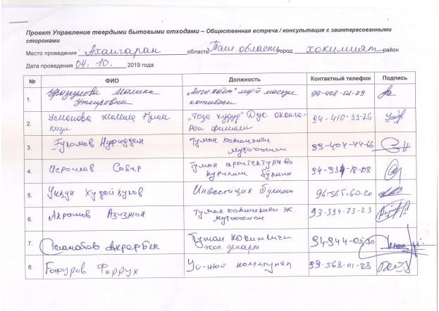
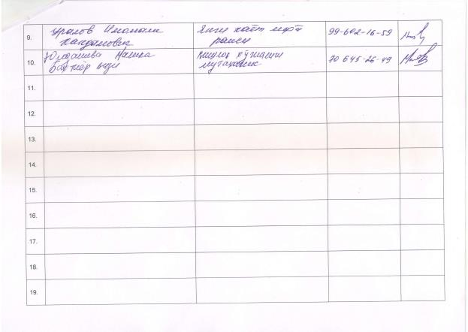
Annex 2 Photo of stakeholders meeting
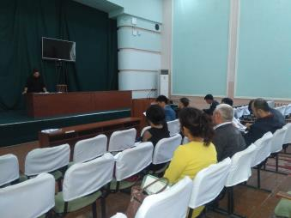
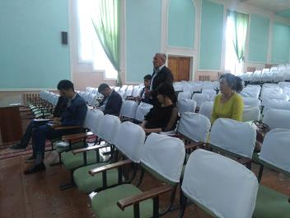

Public consultations, September 2018
Consultant conducts meaningful consultation with project stakeholders and persons involved into the project implementation. During the last 6 months Consultant carried out the public consultations with the waste pickers at the dumpsite and individual consultation with the leasehold farmer (September 2018) assessed as affected person in compliance with the statements of LARP 2012.
Photos of public consultations / meetings
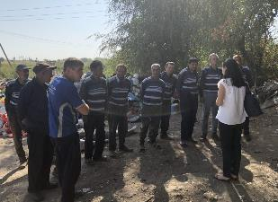 | 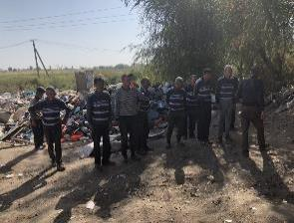
Waste pickers
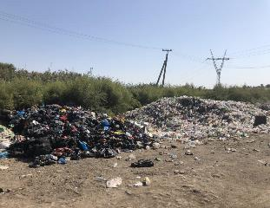 | 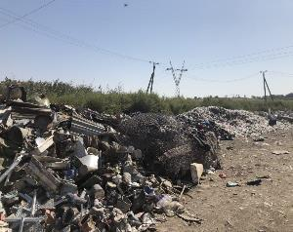
Collected and sorted wastes

List of participants
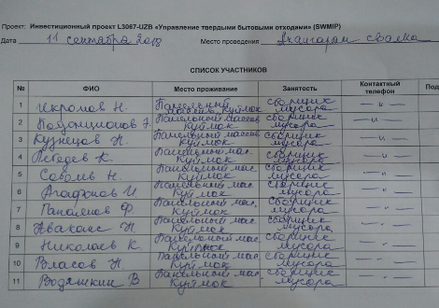
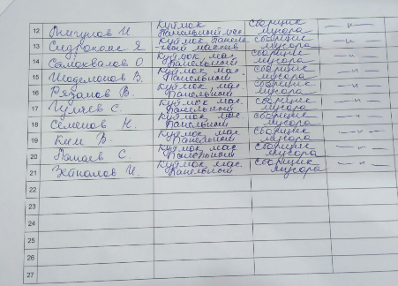

Annex VII Confirmation letter on land acquisition and Involuntary Resettlement avoidance
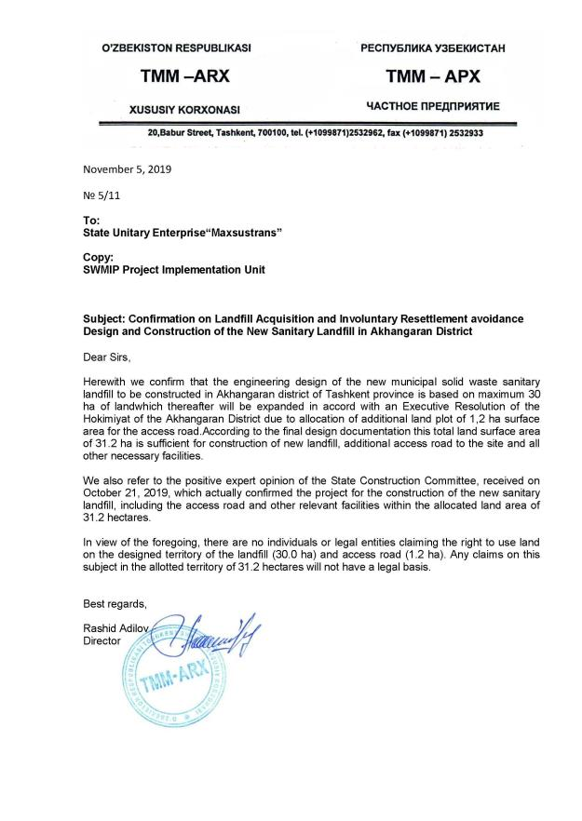

Annex VII Minutes of the Meeting №300 dated October 12, 2012
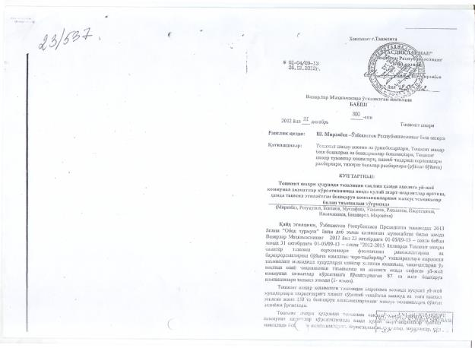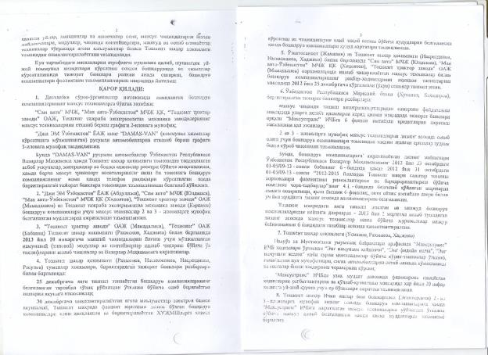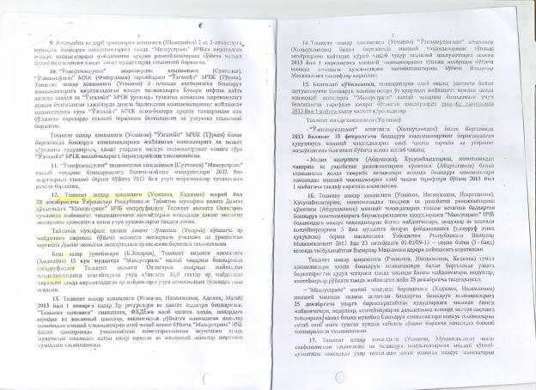

Resolution of the Cabinet of Ministers of RUz No 362 «Measures on optimization of size of land plots allocated for leasehold farming» dated December 15, 2015. The program is aimed at improving the efficiency of land use based on the analysis of the rationality of land use, the financial and economic condition of farms, the availability of material and technical resources, labor resources and working capital, the fulfillment of the terms of the land lease agreement and contracting agreements for the producing agricultural products for state needs. Land optimization has affected farms that have inefficient use of land or do not have enough resources to use the land.
Confirmation letter on avoidance land acquisition and involuntary resettlement is given in Annex IV
Minutes of the Meeting №300 dated October 12, 2012
According to the President Decree # 5024 as of 21.04.2017 the State Committee of Uzbekistan for Nature Protection was renamed into the State Committee of the Republic of Uzbekistan of Ecology and Environment Protection (SCEEP)
See Annex I
Decree of Hokimiyat of Akhangaran district, Tashkent region #1536 dated August 25, 2018 on allocated 30 ha lands from reserve land fund for project needs. See Annex II.
Resolution of the Cabinet of Ministers of RUz No 362 «Measures on optimization of size of land plots allocated for leasehold farming» dated December 15, 2015
Data on sown area are given in the Annex V.
Decree of Hokimiyat of Akhangaran district, Tashkent region #3860 dated June 15, 2019 on allocated 1,2 ha lands from reserve land fund for project needs. See Annex II.
As part of livelihood program, these waste pickers as homeless people was engaged in the Rehabilitation Center via government initiated social support program. These people are homeless people, people without a fixed place of residence, without legal ID documents or those who have fallen into difficult social conditions. The Center provides these people and their families with the social support of their livelihood though providing them legal documents, cloth, shelters, medicines, paid work at public facilities.
According to the President Decree # 5024 as of 21.04.2017 the State Committee of Uzbekistan for Nature Protection was renamed into the State Committee of the Republic of Uzbekistan of Ecology and Environment Protection (SCEEP)
Confirmation letter on avoidance land acquisition and involuntary resettlement is given in Annex VII

